COSHH Assessment Form
Section 1: Details of task
Title of task or project
Manager responsible for area/project
Department
Location of task
Brief description of task being assessed
Assessor name
Date of assessment
Section 2: Hazardous substances

2.2. Hazard classifications – please tick all that apply to the work activity
GHS 01 Explosive | 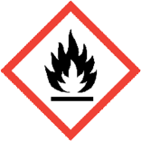GHS 02 Flammable* | 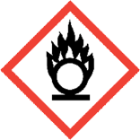GHS 03 Oxidising | GHS 04 Compressed gas | 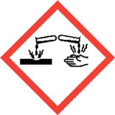GHS 05 Corrosive | 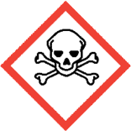GHS 06 Toxic | 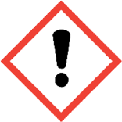GHS 07 Harmful/  Irritant | GHS 08 Health hazard | 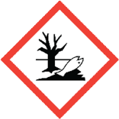  GHS 09 Danger for the environment
Other (e.g. biological hazards or by-products) - please describe:

*If flammable substances are handled, a separate DSEAR assessment may be required. Consult Workplace Health, Safety and Wellbeing (WHSW) for advice.

Please list below the details of all substances covered by this assessment (including any substances/by-products formed). If there are many substances, the information can be attached to the assessment on a separate sheet. Chemicals with similar hazards can be grouped together (for example by their GHS code or hazard statements) as long as the resulting control measures are appropriate for all chemicals in the group.

Ensure that up to date Safety Data Sheets are available for all chemicals and that all containers are clearly labelled with hazard information.

Substance name | CAS Number | Physical state (e.g. solid/liquid/gas) | Quantity and concentration used | Description of usage and how exposure can occur | Frequency and duration of use | Workplace exposure limit (if applicable) | GHS classification(s) | Hazard statements | Max quantity stored | Storage requirements | Notes

Section 3: Who might be harmed
Circle / highlight all that apply:
Staff | Postgraduates | Undergraduates | People at particular risk (e.g. pregnancy)* | Contractors /cleaner | Visitors/ members of the public
* Please give details:

Section 4: Control measures
Comments
Has elimination or substitution been considered?
Physical or engineering controls (e.g. local exhaust ventilation). Include overview of maintenance and inspection regime.

Administrative controls (e.g. safe operating procedure, training and supervision, signage)

Personal and respiratory protective equipment (PPE and RPE) (e.g. lab coat, chemical protective gloves, light eye protection, face mask).
Is exposure monitoring required?
Is health surveillance required?

Section 5: Storage, transport and waste
Comments
Storage requirements (check if any materials should be segregated)
Waste disposal

Transport

Section 6: Emergency arrangements

Do any substances require a special emergency procedure? If so, please state which one(s) and if necessary attach the procedure to this assessment.

Is there a spill kit available?
First aid arrangements.

Name, position and telephone number of the emergency contact person for the area

Section 7: Action List
Action | Actionee | Due date | Date achieved

Section 8: Approval
I confirm that this is a suitable and sufficient risk assessment for the above described work activity | Name | Signature | Date
Line Manager

