Supplier Guide on How to Create invoices in the Proactis Marketplace
  - University of Essex

V0.2 October 2020

Table of Contents
1 How to log into the Proactis Marketplace 3
2 How to create a PO Flip invoice 5
3 How to add a non-PO line to your invoice 8
4 How to create a credit note 9

How to log into the Proactis Marketplace

When a customer creates a new supplier in the Proactis Marketplace an email is sent with details on how to log into the system. The email will contain a link to the Proactis Marketplace and confirmation of your User ID. To log into the Proactis Marketplace, click on the URL link contained in the email.

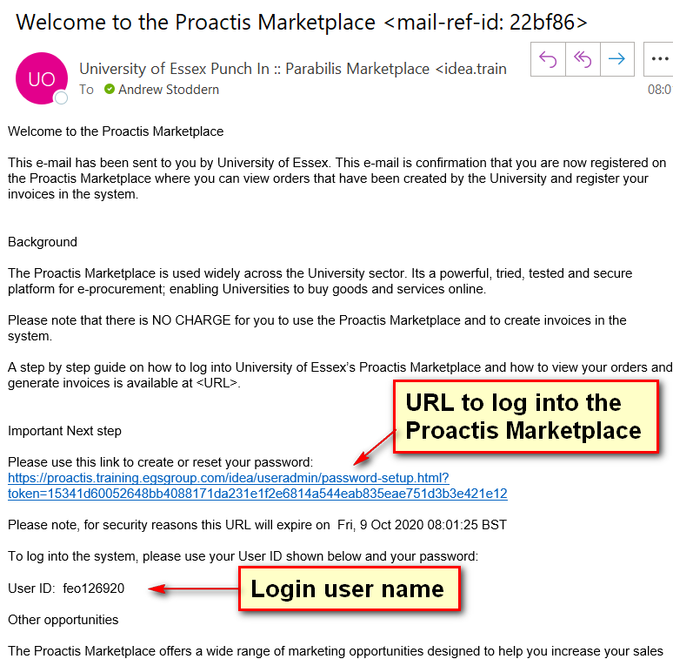

You will need to enter a password. Please note the password needs to be alphanumeric, minimum of 8 characters and at least one letter in capitals.
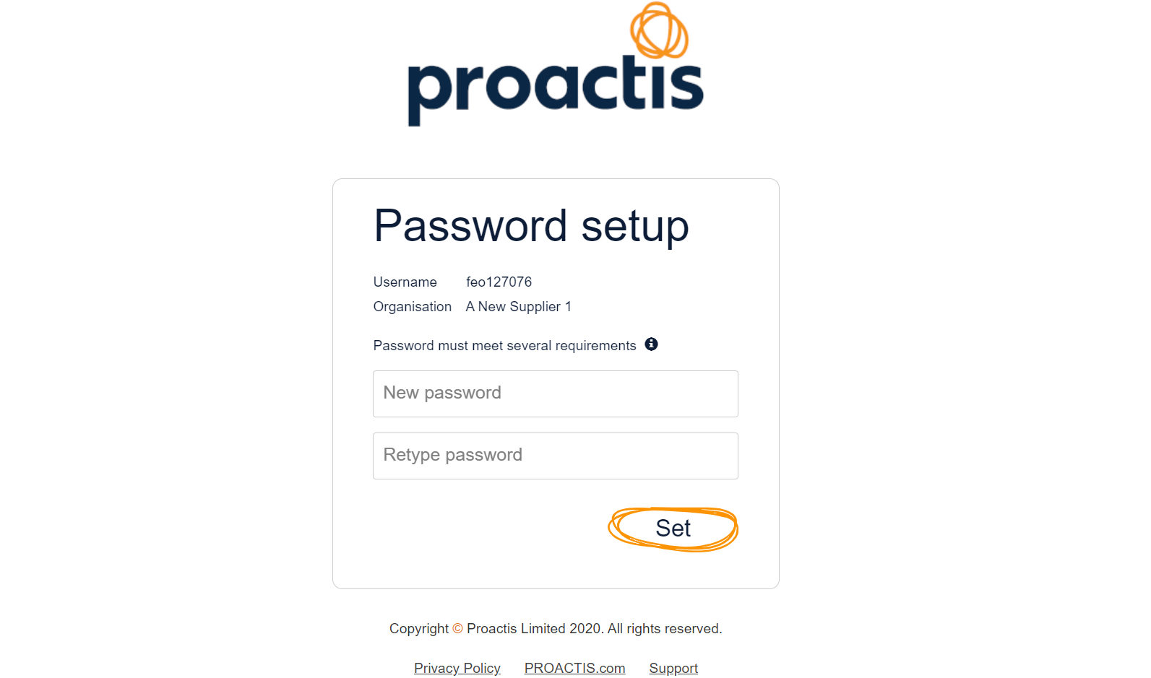

You will then be asked to set up a Password Lookup in case you forget your password, the system will email you a URL link which you can use to reset your password by answering your Password Lookup question correctly. Please note the answer to the Password Lookup question is case sensitive.

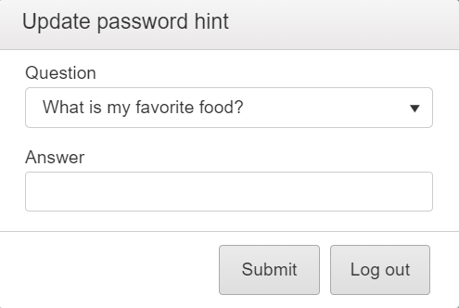

How to create a PO Flip invoice
The Proactis Markeptlace assumes that you want to create an invoice which is exactly the same as the Purchase Order. It assumes that all lines on the Purchase Order will be invoiced and that the invoice will contain the same quantities and prices as per the Purchase Order. You can however create part invoices by invoicing for some of the PO lines and where the quantity and/or prices are different.
You can create your PO Flip invoice against an Order displayed on the home page by clicking on the Create New E-Invoice icon (option 1) or by searching for the PO number using the Purchase Order search field (option 2)

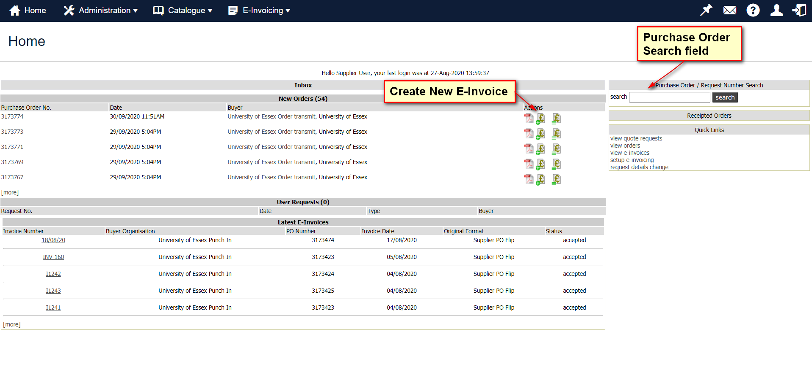

Option 1 – create a new e-invoice from the order displayed. There are 6 mandatory fields (shown in red) that must be completed.
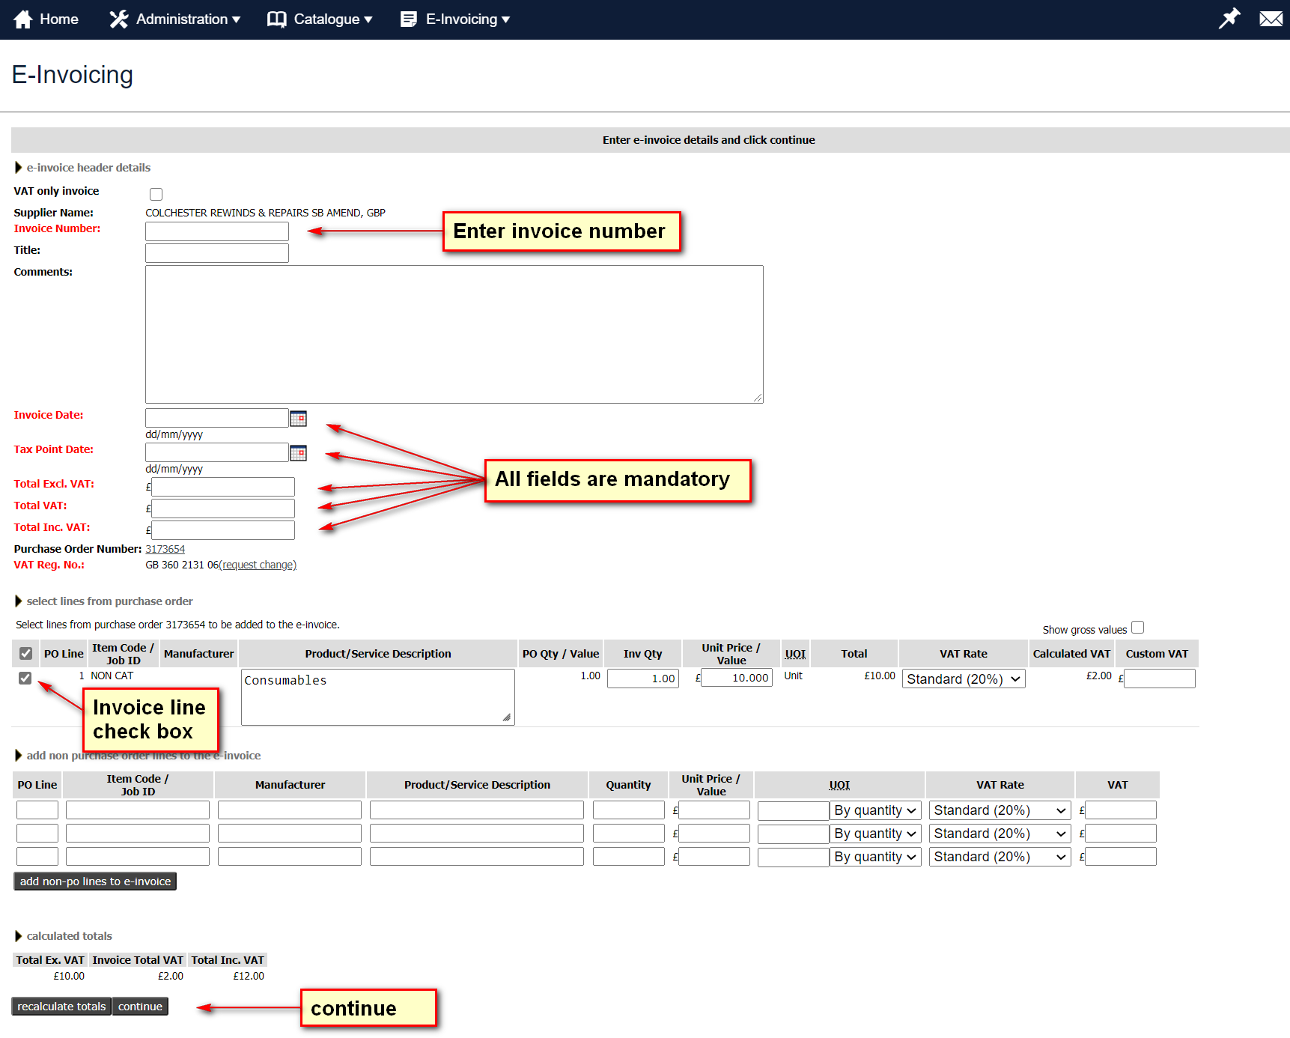

Successfully submitted e-invoice
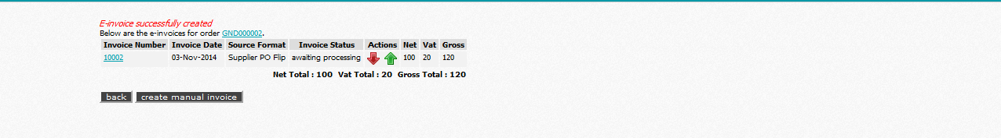
The System will prevent invoices from being created in the system if the Invoice Number has been registered before by the same supplier.
The Invoice Date and Received Date must be entered in the format dd/mm/yyyy otherwise the System system cannot create the e-invoice.
If the VAT Rate displayed per invoice line is incorrect, select the correct VAT description from the drop down list.

Option 2 – Create new e-invoice from the search field
Enter the PO number and click on search. Then scroll to the bottom of the page.

Step 1 – click to create e-invoice
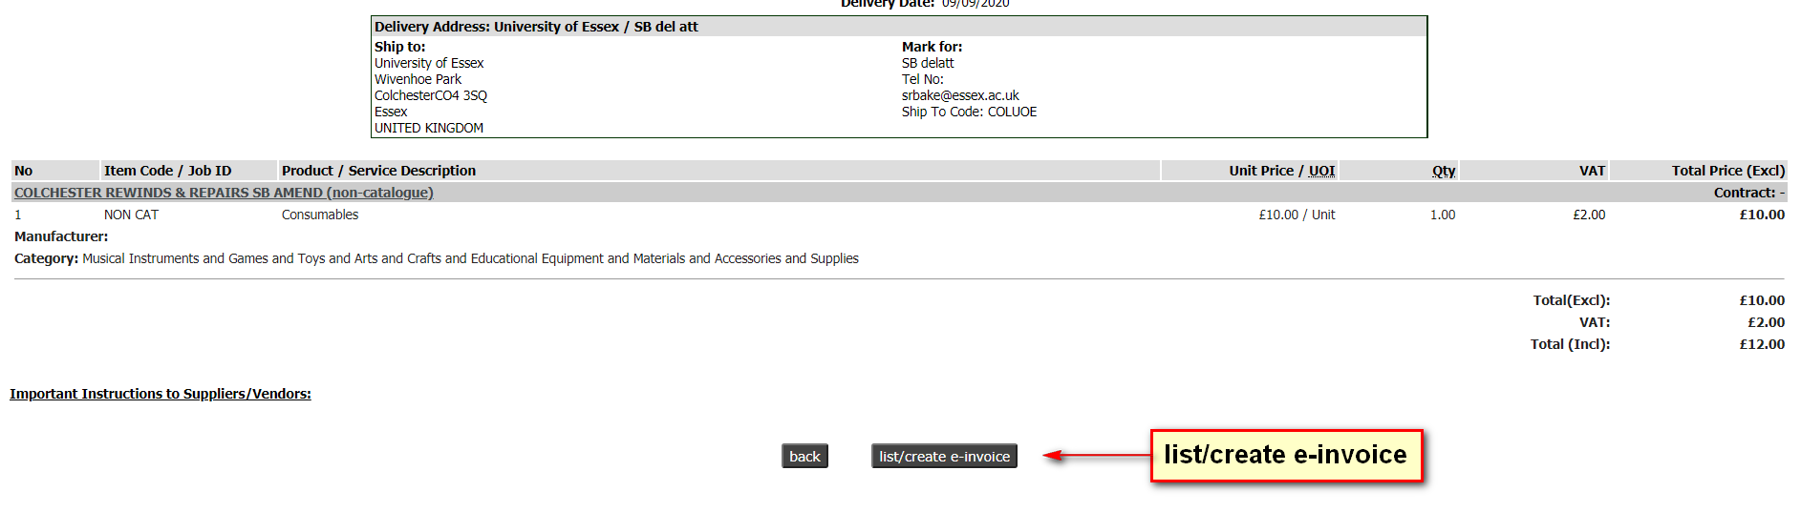

Step 2 – click to create manual invoice
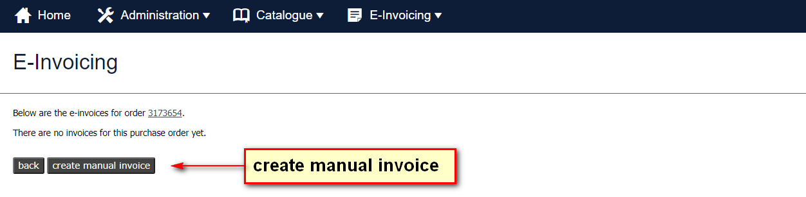

Step 3 – continue to create your invoice as shown in Option 1

Note:
If you only want to invoice for part of the order you can omit a PO line from the PO Flip invoice by un-ticking the invoice line check box. Once the check box has been un-ticked you do not have to delete the quantity or price.
If you would like to create an invoice with a different invoice quantity and/or price, enter the correct figure in the invoice quantity mandatory fields and update the price fields on the Purchase order line.
Clicking on the re-calculate totals button at the bottom of the page will result in the System re-calculating the total value of the invoice. The System will allow the invoice to be created if the values entered in the Total Excl. VAT, VAT and Total Incl. VAT fields are the same as the calculated totals displayed at the bottom of the page.

How to add a non-PO line to your invoice
There may be occasions when you will need to invoice customers for goods or services which the customer has not specifically asked for and are not contained on the Purchase Order. For example, customers typically forget to include delivery costs on Purchase Orders.
To add non-purchase order line/s to an invoice you need to complete the following four mandatory fields and click on the add non-po lines to e-invoice button.
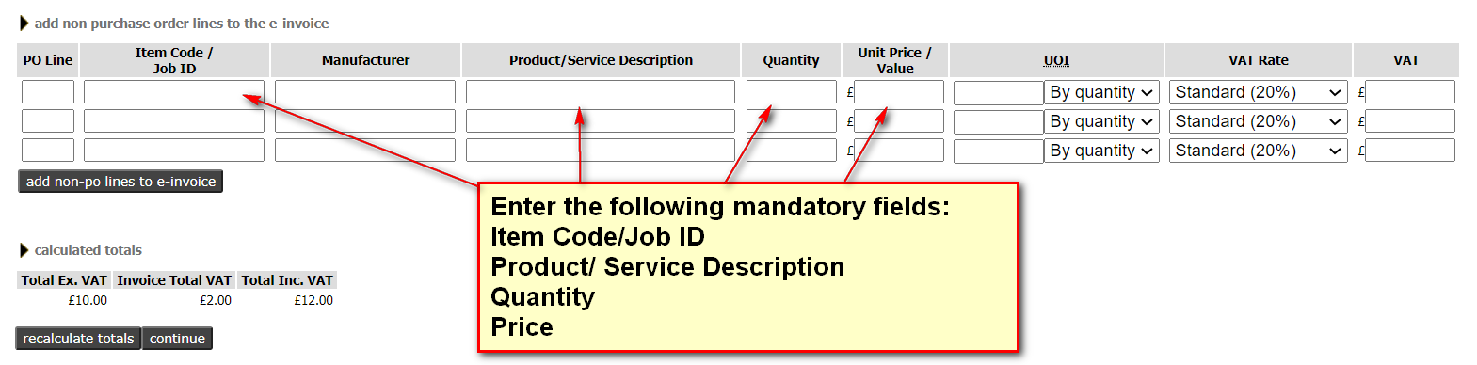
Note:
If you need to add a value rather than a quantity and price, click on the pricing option field and select the option “By value”.
If any of the fields above are not applicable enter “n/a” in the field.
Below is an example of a completed invoice ready for submitting
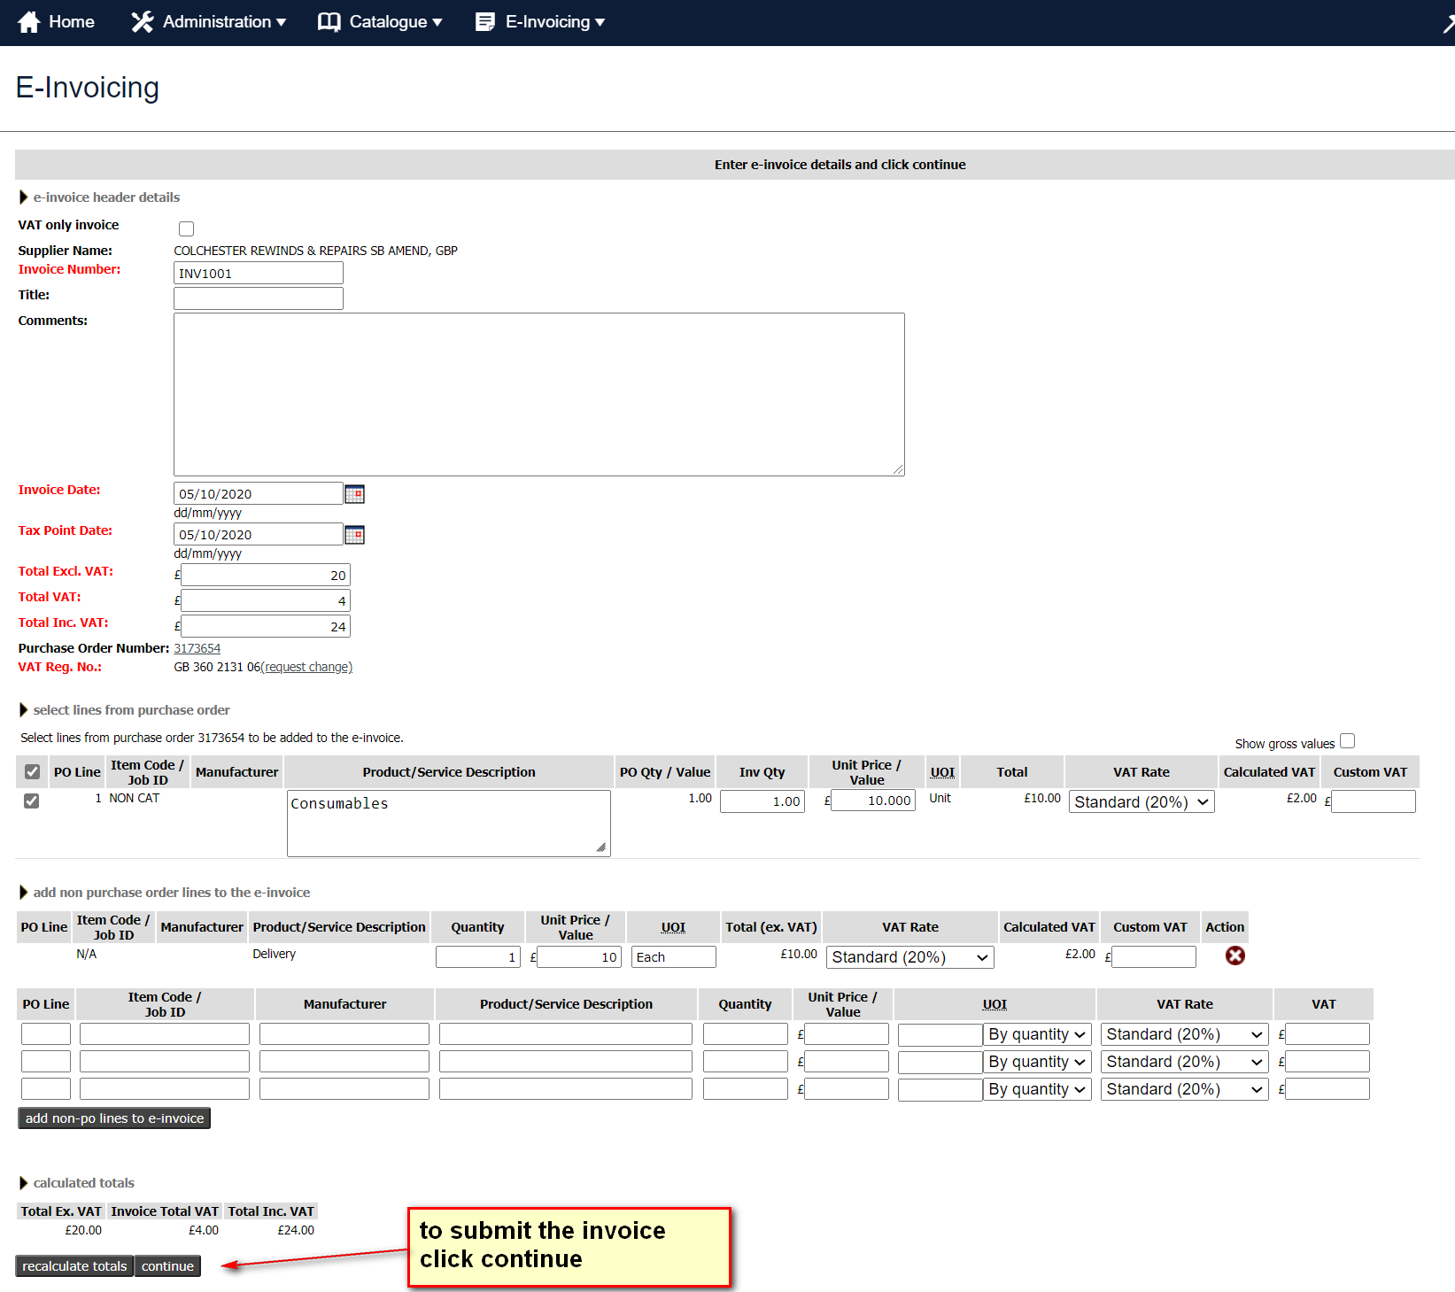

How to create a credit note
Credit notes are created in exactly the same way as the invoice creation except for one small difference; the figures should have a negative value. Follow the guide above for creating your invoice but change the value/price to a negative figure.

