Event Furniture and Office Move Equipment
Available on Request

To request, please complete the Portering request form.

Event Furniture

The below items are stored in different locations across campus and a minimum 1 hour should be allowed for setting up and packing down each event, this may vary depending on size of event. Event set up/pack down requests are accessed on a case-by case
, please provide a minimum 2-week notice.

- Large trestle table
- Small trestle table
- Red & Purple seminar chair
- Green & gold chairs
- Orange plastic chairs
- Screw leg tables
- Circle tables
- Silver tensa barriers
- Black tensa barriers

Office move equipment.

Please provide 5 working days’ notice when requesting one of the below items and 2 weeks’ notice for office moves.

- Blue & silver trolley/bins
- Crates

Pictures and quantities below

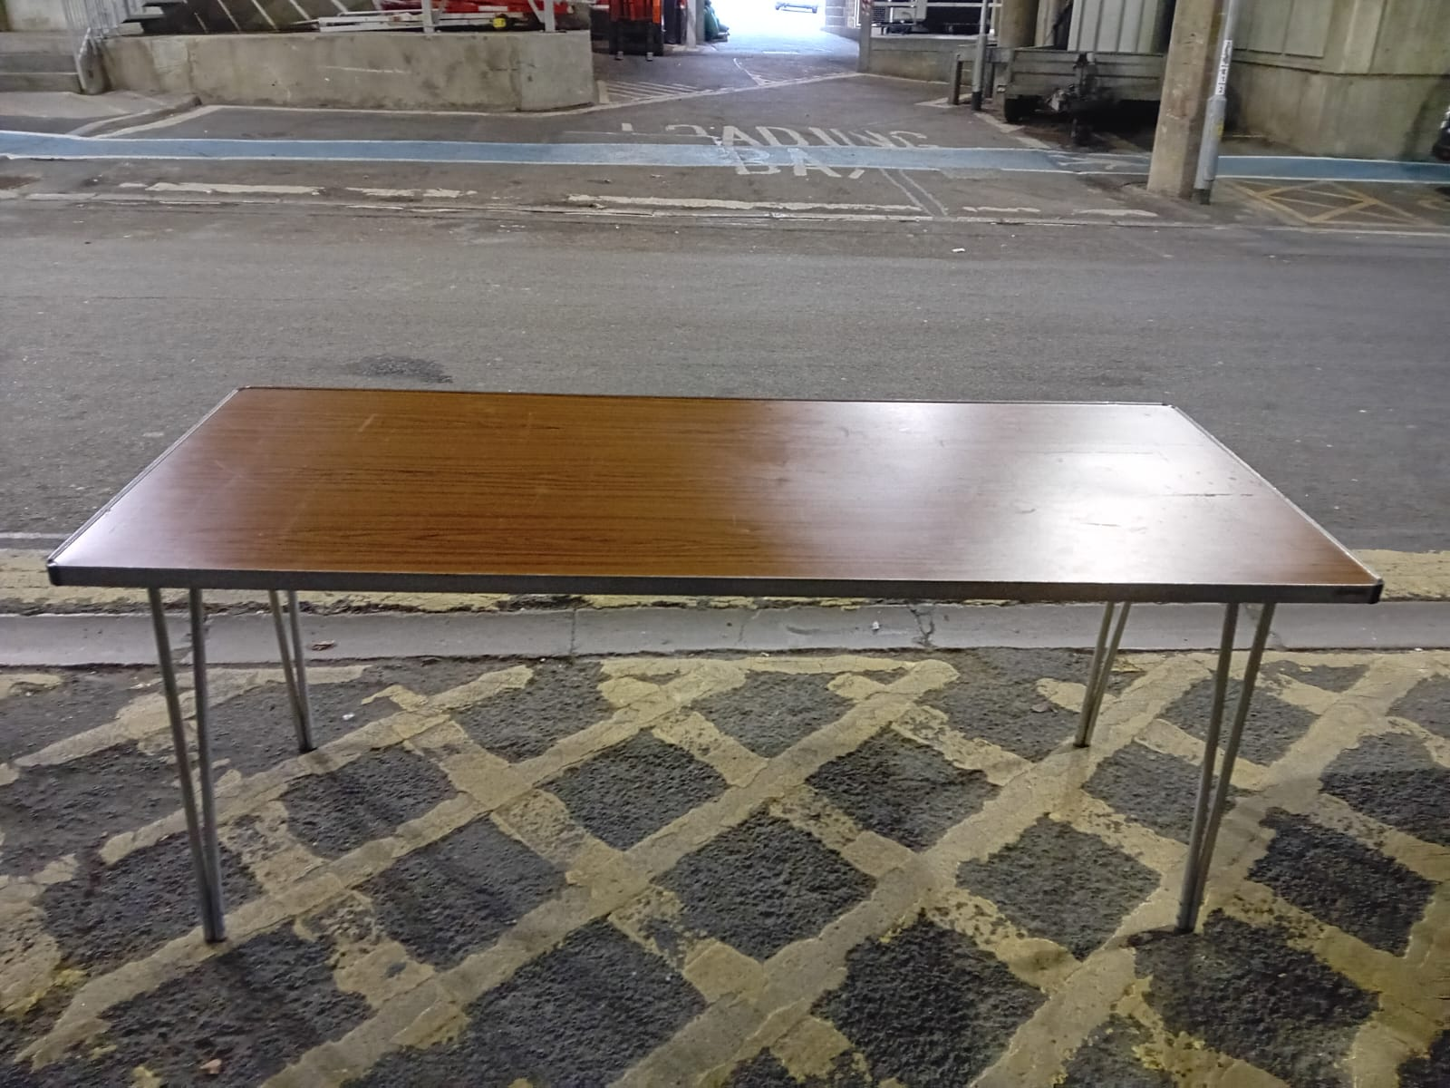 | Item: Large trestle table  Quantity: 1  Dimensions: 6ft x 2ft
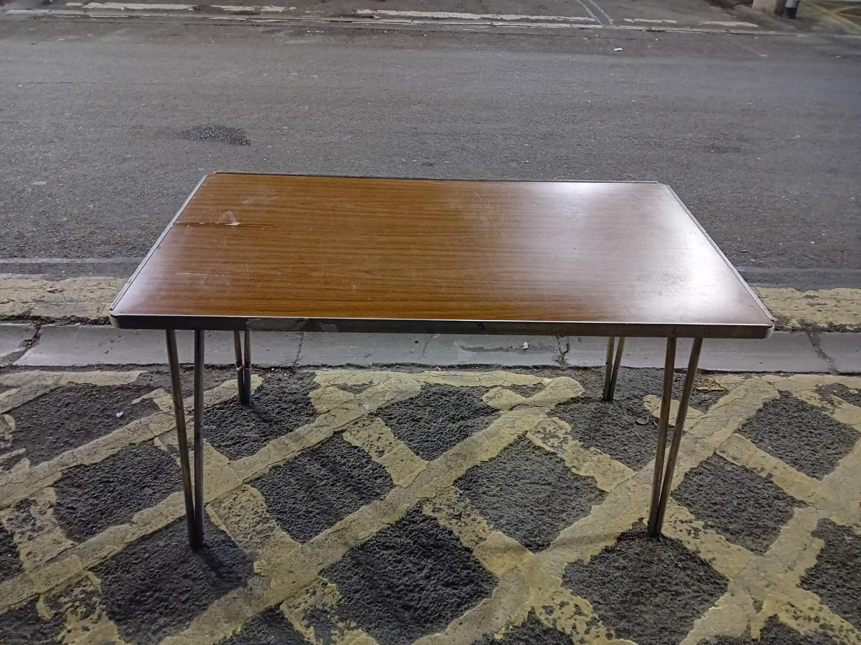 | Item: Small trestle table  Quantity: 13  Dimensions: 4ft x 2ft
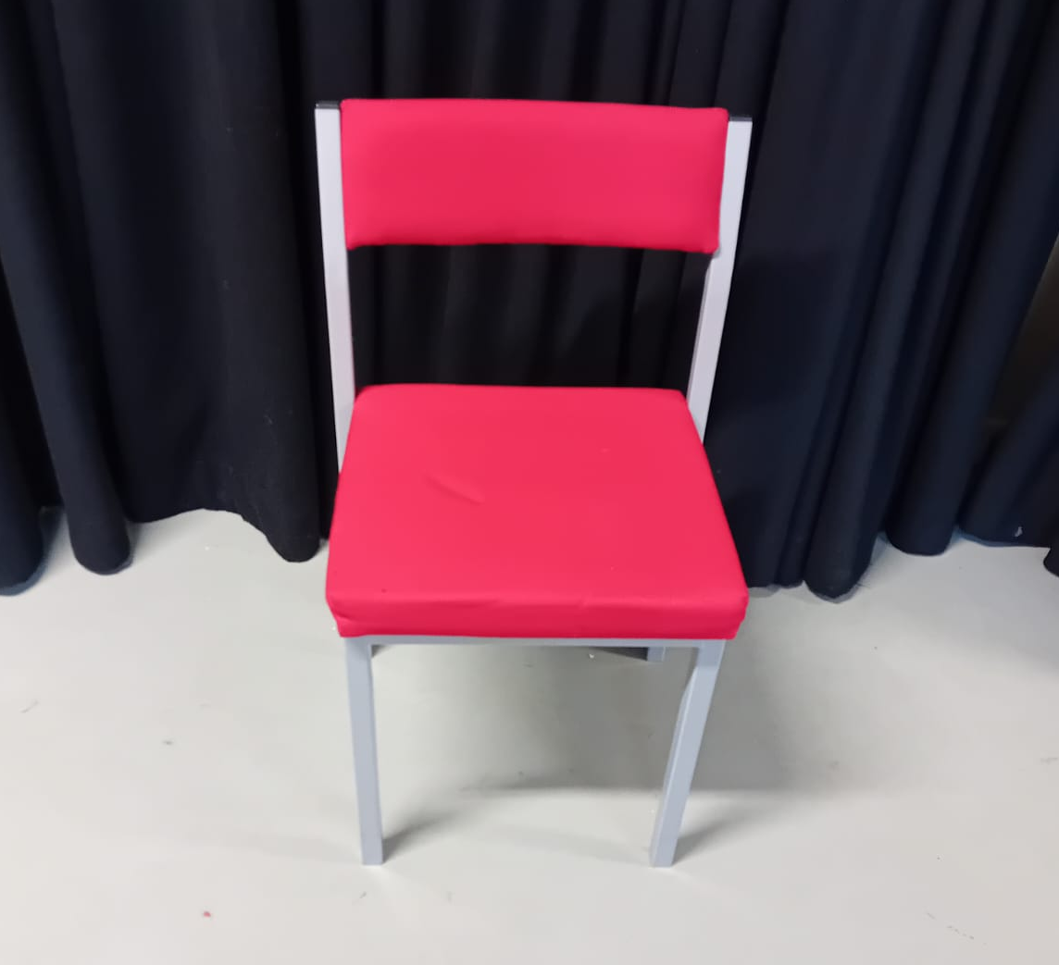 | Item: Red and Purple Seminar chairs (indoor events)  Quantity: 210 Red, 138 Purple
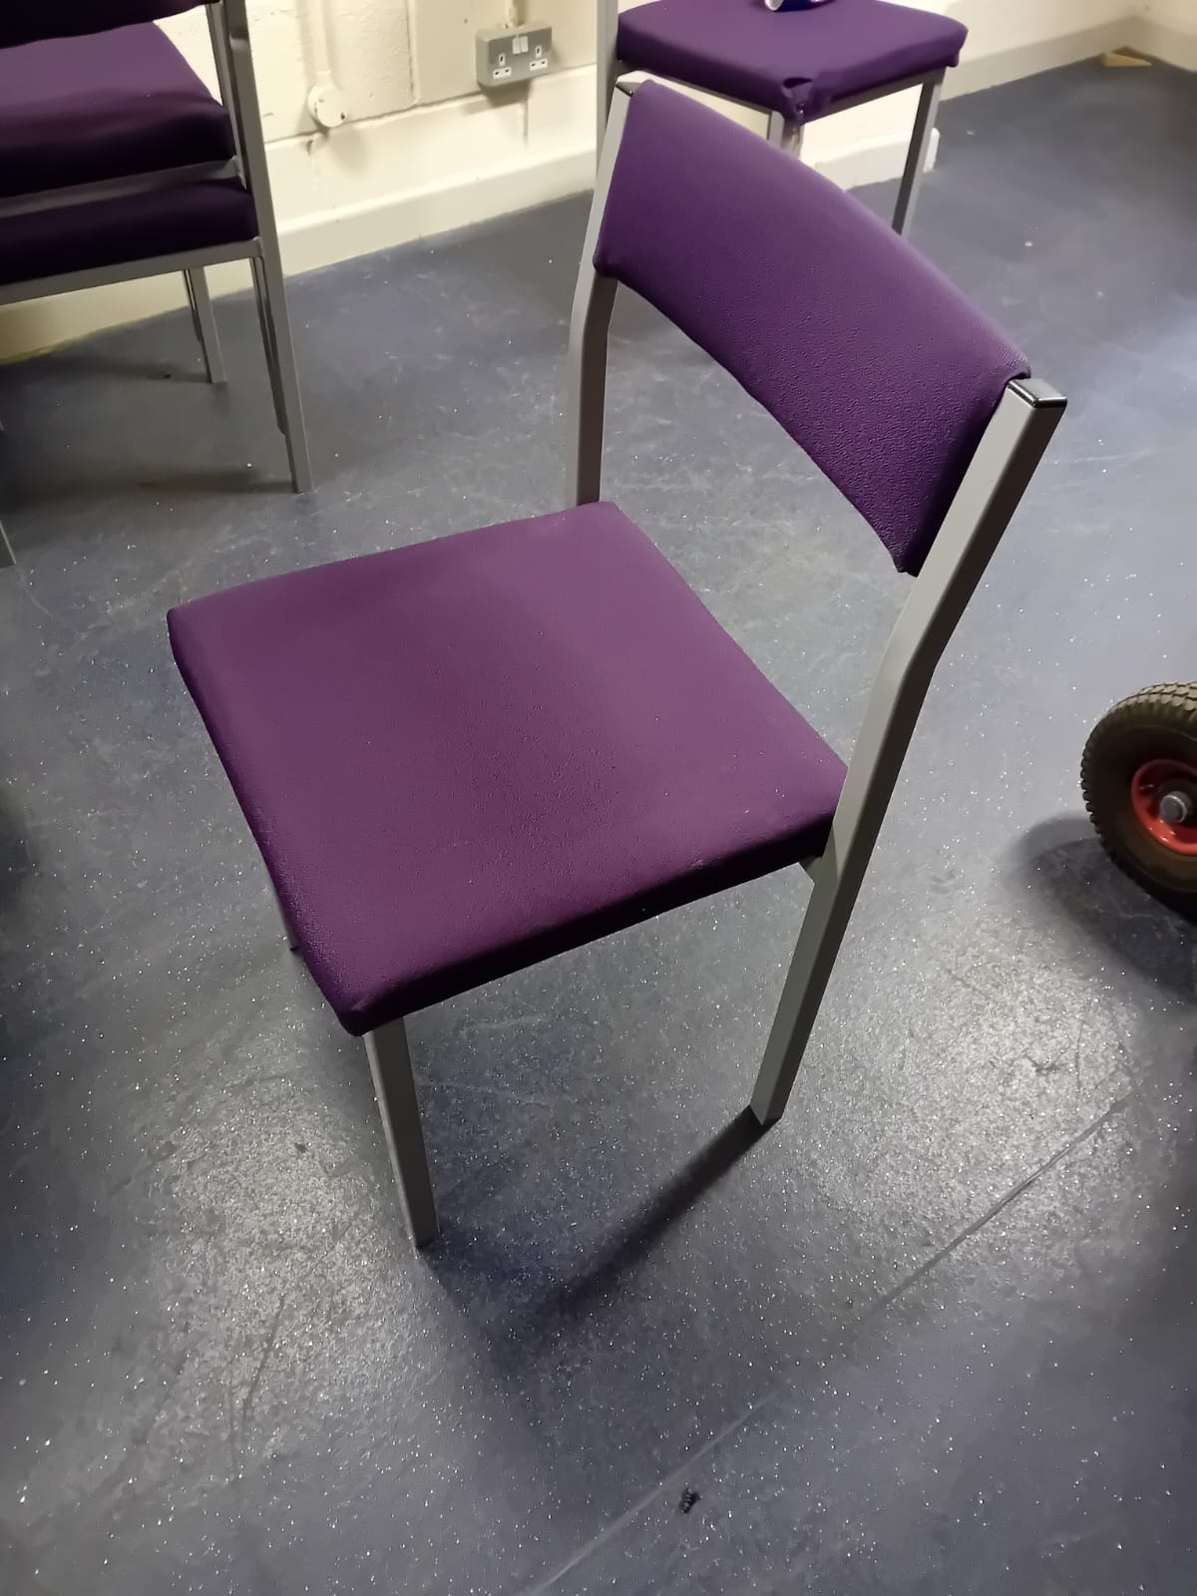
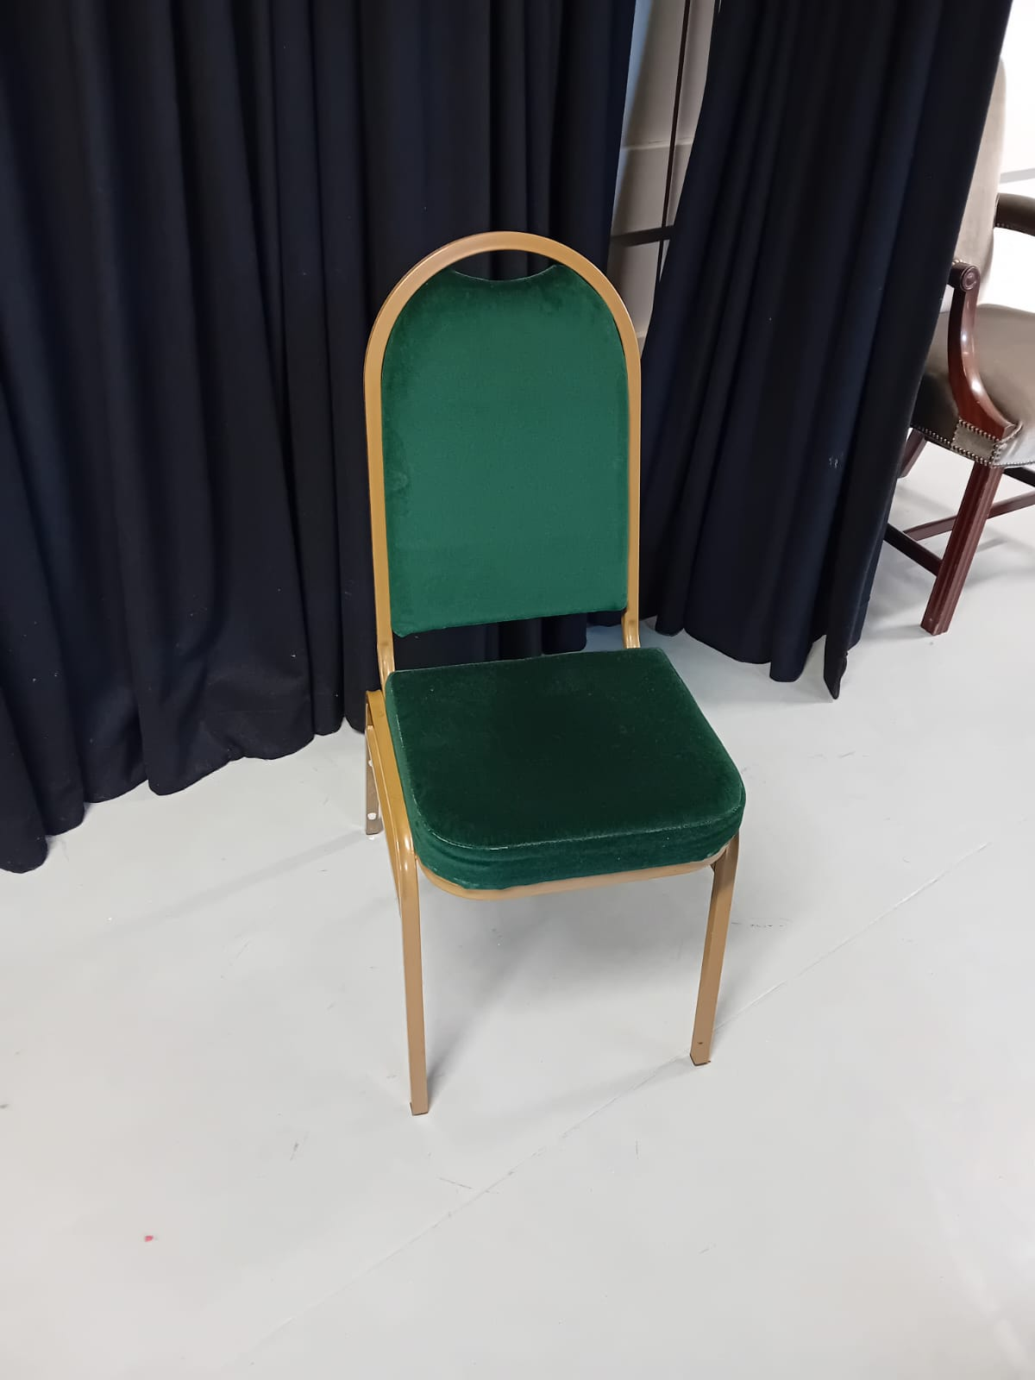 | Item: Green and Gold chairs (Indoor events)  Quantity: 130
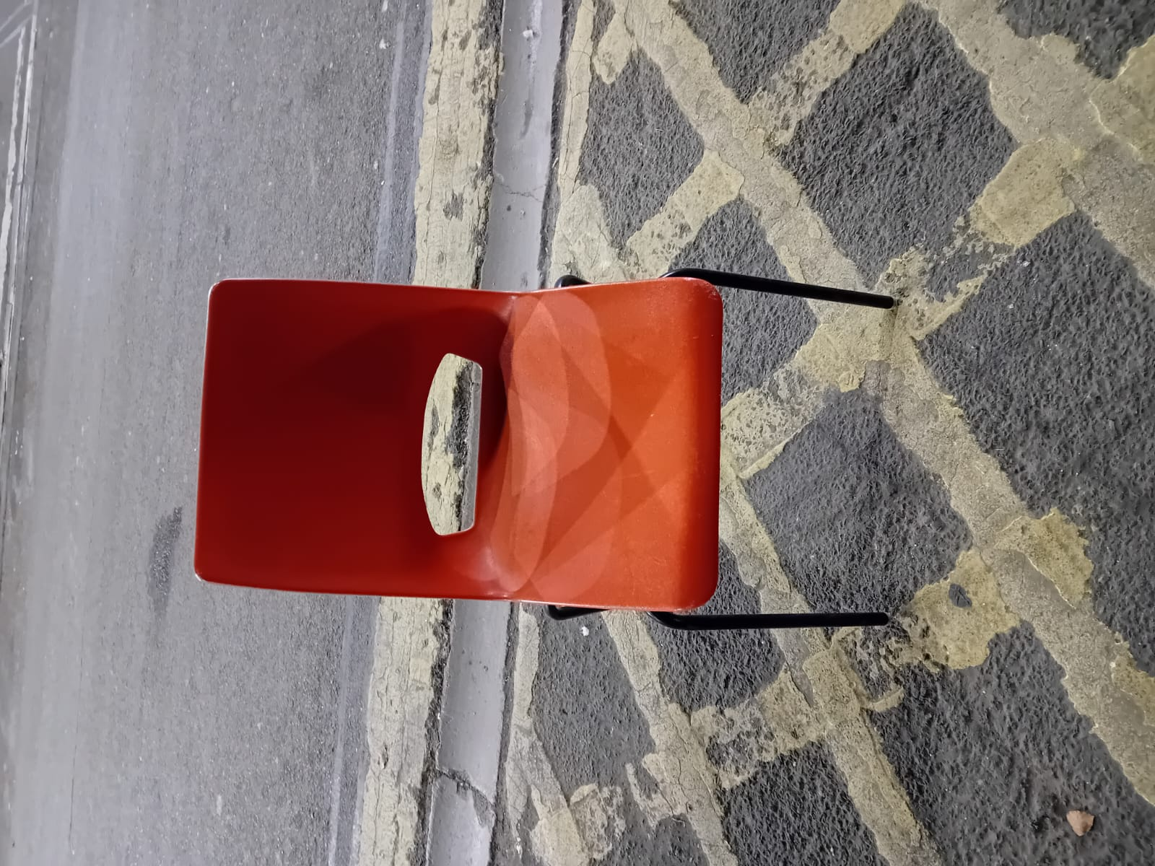 | Item: Orange Plastic chairs (external events)  Quantity: 150
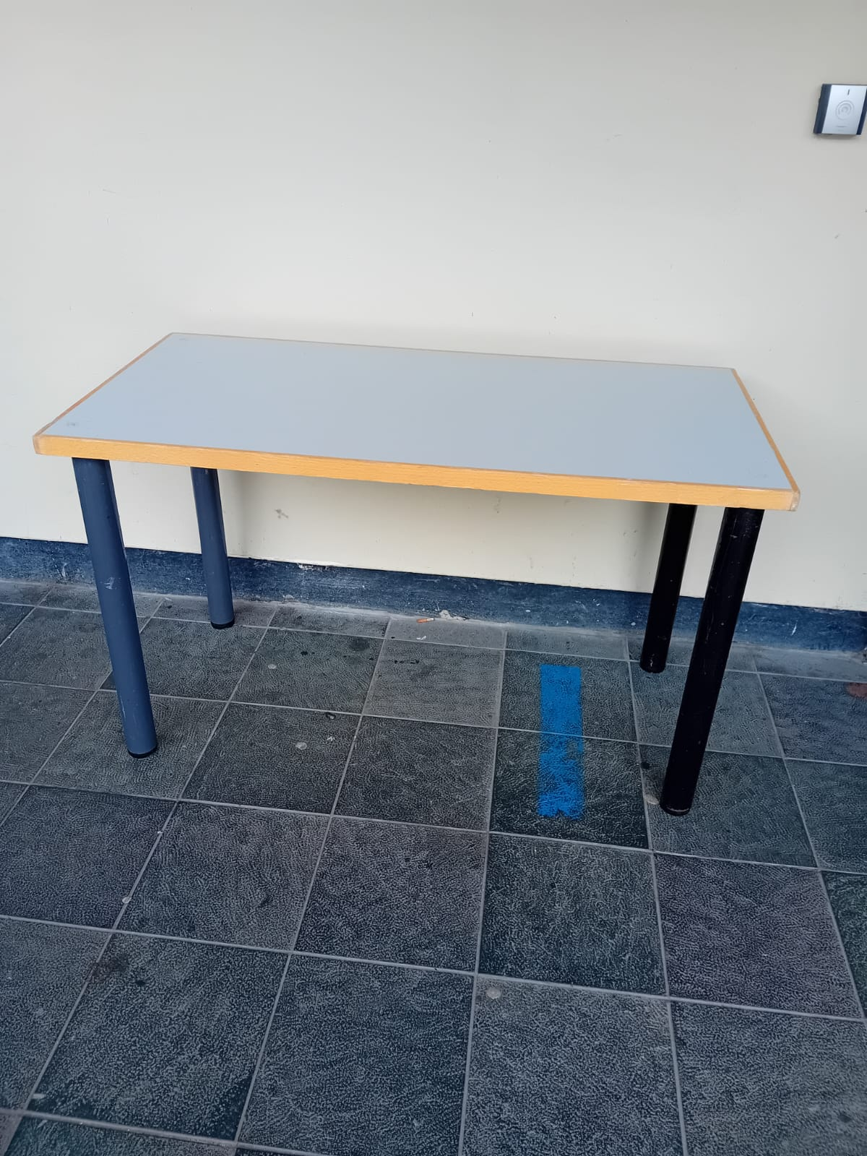 | Item: Screw leg tables  Quantity: 120  Dimensions: 4ft x 2ft
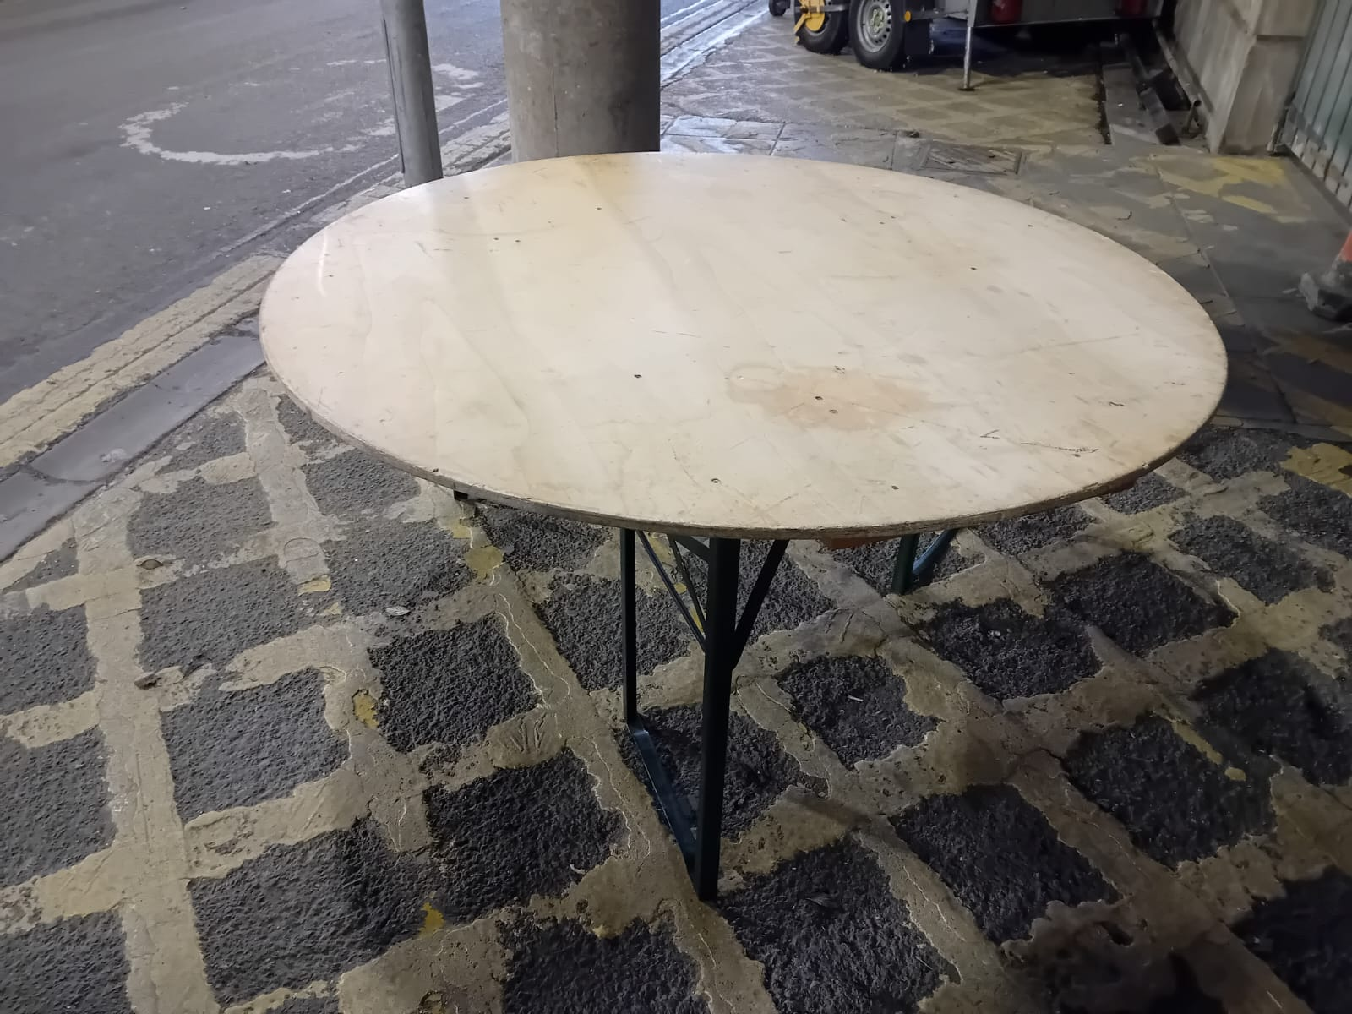 | Item: Round tables  Quantity: 20
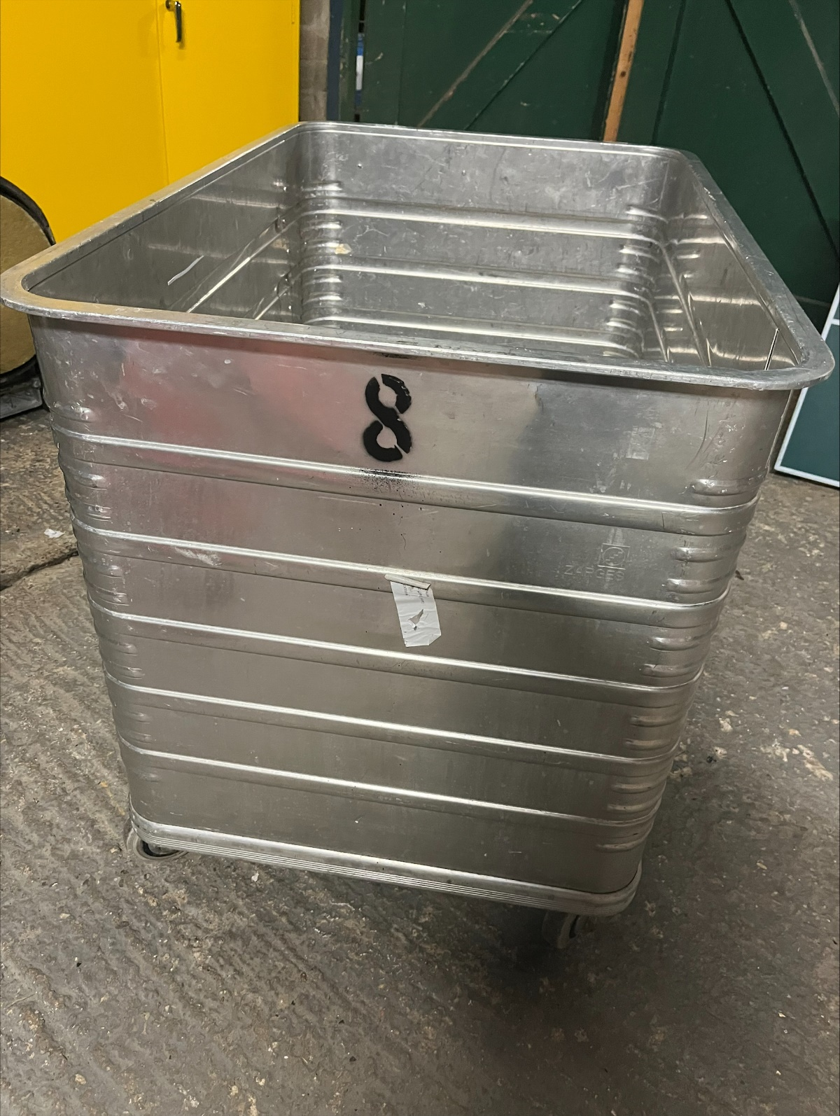 | Item: Silver trolley/bin  Quantity: 8  Dimensions: 67cm x 115cm, 70cm deep  n.b. intended use for transport of office items or bagged waste.
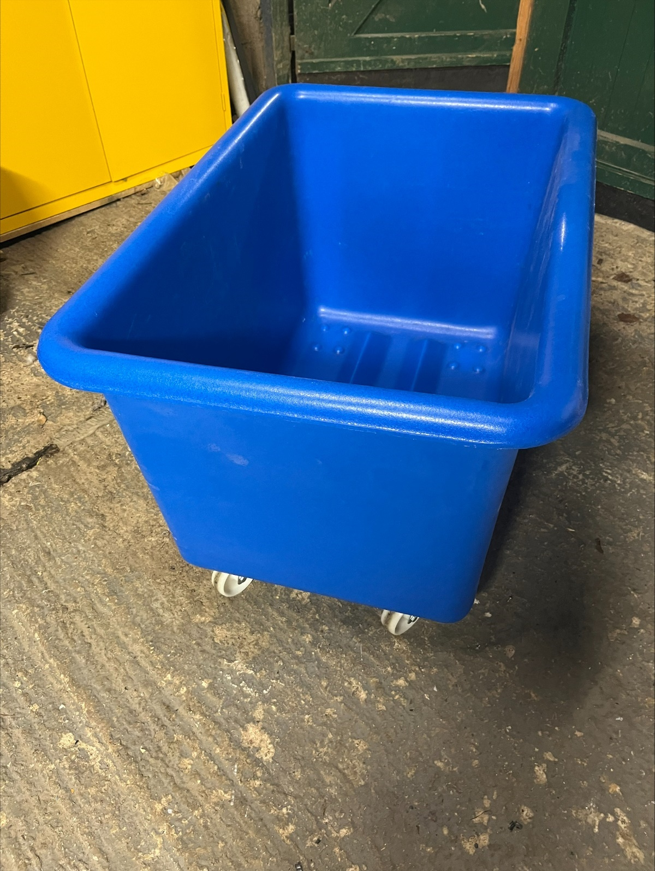 | Item: Blue trolley/bin  Quantity: 4  Dimensions: 67cm x 95cm, 53cm deep  n.b. intended use for transport of office items or bagged waste.
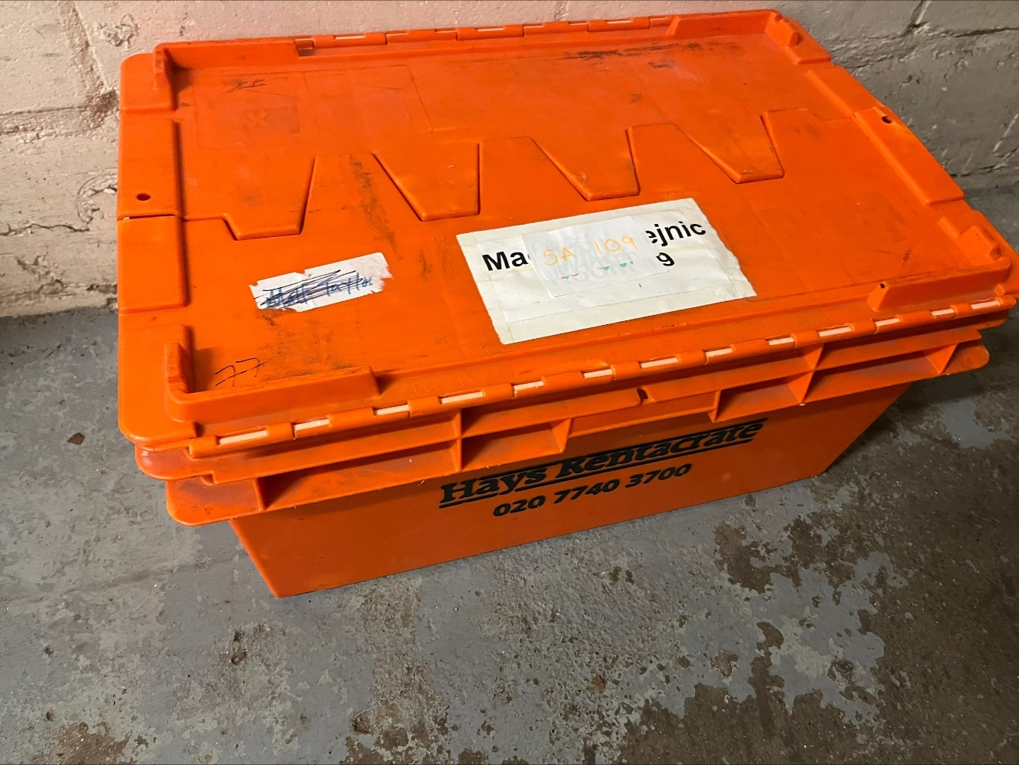 | Item: Crates (Room/office moves)  Quantity: 60 closed top, 50 open top  Dimensions: 33cm x 69cm, 30cm deep
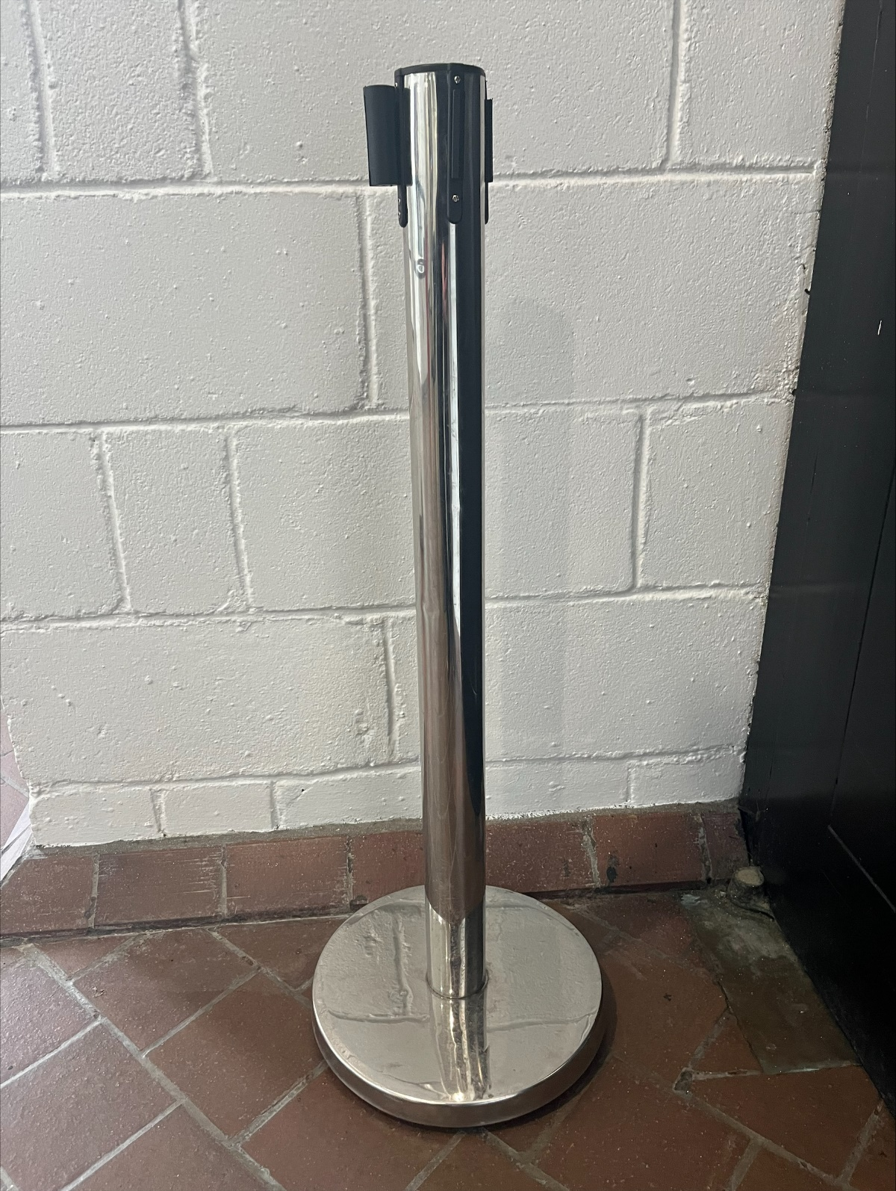 | Item: Silver Tensa barrier  Quantity: 31
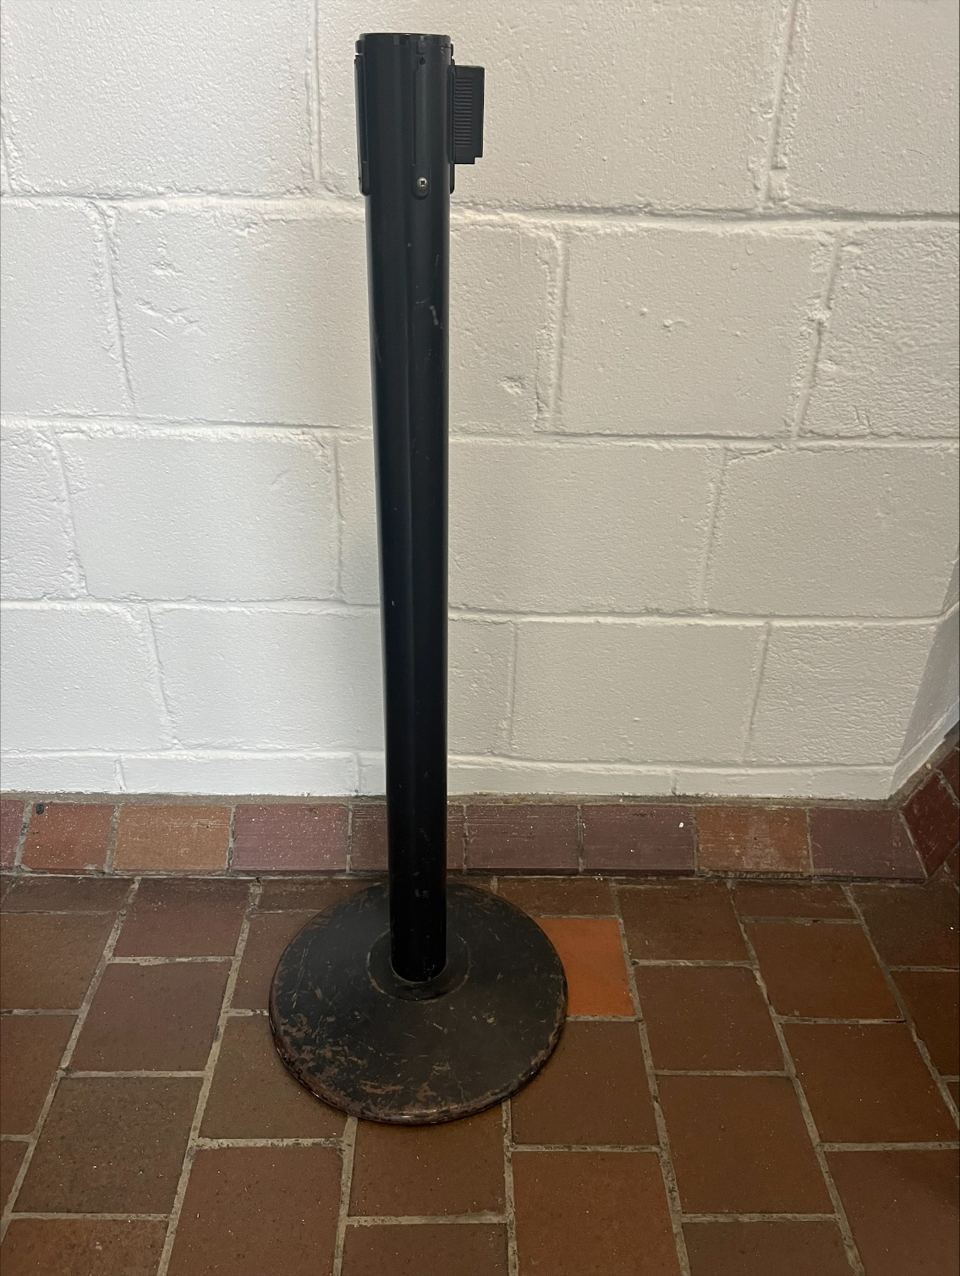 | Item: Black Tensa barrier  Quantity: 25

