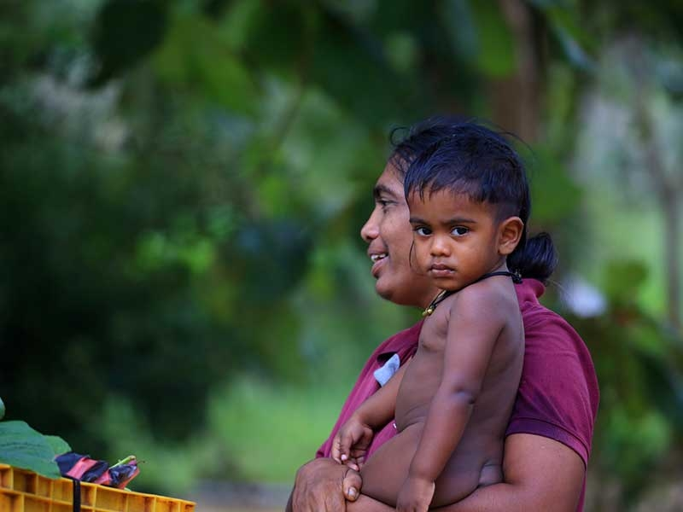
©2020 All rights reserved | SAFE Organization
Corporate Communication Division, No. 146,Priyas House, Kotugoda Road, Seeduwa, Sri Lanka
Email: hello@safeorganization.com
Telephone: (+94) 11 226 57 01

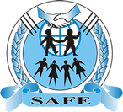
SAFE Organization | Company profile

Table of Contents

Who we are? 3
Our Vision 4
Our Mission 4
Our Values 5
Our efforts – FTZ and Workforce 6
Our efforts - FTZ and Workforce 7
Our efforts – Rural Economy 8
Our efforts – Manufacturing 9
Our efforts – Inter Province 10
Our efforts - in Multi Locations 11
Our Founder & Managing Director 12
Our Core Team 13
Board of Directors 13
Contact Us 14

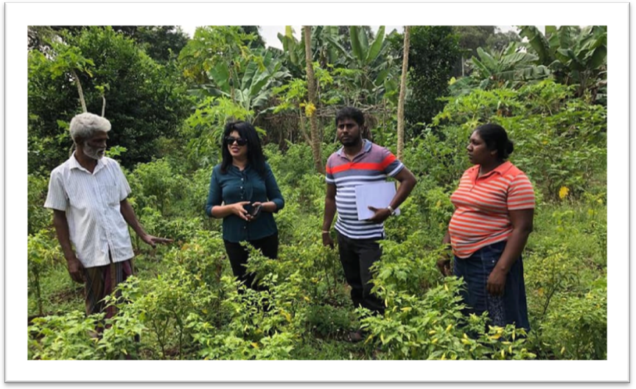

Who we are?

SAFE Organization was founded in 2018 by Mrs. Jayanthi Gunawardena as a Non-governmental organization (incorporated in the same year under Sri Lanka’s companies Act no 07 of 2007), to protect children, women, youth and those who are in need to gain a sustainable life.

Our success is our high performance team. Our multi disciplinary team of experts with extensive hands-on experience from various professions and backgrounds has immensely helped our organization to successfully contribute towards positive outcomes.
We are facilitating towards a strong and fairly law abiding society and that has fast track our growth. Our presence in the areas of sustainable, equitable and participatory program for Children and Women are stronger and has impacted more than 1000 families directly and 3000 families indirectly within this short time span. We are playing a key role in uplifting safety standards (Occupational Health and Safety) in factories based in Free Trade Zones (FTZ) in Sri Lanka.

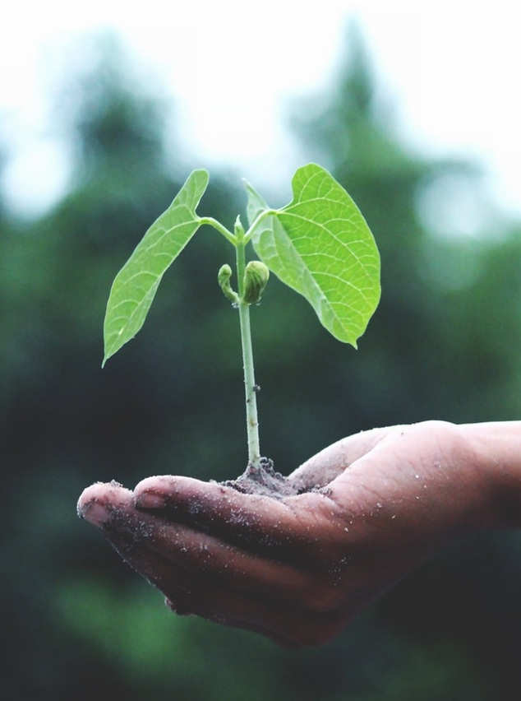
Our Vision
All Sri Lankans to become socially and economically protective

Our Mission
Sustain the protection of fundamental rights and respect for democracy in the country’s workforce
Advocating rules and regulations enforced by government, NGOs, and international authorities
Adhere to all governing regulations; building awareness/training and facilitating the Sri Lankan workforce to gain sustainable livelihood through Occupational Health and Safety
Facilitate economic value creation by woman in rural communities through knowledge sharing, directing towards credible resources that leads to sustainable business solutions.

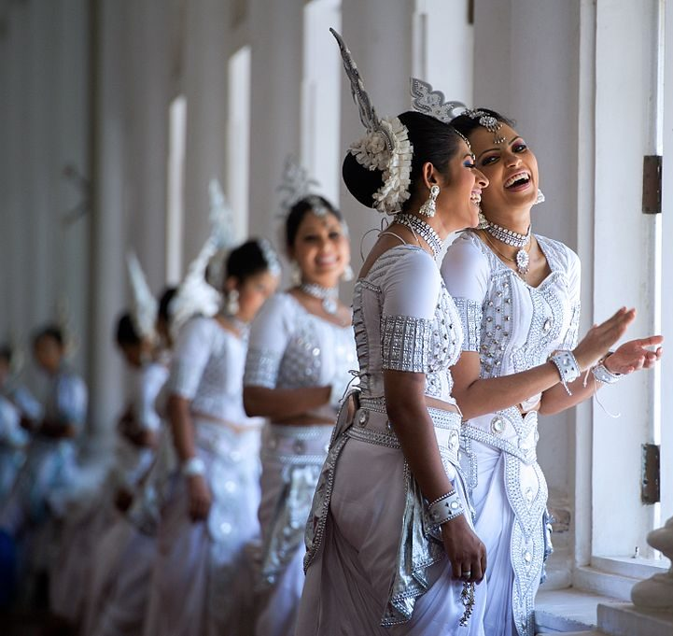

Our Values
- Equality : We don’t discriminate and we respect all
- Productivity : Our efforts are not wasted
- Alliance : We believe in strategic alliances to gain positive outcomes
- Honesty : All our interactions are mutual
- Integrity : We mean what we say and do
- Creativity : Solutions we provide to the society are novel and deliver results

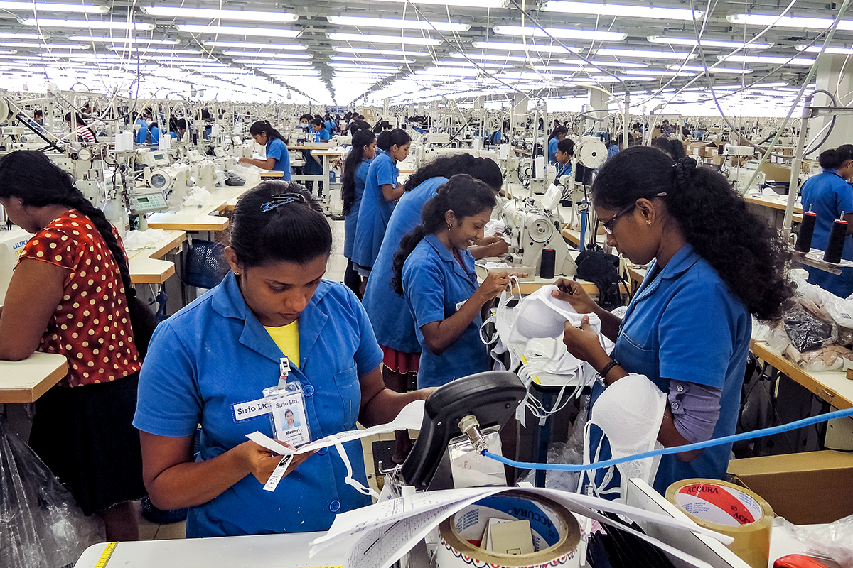
[Picture: Free Trade Zone – Garment Factory]

Our efforts – FTZ and Workforce
The Board of Investment (BOI) in Sri Lanka and the government labor department claims to regulate the operation of factories in the Free Trade Zones (FTZs), but their primary concern is to attract investors by offering cheap labor (low pay, long hours and poor working conditions) along with tax holidays and other financial incentives. As a result, workers pay a terrible price through the loss of their health and in some cases their lives. The vast majority of FTZ workers also face unsafe, dirty and dangerous conditions. Most factories do not provide protective masks, gloves or other safety-gear when needed.
Most of those who work in the Free Trade Zones are young workers from rural areas and lack awareness of occupational health and safety.
We were able to bring tri-party negotiations (Board of Investment – Directors, head of the Labor Department's Occupational Hazard Division, and Factory Senior Management) which resulted in positive outcomes for both the employees as well as for the employer. We were able to player mediator role in bringing everyone’s concerns on-to-the table and facilitate collective bargaining.
Our efforts were fruitful since this was never possible; to bring tri-party to one discussion forum. Everyone who has tried in the past has failed including government authorities.

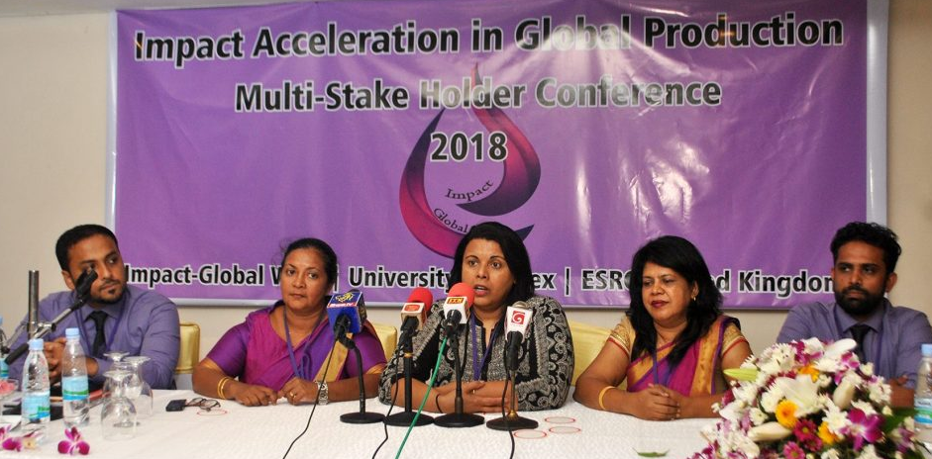
[Picture: ESRC - Press Conference – Dr. Sandya Hewamanne addressing the media correspondents and participants]

Our efforts - FTZ and Workforce

ESRC – Impact Acceleration in Global Production; Multi-Stake Holder Conference was organized by SAFE Organization on 14th September 2018 at The Gate Way Hotel, Katunayaka, Sri Lanka. This was collaborated together with Dr Sandya Hewamanne, Senior Lecturer, Department of Sociology, ESSEX University, United Kingdom.

Objective was to bring the tri-party (Board of Investment – Directors, head of the Labor Department's Occupational Hazard Division, and Factory Senior Management and representatives from workforce) to a single discussion forum to resolve issues faced by the workers at their respective factories. It was highly successful event where factory owners understood the occupational health hazards and agreed to facilitate workers in safety gear, in the same time workers acknowledged that they can be more productive when the environment is conducive for work.

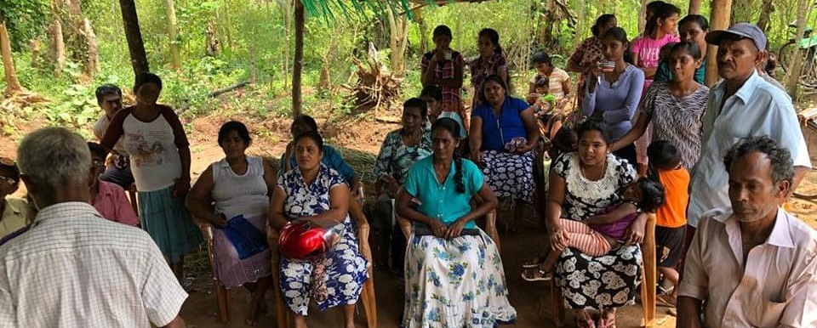
[Picture: Meeting with Rural Community to educate them in economic value creation process (2019)]

Our efforts – Rural Economy
We are empowering woman in rural communities to take part in economic value creation and sustainable development of livelihood.
Our objectives:
- Facilitate women's development
- Launch support mechanisms for women managed income generating activities
- Establish mechanisms to inter province trade programs and leverage self-community-funding for local assets creation

Rural women lack physical access to markets: Rural areas have difficulty accessing markets. They find it challenging to sell their products at a fair price due to the heavy dependency on intermediaries, and failure to establish reliable channels in accessing markets.
Women are deficient in financial literacy: Banks do have loans schemes but due to tight loan procedures (guarantors, statement of income etc.) most of the rural woman prefers micro-finance organizations. However, most of the community members from rural sectors are of the opinion that these loan schemes are not helping women improve their economic status, but are a ‘trap’ that weakens women’s economic advancement. Financial literacy and financial management skills of rural women are lacking to cause this situation.

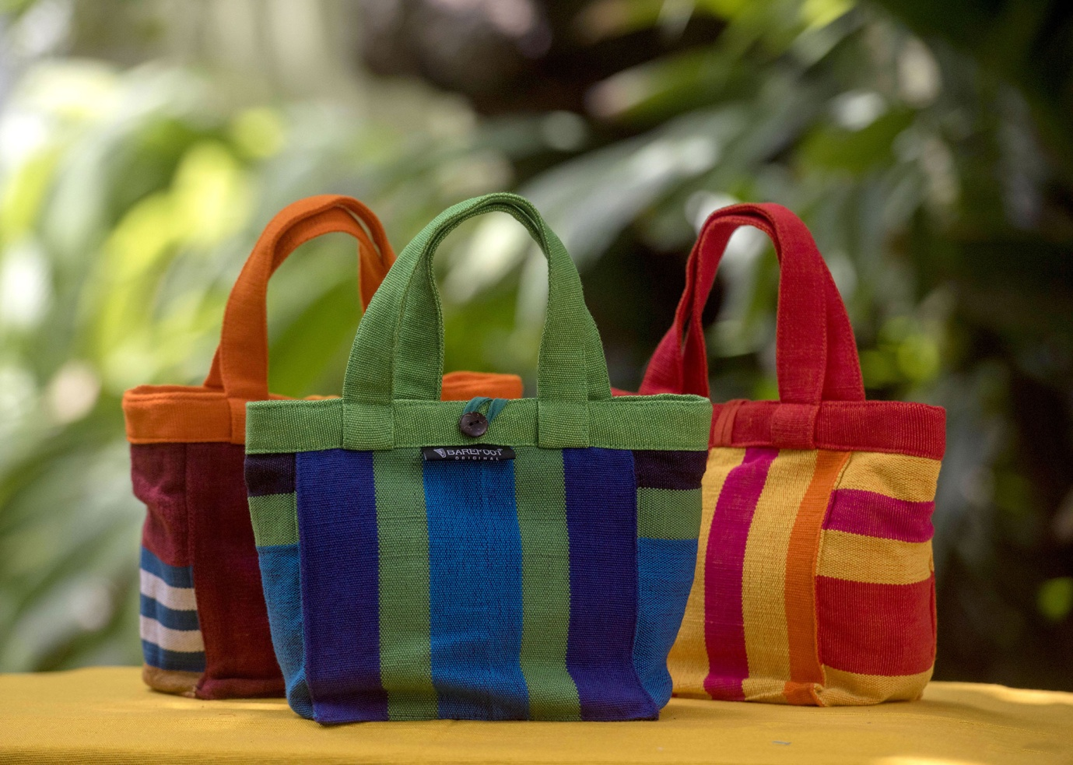
[Picture: Bags manufactured by rural woman]

Our efforts – Manufacturing
We are encouraging the woman to get involved in micro, small business activities so that the family is not dependent on single source of income, which is a high risk factor in rural communities. Most of these families are into cultivation and husband mainly involved in day to day farming activities while wife and kids support.
We have facilitated to establish a value chain to manufacturer Hand Bags (Eco-Friendly) while involving rural communities engaged in the manufacturing process. Raw materials are given to each family and initially they contribute to the manufacturing process. As they become competent, they are encouraged to start their own business venture.
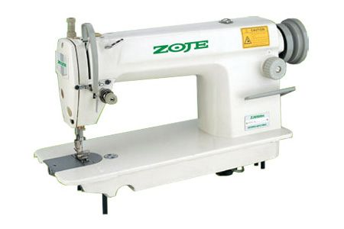
We were able to mediate with Government of Sri Lanka (Divisional secretariats) and were able to donate Sewing machines to these families as a jump-start for their efforts starting a micro business venture. This will enable them to directly reach the consumer and maximize their revenue.
Our efforts to strength the rural woman have been a success story where many families were able to start their own business ventures. We will continue our efforts in building rural economy by involving woman in economic value creation.

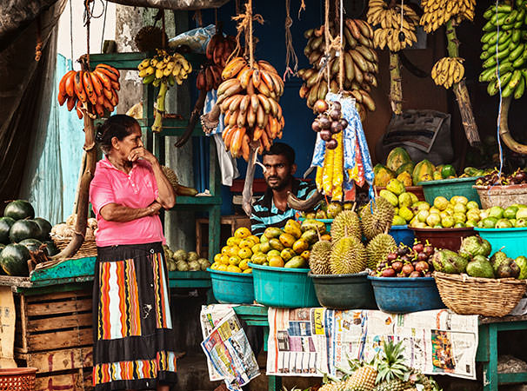
[Picture: Trading of locally produce fruits by rural woman]

Our efforts – Inter Province
We are facilitating inter province trade (Exchange of locally produced crops) by facilitating the producer and the buyer (whole sale) to exchange crops.
We were able to collaborate with the Government - Division Secretariats (The districts of Sri Lanka are divided into administrative sub-units) to identify the local producers and identify buyers in other provinces in order to facilitate trade. We have established these networks by involving rural woman.
This is to strengthen processes that promote economic development of women and create an environment for social change.

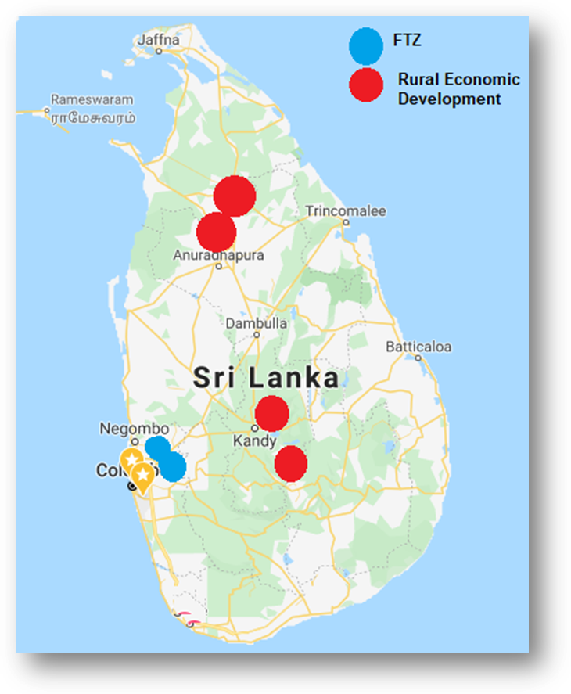
[Picture: Sri Lanka Map with our activity locations]

Our efforts - in Multi Locations
We actively work in multi locations in the island. We actively involved with Free Trade Zone (FTZ) in Katunayaka & Biyagama: We have focused our efforts towards FTZ workforce to uplift occupational health and safety.
Rural Economic Development (Anuradhapura, Vavuniya, Nuwara Eliya and Ampara ): Our objectives were to establish women's self-help groups and address women's needs; Find avenues to increase the incomes of poor women.

Our Founder & Managing Director
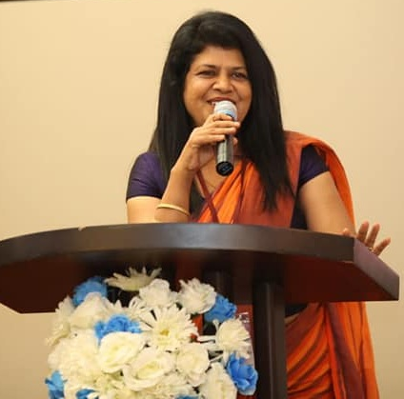
Mrs. Jayanthi Gunawardena started her career in 1998, as a development officer under the National Workers Congress and was given an extensive training with the collaboration from Solidarity Center (U.S.A).
She has received in-depth hands on-training over a period of 5 years on human rights, human trafficking, woman rights, family planning, prevention of spreading AIDS ( HIV) and other sexually transmitted diseases (STD) etc. During this time frame Jayanthi has worked with civil societies, as well as build relationships with female workers in Free Trade Zones in Sri Lanka. Jayanthi was appointed as a women’s union leader at Katunayake FTZ by the National Workers Congress. Jayanthi was innovative to use “Street Drama” a powerful and entertaining form of communication as a mechanism to educate workers to understand human rights, and labor law in Sri Lanka. Jayanthi was nominated as an “independent women’s conveyer” by the National workers congress as recognition of her efforts.
Jayanthi has traveled many parts of the country and closely worked with the cultivation sector. She was exposed to woman workers in tea plantations in Nuwara Eliya (Central Part of Sri Lanka).
Jayanthi has filed cases at labor tribunals, and many instances she has represented female workers (FTZ and Plantation Sector) to justify the rights and spend many hours at government departments / authorities to gain justice.
In 2006, Jayanthi joined Jaya Setha Foundation and worked closely with CAP Foundation (India). She was appointed as a Project Lead to multi-skill garment female workers due to the risk of Sri Lanka losing the export quota system which will close down nearly fifty per cent of existing garment factories. This pilot project was successfully completed by Jayanthi. In 2009, Jayanthi felt she can contribute more to help the woman in rural areas when the 30 year old civil war was ended in Sri Lanka. Initially (2010) she started helping poor families to get involved in bag manufacturing process and establish a value chain. After 8 years of activities, she felt there is lot more can be done to uplift the rural families and SAFE Organization was registered as a non-governmental organization in year 2018. Since then the organization grew rapidly and helped thousands of families to gain a smile on their face!

Our Board of Directors

- Mrs. Jayanthi Gunawardena - Founder & Managing Director

- Mrs. SUMANA ARIYADASA - Director – Legal Adviser Attorney at Law
- Mrs. GAYANI FERNANDO - Director – Program
- Mrs. SASHINI DE SILVA - Director – Program Administration
- Mrs. SUJEEWA PRASHANTHI MENDIS – Director – Woman Empowerment

- Mr. SUNITH MUTHUMUNI DE SILVA - Director – Finance
- Mr. PRIYANTHA RANDHUNU - Director – Program

Consultants:
- Mrs. Nimmi Senanayake - Consultant - Strategic Planning and Program Management
- Mrs. Inoka Perera - Consultant – Corporate Communication

Contact Us

Head office:
146,Priyas House,
Kotugoda Road, Seeduwa,
Sri Lanka

Telephone:
(+94) 11 226 57 01
(+94) 76 140 14 14
Email:
info@safeorganization.com
safeorganisation.7@gmail.com

