Clare’s Law 10 years on: is it working for victims and survivors?

September 2025

Evidence from the international domestic violence disclosure scheme study 2024-5.

Dr Kat Hadjimatheou


Clare’s Law -formally the domestic violence disclosure scheme (DVDS)- has been running for more than 10 years in England and Wales. Over the last decade over 100,000 DVDS applications have been made. Disclosures have become an important part of domestic abuse safeguarding work in policing. Demand for disclosure has become so high that some forces are introducing AI to automate searches in police records and draft disclosure scripts.

The DVDS has also become controversial. In 2023 the BBC revealed that many applications for disclosure across England and Wales were being rejected by police, with victims denied information. Meanwhile Wiltshire police admitted catastrophic mistakes when at least two victims were seriously injured after being wrongly told they were not at risk from partners with a history of violence.

Until now there has been no evaluation of the DVDS nor systematic research into how it is working for victims and survivors, what difference it is making to their safety and empowerment, and what could be improved. DVDS practice is not evidence-based. HMICFRS only examines rates of disclosure.

This briefing presents evidence from the largest and most systematic study to date of disclosure schemes. It highlights what is working and why, how we compare internationally, and where we can improve to better protect and empower victims and survivors.
4 key messages

- Overall, the DVDS is effective. 82% of victims and survivors are very/satisfied with the service they receive. Applicants who receive new information find it empowering and helpful with safety: 97% of them would recommend the DVDS to others.
- But a significant minority are being seriously failed by police. Some are being wrongly denied information. Some are wrongly told there is nothing to disclose, given false reassurance and later suffering terrible abuse. Some are left alone and frightened with no support after being given a terrifying disclosure, with a threat of prosecution if they speak to anyone about what they were told. 34% receive no information about support from police, of which 71% are very/unsatisfied.
- Delivering the DVDS in partnership between police and specialist DA services, in a trauma-informed approach could significantly improve outcomes for victims and survivors. It would reduce the burden on police and ensure everyone applying for or being offered a disclosure receives the support they need. In South Australia, where there is a partnership approach, 99% of victims and survivors are very/satisfied with the service and information received; 98% are helped to make decisions about personal safety; and 95% are helped to make decisions about safety of children, pets, etc.
- Automating searches of police records for relevant information could significantly reduce the burden on police of the rising demand for disclosures, which reached 58,000 applications in 2024.

BACKGROUND

THE DVDS in ENGLAND AND WALES
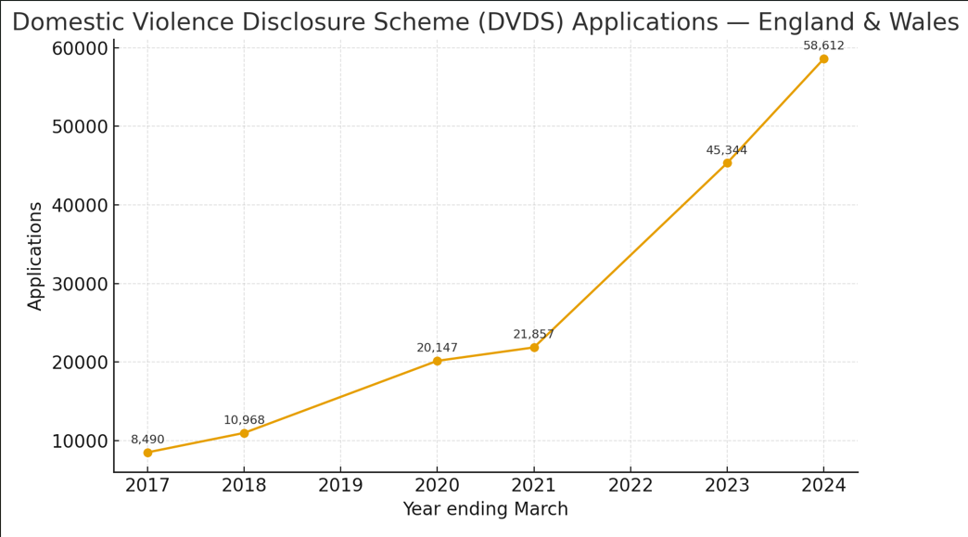
Applications have risen over 300% between 2019-2025

MOST COMMON REASONS FOR SEEKING A DISCLOSURE
- Concerns about a partner’s behaviour;
- Worries about personal safety and safety of children;
- Wanting to understand if abuse experienced is ‘just me’ or if partner has done this before.
Key Messages: what’s working

- Disclosure schemes are an opportunity to reach and support more victims and survivors of domestic abuse: 16% of DVDS applicants had never told anyone about the abuse, 63% had never sought help from DA services, 41% had never contacted police.

- Disclosures are telling victims and survivors new information about their partner: 69% of survey respondents knew something about their partner’s history of abuse before getting a disclosure; of those, 70% were told something new.

- Disclosures empower and safeguard when they reveal a pattern of behaviour. Their value is different at different stages of a relationship.

At the start: ‘planting a seed’.
During a relationship: correcting manipulative and victim-blaming narratives; revealing lies about the past; challenging ‘rescue’ narratives; exposing false promises to change.
At the end: confirming/validating decisions; reducing self-blame; helping to ‘stay away’
Once it’s over: understanding ongoing risk and putting measures in place to stay safe

- Satisfaction with the DVDS is very high among those who receive information: 82% in England and Wales (compared to 85% with IDVA services and 60% with police, Home Office/CSEW)

“It empowered me, and answered a lot of questions, it made me realise that it was not my fault and understood that he was a liar and he had twisted my reality.”

“It helped me make the decision that I would never go back to the relationship. It made me understand that my partner had been lying to me about what had happened with their ex partner, even though they were making out that that they had been open and honest with me”

Key Messages: what’s not working

- Some police are wrongly refusing information to eligible applicants, missing opportunities to safeguard: about 5% of survey respondents said police refused them information on grounds that are illegitimate including because they were no longer in a relationship; their partner was on bail; their partner was a police officer. Nationally, 5% is almost 3000 people annually.

- Some police are not providing support to victims to help them process the disclosure and stay safe in an abusive relationship: 34% said they received no information about support from police. 71% of those who did not receive support were very/unsatisfied with the service they receive.

- Poor attitudes by police, combined with poor support, makes victims and survivors more vulnerable than before the disclosure. Around 5% reported being terrified and losing faith in the justice system to protect them after poor experiences with police. As above, nationally, 5% is almost 3000 people annually.

- Forcing victims and survivors to sign strict confidentiality agreements leaves them isolated and frightened with no way of accessing support to deal with the information in a disclosure.

“It made me feel scared & vulnerable & alone.”

“More vulnerable and losing faith in the justice system, unsupported and scared”

WHAT CAN WE DO BETTER?
While better police training might address some of these problems, it is unrealistic to expect that it will solve them. 10 years on, some police still do not ‘get’ domestic abuse or the point of a disclosure scheme. Police change roles frequently, training is time-consuming and expensive, and there is still widespread risk-aversion around sharing police data.

Victims and survivors of domestic abuse are often wary of police, for a variety of reasons including mistrust and poor past experiences. They are less likely to feel comfortable making disclosures of abuse, discussing their family circumstances, or seek support from police than from a specialist support worker. A disclosure scheme that only allows engagement with police will deter some victims and survivors from applying, disclosing abuse, or seeking support.

Providing a more central role for specialist support workers is likely to encourage more victims and survivors to apply for disclosures, to disclose their own abuse and seek support, to feel less isolated and frightened, and to make the disclosure process an empowering experience that improves safety for them and their families.

A MODEL FOR ENGLAND AND WALES

THE SOUTH AUSTRALIAN DISCLOSURE SCHEME: A TRAUMA-INFORMED, VICTIM-CENTRED APPROACH

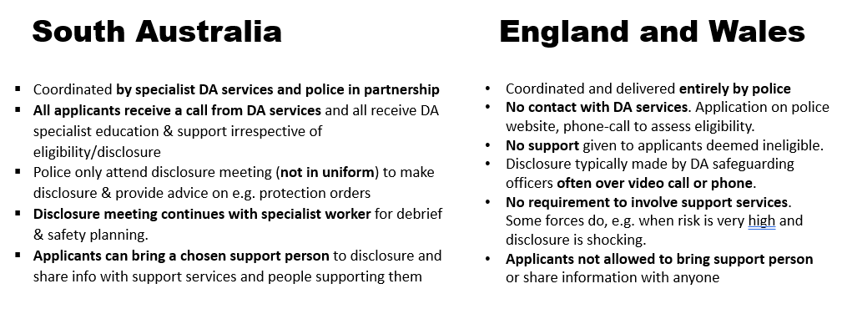

VICTIM AND SURVIVOR OUTCOMES IN SOUTH AUSTRALIA
- 99% very/satisfied with the service and with information provided
- 98% helped to make decisions about personal safety
- 95% helped to making decisions about other aspects of safety, including children and pets
- 0% reported feeling frightened or alone

This service was amazing. I walked out of there feeling so much support.

I will be forever grateful for how I was treated and the assistance given to me. It will help me move on and one day recover from the abuse I have sustained.

I’ve left feeling very hopeful and felt clarity with what I’m going through. A safe and compassionate space to be.

CONCLUSIONS

The DVDS is working well overall, but some victims and survivors are being failed badly and there is significant room for improvement. The huge and constant rise in demand for disclosures risks putting pressure on standards with police delivery becoming more rushed and perfunctory.

The disclosure process is an opportunity to reach and support victims and survivors who have never sought help before. A disclosure can be a ‘reachable moment’ and empowering for victims and survivors if the process is supportive, victim-centred and trauma-informed. It can also be isolating and terrifying if managed poorly.

Police are not best trained or placed to provide the support victims and survivors need to make the disclosure process positive and effective. Only police can check eligibility, search crime records and disclose information, but most of the disclosure process can be more effectively provided by specialist DA services, such as IDVAS.

RECOMMENDATIONS

Delivering the DVDS in partnership between police and specialist DA services, in a trauma-informed approach could significantly improve outcomes for victims and survivors. It would reduce the burden on police and ensure everyone applying for or being offered a disclosure receives the support they need. Potential models for implementation could include police employing IDVAs to coordinate disclosures and provide support, or local commissioning of IDVA services to provide the victim and survivor-facing element of the scheme, as in South Australia.

At the very least:
- The DA Matters training should include training on the DVDS to establish basic standards, guarantee that all applicants receive information about support, and ensure people are no longer wrongly denied information they are entitled to and which could help them stay safe.
- The terms of confidentiality agreements victims and survivors have to sign should be relaxed so they are able to talk about the disclosure to a family member, support worker, counsellor, social worker, or other trusted person.

further engagement/more information
Please contact Dr Kat Hadjimatheou at k.hadjimatheou@essex.ac.uk 07837549931 for more information or to discuss further.

FUNDING
The research for this briefing was funded by the British Academy Mid-Career Scheme 2023-4.

OPEN ACCESS FINDINGS AND RESEARCH

- Independent Review of the South Australian Domestic Violence Disclosure Scheme 2024 https://repository.essex.ac.uk/39915/
- Short explainer on why disclosure rates are low: https://theconversation.com/why-police-in-england-and-wales-are-failing-to-warn-people-about-partners-previous-abuse-220983
- Policing Insight article on international differences in DVDS: https://policinginsight.com/feature/analysis/domestic-abuse-disclosure-schemes-are-being-adopted-by-police-around-the-world-but-england-and-wales-and-south-australia-lead-the-way/
- Academic paper on differences in police practice across forces: https://www.tandfonline.com/doi/full/10.1080/10439463.2020.1795169
- Academic paper on importance of good DVDS process and problems with Children’s Social Care: https://academic.oup.com/bjc/article/62/2/320/6321032
- Academic paper on how disclosures counter abusive narratives and prompt empowerment at different stages in the relationship: https://journals.sagepub.com/doi/full/10.1177/14773708221128249

