Becoming a critical researcher

To be used alongside the ‘Becoming a critical researcher 2020’ workshop. Please do not skip ahead as this will spoil some of the activities and games.

Name
What’s in store? (Slide 2)
Objective
- To have a better understanding of what it means to be a critical thinker and how this will help with research.
How will we get there?
- What is critical thinking?
- Critical thinking exercises
- Applying critical thinking to research

Notes:

Activity 1: Fact or Opinion (Slide 5)
Decide which statements are a Fact and which are an opinion:
Question | Fact? |  | Opinion?
1. Rainbows are created when drops of water are hit by light, and form prisms.
2. I think that rock music is awful.
3. No two people have the same finger prints.
4. It is a long way from London to Liverpool.
5. The lost city of Atlantis is a real city that was lost under the sea.
6. The earth is round.
7. Ford makes better cars than Peugeot.
8. Jupiter is the largest planet in our solar system.
9. The legal age for drinking should be lowered to 16.
10. University of Essex is the best University.

Notes:

Activity 2: A Million-and-one uses (Slide 6)
A Million-and-One Uses
Every day we are faced with similar objects, people and situations. It is helpful for us to have an underlying knowledge of these things. For example, imagine you are helping in the kitchen at home and it is your job to peel the potatoes. You would go straight to the cutlery drawer, retrieve the peeler and begin your job. Without any underlying knowledge it would be a very time consuming process, first you would have to consider what is needed in order to peel the potato (something with a sharp edge, something with a handle etc) and then search the kitchen for an appropriate tool. Prior knowledge helps us to navigate our world efficiently and successfully, whilst making effective decisions.
However, sometimes it can cloud our judgment as in the example below:
A farmer and his wife were living in a small town when the farmer’s wife fell ill during the night. Having experienced appendicitis himself, the farmer knew the signs and believed his wife was suffering from the same. He called the doctor immediately.
"No that can’t be possible!’ the doctor explained, ‘I took her appendix out myself. I am not aware of anyone with two appendices. Give her some painkillers and she will sleep it off."
With that, the doctor ended the call and the farmer was most distressed, ‘No, it is not possible for someone to have two appendices but it is possible for someone to have two wives!’
The doctor was right that the woman did not have two appendices but he failed to question whether it was the same woman. The farmer had in fact re-married.

Consider the objects listed below. Think of as many uses for them as you can.

- A piece of paper
- A book
- A sheet
- A pillow
- A cup
- A piece of string
- A chair
- A box
- A rubber band
- A plastic bag

Notes:

Activity 3: Critical evaluation of a text (Slide 9)
For this activity, you should know that the example essay title is: ‘The floods of 2007 were primarily a result of ineffective government policy. Discuss.’

Read each paragraph carefully and answer the following questions:
- Is the writer’s argument or viewpoint clear? What is their main point?
- What are the reasons or evidence they give for this?
- Is the argument they outline convincing? Why?
- Which is the most convincing argument? Why?
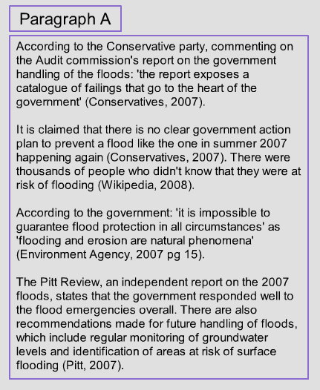

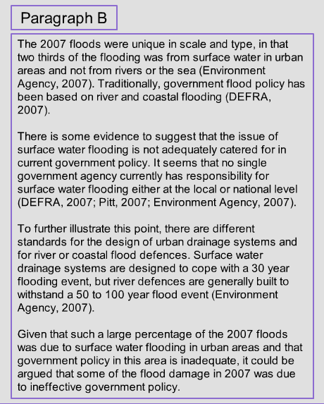

Activity adapted from: http://library.leeds.ac.uk/tutorials/activities/reading/critical-reading/
Notes:

The Danger of a single story (Slide 10)
YouTube: https://www.youtube.com/watch?v=D9Ihs241zeg
Notes:

Conclusion (Slide 11)
Why is critical thinking so important?
- Enhances your thinking skills: beneficial for you academically as well as in your career.
- Develops your language and presentation skills
- Increases your problem solving skills

Thank you for completing our Critical Thinking workshop, we hope you enjoyed it and learned something new!
If you have any questions please send them to www.sli.do and enter #CriticalThinking and one of the team will get back to you as soon as they can. Alternatively, you can email outreach@essex.ac.uk
My Questions/Notes

Answers

Activity 3: Critical evaluation of a text
For this activity, you should know that the example essay title is: ‘The floods of 2007 were primarily a result of ineffective government policy. Discuss.’

Paragraph A:
- Is the writer’s argument or viewpoint clear? What is their main point?

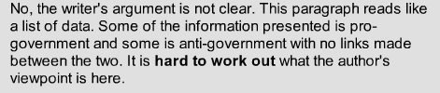
- Is the evidence from reliable sources?
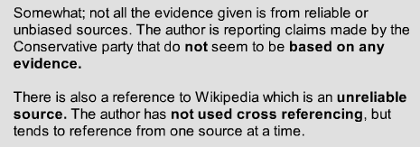
- Is the argument they outline convincing? Why?

Paragraph B:
- Is the writer’s argument or viewpoint clear? What is their main point?

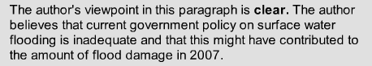
- Is the evidence from reliable sources?

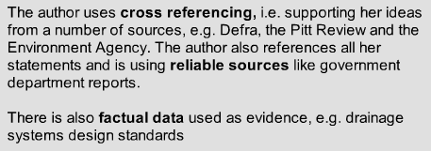
- Is the argument they outline convincing? Why?

Paragraph B is the better paragraph.
Activity adapted from: http://library.leeds.ac.uk/tutorials/activities/reading/critical-reading/
Notes

