Growth Mind-set
Post-16

To be used alongside the Growth Mind-set 2020 – Post 16 session. Please do not skip ahead as this will spoil some of the activities and games.

Name
Learning Objectives
- To understand what a growth mind-set is and how it compares to a fixed mind-set
- Identify the best benefits of having a growth mind-set
- Explore methods of using a growth mind-set
- Explore the language associated with growth mind-set and why it is important
- Devise an action plan for practicing growth mind-set

Notes:

Activity 1: Self-Evaluation (Slide 6)
Spend 5 minutes looking at the pre-made list of common thoughts and feelings many students experience.
Self-Evaluation
I can’t achieve the right grades to get into University | I’m going to fail anyway so I won’t bother trying | I don’t know what a personal statement so I can’t apply to university | I am either good at a topic or not
I don’t understand what this text means | I should be more like that person | Writing flashcards for revision does not help me remember which means I will fail my exams | Challenges are difficult so instead I will do the easy things
I got a bad mark last time which means I’m bad at history | I didn’t achieve one of the best grades in class which means I am a failure | Long division is a lot to figure out so I won’t bother | I wasn’t born smart enough which means it’s fixed
I don’t understand life processes which means I’m bad at science as a whole | I don’t know what I’m doing when it comes to doing an exam | I can only do as much as I know now | My teacher gave me a bad mark last time so clearly she doesn’t like me

Notes:

Activity 2: Self-Motivation (Slide 8)
Spend 5 minutes looking at the second column and coming up with ideas on what someone can say instead using words such as YET and LEARN
Example
Self-Evaluation  (Instead of saying): | Self-Motivation  (I will say): | Action Plan  (I will do):
I am not good at maths | I am not good at maths YET but I will LEARN | I will do more revision on my algebra because that is a topic area which I can improve in
I can’t achieve the right grades to get into University
I don’t understand what this text means
I got a bad mark last time which means I’m bad at history
I don’t understand life processes which means I’m bad at science as a whole
I’m going to fail anyway so I won’t bother trying
I should be more like that person
I didn’t achieve one of the best grades in class which means I am a failure
I don’t know what I’m doing when it comes to doing an exam
I don’t know what a personal statement so I can’t apply to university
Writing flashcards for revision does not help me remember which means I will fail my exams
Long division is a lot to figure out so I won’t bother
I can only do as much as I know now
I am either good at a topic or not
Challenges are difficult so instead I will do the easy things
I wasn’t born smart enough which means it’s fixed
My teacher gave me a bad mark last time so clearly she doesn’t like me

Ways to learn (Slide 10)
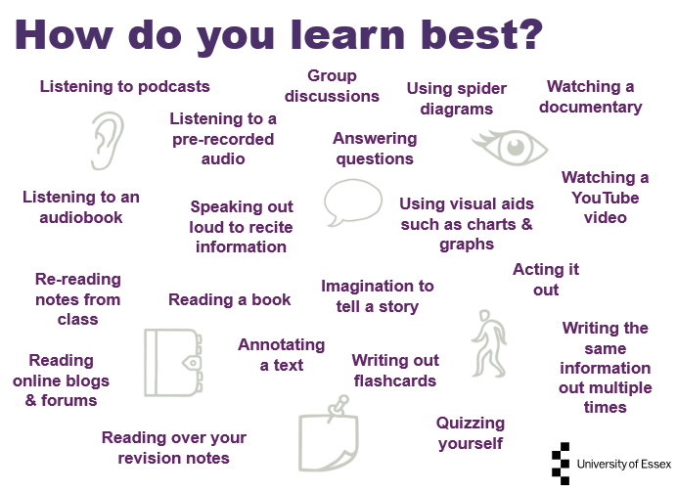
Notes:

Activity 3: Action Plan (Slide 11)
Now that you’ve looked at some different ways to learn, go back to your worksheet and spend 5 minutes coming up with a way to achieve those goals.
Example
Self-Evaluation  (Instead of saying): | Self-Motivation  (I will say): | Action Plan  (I will do):
I am not good at maths | I am not good at maths YET but I will LEARN | I will do more revision on my algebra because that is a topic area which I can improve in
I can’t achieve the right grades to get into University
I don’t understand what this text means
I got a bad mark last time which means I’m bad at history
I don’t understand life processes which means I’m bad at science as a whole
I’m going to fail anyway so I won’t bother trying
I should be more like that person
I didn’t achieve one of the best grades in class which means I am a failure
I don’t know what I’m doing when it comes to doing an exam
I don’t know what a personal statement so I can’t apply to university
Writing flashcards for revision does not help me remember which means I will fail my exams
Long division is a lot to figure out so I won’t bother
I can only do as much as I know now
I am either good at a topic or not
Challenges are difficult so instead I will do the easy things
I wasn’t born smart enough which means it’s fixed
My teacher gave me a bad mark last time so clearly she doesn’t like me

Reminder: Why is Growth Mind-set beneficial? (Slide 13)
- It’s all down to YOU!
Having a growth mind-set is something that anyone can do to help them achieve more and practice makes perfect, so doing activities like these will help you become more comfortable with using growth mind-set more frequently
- Instead of avoiding challenges, embrace them!
This will help you to be open to endless opportunity instead of shying away at the first hurdle! Remember that if you don’t succeed the first time, there is ways to learn and improve.
- Instead of being knocked down by your mistakes, learn from constructive criticism
Remember that when you receive a piece of work back that has a mark that you’re not very happy with, it is not YOU being assessed, it is your WORK.

The Iceberg Illusion (Slide 14) 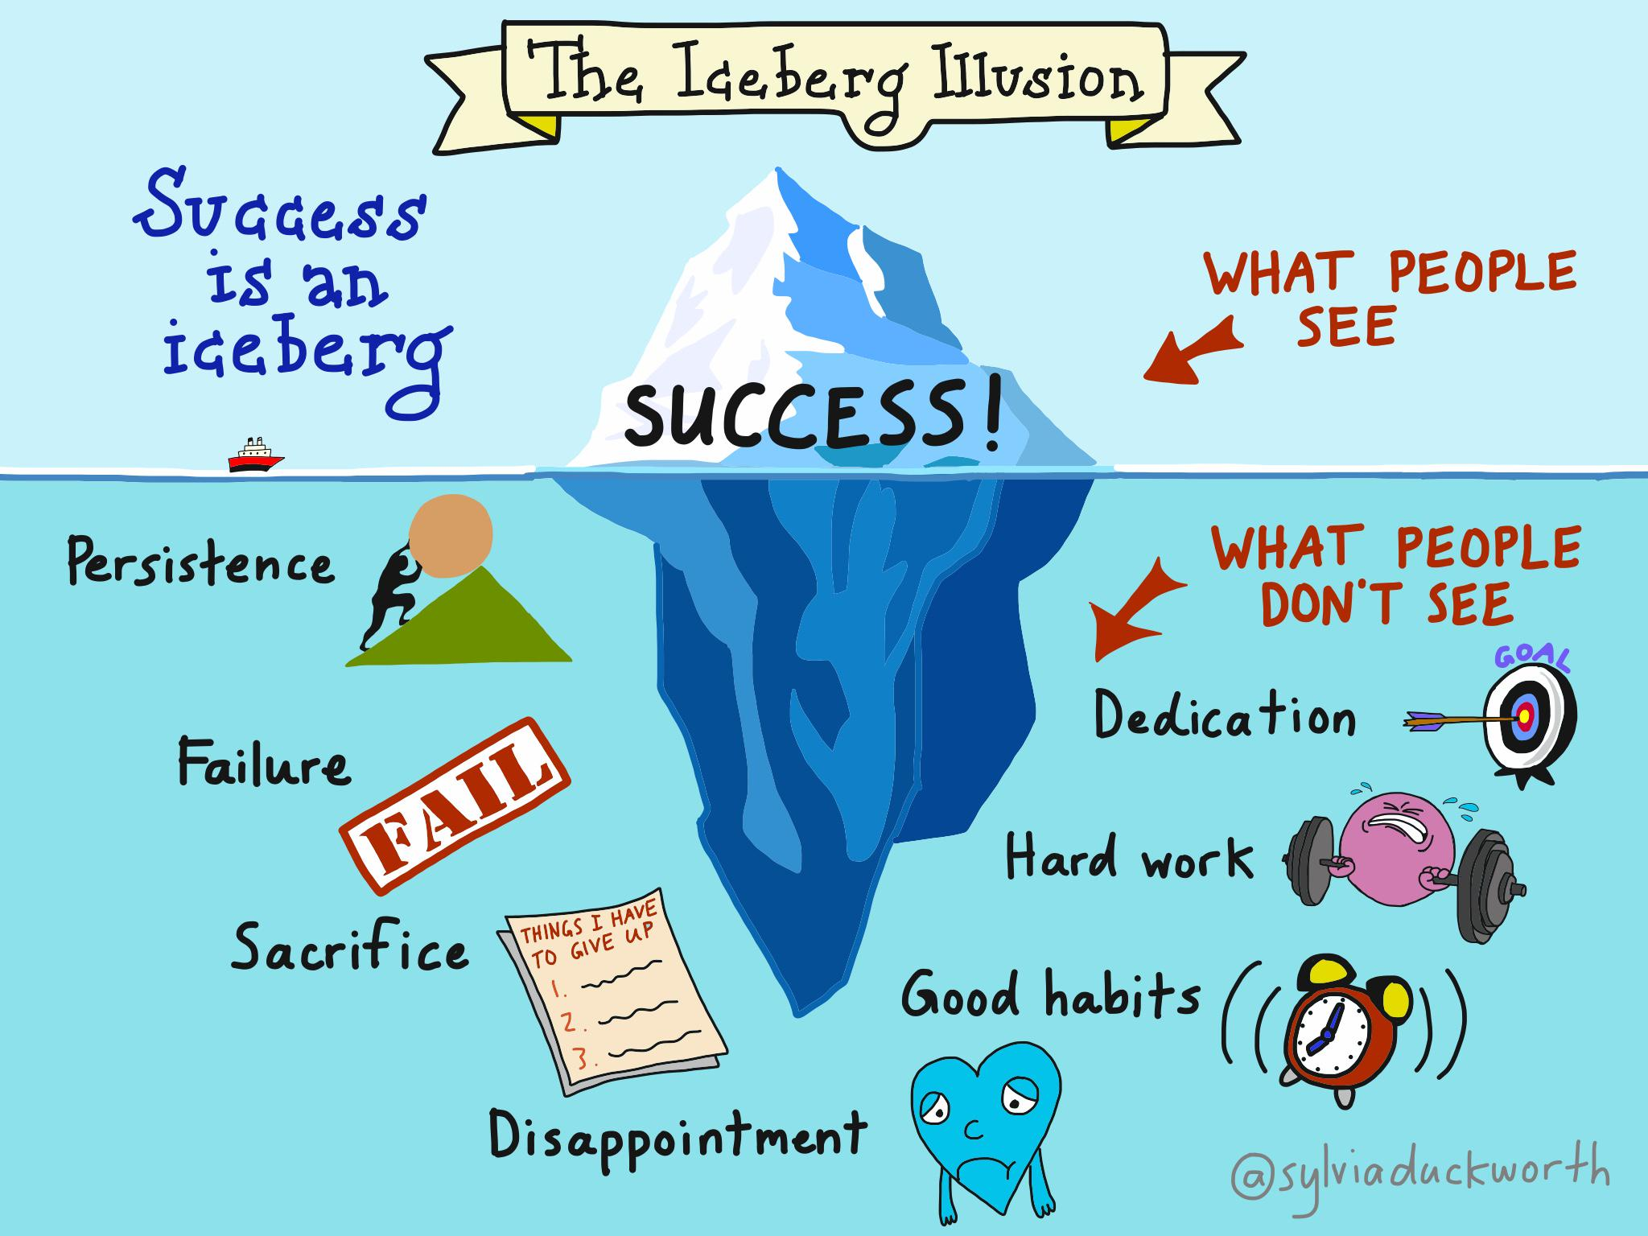
Photo credit to Sylvia Duckworth (twitter: @sylviaduckwoth)

My questions/notes

