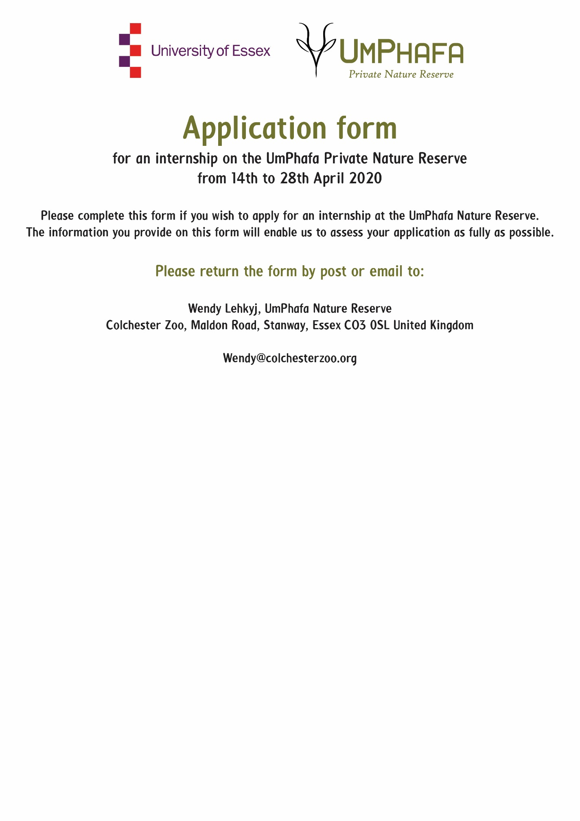

Personal Details
Name: | Surname: |  | D.O.B:
Sex: |  | Nationality:

Contact Details
Street name & number
Town/City
County
Post Code
Telephone
Email

Languages
Primary
Secondary
Others
(please list with level of competency)

Please state your reasons for wishing to take part in the projects of UmPhafa

Costs for two weeks from 14th April to 28th April 2020 - £700

If you are a UK tax payer, you can boost your donation by 25p for every £1 you donate.
- I am a UK taxpayer and understand that if I pay less Income Tax and/or Capital Gains Tax in the current tax year than the amount of Gift Aid claimed on all my donations it is my responsibility to pay any difference.
Are you willing to participate in the strenuous physical activity required by work placements on the reserve?

Do you have any special dietary requirements? (Please specify)

PLEASE ENSURE YOU INCLUDE A COPY OF YOUR CV WITH THIS APPLICATION FORM

