

Third Parties Contact Policy:

Sharing Registered Students’ Information

Authors: Data Protection Officer

Publication date: December 2022

Amended: December 2022

Review date: December 2025

Table of Contents

Introduction 3

Scope 3

A note about protecting students’ vital interests 4

Handling contacts with third parties 4

When can personal data be shared with third parties? 5

Appendix 1 – Information Sharing Flowchart 7

Policy Information 8

## Third Parties Contact Policy: sharing registered students’ information

### Introduction

1. The University is committed to compliance with the General Data Protection Regulation (UK GDPR) and the Data Protection Act 2018. This policy is formulated in conjunction with the University's Data Protection Policy and other relevant University policies relating to confidentiality of personal information.
2. This policy sets out the University's position regarding contact with interested third parties in connection with students registered at the University, such as parents, guardians, partners and sponsors of students. For the purposes of the policy, these potential contacts will be referred to as "third parties”. All staff are required to adhere to the principles of the policy when communicating with third parties about identifiable students.
3. Through a genuine desire to help, particularly in the case of anxious/concerned parents, staff can find themselves caught up in potentially complex family relationships or put in a position where they may end up inappropriately mediating between parent and student. This policy is designed to help give staff the confidence to respond to third party contacts and to ensure a reasonably consistent approach to such contacts throughout the University.

### Scope

1. This policy only covers contact with third parties relating to currently registered students over the age of 18. As such, contact relating to an applicant wishing to study at the University or to an alumnus, post-graduation, is not covered by the policy. Requests for information about prospective or former students should be directed to the Information Assurance Team in the first instance.
2. The University is also sometimes asked to provide information about students to statutory agencies, such as the Police, where other legal obligations may be engaged and/or where separate procedures have been established, in accordance, where appropriate, with Data Sharing Agreements. This policy refers to this activity; however, the policy should be read in conjunction with other relevant documentation (such as the related Data Sharing Agreements). Any staff approached by a statutory authority for information relating to an identifiable student should contact the Information Assurance Team for advice in the first instance.
3. Similarly, the University’s operational approach to contact with third parties in relation to students who are under 18 is not covered by this policy; more information about the University’s support for students under the age of 18 is available in [the Student Directory](https://www.essex.ac.uk/student/student-communities/under-18).
4. Communications linked to safeguarding concerns should be considered in line with the University’s [Policy on Safeguarding Children and Adults at Risk](https://www.essex.ac.uk/-/media/documents/directories/policies/safeguarding-policy.pdf?la=en).

### A note about protecting students’ vital interests

1. The University will contact a relevant third party or release information to a third party using the lawful basis of ‘vital interests’ where this is considered necessary to protect a student's life, for example, should they find themselves in a crisis situation. Such disclosures or contact are made in accordance with data protection law (see paragraphs 11 and 13).

### Handling contacts with third parties

1. A third party may make contact with staff at the University in relation to students for a variety of reasons. The third party may wish to:

* request information about a student
* make a complaint on behalf of a student
* provide information about the student, or
* act as an advocate for the student

1. The University Data Protection (DPO) should be contacted when data about students is requested ([dpo@essex.ac.uk](mailto:dpo@essex.ac.uk)).
2. The University's position in relation to contact with third parties is built around a number of key principles which are designed to ensure a fair, consistent and lawful approach to dealing with activity in this area. These key principles are that:
3. The University has a legal relationship solely with the student. Generally, the University will only liaise directly with the student and not via a third party, including parents, guardians and other interested individuals, groups or organisations.
4. The University aims to treat its students as autonomous adults.
5. The University aims to empower its students, many of whom are living away from home for the first time, and wishes to create a student experience which encourages the development of independent living skills, as well as academic achievement.
6. The University has a duty of care to its students, however, and, where a student has provided written permission for the University to liaise with a third party on their behalf, the University will undertake all reasonable endeavours to act on this request, using the relevant lawful bases for processing personal data. only liaise directly with the student, where, for example, following a risk assessment, a student is perceived to be a serious risk to themselves or others, or where a student is under 18 or an adult at risk and it is judged to be in the student's best interests[1]. With reference to safeguarding matters, the University will share data with third parties in crisis situations where this is necessary in order to protect an individual’s vital interests, or their life may be at risk.
7. The University reserves the right to refuse to liaise with a third party and/or refuse to process the request where, for example, the third party is behaving in an aggressive or threatening way or where the appropriate process has not been followed.

### When can personal data be shared with third parties?

1. The University will release information about a student where there is a legal obligation or a contractual requirement to do so, and/or as set out in the University’s [Student Privacy Notice](https://www.essex.ac.uk/student/my-essex/privacy-notice-students).
2. The University will contact a relevant third party or release information to a third party using the lawful basis of ‘vital interests’ where this is considered necessary to protect a student's life, for example, should they find themselves in a crisis situation. Such disclosures or contact information shared under contractual obligations may include, and is not limited to, sharing information with: the Office for Students; the Higher Education Statistics Agency and Jisc (or any other Designated Data Body of the Office for Students); the Quality Assurance Agency (or any other Designated Quality Body of the Office for Students); the Students’ Union; Government Funding Bodies; Student Loans Companies.
3. The University will release information to the relevant authorities about a student for law enforcement purposes, such as to the Police and the UK Border Agency, and in line with its legal obligations.
4. The University will release information about a student where it relates to sponsorship, such as confirming attendance, achievement and that a student is still registered with the University. The provisions of any agreement, signed by the student, which confirms that a Sponsor may receive information about the student, will be followed.
5. In certain circumstances, the University accepts that a student may nominate a specific individual or organisation with whom/which it may liaise directly in relation to that student. Such liaison is permitted where it is considered to be in the best interests of the student, where written consent is given, and where all parties are content with the terms of the liaison.
6. Where a student gives consent to allow the University to share information about them with a third party, the University may choose not to share information where it considers that it would not be appropriate to do so. If this is the case, the decision, and the reasons for it, will be communicated to the student.

### Appendix 1 – Information Sharing Flowchart

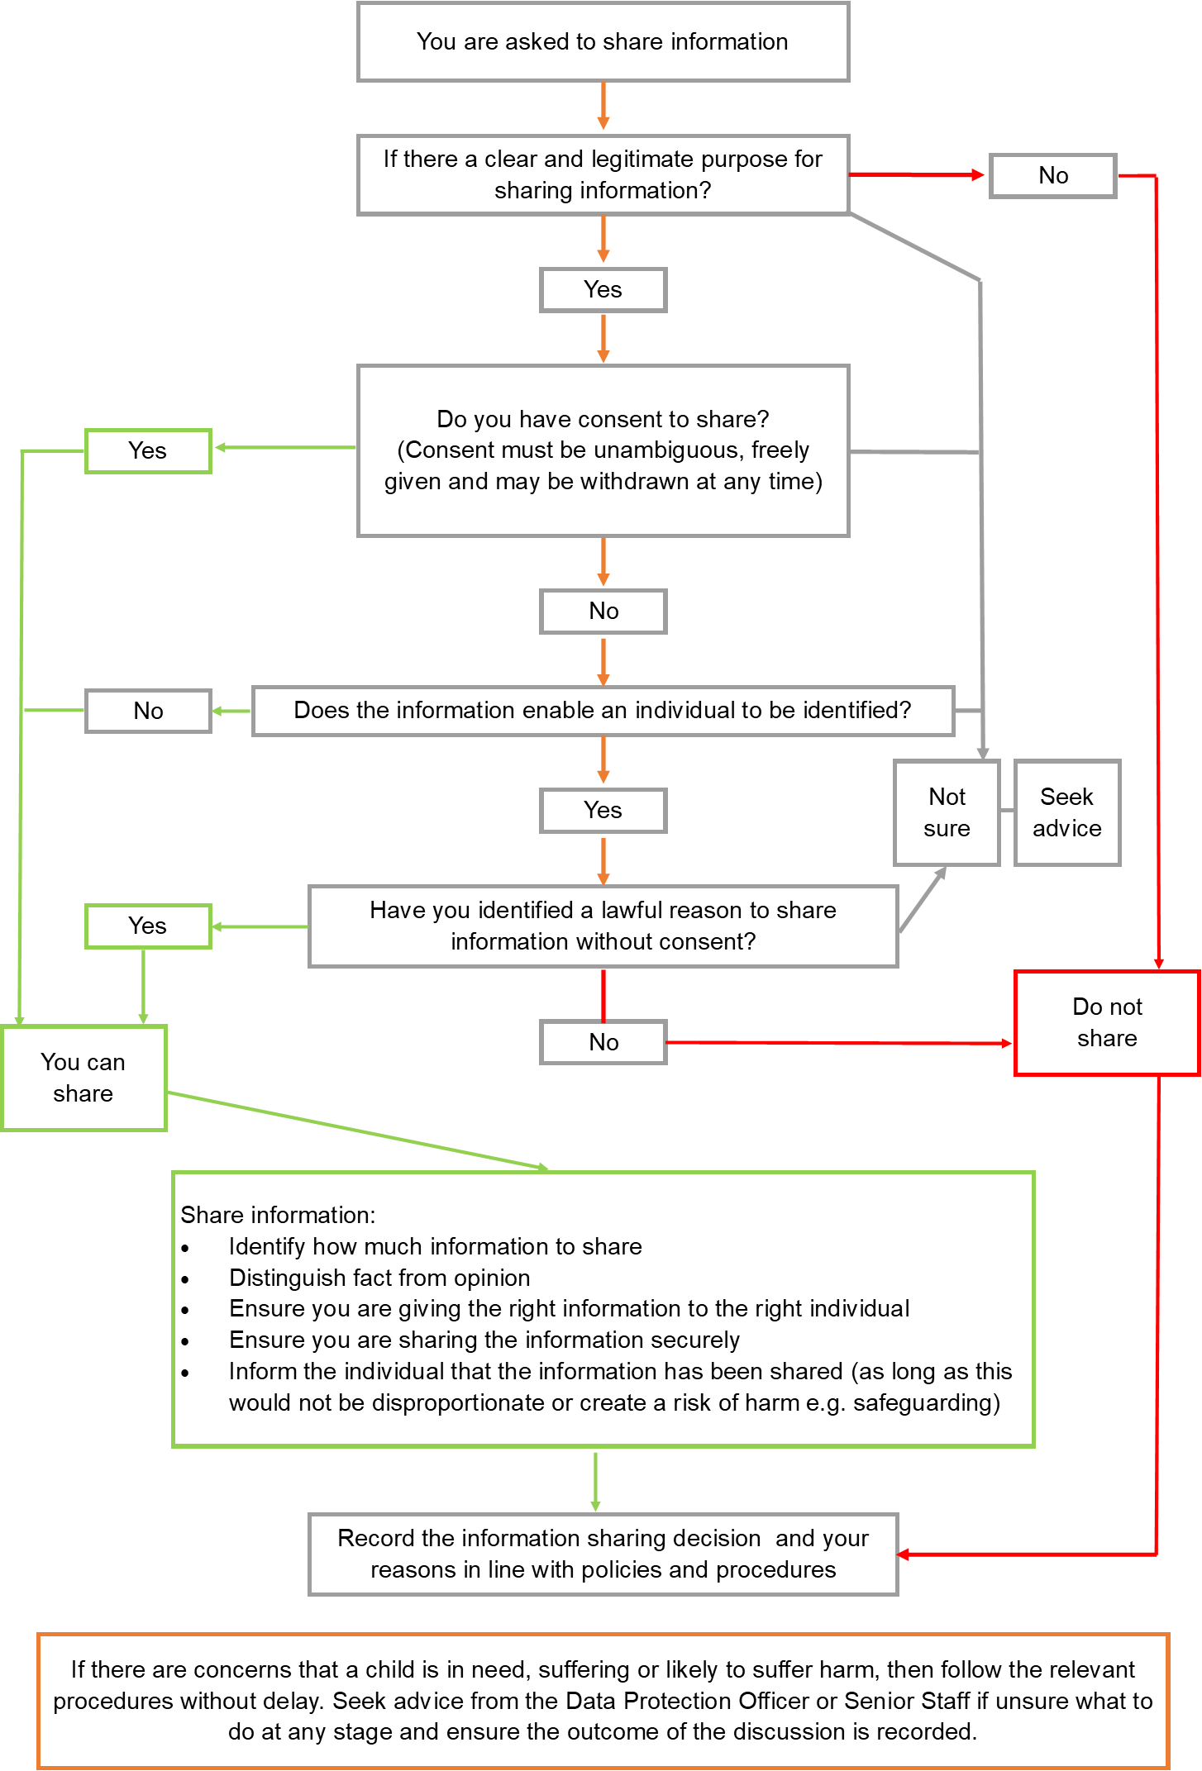

### Policy Information

|  |  |
| --- | --- |
| Field | Description |
| Title | Third Parties Contact Policy: Sharing Registered Students’ Information |
| Policy Classification | Policy |
| Security Classification | Open |
| Security Rationale | N/A |
| Policy Manager Role | Data Protection Officer |
| Nominated Contact | dpo@essex.ac.uk |
| Responsible UoE Section | Office of the Vice-Chancellor |
| Approval Body | USG |
| Signed Off Date | 6 December 2022 |
| Publication Status | Published |
| Published Date | December 2022 |
| Last Review Date | December 2022 |
| Minimum Review Frequency | 3-Yearly |
| Review Date | December 2025 |
| UoE Identifier | 0138 |

If you require this document in an alternative format, such as braille, please contact the nominated contact at dpo@essex.ac.uk

1.