New course approval overview

FINAL
Full course details
Alignment with quality and standards, policy and regulations
DEVELOPMENT
Academic outline Market analysis and feasibility
Business case
CONCEPT
Strategic alignment and portfolio fit High level outline approval
Idea for new course
Approval to proceed:
Dean of Partnerships
Full approval:
Category 1:
­ Dean of Partnerships
Category 2 & 3: AQSC
Approval to proceed:
Dean of Partnerships
Separate decisions:
Course advertised (Yes/No) Offers made & applications accepted (Yes/No)
Information gathered
Information is built on previous stages as the course is developed, in its final format wherever possible.

New course approval categories
New courses are grouped into three categories which indicate the approval route required. Categories are largely determined by the level of new provision.
Courses may move between categories, for example where details changes during development or where those with authority to approve feel further scrutiny is required
Category 1
Dean approval (according to provision)
Category 2
AQSC approval
Category 3
AQSC approval via validation panel

Partnerships

Category
Existing established partners only – courses constructed entirely from existing provision
Existing established partners only – courses constructed from all existing provision plus a small number of new modules
Existing partners – new courses with higher levels of new content or courses in a new curriculum area
All courses for new partners
Consultation

Current External Examiner
Consultation with employer and industry contacts optional
External academic (meeting the same criteria
for External Examiner nomination
Consultation with employer and industry contacts advisable
Evidence of student consultation and response required
Evidence of student consultation and
response to be sought wherever possible
Validation Panel to include student representation wherever possible
External academic (meeting the same criteria for External Examiner nomination)
Validation Panel to include employer and industry contacts wherever possible

External
academic input
Professional input

Student input

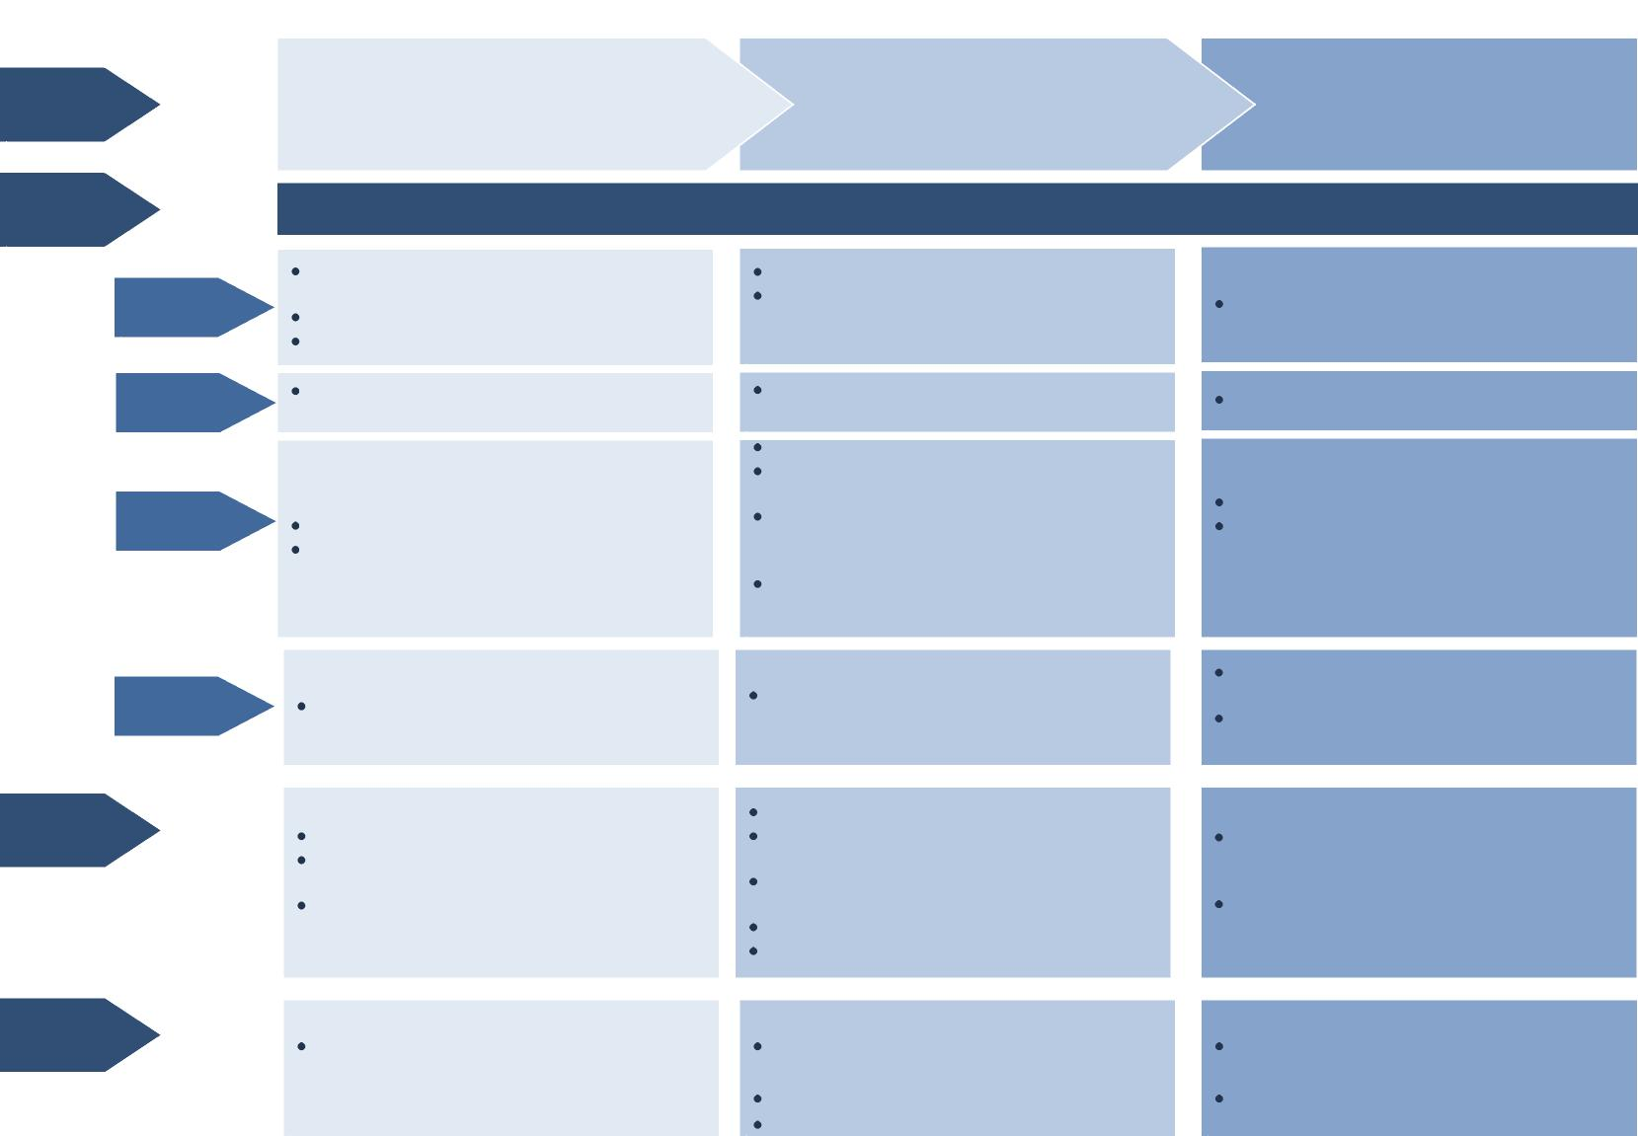
New course approval stages and information gathered
CONCEPT
Log new course proposal
Strategic alignment and portfolio fit
High level outline approval
DEVELOPMENT
Academic outline
Market analysis and feasibility
Business case
FINAL
Full course details
Alignment with quality and standards, policy and regulations
Information built upon as the course is developed
Stages
Information
Quality & standards
Approval
Business case
Brief course overview
Indication of any external requirements
Strategic & portfolio fit
Outcome
Academic design
Update of previous information (if needed)
Update of previous information (if needed)
Academic outline
Clarity over external requirements, influences and involvement
Consideration of relevant areas in course design (e.g. student feedback, varying student needs)
Details of internal and external consultation (academic, professional, student) and response
Course outline
Market analysis and feasibility, recruitment targets, key selling points and marketing message
Business case, incl. systems and resource requirements in Dept and Prof Services
Approval to proceed:
Dean of Partnerships
Indication of any external involvement
Awareness of proposal to initiate discussions Decision to continue with course development or not
Discuss indicative approval category and timelines
Approval to proceed:
Dean of Partnerships
Separate decisions:
Course advertised (Yes/No)
Offers made, applications accepted (Yes/No)
Clarity over internal and external requirements and involvement
Approve academic outline and business case Clarify internal and external requirements to meet
Determine key selling points and marketing message
Identify areas to consider in final stage Review approval category and timelines
Brief overview of course, including title,
level, location and start date
Case for strategic and portfolio fit
Initial indication of potential market demand
Indication of any major new resources or capital expenditure
Full approval:
Category 1:
­ Dean of Partnerships Category 2 & 3: AQSC
Full approval, considering response to internal and external feedback (academic, professional and student)
Course advertised, applications accepted and offers made
Confirmation of alignment with quality and standards, policy and regulations Approved response to conditions and recommendations of approval
Full course and delivery details
Programme specification, module maps and
full module details

New course approval process

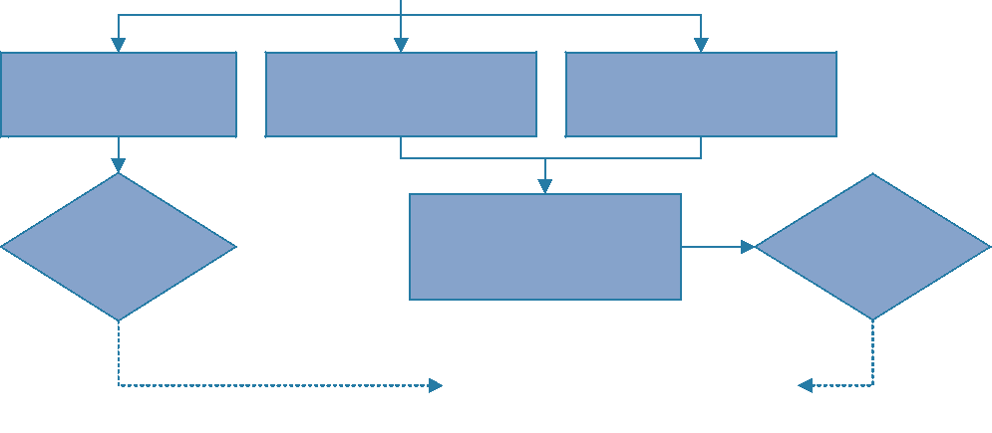
Category 2: Dean’s Review
Small amount of new
content / delivery
Category 1 Existing provision
Final approval Decision⁽³⁾
Partnership Education
Committee members invited
to comment invited in
advance of AQSC
Final
approval
decision
(AQSC)
Reported to AQSC, Education
Committee and Senate.
(3) Dean of Partnerships
Category 3: Validation Panel
New curriculum area or
initiative

Approved to proceed
- Course advertised (Yes/No)
- Offers made and applications accepted (Yes/No)
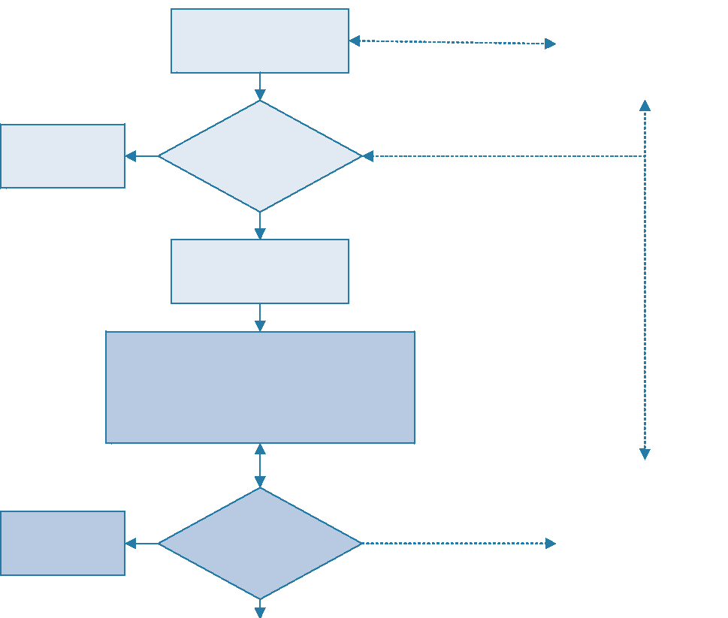
Not approved -
does not
progress
Not approved -
does not
progress
Submitted for Development approval
With recommendations from:
Deputy Dean of Partnerships/ Partnerships
Team, academic department at Essex
Lead contact for course
development submits for
Concept approval
Approved to proceed
Development stage Decision⁽²⁾
Concept stage Decision⁽¹⁾
(1) Dean of Partnerships
(2) Dean of Partnerships
Reported to AQSC,
Education Committee and
Senate.
Data available for
Department Planning and
Product Development
Group
Discussions with relevant
staff, including
Partnerships Manager,
Dean and Deputy Dean of
Partnerships
Submitted for Final approval  With recommendations from:  Deputy Dean of Partnerships, Partnerships  team, academic department at Essex |  | Input from external  academics, professional/  industry expertise and  students

