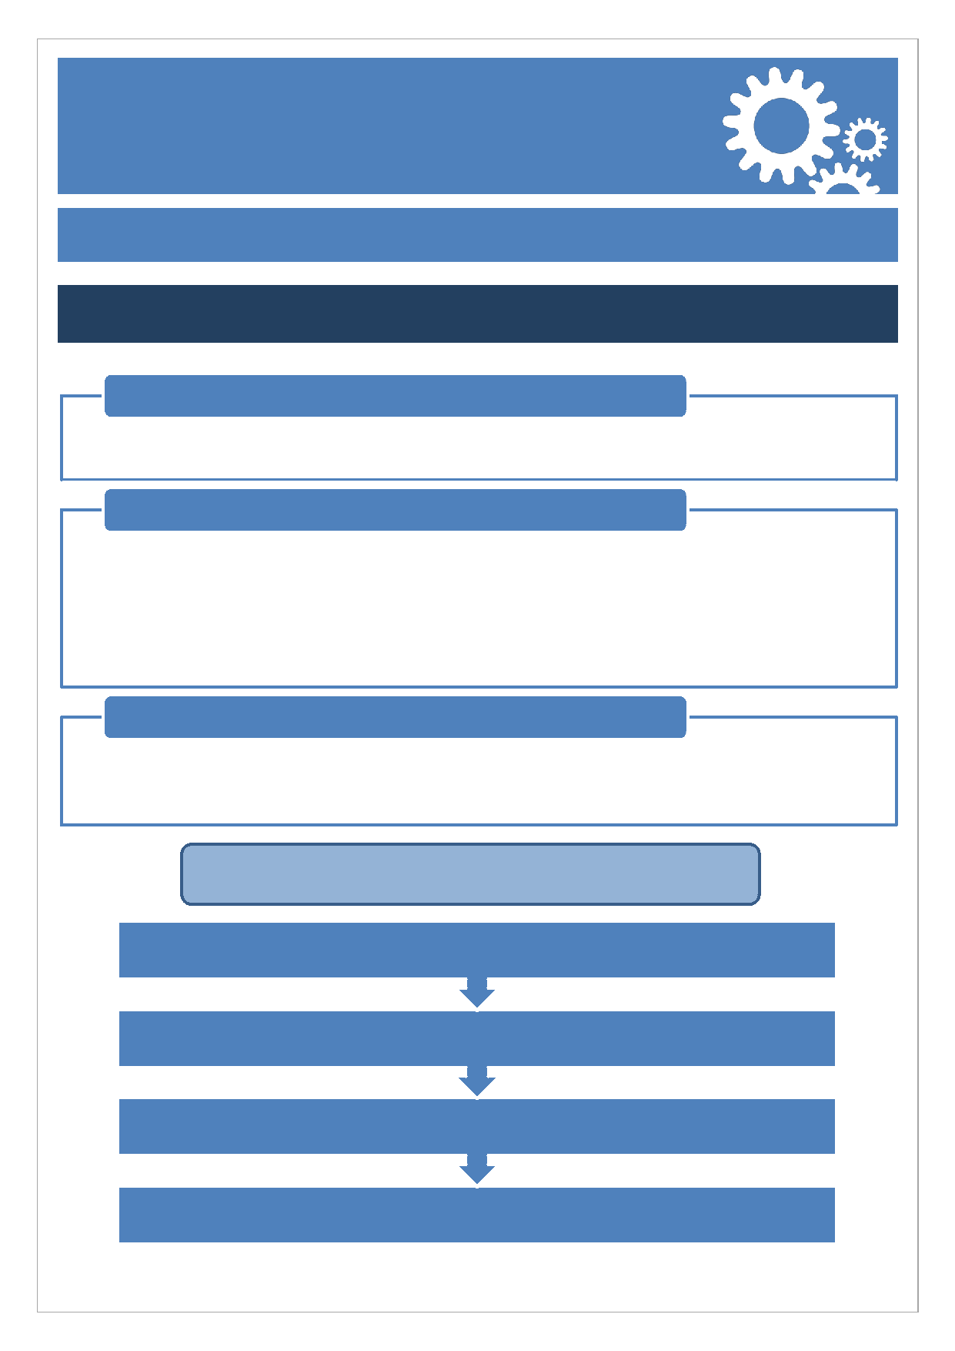
New Course Approval
Process Guidance
Category 1
Definition
- Established partners only - new course constructed entirely from existing provision
Consultation
- Current External Examiner comment
- Evidence of student consultation and response
- Employer/industry (optional)
- All consultation will be captured as part of the Development Stage
- Partnerships Team will arrange for an Academic at Essex to comment on the proposal.
Documentation
- Concept, Development and Final Stage forms
- Module Outlines, Programme Specification (including those for exit awards), Module Map and work based/placement learning forms (if applicable)
Approval and Reporting
Deputy Dean of Partnerships support for new course
Dean of Partnerships approval
Reported to AQSC for information (basic information only - course title)
Sign off sheet sent to Partner confirming approval of new course

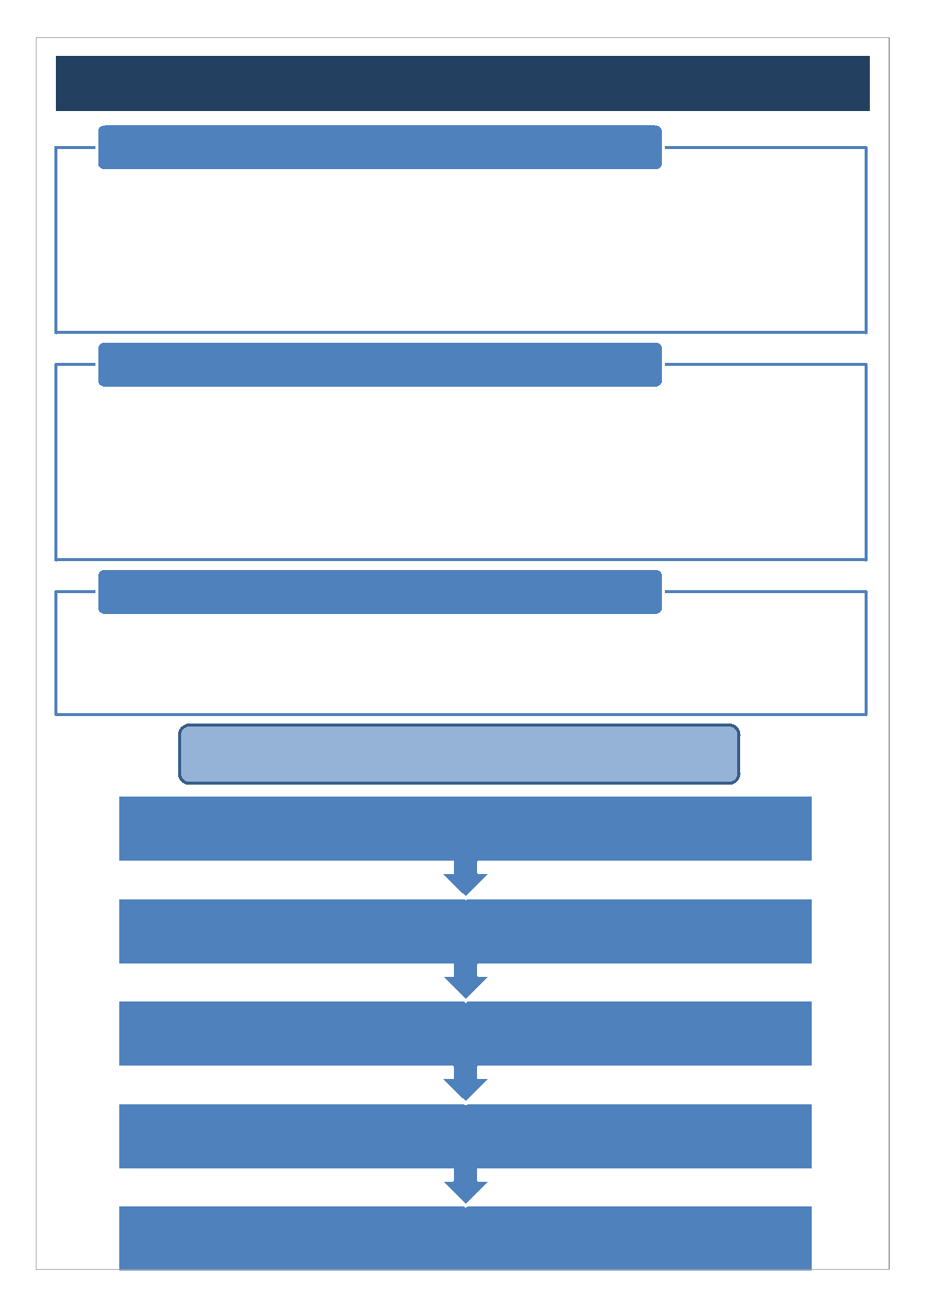
Category 2
Definition
- Established partners only - new course constructed from existing provision plus a small number of new modules:
- Undergraduate and Postgraduate Taught courses - up to one-third new credits for the new target award (for example, 120 credits for a new 360 credit undergraduate programme, 60 credits for a new Masters programme of 180 credits) - Please note, the Partnerships Team can change the category of approval if deemed necessary.
Consultation
- External Academic (meeting the same criteria for External Examiner nomination and sourced by Partner Institution)
- Evidence of student consultation and response to be sought, where possible
- Employer/industry contacts advisable
- All consulation will be captured as part of the Development Stage
- Partnerships Team will arrange for an Academic at Essex to comment on the proposal.
Documentation
- Partner Institution to submit documentation to Partnerships Team for review as detailed in the documentation checklist for Category 2 courses, (which includes Partner Summary Document, Student Handbooks and assessment schedule etc.)
Approval and Reporting
Documentation reviewed and conditions and recommendations to be drafted by the Deputy Dean of Partnerships
Final Review of documentation by Dean of Partnerships and to agree with the
Deputy Dean of Partnerships that Areas for Consideration have been addressed
within the documentation and finalise conditions or recommendations
Summary Outcome Report finalised and sent to Partner Institution
Category 2 Summary report, Final Stage form, Programme Specification and Module Map submitted to AQSC for final approval.
AQSC gives approval. Conditions and recommendations signed off by Deputy Dean of Partnerships. Sign off sheet sent to Partner.

Category 3

- Consultation will be captured as part of the Development Stage

Definition
- Existing partners - new courses with higher levels of new content or courses in a new curriculum area
- All courses for new partners
Consultation
- Validation panel to include:
- External Academic (meeting the same criteria as External Examiner nomination and sourced by the Partnerships Team)
- Internal Academic (sourced by the Partnerships Team)
- Employer and Industry contacts, wherever possible (sourced by Partner Institution)
- Student Representative, wherever possible (sourced by Partner Institution)
- Further guidance, including panel membership is available on the Partnerships Team website.
- Partner Institution to submit documentation to Partnerships Team for review as detailed in the Documentation Checklist, (which includes Partner Summary Document, Student Handbooks and assessment schedule etc.).

Documentation
- Documentation will be circulated to all Panel members by the Partnerships Team in advance of the validation event.
- Panel members will be asked for feedback in advance of the validation event and to indicate whether the Areas for Consideration have been adequately addressed in the documentation and to highlight areas they would like to investigate further at the Panel meetings.

Summary outcome report considered by AQSC
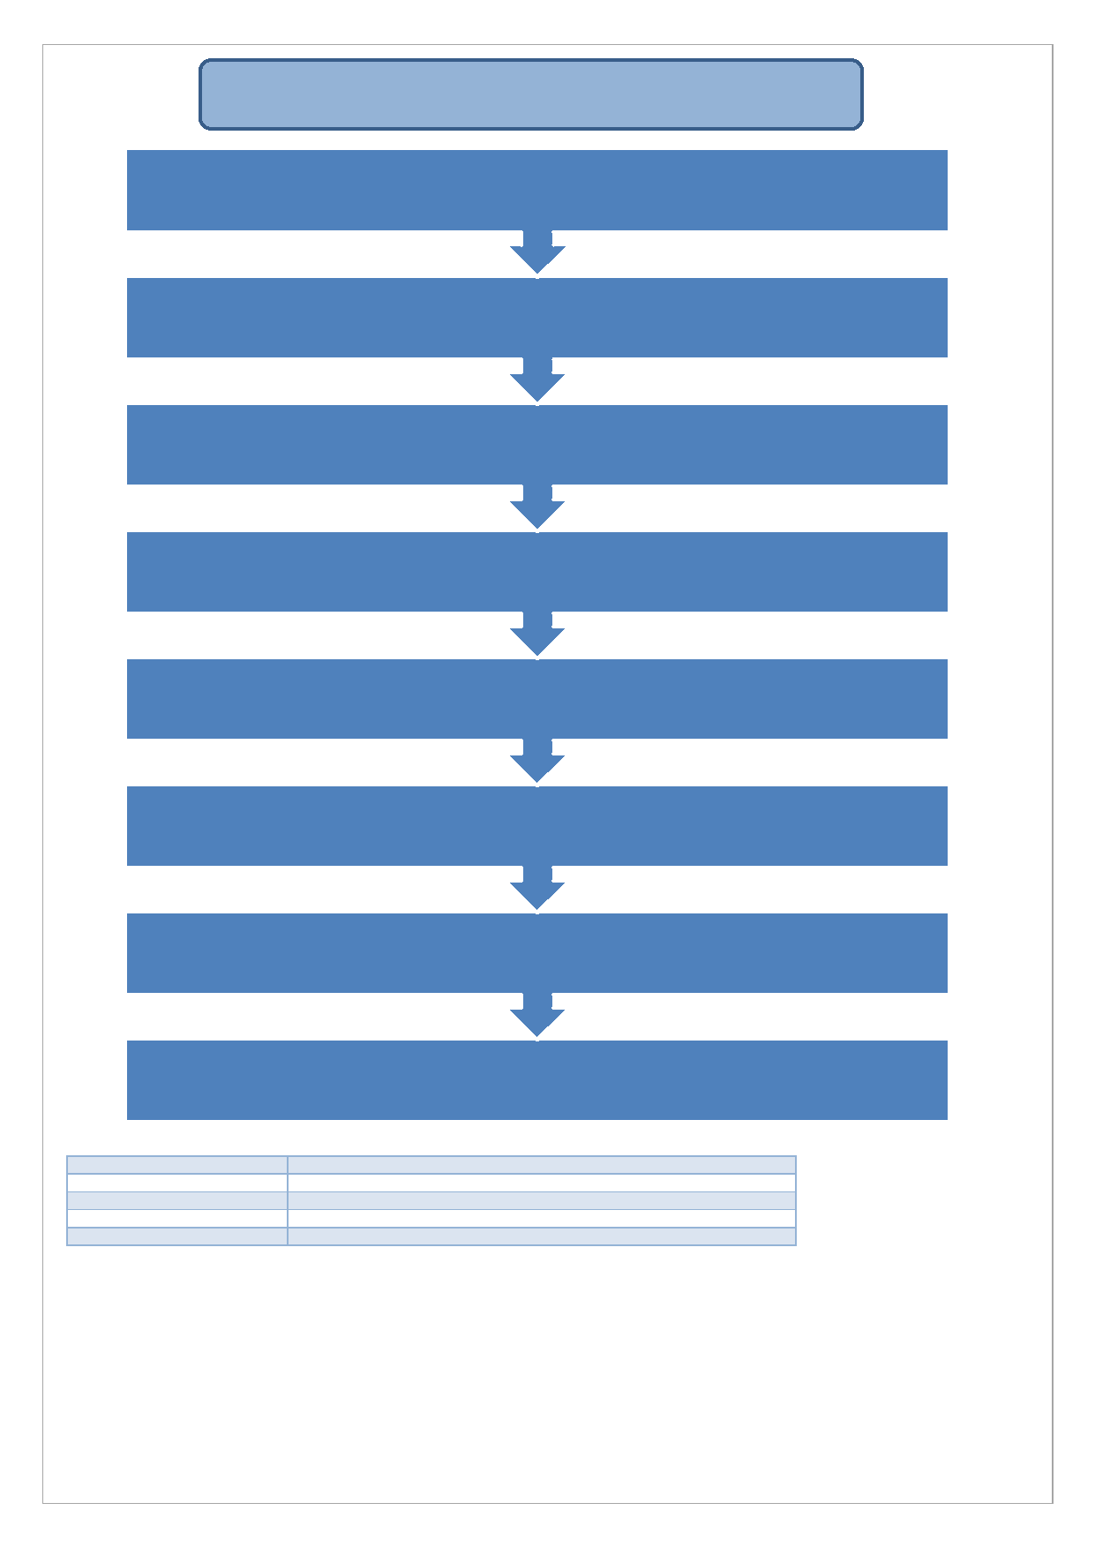
Approval and Reporting
Panel convene to consider the new course(s)
Panel agree that areas for consideration have all been addressed and that the
course(s) be recommended for approval. If additional follow up is required an
appropriate condition or recommendation would be defined.
Summary of commendations, conditions and recomendations sent to Course Team (following approval by the Chair)
Summary outcome report is written and approved by all Panel members and circulated to Course Team at Partner Institution
Documentation submitted: Category 3 Summary Outcome Report
AQSC gives approval. Conditions and recommendations signed off by the Chair
of the event.
Sign off sheet sent to Partner Institution confirming new course approval.

