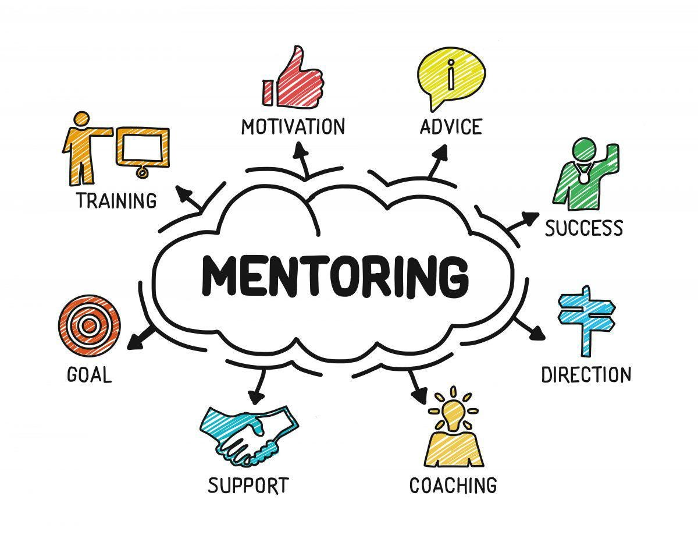

The Black Asian and Minority Ethnic Mentoring Agreement

The mentorship process:
- Mentor- complete profile/training where required
- Mentee- register interest with coordinators
- The mentee is directed to view the BAME mentor profiles and identify the mentor they feel they would like to work with.
- The coordinator contacts the potential mentor to identify interest in supporting the mentee and make the introductions
- Mentor/mentee meet and agree on terms of the mentoring relationship
- Review at the end of the agreed mentoring term and feedback to the coordinator bamementorship@essex.ac.uk

At the beginning of the mentoring relationship, both the mentor and mentee should be clear about and
agree upon what they expect from each other. Some mentors and mentees find it useful to
complete a mentoring agreement (see below for the form) which establishes the ground rules for the relationship. If you think this would be useful for you, then you can discuss and sign
the agreement at the first meeting.
Whether you use the mentoring agreement or not, at your first meeting it is helpful to
discuss:

- How will you conduct the meetings?
- How often will you meet?
- How much time will you spend on each meeting?
- What do you do if a meeting has to be cancelled or rescheduled?
- What method of communication may you use between meetings?

Creating an agreement

This mentoring agreement represents one approach to structuring the mentoring relationship and it is optional to use.

There is a no-fault exit clause for both mentors and mentees. Should a mentoring
relationship not work for any reason, please contact the BAME mentoring coordinators bamementorship@essex.ac.uk and every effort will be made to make alternative
arrangements.

Mentoring relationship

ln this scheme, mentoring is a one-to-one relationship. Meeting frequency is to be agreed at
the onset. The relationship is strictly confidential and its content must not be discussed
with anyone else.

Mentee
Mentor

Objectives

Below, state the mentee’s objectives. If the objective requires the mentee to acquire specific types of knowledge, skill, and/or experiences, you might want to list these here too.

Mentor responsibilities

Within the relationship, the mentor agrees to:

Mentee responsibilities

Within the relationship, the mentor agrees to:

Other responsibilities

Other items discussed and mutually agreed (e.g. meeting length and frequency;
no-contact times; length of the mentoring relationship; etc)

Signatures

Mentee
Mentor

This guide has been adapted from materials EARC Mentoring Scheme as produced by the Women in Universities
Mentoring Scheme (WUMS), and mentoring schemes run at the University of Essex and Cardiff University.

