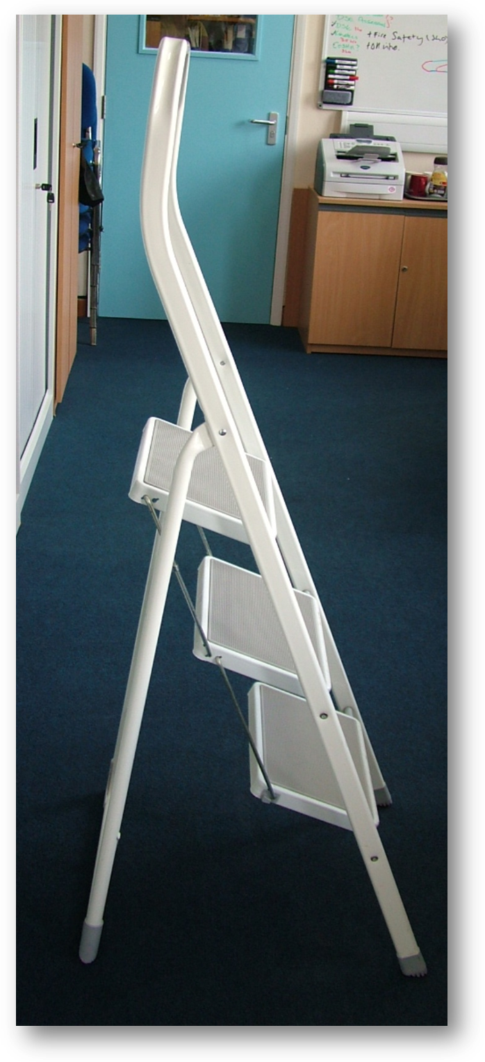
Safety handrail – all stepladders should have one!
Feet – Rubber caps present, no damage or contamination
Uprights – No dents, nicks or splits
Rungs (steps) – No contamination, rivets in place and tight, no dents, nicks or splits. Rubber mats firmly in place
Hinge – Fully engages, no dents, bends, nicks or splits. Rivets and bolts in place and tight
Step lock – No contamination, fully engages and locks into place, no nicks, dents or splits
Stays – some stepladders have stays that are attached to the front and back uprights. These may be rigid or a webbed strap. If fitted they should be taut or locked fully into position. The hinge must be in good condition, rivets and bolts in place and tight.

