University of Essex and UECS
CONFIDENTIAL
HSAS Ref:
Health and Safety Incident Report Form

This form must be completed for any health and safety incident involving University of Essex staff, UECS staff, students, tenants, contractors or visitors which occur on University owned or managed premises, or during the course of University/UECS organised activities (e.g. field trips). It should be used to report all first aid incidents; work or premises related accidents and ill health; acts of violence (physical and verbal abuse and threats to staff, serious incidents involving students); injuries arising from road traffic accidents whilst at work and non injury incidents that had the potential to cause harm (dangerous occurrences or “near misses”).
Please complete the form providing factual and accurate information only, then forward it confidentially to the Health and Safety Advisory Service (HSAS) (email: safety@essex.ac.uk) within 24 hours of the incident. Serious incidents must be reported immediately by calling the HSAS on 01206 87 2944. Further information on the University’s health and safety incident reporting procedures can be found at www.essex.ac.uk/health-safety/report/default
The form should be completed by the affected / injured person, their representative or a witness to the incident. If a First Aider attended he/she should complete the First Aid details. If you need more space continue on a separate sheet, which should be attached to the form.
Your privacy: The information provided on this form and the data held on our systems is stored securely in the UK and kept in line with our retention schedules and will only be disclosed within the University to members of staff who need to know it in order to carry out their duties, e.g. the Occupational Health Service and the University Insurance Officer. Relevant information will be disclosed outside the University where it is required by law to do so. In the event of a personal injury claim, information may be disclosed to the University's Insurers. Anonymised data may also be disclosed to relevant Trade Union officials.

Please do not type in the shaded areas.

About the Incident
Name of person reporting incident:
Department: |  |  |  |  |  |  |  |  |  |  |  |  |  |  |  | Contact details: (e-mail / login):
Date Incident reported: |  |  |  |  |  |  |  |  |  |  |  |  |  |  |  |  |  |  |  |  |  |  |  | Time reported: |  |  |  |  |  |  |  |  |  | am / pm
Date of incident: |  |  |  |  |  |  |  |  |  |  |  |  |  |  |  |  |  |  |  |  |  |  |  | Time of Incident: |  |  |  |  |  |  |  |  |  | am / pm
Precise Location:
What was being done at the time of the incident:
What happened: Continue on a separate sheet if necessary. Include anything that may have contributed to the incident (e.g. icy conditions).
Nature of harm / ill health / damage:
About the person affected
Name in full:
Address
Home / Student accommodation
Contact details: |  |  |  |  | e-mail: |  |  |  |  |  |  |  |  |  |  |  |  |  |  |  |  | Telephone:
Department: |  |  |  |  |  |  |  |  |  |  |  |  |  |  |  |  |  |  |  |  |  | Position (employee):
Age: |  |  |  |  |  |  |  |  |  |  |  |  |  |  |  |  |  |  |  |  |  | Gender (highlight): |  |  |  |  |  |  |  | Male / Female
Status: highlight using:  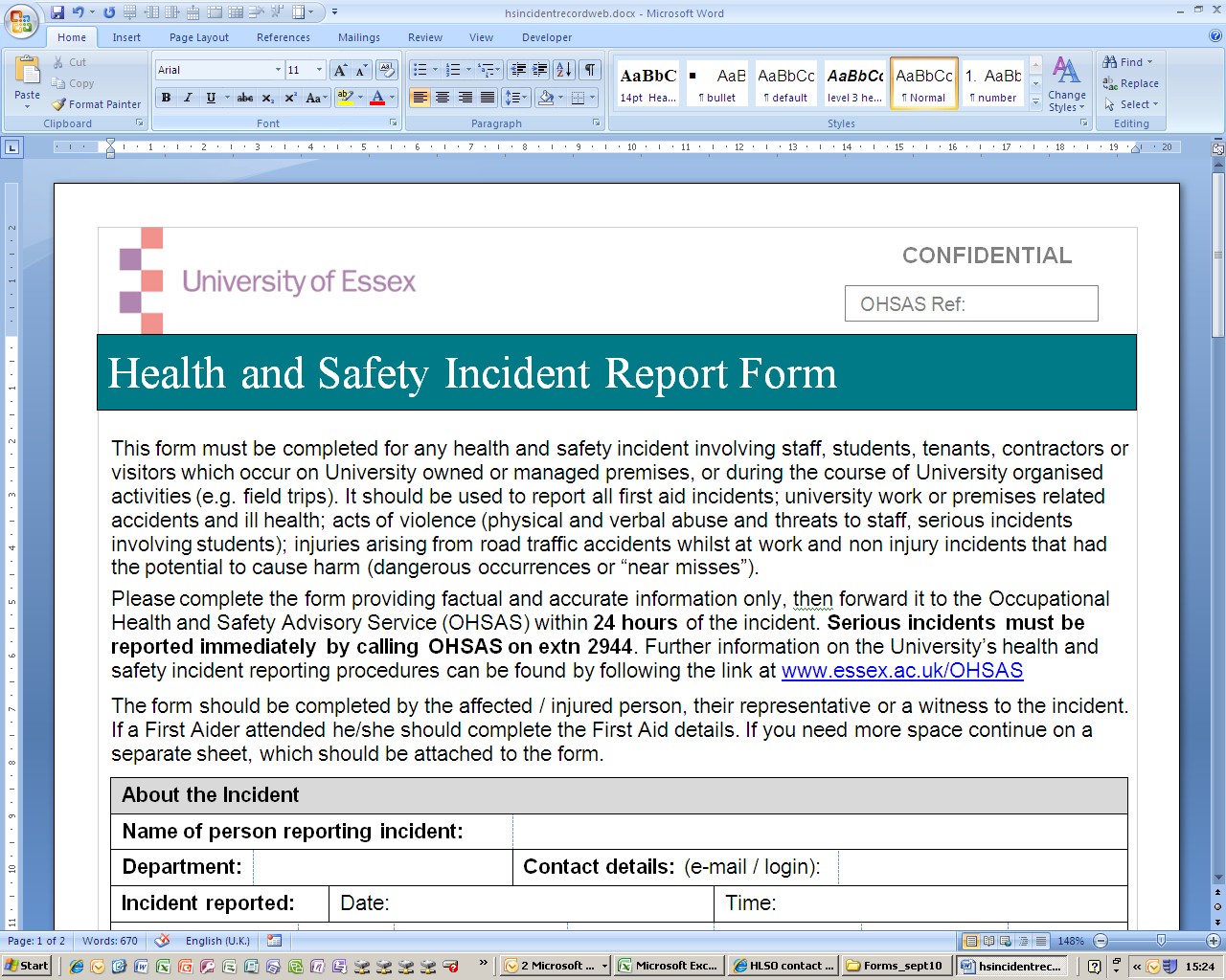 |  |  |  |  |  | Employee |  |  |  |  |  | Student (UG) |  |  |  |  | Student (PG) |  |  |  |  |  | Contractor |  |  |  |  |  | Other (specify):
If visitor: University contact name:
If contractor: Employer’s name:
If under 16: Name of adult responsible for their supervision:
Signature of injured person (or the responsible adult if under 16):
Witness details: Give name and contact details of any witnesses below:
Name(s): |  |  |  |  |  |  |  |  |  |  |  |  |  |  |  |  |  |  |  | Contact details:
First Aid details (If a First Aider attended he/she should complete this section)
First aid provided: |  |  |  |  |  |  | Yes / No / NA |  |  |  |  |  |  |  |  |  |  | Time of attendance:
If Yes give details,
If No give reason:
Name of First Aider: |  |  |  |  |  |  |  |  |  |  |  |  |  |  |  |  |  |  |  |  |  |  |  |  | Signature:
Post incident action
Action taken to make the situation/environment safe:
See www.essex.ac.uk/health-safety/report/concerns for guidance.
What happened to the injured person afterwards: Highlight using appropriate response below:
Taken directly to hospital |  |  |  |  |  |  | Went home |  |  |  |  |  |  |  |  |  | Returned to work/activity |  |  |  |  |  |  |  |  |  | Other: Specify:
If you know the person, responsible for the activity / area where the incident occurred please give their details below:
Name: |  |  |  |  |  |  |  |  |  |  |  |  | Designation: |  |  |  |  |  |  |  |  |  |  |  |  |  |  |  |  | Contact:  e-mail or extn
Thank you for helping the University to provide a supportive, safe and healthy work environment by reporting this incident. Please forward this form confidentially to safety@essex.ac.uk or Health and Safety Advisory Service, Room 4S.6.2 Colchester Campus, who will ensure that an investigation is carried out.
_______________________________________________________________________________________________
This section is for HSAS use.
HSAS ACTION | Received by  HSAS (date / initial) |  |  |  |  |  |  |  | Reviewed by lead adviser (date / initial)
RIDDOR reportable? | Yes / No |  |  | RIDDOR ref: |  |  |  |  |  |  | Date:
Type of incident: | First aid | Work related accident |  |  | Work related ill health |  |  | Work related violence |  | Road traffic  accident |  |  | Non injury incident
Investigated by: | HSAS Department* Not required
*Copy of incident report passed to: |  |  |  |  |  |  |  |  |  |  | Date:
Report passed to OH? | Yes / No |  | Date: |  |  |  |  |  | Report passed to University Insurance Manager? |  |  | Yes / No
Date investigation report returned: |  |  |  |  |  |  |  |  | Witness statements / photos / RIDDOR attached? |  |  | Yes / No
Follow up action: |  |  |  |  |  |  |  |  |  |  |  | NFA

