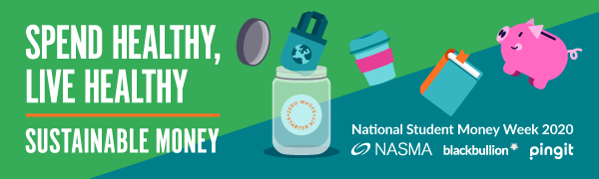
It's National Student Money Week (NSMW) from 3 – 7 February 2020!
We want to help you achieve your money goals, which is why we're supporting this national campaign.
Our Funding Team has teamed up with SU Advice to bring you information, advice and guidance on all things money related, to help you make your money go further. There will be activities, competitions and prizes for you to get involved with, and we'll be sharing loads of top tips on how to be smart with your money.
The theme this year is ‘Spend healthy, live healthy’ and throughout the week you'll find both teams to ask about Student Finance, budgeting advice, hardship support, and achieving your money goals.
We’ll also be running a week long #ZeroWasteJar insta competition with a chance of winning a fitness tracker bracelet!
Take part by collecting a free jar from the Student Services Hub throughout the week or from our Sustainable Money stand*, inspire us with your own recipe and then share your jar filled photo on Instagram with the following tags #ZeroWasteJar #NSMW @Blackbullion @Uniessex. The winner will be chosen at random.

Get involved!
Colchester campus
Location | Time | Event
Student Services Hub | Monday 3 February  11am - 1pm | Money and Funding drop-in
Ground floor Student Silberrad Centre | Tuesday 4 February  10am - 2pm | Sustainable Money stand
Student Services Hub | Wednesday 5 February  9am – 5pm | Money Quiz @ the Hub
Student Services Hub | Thursday 6 February  9:30am - 11:30am | Money and Funding drop-in
EBS building foyer | Friday 7 February  10am - 2pm | Sustainable Money stand

Southend campus
Location | Time | Event
Student Services Hub | Monday 3 February  11am – 1pm | Money and Funding drop-in
Student Services Hub | Tuesday 4 February  9am – 5pm | Money Quiz @ the Hub
SU Lounge | Wednesday 5 February  10am - 2pm | Sustainable Money stand

Loughton campus
Location | Time | Event
Canteen | Thursday 6 February  10am - 2pm | Sustainable Money stand
Student Services Hub | Friday 7 February  11am – 1pm | Money and Funding drop-in

