Once completed, this form must be emailed to the Estates Helpdesk ([**ems-helpdesk@essex.ac.uk**](mailto:ems-helpdesk@essex.ac.uk)), and **you must give at least 3 working days’ notice of your request**. You will receive an email confirmation if your request is approved.

If you intend to have more than 70 guests at your barbecue, or your barbecue has an open and unrestricted guest list, you must **also** complete an [events on campus permission form](https://www.essex.ac.uk/-/media/documents/directories/estates-and-campus-services/event-permission-form.docx).

**Available times to book the barbecue areas:**

|  |  |
| --- | --- |
| Between 01 October and 24 May | 12:00noon-5:00pm only |
| Between 25 May and 30 September | 12:00noon-5:00pm OR 6:00pm-10:00pm |

|  |  |
| --- | --- |
| Name of Organiser: | Phone number: |
| PRID: | Email address: |
| Name of organisation, group, or society: | Address: |
| Date of barbecue:  Click or tap to enter a date. | Number of guests: |
| Booking time:  Select booking time | Will there be any guests aged under 18 attending?  Choose an item. |
| Barbecue Organiser signature *I sign below having read and agreeing to abide by the conditions laid out on page 2*: | Date form completed:  Click or tap to enter a date. |

**FOR COMPLETION BY ESTATES HELPDESK TEAM ONLY:**

|  |  |
| --- | --- |
| Barbecue area/s allocated: | Maximum guests permitted: |

**FOR COMPLETION BY CAMPUS SECURITY SUPERVISORS ONLY:**

There will be no objection to the above function taking place provided the organiser agrees to abide by conditions on the reverse of this sheet and any additional conditions set out.

|  |  |
| --- | --- |
| Any other conditions: | |
| Signed: | Date:  Click or tap to enter a date. |

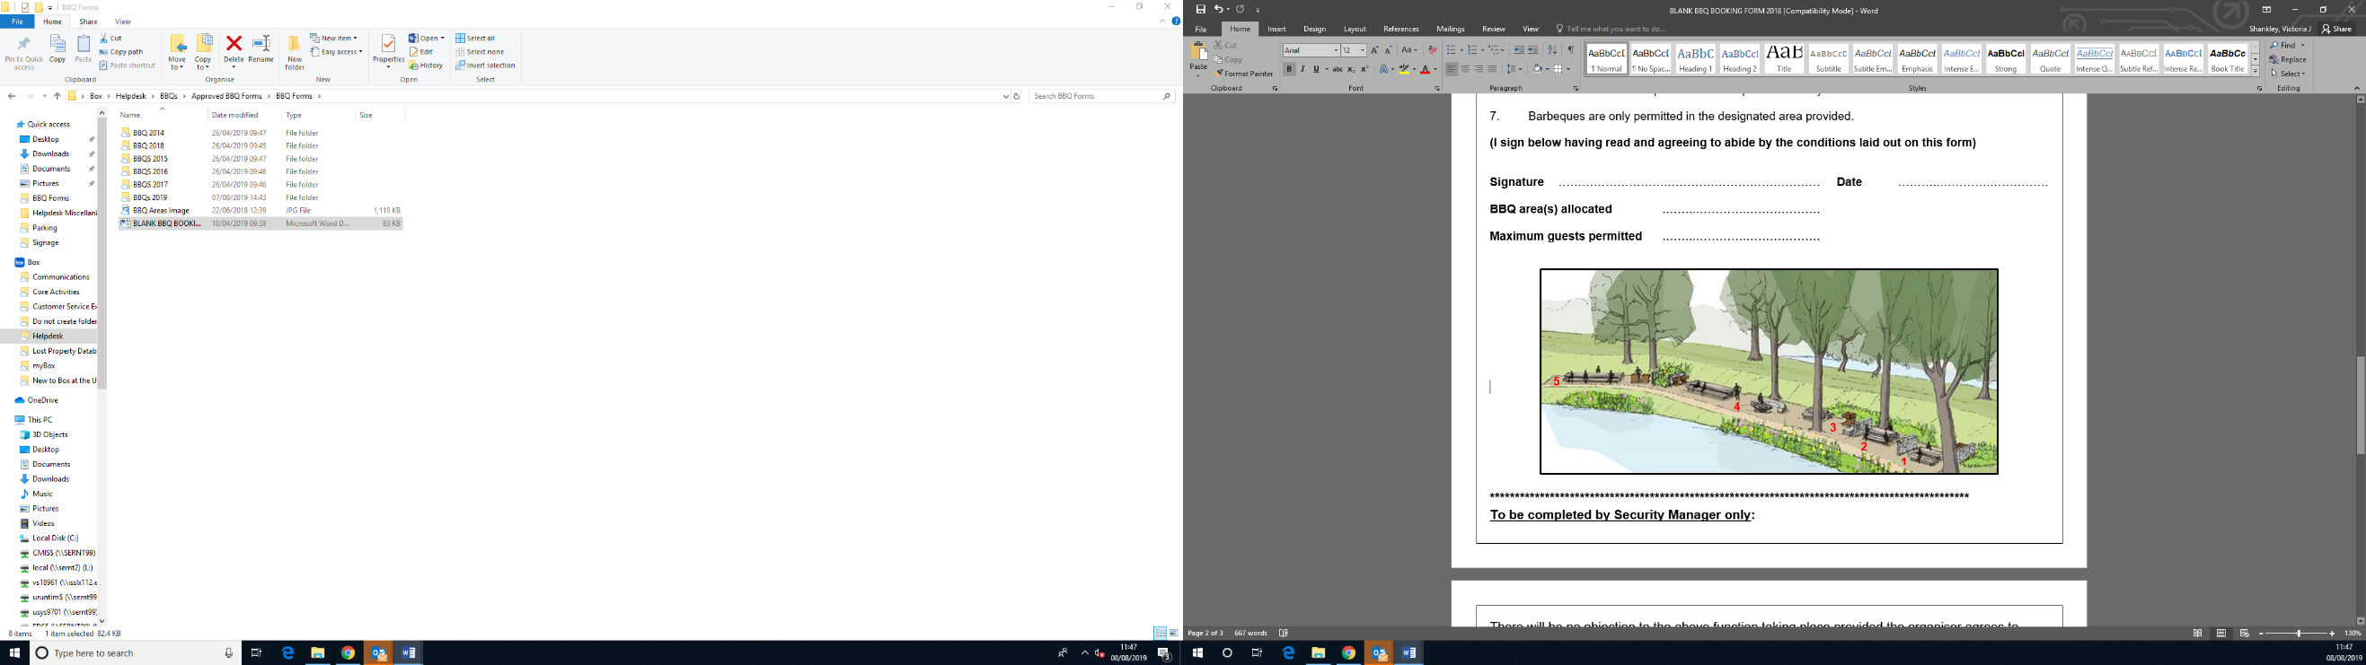

**Conditions of Barbeques**

Barbeques may be permitted to be held by any campus group provided that a member of the group is clearly identified as the ‘Organiser’ on the application form. Only members of staff or students may be the Organiser. The PRID of the organiser must be provided.

The Organiser must give a current address and telephone number at which they may be contacted.

Bookings will only be confirmed after the booking request has been signed on behalf of the University. The University reserves the right to cancel barbeques after a booking has been made. The University will not be liable for any costs incurred.

The University only provides a barbeque area where staff and students may hold barbeques after written permission has been given by the University.

Staff and students organising barbeques are advised that their own safety and the safety of persons attending the barbeque is their responsibility.

Organisers are advised to obtain insurance which would meet the legitimate claim of any person injured due to their activities.

The Organiser must take responsibility for ensuring the additional conditions listed below are complied with:

1. A fire blanket must be collected from the [Security & Campus Safety Centre](https://findyourway.essex.ac.uk/bcdc98e0-e3c3-11eb-b52e-05a67b7792fc/search/projects/23/60ef1a842031e800c2303c30) on Square 3 before the barbecue and returned within one hour of the finish time. The Organiser will be charged for the cost of this item if it is not returned. **Please note: Security staff are trained First Aiders and can be contacted in an emergency on 01206 872222.**
2. **Music will not be permitted.**
3. After the barbecue, the group must clear away all rubbish using the general waste bins provided. All barbecue items such as used disposable barbecue trays, coals etc must be disposed of in the large metal barbecue bins. If this is not done to the satisfaction of the Deputy Director Services, any cost associated with cleaning the area will be charged to the Organiser.
4. The sale of alcohol or food will not be permitted, nor will pre-payment for alcohol or food, by means of an attendance fee or by any other means. Consumption of alcohol is not permitted.
5. The poplar trees in the lake area are known to be old and it is possible in sustained high winds that they could become unsafe. It is the responsibility of the Organiser to cancel any barbecue if high winds are forecast or develop on the day.
6. Private vehicles are not permitted on the parkland at any time.
7. Barbeques are only permitted in the designated area provided.
8. Disposable barbecues must ONLY be used on the barbecue plinths. Do not place these on the benches or tables as this will cause damage.
9. You must not remove wood from trees in the parkland for burning. This damages the parkland and green wood (from a living tree) will produce lots of smoke.
10. Only coals, briquettes and wood should be burnt.
11. Do not burn compressed canisters.
12. Do not burn items containing materials other than wood such as old furniture.
13. Do not burn your rubbish, use the bins provided.
14. No liquid fuel (e.g., petrol / paraffin) to be used on the fire pit.
15. Misuse of the barbecue area may result in Patrol Officers stopping your event.