Web results examples

- A successful candidate

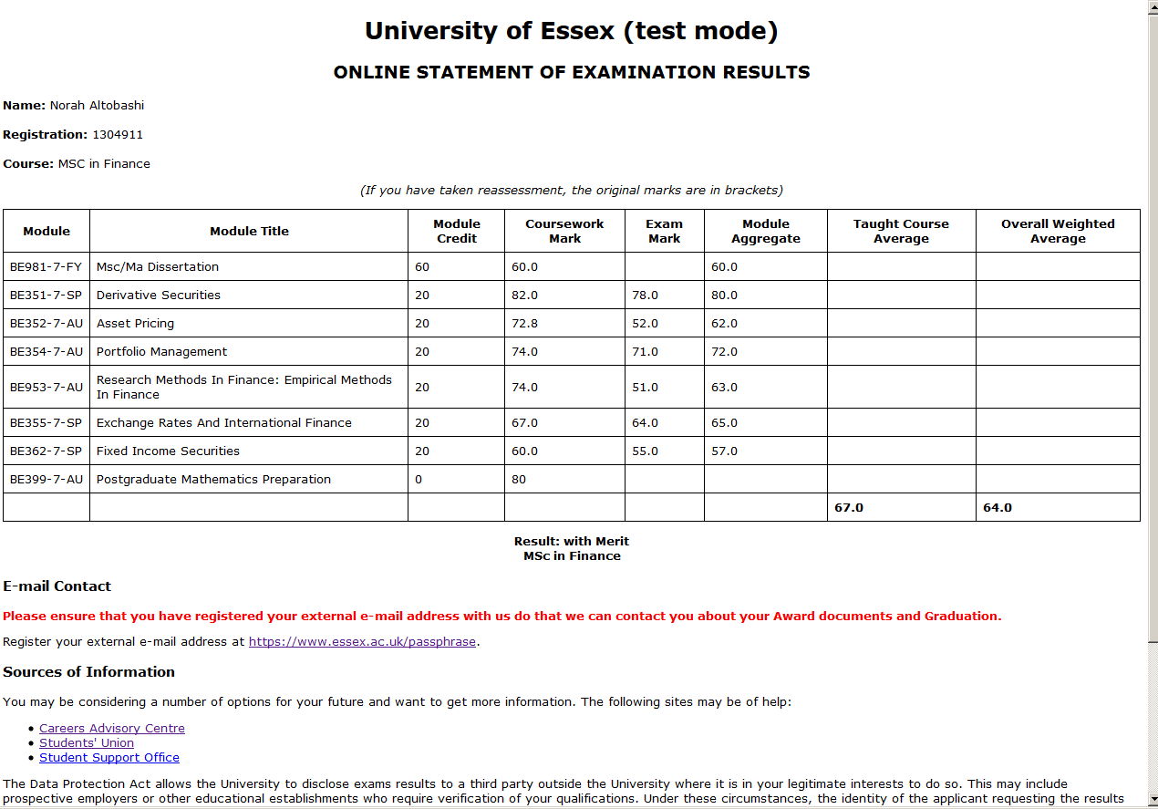
Registration Number
Name

2) Front page of a Candidate with a “DECISION” result

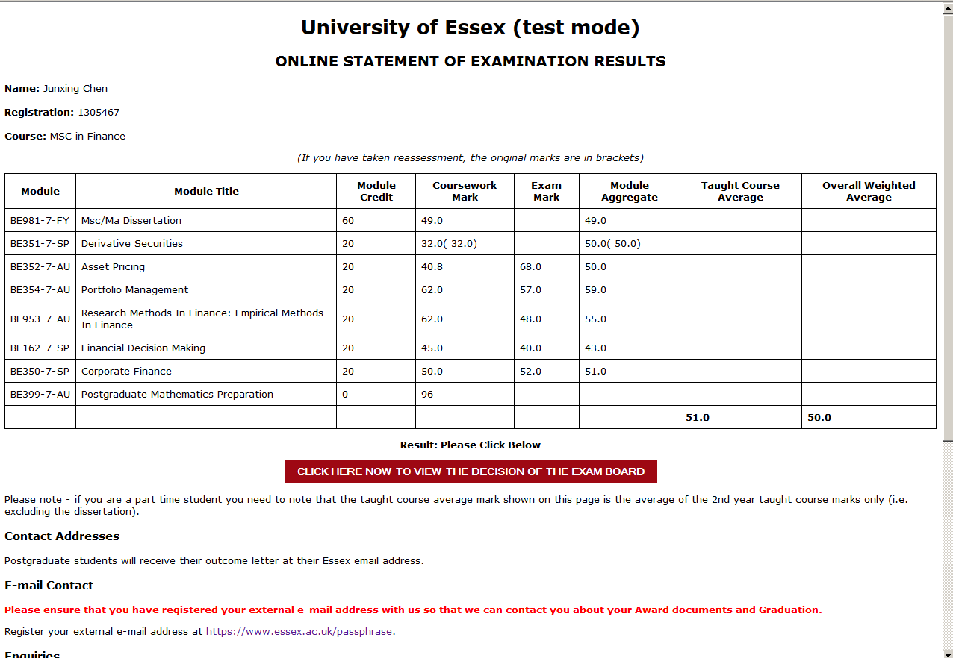
Registration Number
Name

3) 2nd page after “CLICK HERE NOW TO VIEW THE DECISION OF THE EXAM BOARD

This example has two to choose from RESU is expanded. The student will choose their reassessment in “Make your choice column” then click the Select “xxxx….” Button at the foot to confirm

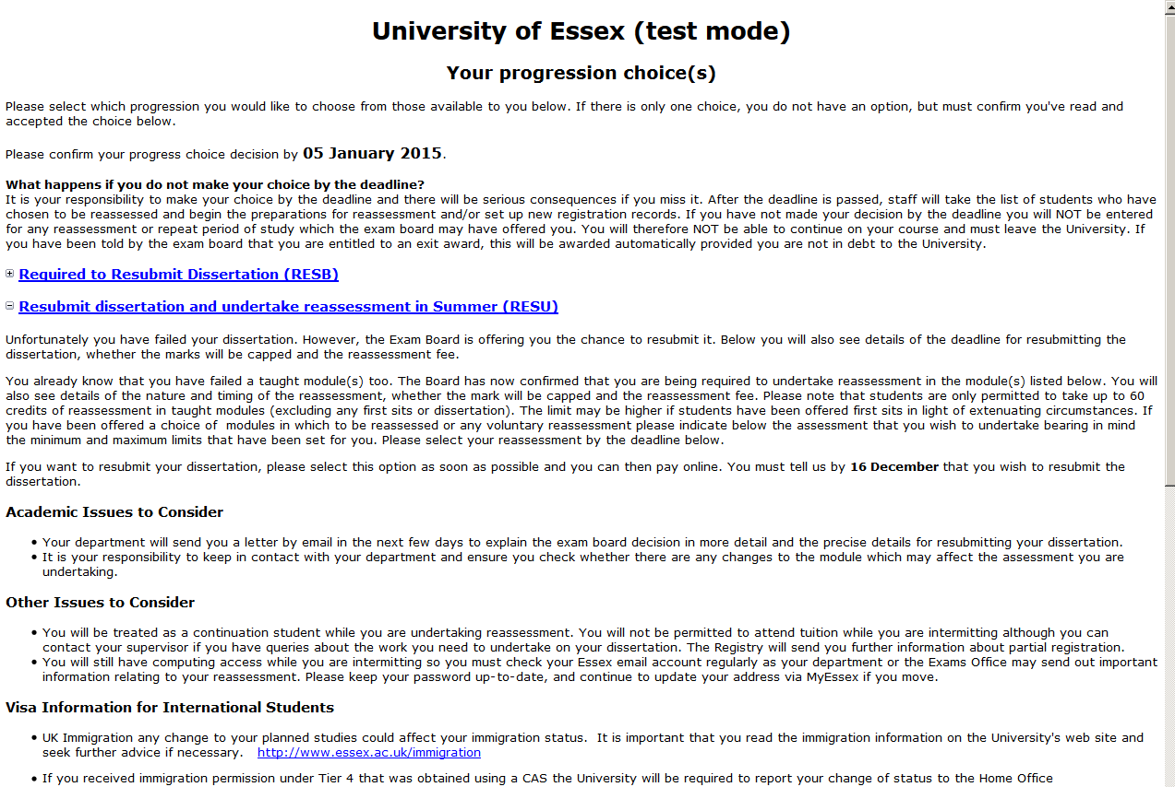
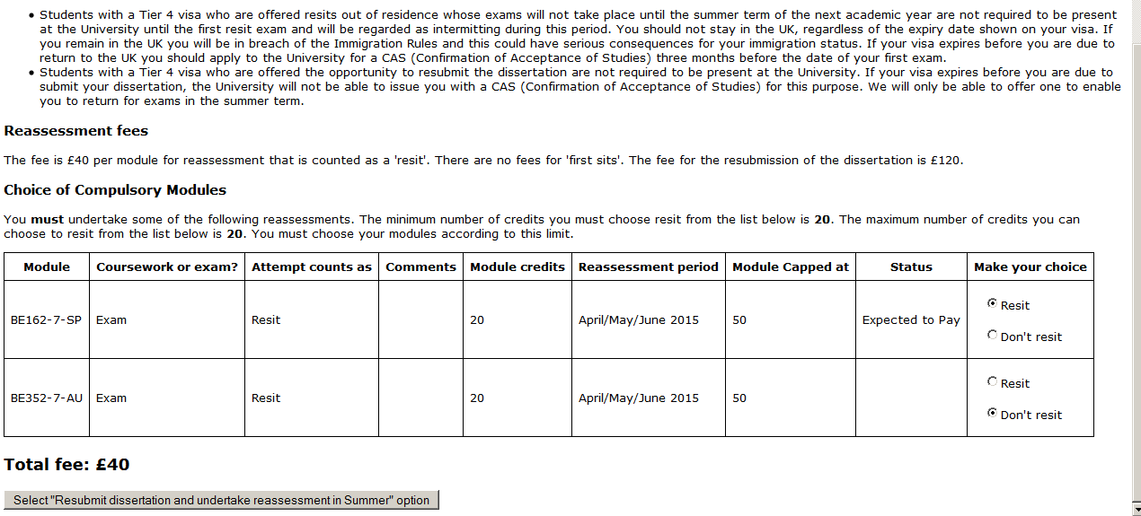

4) Once confirmed the next page is, where they can “go back and select a different option” or “CONFIRM YOUR DECISION”

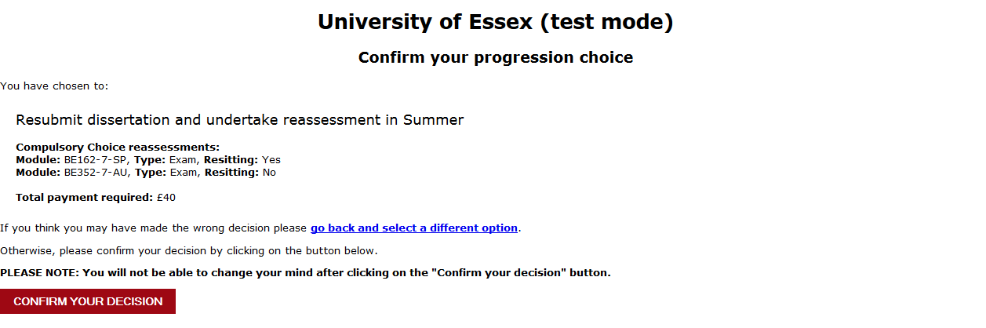

5) If they click “CONFRIM YOUR DECSION” the student will get a summary of their decision and can choose to pay now or later. If they pay now they will get taken to webshop to pay.

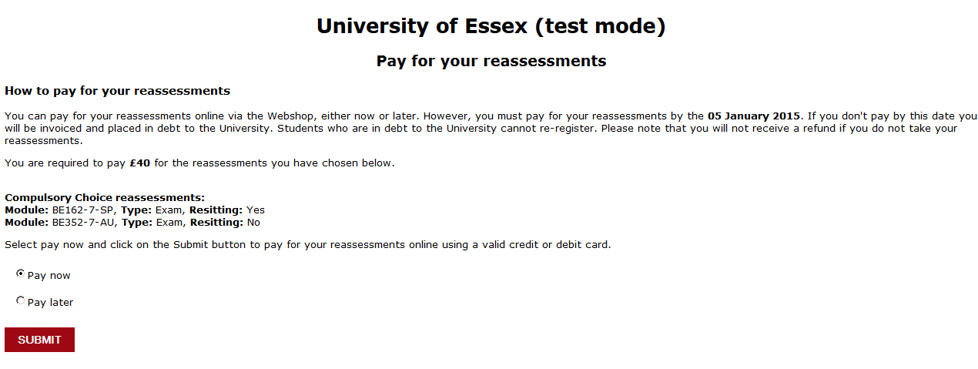
If they pay later they will get a confirmation page as below which will detail the dates of the resit timetable each year.

