Deputy Dean (Education) User Guide
Report Portal for External Examiners
(Taught Provision)

QUALITY AND ACADEMIC DEVELOPMENT
CONTACT US:
external.examiners@essex.ac.uk
bsthelp@essex.ac.uk

Contact us:
external.eaminers@essex.ac.uk
bsthelp@essex.ac.uk

Who will be using the External Examiner online portals?

External Examiners
External Examiners are part of University quality assurance processes. They provide an impartial view of the course and independent advice to ensure courses meet the academic standards and quality expected across the sector.
The online nomination and report portals will allow External Examiners to: submit their initial application information electronically; easily edit and update their details; check their schedules of awards/modules; submit their yearly reports and expenses claims; and check their University of Essex payslips.

Departmental Managers/Departmental Admin Staff
The Departmental Managers and their delegated administrative teams take responsibility for the initial nominations of External Examiner and managing their duties when in post. Using the online nomination portal, External Examiner nominations can now be fulfilled entirely electronically, with the ability to check which stage a nomination process has reached. Departmental Staff can use the portal to manage and update their External Examiners’ award/module allocations and request changes to their contracts.
Using the online report portal, departmental staff can receive and store External Examiner reports, and draft departmental responses, entirely electronically.

Heads of Department
Heads of Department will be able to use the nomination portal to approve or decline External Examiner nominations generated by their departmental admin team. Nominations will be received electronically and will the portal will offer a simple way of storing and accessing the information needed to decide upon the suitability of an appointment.

The report portal offers a straightforward for Heads of Department to monitor External Examiner reports and departmental responses.

Deputy Deans (Education)
Deputy Deans (Education) will electronically receive External Examiner nominations that have been authorised by a Head of Department. The portal will store the details of the nomination and the nominee, alongside additional comments or supplementary information supplied by the nominating department.

The report portal allows Deputy Deans (Education) to access, and comment upon, the External Examiner reports and departmental responses for all departments in their faculty.

Pro-Vice Chancellor (Education)
The Pro-Vice Chancellor (Education) takes overall responsibility for the External Examiner process. If a nomination is progressed to them, the Pro-Vice Chancellor (Education) can access the portals to check the details of a nomination and approve/reject as appropriate. The Pro-Vice Chancellor (Education) will also have access to all External Examiner reports and departmental responses stored in the report portal.

Quality and Academic Development
The Quality and Academic Development team will continue to oversee the External Examiners for undergraduate and postgraduate (taught) provision. More information about the team can be found here: https://www1.essex.ac.uk/quality/default.asp

TABLE OF CONTENTS

INTRODUCTION 4
ACCESSING THE REPORT PORTAL 4
VIEWING REPORTS 4
WRITING YOUR DEPARTMENTAL RESPONSE 6
SUMMARY 6
SCHEDULE 7
HELP AND SUPPORT 7

EXTERNAL EXAMINER REPORT PORTAL GUIDANCE

INTRODUCTION

The report portal is an online system which will enable you to monitor the annual reports submitted by the External Examiners in your faculty. The report portal will be an effective way of storing both the reports and the departmental responses of all the departments in your faculty, and will allow Deputy Deans (Education) easy access to view, download and comment upon External Examiner reports.

This portal is an enhancement of the iTrent system which some may be familiar with already. The new report portal will replace current methods of report submission and all External Examiners will be required to submit via the portal from April 2018 onwards. This guidance is designed to help walk you through some of the system basics, although our teams are on hand if you have any queries at all.

ACCESSING THE REPORT PORTAL

Please use the below link to access the portal:

www.essex.ac.uk/external-examiners-report-portal/internal-staff.aspx

You will then be prompted for your Essex login details.

VIEWING REPORTS

Once you have logged in, you will be able to search for reports by selecting your Faculty, Department and academic year. The report portal will hold reports from 2016/17 and ongoing, so in future you will have easy access to reports from previous academic years. Please note that there is no plan to backload reports which pre-date 2016/17. The Departmental responses have not yet been uploaded to the portal.

The External Examiner reports will have a Report status listed. The different statuses, and the subsequent actions that would need to be taken by Departments, are:

- COMPLETE: This report has been completed and submitted by the External Examiner, checked through and approved by QUAD, and is now ready for the Department to input their response.
- INTERIM: An interim report has been submitted, checked and approved. The report is available for the Department to read as with a report marked COMPLETE, with departmental responses not being obligatory for interim reports.
- AWAITING DEPARTMENT CHECK: A report has been submitted. When checking through the contents, QUAD has identified an issue that they wish to raise with the Department before full acceptance of the report. The report will requiring checking by the Department and any issues clarified before the report is accepted.
- PENDING: The External Examiner is working on the report and has not yet submitted it for checking, or else the report has been returned to the External for more work to be carried out.

If you leave the report status as All, the full list of available reports will be displayed, or you can sort by Report status to identify reports at different stages of the submission/checking process.

Select a report and choose from one of the drop down options.
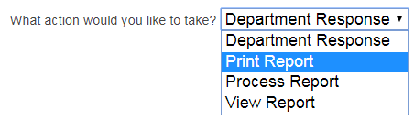

- Department Response
- Print Report
- Process Report
- View Report

If you choose an option which your log in does not give you access to – for example Process Report is a Quality and Academic Development activity, you will get the error message;

‘Function not allowed for user/status’

If this message appears, you will need to select a different option to progress.

You will be able to view the report as shown below, and tab across to the Departmental response; view the Summary; and see the External Examiner’s Schedule of awards and modules.

The report is an electronic version of the current form and so will be familiar to our existing External Examiners and to staff with previous experience with the External Examiner process.
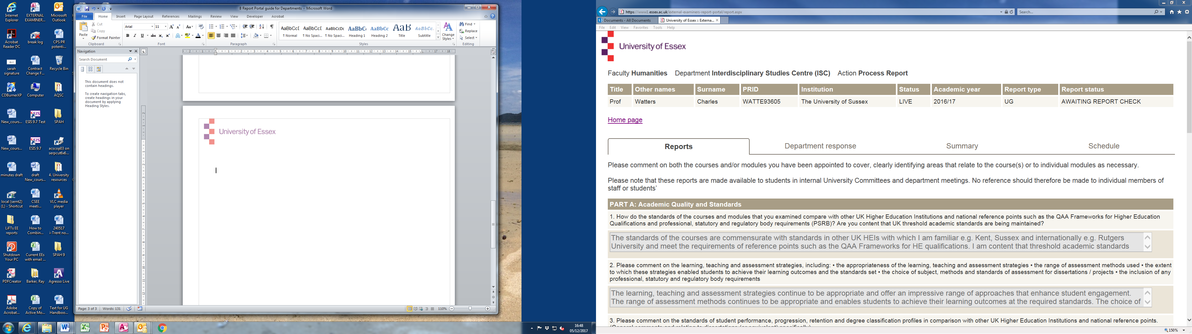
PRINT REPORT
If you need to extract the submitted report from the Portal as a PDF file or as a hard copy, select the action Print Report.

This will bring up a printable page summarising the External Examiner’s schedule and displaying their full report. To print the report, click CTRL+P or select Print from the taskbar of your Internet browser and send the report to the relevant printer. To save the report, change the print destination to Save as PDF (Google Chrome) or the equivalent for your browser.

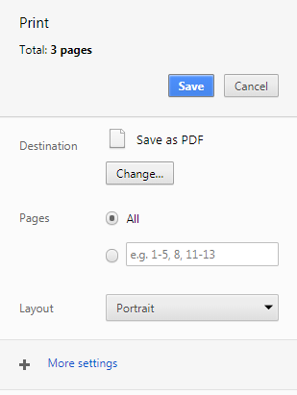

NB The example screen above is from Google Chrome. For advice on saving the page as a PDF from different browsers, please contact the IT Helpdesk ithelpdesk@essex.ac.uk.

SUMMARY

The Summary tab shows all of the actions followed from the report being inputted, through to its being processed. The Person column provides a record of which user has actioned each stage.

SCHEDULE

An example of the Schedule tab can be seen below. This tab allows you to view the External Examiner’s schedule of courses and/or modules, including details of:

- Their level(s) of provision
- Contract start/end dates
- Details of authorised contract extensions
- Module/course codes
- Which campus the module/course is based on
- The title of the course/module
- A module’s weighting

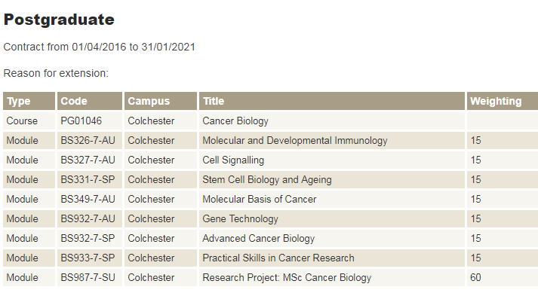

HELP AND SUPPORT

Problems with your login
If you encounter any problems relating to your login, please contact our IT Helpdesk via it.helpdesk@essex.ac.uk or 01206 87 2345

Any other issues with the Report Portal, or general External Examiner related queries:

Please contact the Quality and Academic Development team via

external.examiners@essex.ac.uk or 01206 87 3944/4861

