Practice

Placement

Handbook

Academic Year 2021/22

School of Health and Social Care

MSc Occupational Therapy (Pre-registration)

BSc (Hons) Occupational Therapy (Full time)



|  |  |
| --- | --- |
| Contents | Page |
| Introduction | 4 |
| Practice placements strategy | 5 |
| Introduction and Aims of Practice Based Learning within MSc and BSc (Hons) Occupational Therapy (OT) programmes (full-time) | 5 |
| Placement Opportunities and Organisation | 6 |
| Occupational Therapy Programmes | 7 |
| Teaching and learning approaches | 7 |
| Learner evidence of learning & continuing professional development | 7 |
| Case Study guidelines | 7 |
| Service Improvement | 8 |
| Practice Placement Calendar | 9 |
| MSc OT Programme Structure and Content | 10 |
| BSc OT Full-time Programme Structure and Content | 14 |
| Practice Placement One: EXPLORE  Practice Placement Two: INITIATE  Practice Placement Three: LEAD  Practice Placement Four: MANAGE | 20  23  26  29 |
| Placement Education support | 32 |
| School Contacts  Role of the Practice Placement Lead, Visiting Tutor | 32  34 |
| Placement Educator Continuing Professional Development support | 35 |
| Placement Resources, Practice Placement stages – what happens when | 36 |
| Learner Placement preparation, Placement debrief & Post placement processes | 38 |
| Mandatory Training | 38 |
| General placement information – Hours, Study time, Sickness absence | 39 |
| Placement Absence |  |
| Car Insurance, Placement Expenses, Accommodation, Professional indemnity | 41 |
| Health & Safety, Lone Working, Dress Code | 42 |
| Moving & Handling, Code of Ethics & Professional Conduct, Confidentiality and Consent, Disclosures & Barring Service (DBS), Working with Family members | 43 |
| Equality Act 2010 – Learner’s needs, Alternate placement arrangements, reasonable adjustments procedure | 44 |
| Statement on Deferred Placements | 49 |
| Responsibilities of the Learner, practice educator and work-based mentor  Whistleblowing & Escalating Concerns for Learners | 50  51 |
| Placement Assessment Process | 52 |
| Pre-registration Practice Education Risk of Failure  Fitness to Practise | 56  58 |
| Failure of Practice Placement modules | 59 |
| Assessment paperwork submission | 60 |
| Learning Contracts and Learning Outcomes | 60 |
| Learning Contract example | 62 |
| Supervision | 63 |
| Guidelines for Role Emerging Placements | 64 |
| Practice Placement Education Quality Assurance and Monitoring | 66 |
| Placement Learner Information File | 67 |
| References | 69 |
| Introduction to appendices | 70 |
| Appendices |  |
| 1. Placement allocation process | 72 |
| 1. Pre-placement leaner advanced information form | 73 |
| 1. SWAIN analysis | 74 |
| 1. Example SWAIN analysis | 76 |
| 1. Case study consent form | 77 |
| 1. Supervision log | 78 |
| 1. Weekly action plan | 79 |
| 1. Learning contract | 80 |
| 1. Learner Moving and Handling | 81 |
| 1. Protocol for tutorials | 83 |
| 1. Placement halfway visit tutorial process | 84 |
| 1. Placement halfway tutorial monitoring form | 86 |
| 1. Learner evaluation | 90 |
| 1. Practice educator feedback form | 93 |
| 1. Risk of failure form | 94 |
| 1. PDSA form 2. Checklist for completion of the assessment booklets 3. Occupational Profile proforma | 96  99  100 |
|  |  |
|  |  |
|  |  |

**Introduction**

Welcome to the University of Essex Occupational Therapy Practice Placement Handbook.

The handbook provides an overview of the MSc and BSc (Hons) Occupational Therapy programmes and the processes involved in practice placement provision. Examples of assessment documentation required by all learners and practice educators can be found on the university website link: <https://www.essex.ac.uk/departments/health-and-social-care/placements/occupational-therapy-placements>

Practice placements are an integral part of health professional education programmes and should be a positive and satisfactory experience for both practice educators and learners.

Maintaining the quality of practice education requires a working partnership between the University of Essex and placement providers. Each party has a responsibility to enhance the learner experience through open communication channels. Alongside having direct contact with visiting tutors from the University of Essex, placement educators are encouraged to use the Placement Educator’s Feedback Questionnaire as an effective method for informing the University of any issues.

If you have any queries about any aspect of practice education please contact: Placement Administrators,

Telephone: 01206 874312 or 874974,

Email: [practiceplacements@essex.ac.uk](mailto:practiceplacements@essex.ac.uk)

We aim to resolve any issues of complaint as speedily as possible.

If you wish to make a formal complaint about any aspect of practice education, it should be addressed to:

Professor Victoria Joffe (Dean)

School of Health and Social Care

University of Essex

Wivenhoe Park

Colchester

CO4 3SQ

T 01206 874927

E vjoffe@essex.ac.uk

Practice Placement Strategy

This strategy provides an overview of the MSc and BSc (Hons) Occupational Therapy programmes (full-time [F/T]) and the processes involved in practice placement provision.

Practice placements are an integral part of health professional education programmes and should be a positive and satisfactory experience for both practice educators and learners. Maintaining the quality of practice education requires a working partnership between the University of Essex and placement providers.

All learners will experience four different practice placements during their studies across the following settings:

**NHS/Local authority commissioned services**

**Non-traditional sites** – e.g., vocational/educational services/private/independent practice.

**Role emerging placements** – where there is not an established Occupational Therapy role.

There may be the opportunity for learners on penultimate and final placements to experience working in a setting where there is not an established occupational therapy role.These ‘role emerging’ opportunities may occur in settings such as residential homes, hostels, homeless services, outdoor pursuit centres, independent drug agencies, schools etc. learners may undertake this type of placement individually or as a shared experience with a peer. This type of placement can challenge learners to develop a strong sense of professional identity. Learners are encouraged to discuss the opportunities with their programme lead and role emerging placement tutor in conjunction with the Placement Lead.

**Introduction to Practice Based Learning**

Practice-based learning is a vital and indispensable part of the occupational therapy learners’ learning process in their educational and professional development. Practice experience enables the acquisition of new knowledge and skills as well as the application and consolidation of and reflection upon learning gained in the university environment. Essentially, the aim of practice placement learning is to offer learners opportunities to develop core practice and transferable skills across a range of settings. The Health and Care Professions Council (HCPC) Standards of Education and Training (2017)(Standard 5) sets out the different requirements for practice learning, teaching and supervision to be designed to encourage safe and effective practice, independent learning and professional conduct <https://www.hcpc-uk.org/globalassets/resources/standards/standards-of-education-and-training.pdf>

**Aims of Practice Based Learning**

During practice placements, learners have opportunity to work alongside skilled role models as well as with professionals from other disciplines to support development of a collaborative working ethos. Placement interactive experiences, across a variety of settings, facilitate a naturally occurring transferable learning and teaching process to incorporate academic knowledge and skills in the development of personal and professional skills, knowledge, and competence as an occupational therapist. To facilitate learner confidence, care is taken to ensure that the experiences of the individual learner are sufficiently challenging to their unique practical, intellectual, imaginative, and creative powers and are commensurate with their identified learning needs.

Formal practice placement supervision is undertaken by registered occupational therapists and provides the forum for constructive critical appraisal, feedback and guidance on the learner’s skills, performance, and development needs.

Reflective space ensures that learners incorporate a sense of professional identity (roles, values, and attitudes), an analytical approach to critical problem-solving and a growing sense of self-awareness (and of others) to foster independent judgement.

**Placement Opportunities and Organisation**

The School of Health and Social Care Occupational Therapy programmes access practice placements primarily in Essex. Learners can also expect to access available services in Hertfordshire, Suffolk, Cambridgeshire, and the fringes of London. Learners are placed in a variety of multi-disciplinary healthcare settings and experience will be gained with people who have physical and mental health care needs.

Learners are guided to use practice placement opportunities to develop and consolidate core skills whilst also pursuing areas of specialist interest. They will access a range of placement settings which may encompass services based within the National Health Service (NHS), Private Sector, Social Services and Primary Health Care Services. In addition, there can be opportunity to experience occupational therapy in developing areas such as private and voluntary sector agencies to access ‘role emerging’ placement opportunities.

**Important information about placement organisation**

In all circumstances placements will be organized and allocated by the University of Essex Practice Placement team. There are accepted placement provision protocols negotiated with service providers across the region and learners must not approach services directly to seek placements. Any deviance from this process will not be sanctioned.

Placements may be subject to short notice or changes due to circumstances outside the control of the University of Essex.

Placements start and finish dates may occasionally be extended beyond scheduled dates to accommodate availability although every effort to secure placements for the stated periods will be made.

Without exception, all learners will be allocated their placement information from the placement administrative database only after the learner has successfully completed the relevant pre-placement requirements i.e., mandatory training for both online and practical elements.

Learners are expected to plan to travel to placements and adhere to conventional service working hours.

**Local placements cannot be guaranteed:**

You may have to stay away from home, and meet the costs associated with this (Help may be available for learners via the Learning Support Fund (see page 49). Wherever possible we will try to keep your journey times to under 90 minutes, but again, this is subject to placement availability. **Refusal to accept a placement on the grounds of location may be regarded as a ““failure”” unless you have extenuating circumstances**.

**Occupational Therapy Programmes**

The University of Essex provides two routes to registration as an Occupational Therapist with the Health and Care Professions Council

* 2-year MSc accelerated route and 3-year full time BSc (Hons) programme, all with practice placements of 4-, 6-, 8- and 10-weeks duration.

**Teaching and learning approaches**

Learners will take an incremental approach to their learning in the placement setting, building their professional practice in preparation for when they have qualified. SWAIN forms are used by learners to translate their learning from the academic setting to the practice setting and throughout placements. Placements are selected and allocated based on the learner’s learning requirements, amongst other factors. CPD occurs throughout placements and is an important part of the placement experience.

**Learner evidence of learning and Continuing Professional Development (CPD)**

Placement education provides an essential environment for both personal and professional development from learner to competent practitioner, enabling the learner to utilise available experiences and resources to inform their learning. Throughout the placement the learner will collect both formal and informal evidence of learning using learning contracts, supervision logs, placement assessment and feedback.

# A moving and handling log (Appendix 9) is an integral part of the portfolio framework.

A CPD portfolio framework provides the learner with a variety of tools to aid supervision and reflection processes. It is strongly recommended that the learner has opportunity through formal and informal supervised practice to reflect on practice placement experiences. Learners will demonstrate learning as they progress through the placement and summarise achievements using a continuing professional development activity (HCPC, 2018) which has been agreed and negotiated with their placement educator.

HCPC (2018) *Standards of continuing professional development: Our expectations around demonstrating continuing learning and development. Available:*

<https://www.hcpc-uk.org/standards/standards-of-continuing-professional-development/> [accessed 07/08/21]

The following provides examples of work-based activity guidance:

Case study

Learners can use a case study as one form of evidence of their learning on any placement. Below are some general guidelines for presenting this information.

**Occupational Profile**

BSc Occupational therapy learners will complete an occupational profile of a service user whilst out on their first placement (Appendix 18)

**General guidelines for all case studies**

A case study could include information relevant to the occupational therapy process as appropriate to the service area and to demonstrate learner professional reasoning processes at an appropriate level for stage of training.

* Overview of person referred to the service and the service user’s perspective
* Reason for referral
* Identified needs
* OT process – assessment, interventions, evaluation
* Occupational focused practice
* Guiding theories, policies, legislation
* Benefits and outcomes for people who use services (service users)
* Service/resource limitations
* Future learning and development
* Evidence base for study – source references

Learners must obtain signed consent from the chosen case study person and their placement educator using the consent form (Appendix 4).

Please note: it is recognised that it is not always possible to ascertain or accommodate a service users’ wishes for mental capacity or legal reasons. In such circumstances learners and placement educators must always act in the service users’ best interests and abide by legal and local requirements.

**Service improvement**

The NHS Service Improvement Agenda means that service improvement is now expected of anyone working in the NHS. Therefore, since 2006, there has been an ongoing national project to include service improvement within all pre-registration healthcare education programmes in England.

The University of Essex follows the nationally agreed mandate set out by the Institute for Innovation and Improvement and in accordance with this, learners are expected to undertake a small-scale service improvement analysis and planning activity from an idea they have had during one of their placements. Learners have access to a PDSA pro-forma which is aligned with the service improvement process adopted by the NHS and can be used to write up their idea. There are also other service development resources available.

Placement educators involved with learners’ education are being asked to facilitate this process as much as possible. It is recommended that learners utilise the placement education Open access (MoodleX) site with a copy of a completed PDSA pro-forma or other relevant paperwork. The learner can be asked to deliver a presentation on their service improvement to their placement educators.

In accordance with the NHS Innovation and Improvement strategy of service improvement, learners on the BSc programme will be required to identify and complete a service improvement project whilst on their penultimate placement. The project will be documented in a format deemed to be appropriate to the project. Further information can be found on the HSC Service improvement Moodle page.  Depending on the project, learners may wish to include additional supporting tools e.g., fishbone chart. Further details of these requirements will be made clear in your relevant module launch.

Learners could use the PDSA form to reflect on their learning (further information can be found on the HSC Service Improvement Moodle page) <https://moodle.essex.ac.uk/course/view.php?id=1367>

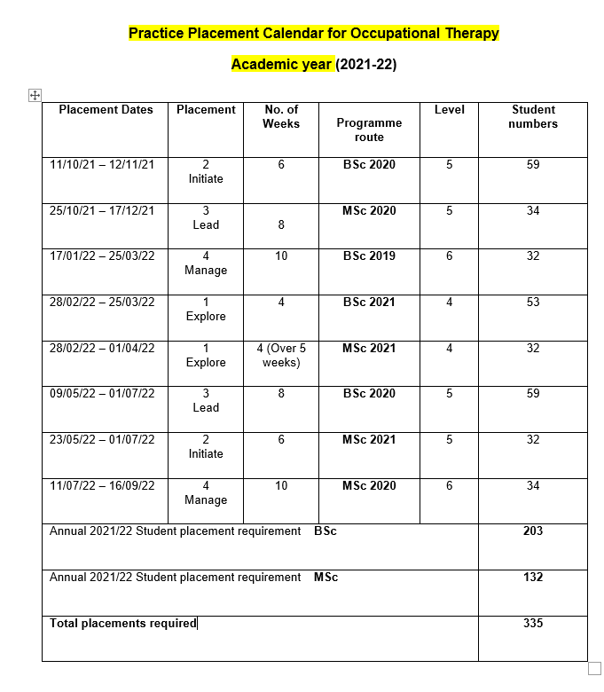

**MSc (pre-registration) Occupational Therapy**

The overall aim of this programme is to prepare graduates for registration with the Health and Care Professions Council to practice as an Occupational Therapist. During the programme we provide learning opportunities to develop the required knowledge, understanding and skills for:

* Professional practice: knowing and understanding how to think and act as an occupational therapist for the benefit of service users, carers, families, communities, and services.
* Occupational Therapy: knowing and understanding occupational performance and engagement, by analysing the impacts of health and social conditions and addressing them by designing, delivering, and evaluating occupationally focused interventions.
* Context: knowing and understanding how to advance occupational therapy practice in a range of settings based on evidence-based practice, reflection and service development through collaborative working, leadership, scholarship, and research.

The MSc Occupational Therapy (pre-registration) programme runs for two years. The programme is designed as a continuous progression of integrated theory and practice, which is reflected in the learning and practice outcomes and assessment strategy for each module. The programme is delivered only in full-time mode, consisting of forty-five weeks per year including an induction week at the beginning of year 1. The structure of the programme adopts a developmental approach, with practice placements spread across the two years.

The World Federation of Occupational Therapists (WFOT) requires evidence of 1000 hours prior to qualification. The programme enables learners to undertake a minimum of 1050 hours in practice through the completion of four practice placements. Currently, across the UK, placement learning is not accredited at master’s level unless there is an academic component assessing the learners critical thinking about their practice. At the present time, it suits our purpose to have zero credit-rated placements, so placement educators can focus on ensuring the learner is practicing occupational therapy at an acceptable standard for qualification. Therefore, the placements are the same as the BSc (Hons) Occupational Therapy in every respect except credit-rating.

Programme Structure Diagram – MSc Occupational Therapy (pre-registration)

.

**Programme Content MSc (pre-registration) programme**

Occupational Therapy modules

Foundations for Occupational Therapy HS892

You will be introduced to the foundations for occupational therapy, studying informing theories and sciences of occupation, and learning core skills for professional practice. Theory and practice will be brought together in enquiry-based learning, developing your understanding of professional practice.

Research in Healthcare HS858

This module will help you to develop rigorous critical appraisal skills to support evidence-based practice in health care and to develop a rich understanding of research methods, to appraise published materials, to apply evidence in practice settings, and to support the skills necessary to produce a literature review that appraises, synthesises, and interprets the implications of a body of evidence.

Interprofessional collaboration and development HS810

This module introduces you to the concept of learning together to promote collaboration in healthcare. The emphasis is on person-centred care, the team around the service user and the potential to enhance outcomes through collaborative working. The module seeks to begin to develop reflective team workers who understand the value of collaborative working and seek to incorporate this in their further professional development.

**Practice placement one: EXPLORE HS891**

In this first four-week placement, you will learn to develop an occupational focus, seeing people as occupational beings and using the occupational therapy process to understand their progress through a service. You will explore how this focus contrasts and complements the work of multi-disciplinary teams and other services. You will explore how the core values, skills, and beliefs you have learned about so far are enacted in the placement setting, including communication skills and occupational theories. This placement will be Tuesday to Friday across five weeks.

Occupational Performance and Process HS893

This module focuses on the performance of occupation, investigating how the occupational therapy process is adapted in response to professional reasoning about the experiences of people using health and social care services.

**Practice placement two: INITIATE HS897**

This six-week placement requires active participation in practice, initiating elements of the occupational therapy process and sharing your professional reasoning at each stage. Your reasoning will involve thinking critically about the different aspects of practice and the knowledge and evidence which informs your practice. You will use reflection to develop awareness of yourself as a practitioner and identify areas for further learning. You will initiate interactions with other team members and those involved in this setting, based on the understanding of the contexts for practice.

Advancing Professional Practice in Occupational Therapy HS894

This module focuses on the informed and skilled use of occupation as a therapeutic medium to transform lives of individuals, groups, and communities.

Research Activity HS859

This module seeks to further advance your research and problem-solving skills to enable you to undertake research in your future practice and use critically the research of others to inform your practice.

**Practice placement three: LEAD HS898**

This eight-week placement will offer the opportunity for leadership, where you will demonstrate your practice based on decisions about how you work, using the best evidence, knowledge and understanding of the setting. This placement requires the development of innovative and creative ideas for practice based on sound theories. You will identify an issue arising from the context, generate and evaluate solutions and apply one as a practice innovation. You will also have the opportunity to discover quality monitoring processes and the implications of these in practice.

Mastering occupation HS895

This module focuses on the theories which inform occupational therapy, aiming for a deep critical investigation of their relevance for, and application to, contemporary practice.

The Thinking Therapist HS896

This module focuses on a thinking therapist, who can evaluate and synthesise diverse experiences and sources of information, to lead innovations in occupational therapy and sustain continuing professional development.

**Practice placement four: MANAGE HS899**

This final ten-week placement will require you to manage your own learning under supervision, fully engaging with the practice setting and its broader context. You will be required to demonstrate evidence of competent practice and readiness for transition from student to therapist. This placement requires demonstration of a highly professional level of skills and the use of critical evaluation and reflection to continually develop practice from a robust evidence base. You will be required to share your knowledge and skills.

**BSc (Hons) Occupational Therapy (Full-time)**

Practice placement education is an integral part of the BSc (Hons) Occupational Therapy programme. Within the spiral curriculum design, learners will apply and develop theoretical and practical profession-specific knowledge, skills, and experiences throughout. Practice placements will offer learners the opportunity to draw upon past experiences and learning to consolidate and further develop their occupational therapy practice across a range of diverse contexts.

The World Federation of Occupational Therapists (WFOT) requires evidence of 1000 practice hours prior to qualification. Learners on the programme will undertake a minimum of 1050 hours in practice through the completion of four practice placements.

Placements are of increasing duration ranging through 4, 6, 8 to 10 weeks with incremental levels of responsibility expected as professional skills and knowledge advance. The first placement is assessed at level 4, the second and third at level 5 and fourth placement at level 6.



BSc (Hons) Occupational Therapy - Full-time

LEVEL 4

HS173 Informing Sciences 1

15 credits

This module is designed to introduce learners to the basic sciences that inform professional practice, including anatomy, physiology, psychology, and sociology.

HS171 Occupational Being

15 credits

This module will introduce learners to the core knowledge and skills of occupational therapy, enabling them to develop an understanding of the occupational nature of human beings. Learners will be encouraged to consider themselves and others as occupational beings, to relate relevant theories to the occupational therapy profession.

HS140 Inter-professional Working and Development

30 credits

The aim of the module is to develop the learners’ awareness of concepts of professional and inter-professional practice through the exploration of relevant roles within health and social care contexts. Occupational therapy and physiotherapy learners will work collaboratively to develop an awareness of the professional and regulatory standards, with consideration of their own continuing professional development needs in meeting the expectations. Learners will also be introduced to basic academic and research skills, with opportunities to develop and apply these skills throughout the module

HS175 Engagement in Occupation

15 credits

This module will enable learners to explore how people engage in their occupations and identify the influences upon occupational performance across the lifespan

HS172 Practice Placement one - EXPLORE

15 credits

A 4-week full-time placement with pass/fail criteria

In this first four-week placement, you will learn to develop an occupational focus, seeing people as occupational beings and using the occupational therapy process to understand their progress through a service. You will explore how this focus contrasts and complements the work of multi-disciplinary teams and other services. You will explore how the core values, skills, and beliefs you have learned about so far are enacted in the placement setting, including communication skills and occupational theories.

HS174 Informing Sciences 2

15 credits

The aim of this module is to further develop learners’ knowledge of the basic sciences introduced in Informing Sciences 1. Drawing on their previous learning and other experiences, learners will apply knowledge to further advance their understanding of the influence of anatomy, physiology, psychology and sociology upon health and ill health.

HS176 Concepts of Therapy

15 credits

This module allows learners to develop an understanding of the relative role, value, and impact of therapy within multiple contexts and environments. Learners will identify the constituents of therapy and understand the therapeutic use of self in relation to the development of their professional identity. They will also explore the interaction between themselves and others within the therapeutic relationship.

LEVEL 5

HS276 Leadership in Service Enhancement

30 credits

This module is designed to enable learners to develop effective leadership skills through the identification and development of an appropriate service enhancement idea drawn from practice placement experiences. Learners will extend their understanding of the considerations required to positively affect change to enhance service delivery and benefit service users.

HS274 Therapy and Occupation

30 credits

This module aims to develop the learners’ understanding and application of the occupational therapy process in enabling occupational performance within therapy. Learners will be expected to demonstrate professional reasoning within the process of occupational therapy to benefit service users and significant others.

HS272 Professional Reasoning

15 credits

Within this module, learners are introduced to the theory and practice of professional reasoning. Learners will also develop an understanding of the person central to the reasoning process, and how concepts, such as duty of care or personal values and beliefs, can influence professional reasoning. Learners will be expected to justify the process of their reasoning to reach appropriate outcomes.

HS240 Professional Enquiry

15 credits

This module focuses on facilitating an understanding of evidence in its widest sense; evidence and using a variety of sources leading to research design, analysis, and synthesis. This module will focus on the development of literature searching, synthesising literature within a critical review and identification of a specific topic for professional enquiry. The implications of the nature and overall quality of professional research literature as potential ‘evidence’ to inform practice will be considered.

HS273 Practice Placement two - INITIATE

15 credits

A 6-week full-time placement with pass/fail criteria

This six-week placement requires active participation in practice; initiating elements of the occupational therapy process and sharing your professional reasoning at each stage. Your reasoning will involve thinking critically about the different aspects of practice and the knowledge and evidence which informs your practice. You will use reflection to develop awareness of yourself as a practitioner and identify areas for further learning. You will initiate interactions with other team members and those involved in this setting, based on the understanding of the contexts for practice.

HS275 Practice Placement three - LEAD

15 credits

An 8-week full-time placement with pass/fail criteria

This eight-week placement will offer the opportunity for leadership, where you will demonstrate your practice based on decisions about how you work, using the best evidence, knowledge and understanding of the setting. This placement requires the development of innovative and creative ideas for practice based on sound theories. You will identify an issue arising from the context, generate and evaluate solutions and apply one as a practice innovation. You will also discover quality monitoring processes and the implications of these in practice. 19

LEVEL 6

HS373 Practice Placement four - MANAGE

15 credits

A 10-week full-time placement with pass/fail criteria

This final ten-week placement will require you to manage your own learning under supervision, fully engaging with the practice setting and its broader context. You will be required to demonstrate evidence of competent practice and readiness for transition from learner to therapist. This placement requires demonstration of a highly professional level of skills and the use of critical evaluation and reflection to continually develop practice from a robust evidence base. You will be required to share your knowledge and skills

HS340 Professional Enquiry Proposal

30 credits

This module is designed to extend learners’ learning in relation to evidence-based practice and research and culminates in the individual preparation and submission of an in-depth literature review and either research proposal or service improvement project proposal. Learners are expected to undertake the work associated with this module in an autonomous fashion, under the supervision of allocated supervisor. Learners will be expected to present the implications to practice of their proposal at an inter-professional conference at the end of the module.

HS372 Employability in Occupational Therapy

15 credits

This module aims to prepare learners for employment within a diverse range of Occupational Therapy settings. Learners will draw upon and utilise transferrable and core skills to prepare for employment as an Occupational Therapist. The value of continuing professional development is examined within this module, giving learners the opportunity to identify and plan for their future developmental needs and interests. The module provides self-directed and autonomous learning opportunities.

HS371 Advancing Occupational Therapy Practice

30 credits

Within this module, learners will acquire an understanding of the legal, political, and cultural contexts in which occupational therapy practice occurs. Learners will consider occupational therapy practice in relation to developing societal trends, government policy, research evidence, legislation, and ethics, from national and international perspectives. Such learning is then extended by supporting learners in identifying and exploring novel and emerging areas of occupational therapy practice.

HS374 Transition from Learner to Occupational Therapist

30 credits

This final module provides learners with opportunities to explore the concepts of the transformative process from competent learner to novice practitioner, to demonstrate a readiness to practice as an occupational therapist.

Practice placement modules for BSc (Hons) and MSc Programmes

Practice learning is required by the World Federation of Occupational Therapists (1000 hours). The module hours for each placement represent above the total hours required by the World Federation of Occupational Therapists

Module title: Practice Placement One: EXPLORE

BSc (F/T) Code: HS172

MSc Code: HS891

Level: 4

Credit rating: BSc 15 credits MSc 0 Credits for all placements

Type of Module: Practice placement

Module Hours: 150

Description:

In this first placement, you will learn to develop an occupational focus, seeing people as occupational beings and using the occupational therapy process to understand their progress through a service. You will explore how this focus contrasts and complements the work of multi-disciplinary teams and other services. You will explore how the core values, skills, and beliefs you have learned about so far are enacted in the placement setting, including communication skills and occupational theories. You will demonstrate your learning as you progress through the placement and summarise your achievements using a continuing professional development activity (HCPC, 2018) which has been agreed and negotiated with your educator.

Aim:

Over a 4-week placement, you will explore the practice of occupational therapy in a specific setting. By the end you will be able to identify and describe routine practice you have encountered in your exploration.

Learning outcomes:

* Demonstrate knowledge of the OT process relevant to your placement setting
* Demonstrate effective use of reflection to develop the professional practice
* Demonstrate the ability to interact with individuals/people using a broad range of communication styles

Pre-requisite

* Completion of all mandatory training requirements and PEMS declarations

Module content:

* Placement preparation session for placement: SWAIN, learning outcomes, placement expectations, assessment documentation
* Placement debriefing session

Teaching and learning strategies:

* Practice- based learning practice experience in a relevant practice setting
* Preparation and debriefing workshop details will be available to learner prior to sessions on Pre-registration occupational therapy Placement Moodle page
* Learners to draw upon previous experiences and learning to date to inform their practice placement
* Learners will develop relevant skills for their practice placement setting in line with the assessment criteria
* BSc Occupational therapy learners will complete an occupational profile of a service user whilst out on their first placement

Learning support:

You will have access to support from your practice educator, peers, personal tutor, Practice Placement team and learner support during the practice placement. The practice educator acts as facilitator; mentor and assessor of the learner’s development and learning. Where two learners are on placement together, they can provide peer support; opportunities for self-directed study and an increased depth of experience for all parties.

You are encouraged to disclose any learning needs to the practice educator(s) and consider strategies to support learning. This is indicated on completion of the SWAIN form.

Support from the University of Essex occupational therapy placement tutor is available to both learners and educators throughout the placement together with support from other tutors at half-way tutorial if one is carried out. See Appendix 10 for the half-way visiting process.

Assessment:

Assessment of this placement is based on evidence of achievement of negotiated learning outcomes via

* half-way formative assessment at the end of week 2 of the placement
* final assessment at the end of the placement (100% weighting)

The online practice placement assessment booklet with marking guidance is completed by educator(s) in practice. This can be found using the following link: <https://www.essex.ac.uk/departments/health-and-social-care/placements/occupational-therapy-placements> [accessed 07/08/21].

Once completed, learners should upload this document to FASer

Educators should email this document to [hscplacements@essex.ac.uk](mailto:hscplacements@essex.ac.uk)

Online resources:

Open Essex (Moodle X) OT placement page: <https://moodlex.essex.ac.uk/course/view.php?id=39> [accessed 07/08/21]

Access to PEMS: <https://pems.essex.ac.uk/Login.aspx> [accessed 07/08/21]

Essential reading:

HCPC (2012) *Your guide to our standards for continuing professional development* <https://www.hcpc-uk.org/standards/standards-of-continuing-professional-development/> [accessed 07/08/21]

Indicative reading:

Health and Care Professions Council (HCPC) Continuing Professional Development (CPD) Portfolio & Framework as well as an ongoing professional resource [www.hcpc-uk.co.uk](http://www.hcpc-uk.co.uk)

Learning styles questionnaires (for example Honey and Mumford Learning styles questionnaire)

Royal College of Occupational Therapists (2021) Professional Standards for Occupational Therapy Practice, Conduct and Ethics as well as an ongoing professional resource <https://www.rcot.co.uk/practice-resources/rcot-publications/downloads/rcot-standards-and-ethics> [accessed 07/08/21]

Skills for health <http://www.skillsforhealth.org.uk/images/projects/dementia/Dementia%20Core%20Skills%20Education%20and%20Training%20Framework.pdf>

Module title: Practice Placement Two: INITIATE

BSc (F/T) Code: HS273

Developing professional practice skills through therapy and occupation

MSc Code: HS897

Level: 5

Credit rating: BSc 15 credits MSc 0 Credits for all placements

Type of Module: Practice placement

Module Hours: 225

Description:

This placement requires active participation in practice; initiating elements of the occupational therapy process and sharing your professional reasoning at each stage. Your reasoning will involve thinking critically about the different aspects of practice and the knowledge and evidence which informs your practice. You will use reflection to develop awareness of yourself as a practitioner and identify areas for further learning. You will initiate interactions with other team members and those involved in this setting, based on the understanding of the contexts for practice. You will demonstrate your learning as you progress through the placement and summarise your achievements using a continuing professional development activity (HCPC, 2012) which has been agreed and negotiated with your educator.

Aim:

Over a 6-week placement, you will initiate occupational therapy in a specific setting. By the end you will be able to question situations to identify problems and demonstrate the application of solutions within your initiatives.

Learning outcomes:

* Evaluate sources of knowledge, evidence, and information for practice in a specific setting
* Use reflection and professional reasoning to guide the occupational therapy process and develop own practice for the benefit of service users, carers, and the service as a whole
* Select apply and evaluate appropriate actions to initiate occupational therapy in a specific setting

Pre-requisite

* Completion of all mandatory training requirements and PEMS declarations

Module content:

* Placement preparation session for placement: SWAIN, learning outcomes, placement expectations, assessment documentation
* Placement debriefing session

Teaching and learning strategies:

* Practice- based learning practice experience in a relevant practice setting
* Preparation and debriefing workshop details will be available to learners prior to sessions on Pre-registration occupational therapy Placement Moodle page
* Learners to draw upon previous experiences and learning to date to inform their practice placement
* Learners will develop relevant skills for their practice placement setting in line with the assessment criteria

Learning support:

You will have access to support from your practice educator, peers, personal tutor, Practice Placement team and learner support during the practice placement. The practice educator acts as facilitator; mentor and assessor of the learner’s development and learning. Where two learners are on placement together, they can provide peer support; opportunities for self-directed study and an increased depth of experience for all parties.

You are encouraged to disclose any learning needs to the practice educator(s) and consider strategies to support learning. This is indicated on completion of the SWAIN form.

Support from the University of Essex occupational therapy placement tutor is available to both learners and educators throughout the placement together with support from other tutors. See appendix 10 for half-way visiting process.

Assessment:

Assessment of this placement is based on evidence of achievement of negotiated learning outcomes via

* half-way formative assessment at the end of week 3 of the placement final assessment at the end of the placement (100% weighting)
* The online practice placement assessment booklet with marking guidance is completed by educator(s) in practice.

Essential reading:

HCPC (2012) *Your guide to our standards for continuing professional development* <https://www.hcpc-uk.org/standards/standards-of-continuing-professional-development/> [accessed 07/08/21]

Indicative reading:

Health and Care Professions Council (HCPC) Continuing Professional Development (CPD) Portfolio & Framework as well as an ongoing professional resource [www.hcpc-uk.co.uk/cpd](http://www.hcpc-uk.co.uk/cpd) [accessed 07/08/21]

Learning styles questionnaires (for example Honey and Mumford Learning styles questionnaire)

Learning Support Fund <https://www.nhsbsa.nhs.uk/learning-support-fund> [accessed 07/08/21]

Royal College of Occupational Therapists (2021) Professional Standards for Occupational Therapy Practice, Conduct and Ethics as well as an ongoing professional resource<https://www.rcot.co.uk/practice-resources/rcot-publications/downloads/rcot-standards-and-ethics> [accessed 07/08/21]

Skills for health <http://www.skillsforhealth.org.uk/images/projects/dementia/Dementia%20Core%20Skills%20Education%20and%20Training%20Framework.pdf> [accessed 07/08/21]

Module title: Practice Placement Three: LEAD

BSc (F/T) Code: HS275

MSc Code: HS898

Level: 5

Credit rating: BSc 15 credits MSc 0 Credits for all placements

Type of Module: Practice placement

Module Hours: 300

Description:

This placement will offer the opportunity for leadership, where you will demonstrate your practice based on decisions about how you work, using the best evidence, knowledge and understanding of the setting. This placement requires the development of innovative and creative ideas for practice based on sound theories. You will identify an issue arising from the context, generate and evaluate solutions and apply one as a practice innovation. You will also have the opportunity to discover quality monitoring processes and the implications of these in practice. You will demonstrate your learning as you progress through the placement and summarise your achievements using a continuing professional development activity (HCPC, 2012) which has been agreed and negotiated with your educator.

Aim:

Over an 8-week placement you will lead on an aspect of the delivery of occupational therapy in a specific setting. By the end of the placement, you will be able to demonstrate the use of professional reasoning to justify your decisions and judgements you have made as part of your leadership.

Learning outcomes:

* Critically analyse the setting for occupational therapy from a range of relevant perspectives
* Critically appraise and evaluate the scope for evidence-based practice
* Evaluate the effectiveness of leadership for service improvement

Pre-requisite

* Completion of all mandatory training requirements and PEMS declarations

Module content:

* Placement preparation session for placement: SWAIN, learning outcomes, placement expectations, assessment documentation
* Placement debriefing session

Teaching and learning strategies:

* Practice- based learning practice experience in a relevant practice setting
* Preparation and debriefing workshop details will be available to learners prior to sessions on Pre-registration occupational therapy Placement Moodle page
* Learners to draw upon previous experiences and learning to date to inform their practice placement
* Learners will develop relevant skills for their practice placement setting in line with the assessment criteria

Learning support:

You will have access to support from your practice educator, peers, personal tutor, Practice Placement team and learner support during the practice placement. The practice educator acts as facilitator; mentor and assessor of the learner’s development and learning. Where two learners are on placement together, they can provide peer support; opportunities for self-directed study and an increased depth of experience for all parties.

You are encouraged to disclose any learning needs to the practice educator(s) and consider strategies to support learning. This is indicated on completion of the SWAIN form.

Support from the University of Essex occupational therapy placement tutor is available to both learners and educators throughout the placement together with support from other tutors. See Appendix 10 for the half-way visiting process.

Assessment:

Assessment of this placement is based on evidence of achievement of negotiated learning outcomes via

* half-way formative assessment at the end of week 3 of the placement final assessment at the end of the placement (100% weighting)
* The online practice placement assessment booklet with marking guidance is completed by educator(s) in practice.

Essential reading:

HCPC (2012) *Your guide to our standards for continuing professional development* <https://www.hcpc-uk.org/standards/standards-of-continuing-professional-development/> [accessed 07/08/21]

Indicative reading:

Health and Care Professions Council (HCPC) Continuing Professional Development (CPD) Portfolio & Framework as well as an ongoing professional resource [www.hcpc-uk.co.uk/cpd](http://www.hcpc-uk.co.uk/cpd) [accessed 07/08/21]

Learning styles questionnaires (for example Honey and Mumford Learning styles questionnaire)

Learning Support Fund <https://www.nhsbsa.nhs.uk/learning-support-fund> [accessed 07/08/21]

Royal College of Occupational Therapists (2021) Professional Standards for Occupational Therapy Practice, Conduct and Ethics as well as an ongoing professional resource<https://www.rcot.co.uk/practice-resources/rcot-publications/downloads/rcot-standards-and-ethics> [accessed 07/08/21]

Skills for health <http://www.skillsforhealth.org.uk/images/projects/dementia/Dementia%20Core%20Skills%20Education%20and%20Training%20Framework.pdf> [accessed 07/08/21]

Module title: Practice Placement Four: MANAGE

BSc (F/T) Code: HS373

MSc Code: HS899

Level: 6

Credit rating: BSc 15 credits MSc 0 Credits for all placements

Type of Module: Practice placement

Module Hours: 375

Description:

This final placement will require you to manage your own learning under supervision, fully engaging with the practice setting and its broader context. You will be required to demonstrate evidence of competent practice and readiness for transition from learner to therapist. This placement requires demonstration of a highly professional level of skills and the use of critical evaluation and reflection to continually develop practice from a robust evidence base. You will be required to share your knowledge and skills. You will demonstrate your learning as you progress through the placement and summarise your achievements using a continuing professional development activity (HCPC, 2012) which has been agreed and negotiated with your educator.

Aim:

Over a ten-week placement, you will manage your provision of occupational therapy in a specific setting. By the end you will be able to critically analyse and evaluate practice from multiple perspectives, self-managing.

Learning outcomes:

* Draw upon and critically evaluate relevant knowledge from a wide range of sources to demonstrate understanding of key factors within the placement setting.
* Synthesise theory and practice for effective service delivery
* Effectively manage self to respond to changing and complex situations and initiate appropriate action.

Pre-requisite

* Completion of all mandatory training requirements and PEMS declarations

Module content:

* Placement preparation session for placement: SWAIN, learning outcomes, placement expectations, assessment documentation
* Placement debriefing session

Teaching and learning strategies:

* Practice- based learning practice experience in a relevant practice setting
* Preparation and debriefing workshop details will be available to learners prior to sessions on Pre-registration occupational therapy Placement Moodle page
* Learners to draw upon previous experiences and learning to date to inform their practice placement
* Learners will develop relevant skills for their practice placement setting in line with the assessment criteria

Learning support:

You will have access to support from your practice educator, peers, personal tutor, Practice Placement team and learner support during the practice placement. The practice educator acts as facilitator; mentor and assessor of the learner’s development and learning. Where two learners are on placement together, they can provide peer support; opportunities for self-directed study and an increased depth of experience for all parties.

You are encouraged to disclose any learning needs to the practice educator(s) and consider strategies to support learning. This is indicated on completion of the SWAIN form.

Support from the University of Essex occupational therapy placement tutor is available to both learners and educators throughout the placement together with support from other tutors. See Appendix 10 for the half-way visiting process.

Assessment:

Assessment of this placement is based on evidence of achievement of negotiated learning outcomes via

* half-way formative assessment at the end of week 3 of the placement final assessment at the end of the placement (100% weighting)
* The online practice placement assessment booklet with marking guidance is completed by educator(s) in practice.

Essential reading:

HCPC (2012) *Your guide to our standards for continuing professional development* <https://www.hcpc-uk.org/standards/standards-of-continuing-professional-development/> [accessed 07/08/21]

Indicative reading:

Health and Care Professions Council (HCPC) Continuing Professional Development (CPD) Portfolio & Framework as well as an ongoing professional resource [www.hcpc-uk.co.uk/cpd](http://www.hcpc-uk.co.uk/cpd) [accessed 07/08/21]

Learning styles questionnaires (for example Honey and Mumford Learning styles questionnaire)

Learning Support Fund <https://www.nhsbsa.nhs.uk/learning-support-fund> [accessed 07/08/21]

Royal College of Occupational Therapists (2021) Professional Standards for Occupational Therapy Practice, Conduct and Ethics as well as an ongoing professional resource<https://www.rcot.co.uk/practice-resources/rcot-publications/downloads/rcot-standards-and-ethics> [accessed 07/08/21]

Skills for health <http://www.skillsforhealth.org.uk/images/projects/dementia/Dementia%20Core%20Skills%20Education%20and%20Training%20Framework.pdf> [accessed 07/08/21]

Placement education support

The Placement team and academic staff at the University of Essex and within the School of Health and Social Care support the placement experience for the learner and their placement providers. Members of the University staff are directly involved in the learners’ placement experiences. Close links are fostered between school staff, practice educators, employers, and learners through regular communication. It is essential that the learner and their practice educators be effectively supported throughout the placement learning experience. All are encouraged to be proactive and seek additional support from the school as necessary with negotiated ‘open accesses to the Placement team, visiting tutor or programme led to address concerns as they arise.

See below for a list of people involved in supporting placement education and overleaf for a general guide to learner support during placement.

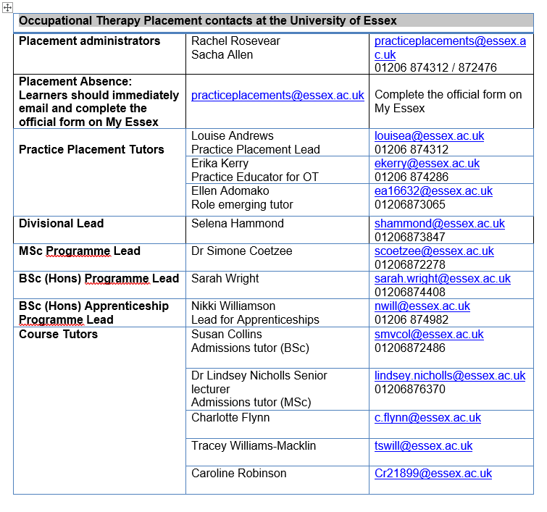

Supporting learners on placement

Ring 01206 874312

Notify MyEssex and placement admin team by email: [practiceplacements@essex.ac.uk](mailto:practiceplacements@essex.ac.uk) Follow procedures for absence in handbook

If you have a concern: follow guidance provided in the handbook. Discuss with your educator and our Practice Placement team

Urgent placement issues

Access to university support

Administrative queries can be dealt with by the Placement Admin Team [practiceplacements@essex.ac.uk](mailto:practiceplacements@essex.ac.uk)

Questions about placement

Via email and phone: you can access campus-based learner support and your personal tutor

Prolonged absence: discuss with Practice Placement Lead and placement educators. See procedures for absence in handbook

Absences

Role of the Practice Placement Lead

The Practice Placement Lead is responsible for liaising with practice placement co-ordinators and/or other identified personnel in service settings to source appropriate placement opportunities for learners to access. It is the Practice Placement Lead and Practice Educator’s role to ensure that the learners are ready for placement in that they receive the required information, paperwork, and preparation prior to the commencement of the placement.

The Practice Placement Lead and Practice Educator will plan and deliver practice educator courses and identify practice educator continuing professional development support as required. Monitoring of practice placement provision commensurate with professional and statutory body quality assurance standards will occur through placement evaluative processes and the Practice Placement team will take action as required.

Placement evaluation

After each placement both learners and educators are emailed a link from the PEMS placement system to complete an online placement evaluation. We ask that learners and educators complete these honestly, but professionally and constructively to allow our placements to continue to improve.

Practice educators can login to PEMS to view learner evaluations. Within NHS placement settings the Education Liaison Managers will be reminded that feedback is available two weeks after every placement. Both learner and educator feedback is reviewed by the Practice Placement Lead to continue to monitor placement experiences.

If you have a specific and urgent matter relating to a placement currently in progress

Please contact the Practice Placement Team. Tel: 01206 874312 Email: [practiceplacements@essex.ac.uk](mailto:practiceplacements@essex.ac.uk)

Placement monitoring is a regular item on the Occupational Therapy Programme Committee meeting agenda and placement quality and issues are regularly discussed.

Role of the Visiting Tutor on placement (See also Appendix 10)

A halfway visit will take place at least once during the programme. This tutorial will take place with one of the academic tutors to discuss the learners’ progress. However, educators and learners can contact the Practice Placement Lead, or the visiting tutor anytime should they need support, advice, or guidance. The halfway visit is an opportunity for the learner and placement educator to review the placement experience, seek support, ask questions, and gain further advice and feedback as appropriate. It is an opportunity to review the learner’s assessment progress and identify recommendations for further development.

Only one visit is required during the programme, however, if there are areas of concern identified, a visit or subsequent visits can be arranged after consultation with the Practice Placement Lead or practice educator. Where a visit is deemed to be required the learner or educator can contact the Practice Placement Lead to request a visit. See appendix 10 for an overview of the tutorial process.

Should educator or learner have concerns earlier in the placement then these should be communicated for advice or action to the Practice Placement Lead or tutor.

During the placement the visiting tutor will discuss the following areas and record their observations on the appropriate halfway tutorial monitoring form (See Appendix 11). The visiting tutor will evaluate the experience at this stage to ensure that the learner's learning needs are being met and that placement quality standards are maintained.

* Discuss the learning experience with the learner and educator/s individually, followed by a joint discussion if required
* Monitor learning performance by reviewing the learning experience, the learning contract, the assessment process, and supervision notes
* Support the educator through reviewing the learner’s learning experience, acting as a second marker if required
* Discuss pastoral issues which may have a bearing on the success of the placement
* Raise any significant issues regarding the placement experience with the practice educator and learner

Placement Educator Continuing Professional Development support

All educators are invited to attend an educator training course prior to taking a learner on placement. These courses are designed to inform the educators about the occupational therapy courses at the university (content and philosophy), consider the aims and learning outcomes for the placement, discuss assessment and documentation procedures, supervision requirements and provide an opportunity to network with other organisations. The university also offers update courses for experienced educators. Educator training can be personalised to meet the needs of the attendees and can be carried out at the university or in-house.

It is expected that by attending an educator course new placement educator will have the requisite skills and knowledge to effectively support and supervise the learner placement experience commensurate with placement education standards. In addition to these courses, educators can access the schools online update for mentors and practice educators via Moodle X: <http://moodlex.essex.ac.uk/>. Educators can enrol online and complete relevant mandatory aspects for all and those specific for AHPs. There are additional optional choices: Learners with additional needs, supervising underperforming learners, NHS constitution and Service improvement, followed by a short test of all mandatory aspects and one of the above choices. This can be completed prior to attending an educator course and in preparation for offering practice placement opportunities.

Placement Resources

There are a wide range of resources available which can be used to develop learners understanding and experience in the practice setting. These are employed most constructively when the placement educator uses them as a means to fulfil the learning objectives identified for the placement and the requirements of the programme curriculum. The placement educator needs to consider what the learner should gain from each experience they have whilst on a placement. Some resources are common to all practice areas, whilst others are less widely available.

* Service users are the most valuable component of practice-based education. Working with service users gives learners the opportunity to apply knowledge and skills they have learned at University and observe the outcomes of their interactions and interventions in the real world
* The opportunity to discuss, observe and work with a variety of other practice-based staff including those from other professions is very useful. These experiences emphasise the importance of the holistic approach to patient management allowing the learner to experience involvement with the multi-disciplinary team and give different perspectives on patients and their needs. Interaction with the other practice-based staff also helps the learner begin to understand the organisation and management structures of the area.
* Related activities e.g., opportunity to attend ward rounds and case conferences help the learner to understand the role of other professionals, the function of the multi-disciplinary team and the place of occupational therapy in overall patient management.
* Practice-based learning experiences tend to stimulate the learner’s interest and desire to find out more about a subject. Hence, it is helpful if learners have access to books, journals, and other on-site facilities such as department protocols and treatment approaches all of which are useful in providing the learner with information about expected rates of progression for patients with specific conditions.
* The placement educator is an important learning resource for the learner. One of their major functions is to help the learner make sense of their placement by facilitating the planning and organising of their workload and service user experiences. The establishment and agreement of individualised placement learning goals helps to achieve this.

Practice Placement stages – what happens and when

The process of obtaining, allocating, supporting, and monitoring of placement provision is the responsibility of the Practice Placement Lead and practice educator supported by the placement team. See appendix 1 - Allocation process.

Placement Scheduling Times

We aim to allocate and notify placement providers of learner names 8 weeks prior to the placement start date. Learners can expect to be notified of their placement location approximately 6 weeks before. However, due to the nature of sourcing placements these times may differ on occasion.

Pre-placement

* A Practice Placement offer form is sent annually to all occupational therapy practice placement education co-ordinators and other individual placement providers followed by reminders throughout the year
* Placements are allocated to learners following consultation and taking account of individual learner placement needs whenever feasible
* Learners do not have the right to contest their placement allocation on the grounds of, for example travel, time, or financial resources.
* Learner’s long standing health issues identified by occupational health will be accommodated wherever possible under the Equality Act 2010
* Placement allocations are allocated by the placement team and discussed and agreed with programme leads. If necessary, the allocations may be discussed with personal tutors. See appendix 1 - Allocation process.
* The Practice Placement team confirms placement allocations with placement education co-ordinators or individual placement educators 6 – 8 weeks, or as soon as possible before placement commencement.
* Learners must evidence completion of requisite mandatory training before contact can be made with their placement provider
* Once a placement is formally allocated from the placement database, the following information is provided for the practice educator:
* Learner details
* Link to access placement assessment form
* Placement educator placement evaluation form

On being allocated their placement learners are expected to:

* Complete the Placement Advance information (Appendix 2) (where applicable) and SWAIN individual learning needs forms (Appendix 3) and send these to their placement educator with an introductory email devised by the learner
* Arrange a pre-placement visit (if possible)
* Identify specific placement requirements, for example NHS Trust inductions, additional DBS clearance or mandatory training
* Obtain the following placement documentation from the pre-registration occupational therapy placement Moodle page:
* Appropriate assessment document
* Supervision logs
* Moving and handling log (if applicable to the setting)
* Case Study consent form (if applicable)

Learner preparation for placement

Learners will receive pre-placement preparation workshops prior to the placement. These sessions offer an opportunity for the learners to familiarise themselves with the aims and learning outcomes of the placement. Learners will also be invited to a debrief workshop following on from the placement, where appropriate.

Learner Pre-placement preparation

During induction to the programme and within the first modules learners will be introduced to the following:

Mandatory training

* Basic Life Support – CPR/choking (Online and practical)
* Moving & Handling (Online, theory and practical)
* De-escalation and breakaway (PMVA 1) Practical – completed once during the programme)
* Infection prevention and control (Online)
* Safeguarding Vulnerable Adults, including PREVENT [CHANNEL] (online)
* Safeguarding Children
* Information governance & Records(online)
* Disability awareness (online)
* Risk assessment (online)
* Equality, diversity & human rights (online)
* Health, Safety & Welfare (online)
* Fire safety (online)
* NHS values (online)
* Food hygiene (online)

During the module preceding each practice placement learners receive:

* Review of paperwork required
* Discussion of any issues relevant to the level of placement
* Discussion concerning written work and presentation of evidence of learning
* Mandatory Training is updated regularly and rigorously monitored to ensure that learners are deemed fit to practice

Learner support during placement

See page 40 for an overview of general support and Appendix 10 for an overview of the halfway tutorial process.

Post placement processes

* Placement assessment forms are ratified by the Practice Placement team and marks and hours entered on the assessment data base
* Placement educators and learners complete an evaluation of the placement experience via PEMS
* Learner and placement educator feedback forms are reviewed by the placement team for course evaluation quality monitoring and feedback for learners and placement educators
* Placement educators can access feedback directly via PEMS
* Learners undertake a development review with their personal tutor and/or the Practice Placement Lead/practice educator and complete the next placement information form

General and practical issues in practice-based education

Placement Hours

The requirement of the World Federation of Occupational Therapists is that each learner should complete a minimum of 1000 hours in practice to achieve professional status. On BSc (F/T) and MSc Pre reg programmes, learners are required to complete 28 weeks of full-time practice learning, of which all will be assessed.

|  |  |  |
| --- | --- | --- |
| Placement | 37.5 hour/weeks | hours |
| Placement 1: Explore | 4 | 150 |
| Placement 2: Initiate | 6 | 225 |
| Placement 3: Lead | 8 | 300 |
| Placement 4: Manage | 10 | 375 |
| Total |  | 1050 |

The placement educator is required to verify the placement hours worked by signing the learner hours log in the Practice Placement Education Assessment form.

Hours of working, weekends, and Public Holidays

Learners are expected to conform to the conventional working hours of the service setting they are placed in. However, where extended practice hours are negotiated e.g., to take advantage of specific learning opportunities such as late clinics, treatment groups or out of hours visits, these hours must be balanced with taking appropriate time in lieu or study time. Extended hours must not be used to prolong a placement assessment period. A learner may be expected to travel up to 1.5 hours each way to attend placement.

Several NHS trusts operate a seven-day working system and learners may therefore be requested to work on Saturday or Sunday instead of a weekday. Placement providers are asked to alert the university ahead of time if this is a placement requirement so that a learner’s other commitments are taken into consideration when allocating placements. If a learner is required to work outside of normal working hours and this is problematic, they should contact the Practice Placement team to discuss the issue.

The BSc (Hons) full-time and MSc programmes have been carefully scheduled, to make it less likely a public holiday falls within placements. For this reason, no placements are scheduled over Christmas/New Year and in most years, Bank holidays aim to be avoided. However, many services continue to be delivered over public holidays, so learners may be requested to cover these days if they fall within a placement. As with weekend working, advance notice should be given so this can be discussed and planned as appropriate.

Placement study time

A requirement of the programme is that each learner is allocated a half day of study per week or one full day every two weeks whilst on practice placement. This should be taken at a time agreed with the placement educator. Study time is to be included in the overall placement hours.

Attendance

Precise hours of attendance will be agreed between the learner and the placement educator, based on the expectation that the learner will work 37.5 hours a week, including study time (as above). A practice hours log is kept by each learner so that the total practice hours worked can be carefully monitored. The number of hours worked, and any absences must be verified by the placement educator on the practice assessment form. Should a learner miss a substantial amount of time within a placement, they will be required to undertake further practice education. If a learner is absent from any specific placement for more than 37.5 hours this may result in the placement being terminated and the learner re-taking the placement later. Lunch breaks must not be included in the practice hours.

Sickness or absence from placement

Time away from the placement will naturally impact on the optimal performance time required to meet placement learning outcomes. Hence, the learner must promptly notify the University of any absence from the placement. Absence reporting is monitored centrally. The official absence form can be found on the learner’s My Essex account under the education tab and must be completed for all absences. The absence will not be authorised unless the official absence form is used.

**Procedure in case of absence from placement**

Learners must not be absent from placement for any reason without having obtained authority for their absence in advance from Louise Andrews, the University of Essex OT Practice Placement Lead. Learners will only be authorized to take time off from placement in exceptional circumstances and with the official absence form completed. The only exception to this is illness.

If a learner is going to be absent from their placement due to ill health or an emergency, they **are expected to**:

* Telephone the practice area before the start of the working day and leave a message for their placement educator.
* Complete the official absence form on their My Essex account
* Email the Practice Placement Admin team [practiceplacements@essex.ac.uk](mailto:practiceplacements@essex.ac.uk)

As soon as possible in the working day the learner should speak to their placement educator to explain their absence and to suggest when they are likely to return to work.

All absences must be recorded on the Practice Placement Absence Record form in the Practice Placement Education Assessment form and signed by the placement educator. A GP medical certificate is required for absences of one week or more. GP medical certificates and self-certification sickness certificates must be promptly sent to the practice placement administrator and will be entered on the learner record. To obtain a self-certification form please email [ipl-admin@essex.ac.uk](mailto:ipl-admin@essex.ac.uk) .

The student handbook should be referred to for all other absence issues.

Car insurance information

If it is necessary for a learner to use their car for official business purposes, other than getting to and from their placement i.e., on a community placement or carrying out visits to other organisations during their working day. Learners must check that their insurance policy covers “official business purposes” and not just “social, domestic or pleasure purposes”.

Placement travel and accommodation expenses

The Learning Support Fund (LSF) was introduced to assist eligible healthcare learners starting their courses on or after 1 August 2017 and is intended to provide supplementary funding for eligible pre-registration healthcare learners who are in receipt of support through the Student Loans Company. One aspect of this fund applies to placement Travel and Dual Accommodation Expenses (TDAE). Help with travel and temporary accommodation costs for learners attending practice placements are available for eligible learners in respect of travel in excess of their ‘normal’ commute to University.

For eligibility criteria and guidance please access the relevant page on the NHS Business Services Authority website via the following link:

[www.nhsbsa.nhs.uk/learning-support-fund](http://www.nhsbsa.nhs.uk/learning-support-fund)

A claim form must be completed by the learner for each placement then signed and stamped by a placement administrator; before being sent to the NHS Bursary Unit for processing. It is the learner’s responsibility to photocopy the claim form for their records and to send the original to the bursary unit. A placement administrator is unable to sign and stamp the form without a personal coversheet attached. This cover must be printed by the learner from their LSF account. The claim forms can be accessed and printed off the same way.

Learners should ensure that all tickets/receipts for public transport, parking and accommodation are kept as evidence in the event of a claim being made. These should be presented to the placement office, but not included with your claim form when you send it to the bursary unit. However, it is advised that you do keep any evidence until your claim has been processed.

Information sheets with full details of how to claim are available from the placement administration office.

Accommodation

Accommodation may be available close to a placement and may be arranged through the placement provider or by the learner as appropriate. learners are entitled to claim reasonable accommodation costs whilst on placement if they are eligible for the TDAE part of the learning support fund (as explained above).

Professional Indemnity on placement

All pre-registration learners from the University of Essex are required to register as learner members of the Royal College of Occupational Therapists (RCOT), which provides them with the benefit of additional professional liability insurance cover for practice placement education. OT learners must be under supervision of a registered Occupational Therapist for the insurance to be valid. This does not necessarily mean they have to be in eyeshot of each other. Band 5 occupational therapists and unqualified staff can also provide a valuable role in learner education.

Practice Education contexts are advised to explore their policies and procedures regarding insurance whilst offering learner placements.

Health and Safety on placement

The learner must be inducted into the placement provider organisation or department and must be acquainted with policy and procedures governing safe practice. The learner must always observe these. Learners are required to be always aware of their own personal safety and adhere to service protocols. Infection control procedures within practice settings must be observed. Learner are required to complete the health and safety induction situated in the Practice Assessment Document.

Lone Working

The responsibility for the learner always remains with their placement educator when undertaking lone or community working. The placement educator must satisfy themselves that the learner has the necessary skills and knowledge to carry out the intervention safely and that it is within their scope of practice to do so at the individual learner’s stage of professional development.

Learners must observe the Professional Standards for Occupational Therapy Practice, always Conduct and Ethics (RCOT 2021) and refer to the placement organisation’s policy and procedure specifically regarding risk assessment and safe management strategies for lone working situations.

Learners must understand and adhere to the placement services designated safe, practical, and logistical processes for lone working e.g., sign-out and sign-in, travel, expected time scales, risk assessment, contact arrangements, emergency procedures and practice feedback mechanisms. Learners have the right to refuse to undertake lone working if they feel it is outside their scope of practice or where it poses risk to their health and safety, or the health and safety of the people they are working with.

Dress code

On placement learners are expected to look neat, clean, and professional always. Learners must be advised of uniform or non-uniform dress code prior to commencing placement and will be expected to always adhere to it. Learners must wear suitable footwear, long hair must be tied back, and jewellery kept to a minimum, only small ear studs and wedding/civil partnership rings are acceptable. Watches should be removed when handling patients. Learners should not wear their uniform in public unless undertaking practice learning activities.

Learners are issued with a University of Essex identity badge which should be always clearly visible unless this poses a risk to them or the patient.

If learners feel they require more uniform they can purchase more but the University of Essex will not fund it. There is an online ordering portal set up where learners can purchase additional uniform for their placement. The uniforms are listed by course and can be selected and paid for online. Please contact [frhynas@essex.ac.uk](mailto:frhynas@essex.ac.uk) for further information relating to uniform/ID badges.

If learners are unsure which size to order, The School of Health and Social Care has a complete range of sample sizes which learners can try on for size as items ordered are non-refundable unless there is a fault with them. To try the uniforms for size please contact Fiona at [frhynas@essex.ac.uk](mailto:frhynas@essex.ac.uk)

Personal mobile phones are only to be used for professional purposes within working hours and used according to Trust or organisation operational policy.

Moving and Handling

Learners will cover the broad principles of moving and handling during their programme induction period and receive timely theoretical and practical updates (using each other as models). The moving and handling programme has been developed with a focus upon risk assessment, for learners to acquire and advance their problem-solving skills to identify appropriate outcomes for situations presented in a diverse range of contexts.

Learners will identify their individual moving and handling learning needs and keep a log of moving and handling experiences (signed by their placement educators) as part of their portfolio (appendix 9). Learners should seek requisite support from the placement educator to ensure that placement moving, and handling techniques are managed safely and within their remit.

Code of Ethics and Professional Conduct – Confidentiality & Consent

Learners are required to be conversant with and adhere to the Professional Standards for Occupational Therapy Practice, Conduct and Ethics (RCOT 2021). Learners are required to be particularly aware of the need to safeguard confidential information. Learners must follow University guidelines for maintaining confidentiality and gaining signed consent when conducting a case study (Appendix 4) and in obtaining any information for portfolios to comply with the Health and Care Professions Council (HCPC) Standards of Conduct, Performance and Ethics (2016) and the Data Protection Act (2018).

So far as is possible, permission should be sought from service users and consent to be treated by a learner occupational therapist documented (HCPC 2016). Please note; it is recognised that it is not always possible to ascertain or accommodate a service users’ wishes for mental capacity or legal reasons. In such circumstances learners and placement educators must always act in the service users’ best interests and abide by legal and local requirements (RCOT 2021).

Disclosure and Barring Service (DBS)

It is the requirement of all learners applying to study on non-medical health professional programmes to obtain an enhanced disclosure of convictions. This is in accordance with the Safeguarding Vulnerable Groups Act, 2006 (*see UoE Safeguarding Policy, page Resource folder) The decision to accept learners on to a course of study lies solely with the University of* Essex, and placement providers can be assured that each learner has an enhanced Disclosure & Barring Service (DBS) check prior to commencement of their first placement. Learners are made aware of the need to disclose any convictions acquired after acceptance on to the course, and any learner who chooses not to inform the University of Essex, and is subsequently discovered, will be dealt with under the regulations for professional suitability.

Working with a family member or significant other

To avoid potential conflict of interest, learners are asked to inform their placement educator and the Practice Placement Lead if it is found they would be working with a family member or significant other who may either be a patient or who could be involved in the learner’s placement assessment.

Equality Act 2010

The Equality Act applies to universities and placement providers. The University of Essex recognises its responsibilities under the legislation and is committed to working in the best interests of people with a disability and therefore aims to generate a more ‘enabling’ environment and non-discriminatory culture, for the benefit of all University learners, staff, and visitors. Learners are encouraged to disclose to the University of Essex Disability Team in Learner Support. This team have responsibility for assessing evidence and notifying those people who need to know once the confidentiality contract has been signed.

All Staff have a responsibility to ensure that they do not:

* treat a disabled person less favourably than someone else for a reason relating to the person’s disability
* indirectly discriminate against a learner with a disability by failing to make a ‘reasonable adjustment’ when a disabled learner is placed, or is likely to be placed, at a ‘substantial disadvantage’ in comparison with a person who is not disabled

The legislation identifies that placement educators act as facilitators for University of Essex learners and hence learners are encouraged to discuss any disabilities and strategies with them. The learning contract section of the practice placement assessment form is used to ensure that learners have an opportunity to disclose specific needs which may impact on the learning experience and discuss these with their practice educator. During induction practice educators must ask all learners whether they want to disclose a disability or specific learning need. The learning contract statement: I have disclosed a disability or specific learning need to my educator Yes/No must be completed, dated, and signed by the educator. This is reflected as part of the SWAIN in the Practice Placement Education Assessment form.

**Faculty of Science and Health Reasonable Adjustments Procedure**

Who is this document for?

This document is for learners who are considering disclosing a disability and/or health condition that may affect their day-to-day activities. It is also for educators and staff members within the faculty who may support a learner with a disability. This document should be read in conjunction with the *Reasonable Adjustments Procedure* Flowcharts.

Disclosing a disability and/or health condition

*Learner responsibilities*

Disclosure of a disability and/or health condition is not mandatory but is highly recommended. Disclosure enables the university and practice placement providers to make reasonable adjustments, in line with the Equality Act (2010), to ensure that learners are not disadvantaged in accessing learning and assessment. Disclosure is possible at the point of application (for example, through the UCAS or Post-graduate application) or at any time during the programme of study. If disclosing during the programme of study, it is recommended that the learner seeks support through the learner well-being and inclusivity service (SWIS), Occupational health or the departmental disability liaison officer (DDLO).

If a learner with a disability or health condition chooses not to disclose, the department will not be able to identify and implement adjustments to meet the learner’s needs. We therefore encourage disclosure to ensure learners are not disadvantaged in their academic and practice learning experience.

*Faculty staff responsibilities*

The university and our practice placement partners are obliged to make adjustments that are considered reasonable in line with the protected characteristics of the Equality Act (2010).

If a learner discloses to a member of staff within the faculty it is recommended that they advise the learner to seek support from their personal tutor and to recommend for the learner to visit either the SWIS and/or OH teams. They should document this disclosure on the learner’s Learner Engagement Activity Portal (LEAP) file for future reference.

*Practice staff responsibilities*

If a learner discloses a disability and/or health condition to staff within the practice learning environment, they are advised to suggest to the learner to liaise with the personal tutor who will provide them with further guidance.

Assessment of needs

The learner is required to work closely with the named advisor in SWIS and attend any meetings scheduled.

The named advisor will work closely with the learner, occupational health and during the assessment process. Learners will be asked to sign confidentiality and consent form. This identifies who can be informed about the learner’s need for a reasonable adjustment.

The named advisor will communicate recommendations for reasonable adjustments to the DDLO of the learner’s host department.

Learner support notifications

The recommendations provide an overview of a learner’s needs and recommends reasonable adjustments which might be appropriate. The DDLO will work with a nominated person within the learner’s subject area (e.g., programme lead, placements link lecturer, personal tutor) to determine how reasonable adjustments can be made in line with the professional and regulatory standards of the learner’s programme.

Several factors will influence meeting the recommendations made for reasonable adjustment. When deciding how and when to make reasonable adjustments for the learner with a disability, the principles of safety and protection of service users, families and carers must override all other considerations. Reasonable adjustments may be made to the ways a learner meets a competency or standard, however, the standard itself cannot be adjusted. This is to guarantee the required professional standards of are met.

What happens next?

*Academic setting*

The DDLO will review the notification and liaise with the relevant academic staff. They will meet with the learner and relevant academic staff as required to develop a plan of the reasonable adjustments that could be provided through their academic course or programme.

*Practice placement*

The DDLO will review the notification and liaise with the relevant academic staff. The department will appoint a member of academic staff (e.g., link lecturer, practice educator) from within the learner’s subject area to liaise with the relevant supervisor or educator within the practice setting prior to each placement. This liaison will establish that reasonable adjustments can be made for the learner to practise safely and ensure equitable access to learning and assessment opportunities.

Determining the ‘reasonableness’ a reasonable adjustment

The university and its practice placement partners are committed to ensuring reasonable adjustment are made that allow learners to access learning and assessment. There may be some cases where adjustments are not considered ‘reasonable’, some circumstances are listed below but this is not an exhaustive list:

* Where the adjustment would prevent the learner from achieving the required professional standards associated with their programme, as determined by the relevant regulatory body (e.g., HCPC, NMC);
* Where the adjustment is very high cost or would cause significant disruption;
* Where the adjustment would not enhance access to learning and assessment opportunities

Where requests for adjustments are declined, full justification will be provided and recorded by the DDLO.

Concerns about the Reasonable Adjustments Procedure

If you have concerns about the Reasonable Adjustments Procedure or the ways in which your support needs have been considered, please raise these with the Departmental Disability Liaison Officer (DDLO) for Health and Social Care in the first instance, or Learner (learner) Support Services at your campus. Contact details are below:

DDLO: Natalie Cowan

Email: [njcowa@essex.ac.uk](mailto:njcowa@essex.ac.uk)

Tel: +44 (0)1702 328360 – Southend Campus

Tel: +44 (0)1206 876558 – Colchester Campus

Mobile +44 (0)7826 993806

Student (learner) Services Hub website: <https://www.essex.ac.uk/student/advice-and-support> [accessed 07/08/21]

Colchester campus student support services:

<https://www.essex.ac.uk/student/advice-and-support/ssh-colchester> [accessed 07/08/21]

+44 (0)1206 874000

Southend campus student support services:

<https://www.essex.ac.uk/student/advice-and-support/ssh-southend> [accessed 07/08/21]

+44 (0)1702 328444

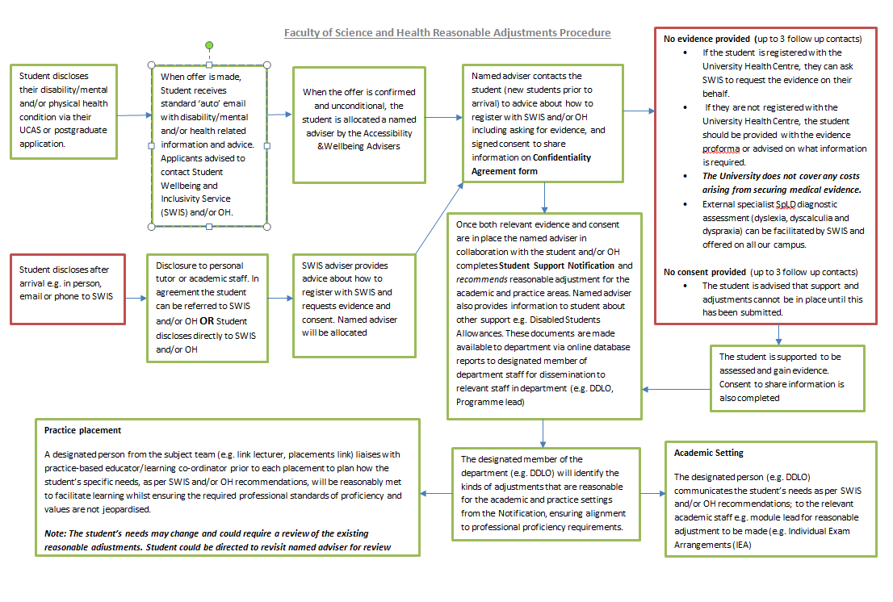

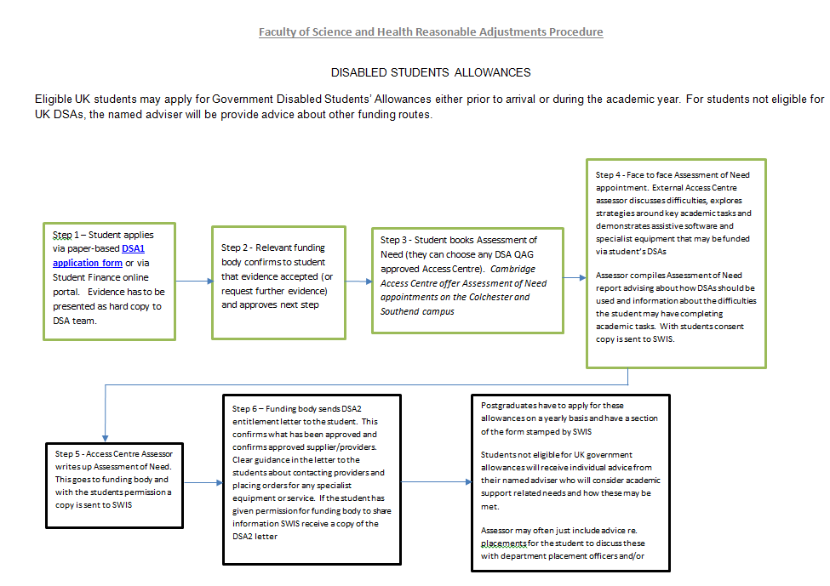

Alternative placement arrangements

Alterations may be made to placement working arrangements to meet the needs of learners with diagnosed health needs e.g., shorter hours over a longer placement period.

The Practice Placement Lead will negotiate the placement arrangements with the placement educator and the learner.

Statement on deferred placements

The programme leads meet with the Practice Placement team prior to each placement for placement allocation and once the placement co-ordinator has allocated a learner to a placement that the programme leads have deemed to be suitable the decision is final. Placements cannot be deferred except in very exceptional and unavoidable circumstances, such as illness or injury. In such circumstances, the learner must discuss the issue with the Practice Placement Lead and the relevant programme lead. Please note that, in such circumstances an assessment from the University's Occupational Health Department may be required prior to any deferral being approved.

Learners must pass all practice-based learning placements and will be required to retake any failed placement. If a learner fails a placement on re-assessment or fails 2 placements at first attempt they will be required to withdraw from the programme.

If a learner fails a placement, they will be required to undertake and pass a full repeat placement in the same clinical speciality for a pass grade (as all placements are pass/fail). The repeat placement will be undertaken at the earliest opportunity and must be completed before the learner is eligible to progress to the next level of study.

Learners’ placement responsibilities:

* To broadly prepare for the placement - obtain information relating to the practice area
* To complete the advance information/SWAIN form and send to the placement educator in a timely manner
* To arrange and undertake a pre-placement visit where possible
* To confirm details of the placement with the placement educator and ask any relevant questions
* To consider personal learning needs for the stage of training and use every opportunity on placement to develop these
* To develop a learning contract and outcomes in collaboration with the educator
* To develop knowledge and skills gained in both the academic and placement settings
* To underpin practice with an appropriate theoretical evidence base
* To constructively use formal & informal supervision processes, engage in self-assessment and actively prepare for & participate in these processes
* To further professional skills with a range of needs, working at a level appropriate for the stage of training reached
* To contribute towards discussion and intervention as part of an inter-professional team
* To observe the College of Occupational Therapists Code of Ethics and Professional Conduct (2017) in all aspects of practice
* As future registrants of the Health and Care Professions Council, learners should be aware of and comply with the Standards of Conduct, Performance and Ethics (HCPC 2016).
* To use reflective practice as a tool for further development
* To inform the placement educator and the University of any change in personal circumstances which may affect the ability to complete the placement
* To follow the University procedures
* To complete relevant paperwork by the required date
* To always behave in a professional manner
* To record practice experiential learning in a professional development portfolio
* To contact the Practice Placement team immediately should difficulties arise

Placement educator responsibilities:

* To prepare for the learner, providing information relevant to the practice area
* To plan and source suitable inter-professional and multidisciplinary learning opportunities with the learner, considering the level of training, their individual learning needs, and prior experience
* To provide support and supervision to the learner as appropriate
* To facilitate regular learner supervision using the learning contract, supervision log and assessment criteria to guide the process
* To assess the learner’s performance throughout the placement and give regular feedback through formal and informal discussion and assessment recording
* To inform the University as soon as possible of any concerns regarding the learner’s performance and to formally document these as an issue of concern
* To evaluate the placement via the educator placement evaluation form
* To update and develop placement educator skills through CPD opportunities
* To meet practice placement education standards

Work-based learning mentor roles and responsibilities (apprenticeship)

* To undertake relevant training provided by the university to ensure they are aware of appropriate policies and procedures relating to apprenticeships
* To be familiar with course, placement or apprenticeship handbooks and associated review paperwork
* To be familiar with the apprenticeship standards and the associated knowledge, skills, and behaviours which the apprentice will need to demonstrate
* To have a sound knowledge and understanding of what the apprentice is learning during their academic studies and help the apprentice to use this to inform their own practice
* To be prepared for and participate in the quarterly tripartite reviews and ensuring any actions highlighted are actioned
* To develop a transparent, honest, and open relationship with the apprentice to facilitate a safe learning environment in the workplace
* To facilitate the apprentice to undertake and record their work-based tasks/learning in their portfolio and to maintain their skills portfolio as a record of their learning, ready for the EPA
* To provide regular progress meetings and honest feedback to facilitate the professional development of the apprentice. Ensure that a bespoke work-based learning plan is in place identifying opportunities for the learner. The plan contributes to ensure that your journey as an apprentice is individualised (though not limited) to their specific workplace.
* To support the apprentice to increasingly use their initiative and to take increasing responsibility of their own learning and development as they progress through the programme
* To facilitate the apprentice to undertake and record their work-based tasks/learning in their portfolio in an appropriate way and to maintain this portfolio as a record of their learning across the apprenticeship, ready for the EPA and final module viva voce.
* To support the apprentice to ensure their workload is at an appropriate level, so they can balance the demands of work and study and maintain a positive level of wellbeing
* To ensure there are clear, timely communications with the university about the apprentice and their development
* To promote a positive perception of apprenticeships as a route into occupational therapy
* Contribute to the decision as to whether the apprentice is ready to go through to End Point Assessment
* Endeavour to ensure any handover to a different work-based mentor is made in a way that involves the apprentice and provides continuity of support in conjunction with their service manager

Whistle-Blowing and Escalating Concerns for Learners

In situations where you are concerned about any aspects of care delivery you must adhere to guidance from the Royal College of Occupational Therapists – Professional standards of Occupational therapy practice, conduct and ethics (2021) and HCPC Standards of conduct, performance, and ethics (2016). Should you at any time have concerns regarding the standard of care in your placement and/or workplace, or if you observe poor practice, you must discuss this with your Educator or the service manager in the first instance. You must also inform the University of these concerns; the most effective way of doing this is to contact your visiting tutor or the placement team. They will listen to your concerns and may involve other members of the team to establish further information. If appropriate the decision may be taken to remove you from the placement. The Programme Lead or divisional lead for occupational therapy will take the concerns forward with the relevant authorities. It is mandatory for all staff to undertake Safeguarding training, learners complete mandatory training requirements for Safeguarding adults and children. Further information about the University’s safeguarding policies can be found via the University’s webpage [Safeguarding | Student Directory | University of Essex](https://www.essex.ac.uk/student/safeguarding) If you are concerned about the welfare of a learner or member of the university community (e.g. staff or learner) you can report a concern via the University’s website (see the following link for further information) [Reporting a concern about the welfare of a member of the University community | University of Essex](https://www.essex.ac.uk/student/safeguarding/reporting-a-concern-about-someone) [accessed 07/08/21]

Placement assessment process

Placement assessment processes serve two purposes; to provide the learner with ongoing feedback on their performance, and to formally assess the level of that performance against defined criteria for the learner’s stage of training.

The assessment and supervision process provides a framework to continually monitor the development of professional skills, knowledge and attitudes enabling the practice educator and the learner to engage in a continuing cycle of monitoring, review, feedback, and action planning. Regular performance feedback is expected to occur during formal and informal supervision times.

For the most up to date practice placement handbook and placement documentation please follow this link: <https://www.essex.ac.uk/departments/health-and-social-care/placements> [accessed 07/08/21]

Assessment requirements

The placement assessment form provides guidance for pass/fail criteria. The assessment aims and learning outcomes take account of increasing levels of responsibility and involvement as learners’ progress through placements.

Important: The assessment form must be used in conjunction with the placement guidance denoted at the beginning of each assessment document. Additional assessment guidance and information are also included with each assessment form to help with assessing performance.

Halfway assessment

A formative halfway assessment of professional practice will occur halfway through the placement. The halfway assessment is to only be used at this point to indicate the learners’ level of achievement with supporting comments. If a learner is not achieving an area of professional practice it should be clearly stated what needs to be done either by the learner and/or educator to pass the area by the end of placement.

Formal final assessment

A formal final (summative) assessment meeting is held at the end of the placement.

The practice educator is required to complete both part one – professional conduct and part two- professional practice – final assessment form indicating the level of achievement with clear supporting comments with areas for future learning and development.

Each of the five sections of the placement assessment form must be awarded a pass or fail. All performance criteria must be met, and the learner must obtain a Pass in each of the five sections to satisfactorily complete placement practice components. It is a requirement that specific examples of the learner’s performance must be given in the comments box for every section to support the mark awarded and to comment on where and how they can develop their future practice.

MSc and BSc (Hons) Assessment

The assessment of the learner’s performance is divided into two parts. Part 1 is concerned with professional conduct and Part 2 is concerned with five areas of professional practice:

Part 1 Professional Conduct

This part of the assessment includes learning outcomes for safe practice, non-discriminatory practice, and professional behaviour. The learner’s performance must be satisfactory in all three learning outcomes to pass the placement. Failure of any of these three outcomes at any stage of the placement will override part 2 and cause the learner to fail the placement. In a situation where there is concern relating to safety or professional behaviour a written warning must be completed and must be signed by both learner and practice educator. A written warning does not constitute failure. Educators: please ensure you place a tick in the relevant box, sign, and date to indicate pass or fail for each outcome in Part 1.

Part 2: Professional Practice

This part of the assessment contains 5 areas of professional practice, each of which must reflect a negotiated learning objective (indicated in the learning contract) to be passed by the end of the placement. Learners must reach a satisfactory pass grade in all practice areas, indicating the learner has good potential. A failure in one or more sections will result in overall failure of the placement. At the halfway stage these areas indicate the level of achievement.

Assessment of this placement is based on evidence of achievement of negotiated learning outcomes via:

* A half-way formative assessment

* Final assessment at the end of the placement (100% weighting)

After discussion between the practice educator and the learner, the practice educator will make the final overall pass/fail marking for all placements using the guidance provided in thePractice Placement Education Assessment form.

**Retaking a failed placement**

If a learner fails their first attempt at a placement, they will be expected to retake this in a similar setting. Learners will have to withdraw from the programme if they fail a placement at a second attempt.

Risk of failure

Guidance for placement-based educators, supervisors, and assessors

There is an expectation that learners will be continuously assessed when they work and learn in practice-based settings. Every time an educator works with a learner, the educator should be able to provide learning opportunities that allow the learner to fully participate in supervised practice. In this way, learners gain practical experiences that they can reflect upon and learn from. If learning opportunities are provided, learners should become proficient in applying knowledge, develop practical skills and professional behaviours, and become a functioning member of the team in the service that provides the placement.

These proficiencies are measured through the assessment criteria in the learner’s practice assessment document, aligned to the professional regulatory standards of the HCPC. This document is the record of a learner’s learning, development, and achievement of proficiency whilst on placement. Placements contribute to the learner’s curriculum and a learner’s practice assessment outcome directly impacts upon their ability to progress on their programme of study.

All involved (learners, placement providers and educators, university staff, and professional regulators) need to be assured that sufficient learning opportunities have been provided in placement and that continuous robust assessment of practice learning has been undertaken. It is likely that learners will be working towards or meeting the assessment criteria during their placement. It is imperative that, where there is a risk of failure of one or more of the agreed assessment criteria, actions are put in place to mitigate this risk.

Please follow the processes outlined in the flow charts below when supervising and assessing learners in placement:

Overview of practice-based learning and assessment

Risk of Failure process

If, at any point during continuous assessment, the educator identifies a risk of failure against one or more assessment criteria it is incumbent upon them to initiate the risk of failure process. Educators and learners can feel worried and anxious when the risk of failure process is initiated, sometimes under difficult circumstances. However, the process is not punitive. It is designed to ensure that appropriate actions are taken to provide support to everyone involved: the learner; the placement-based educators, supervisors and assessors involved; and the placement setting.

How will I know when to initiate the risk of failure process?

During continuous assessment the educator will need to make a robust judgement about whether the learner is achieving the expectations set in the assessment criteria, working towards these expectations, or at risk of failure of one or more assessment criteria. Examples of when you might initiate the risk of failure process are as follows:

* The learner has been working towards the standards set in the assessment criteria, given sufficient opportunity to learn and develop proficiency, but has made little or no progress in the quality of their performance;
* The learner has been provided with sources of verbal and written feedback whilst working towards an assessment criterion, but makes little attempt to act upon this feedback;
* The learner has been offered opportunities to reflect on their own performance, with respect to selected assessment criteria, to identify areas for development but demonstrates little or no insight into how they might enhance their own performance.

It is likely that through continuous assessment the educator will have identified the risk of failure well before the final week of placement. The earlier that the risk of failure is initiated the more likely it is that conditions can be cultivated, and actions agreed that can support the learner’s progress. It is theoretically possible for the risk of failure process to be initiated right up to the final day of placement. However, this is only likely to happen in rare, exceptional circumstances.

The process for initiating Risk of Failure is as follows (the related paperwork can be found in appendix 14 and 15):

The risk of failure process: a guide for educators, supervisors, and assessors

Fitness to Practice

In some cases, an educator may have significant concerns about a learner’s conduct, behaviour or performance that question their fitness to practice. Concerns about a learner’s fitness to practice refer to actions and omissions relating to professional conduct and professional suitability, including:

* actions that are harmful to service users, other members of the public or service providers;
* actions that are likely to constitute an unacceptable risk to the learner or others;
* contravention of the relevant professional code of conduct;
* concerns about health, disability, or wellbeing, including a failure to seek appropriate medical treatment or other support, which might impair fitness to practice;
* actions that are prejudicial to the development or standing of professional practice.

The full Fitness to Practice procedure is available via the following link [Fitness to Practise | University of Essex](https://www.essex.ac.uk/student/values/fitness-to-practise) i If you have a significant concern about a learner’s Fitness to Practice then please contact the programme placement lead, link lecturer/visiting tutor or programme tutor, who will be able to advise on the appropriate action for any given situation.

To initiate a Fitness to Practice referral, you will need to email vjoffe@essex.ac.uk (Dean of School)stating your specific concerns.

Failure of Practice Placement modules

* Each practice placement must be passed to progress through the academic levels to achieve final qualification
* A learner failing a placement must successfully resit their first attempt. The hours undertaken on a failed placement do not contribute to the minimum 1000 hours required.
* If a learner fails a practice-based learning component on substantiated grounds of fitness to practise concerns a retrieval attempt will not be permitted (RCOT 2019 Standard 6.4) See guidelines for removal from placement.
* A resit placement will normally be found which will provide similar learning opportunities in a comparable setting
* A second fail at any practice-based learning component will normally result in being withdrawn from the course and procedures are consistent with those for academic modules (RCOT 2019: Standard 6.4.3)
* Only one failed practice placement is permitted to be re-sat as a second attempt. Learners who fail more than one practice placements will normally be required to leave the programme.
* If learners double fail on the academic component of the course whilst out on placement then they will be removed from placement. A tutor will visit to withdraw the learner. This is in accordance with University policy and guidelines.
* If a learner withdraws from a placement without University approval it is deemed a failed placement.
* Refer to the Rules of Assessment which can be accessed via a link in the Programme Handbook.

Guidelines for Removal from Placement

The University recognises the need for termination of a placement where a learner’s behaviour seriously breaches codes of conduct or procedures operating in the practice setting or the professions. Evidence of professional unsuitability or misconduct and/or ill health must be clearly documented to support the placement educator’s decision to exclude the learner from the workplace. The educator will need to complete part 1 – professional conduct in the Practice Placement Education Assessment form. In extreme cases the placement educator has the right to send the learner off site immediately but must notify the Practice Placement Team without delay on 01206 874312.

The University will then implement, where necessary, the appropriate procedures governed by University Breach of Professional Conduct and Fitness to Practice regulations.

Assessment paperwork submission

If paperwork is incomplete this is likely to result in a delay in completion of the course. The remainder of placement documentation: supervision logs and other reflective logs/material are to be filed in the learner’s Continuing Professional Development (CPD) portfolio and be available for use in discussions and for external moderation purposes if required. Learner and educator placement evaluation forms must be completed on PEMS. All learners are expected to attend a debrief session at the end of each placement, if applicable.

It is the learners’ responsibility to ensure ALL elements of the assessment form are completed. The assessment form is to be submitted by the learner via FASer on the last day of placement and the placement educator is expected to email a copy of the same document to [hscplacements@essex.ac.uk](mailto:hscplacements@essex.ac.uk). It may be possible to negotiate with the programme lead and placement lead up to 1 week’s delay for submission. Learners should retain a copy as once submitted assessments will NOT be returned. Submission of incomplete or inaccurate booklets is likely to prevent completion of the related module and therefore potentially the course.

Negotiated learning contract

Learners and educators will negotiate a learning contract which will relate effectively to the overall learning outcomes for the placement. The Learning Contract reflects the self-directed nature of learning within the total programme, enabling learners to identify learning outcomes that are specific to their individual requirements. Hence, the Learning Contract is used to guide and individualise the learner’s learning experience and to provide a clear plan for their specific learning and experience throughout the placement.

The learner and practice educator work collaboratively to negotiate and complete the Learning Contract by the end of the first week. Once negotiated, the contract is flexible to allow for changes as new outcomes are developed or new resources identified. The learner becomes a more active participant in the learning process and takes responsibility for identifying their learning needs, evaluating their strengths and area for development.

Learning Contract Objectives

The learning outcomes can be identified within the module details in this handbook. The learner and educator should use the module learning outcomes and SWAIN to negotiate and agree learning objectives, recording them in the learning contract. There should be learning objectives for each of the five areas of practice, listed on the Assessment Summary within the assessment documentation. These learning objectives should be SMART (specific, measurable, achievable, realistic, timely) and cross referenced on the assessment form. To help you, suggested general statements for learning objectives are listed in the guidance section of the assessment documentation. The learner’s performance must be satisfactory in each of the practice areas relevant to the placement setting to pass the placement.

To develop learning objectives in conjunction with the practice educator, learners should ask themselves the following questions: -

* What do I want to learn or develop during this placement, which is at an appropriate level to meet the placement module outcome expectations?
* What are my needs and interests, baseline knowledge and understanding, previous experience and knowledge gaps?

A useful starting point for the basis of drawing up learning objectives is to think about them in three groupings:

* Knowledge - What do I need to know?
* Skill - What do I need to do?
* Attitude - How do I need to go about it?

It may also be beneficial to consider the following terminology in relation to the level of the placement:

|  |  |
| --- | --- |
| Placement levels | Terminology examples to support development of learning objectives for assessment for each area of practice |
| Level 4 | Observe, identify, demonstrate, describe, basic understanding, discuss |
| Level 5 | Discuss and critically evaluate, develop, and maintain, integrate, apply, summarise, build, and sustain professional relationships, analyse |
| Level 6 | Be able to assess and manage, synthesise, evaluate, and critically analyse, debate, determine appropriate actions, monitor, and review, critically evaluate own practice |

*Examples Based on Blooms Taxonomy (1994)*

A balanced learning contract will have objectives that reflect each of these components.

The Learning Contract should be reviewed regularly throughout the placement and used as a focus for reflection and feedback in supervision.

The following page outlines some examples for learning objectives for a level 5 learner placement:

[](http://www.essex.ac.uk/)School of Health & Human Sciences

Occupational Therapy Placement Learning Contract: Level 5 Examples

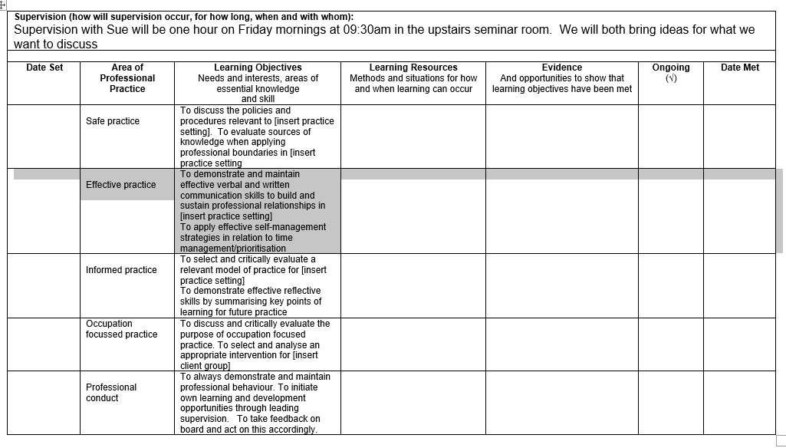

Supervision

The learners understanding and knowledge of professional practice will be explored and developed through supervision with their placement educator. Supervision processes provide an opportunity for education, support, feedback, action planning and reflection. Formal supervision should be provided for a minimum of 1 hour per week and should ideally be regularly timetabled and take place in a quiet environment, free from external distractions. This formal time will be supplemented with ongoing informal feedback and discussion as appropriate. Supervision should be confidential, safe, and supportive, to allow exploration of the learner’s strengths and areas for development.

The formal supervision session should be discussed during the first week, to establish how supervision will take place, for how long, when, where and with whom. This information is recorded on the Learning Contract. It is useful when setting up supervision, to discuss the learner’s previous experiences of supervision, clarify expectations and reach agreement on the use of the sessions.

In traditional and non-traditional settings, the learner will be supervised by the on-site Occupational Therapy educator

For role emerging placements: These placements require one member of the organisation acting as an ‘onsite’ supervisor for the learner, providing 1 hour of supervision per week. The person will take responsibility for the day-to-day management of the learner and on-site supervision.

An external registered occupational therapist or member of university staff will provide one hour per week of professional supervision and facilitate occupational therapy-specific learning. This supervision will be provided either by face-to-face contact, emails or telephone contact and they will be responsible for completing the assessment paperwork.

It is suggested that the learner, on-site and offsite educator agree the learning contact in the first week and meet at the halfway point and then at the end to complete the summative assessment.

The learner’s responsibilities as supervisee include:

* Preparing for supervision
* Reviewing the Learning Contract and current learning needs
* Reviewing practice and level of involvement in the practice setting
* Selecting issues from reflections completed to share and discuss
* Reviewing the previous week's supervision log and prepare an agenda
* Participating equally in discussion

The placement educator's responsibilities as a supervisor include:

* Preparing for supervision
* Guiding learning by facilitating the integration of theory and practice
* Promoting reflective dialogue and providing specific feedback on performance
* Monitoring assessment of competence and confidence and to plan assessment opportunities
* In the case of joint supervision, agreeing how sessions will be structured or shared
* Ensuring collaboration between joint supervisors

The Supervision Log and action plan

The Supervision Log (Appendix 5) should be completed by the learner & signed off by the placement educator after each supervision session. It aims to ensure that discussions have been clearly documented and provides evidence that weekly supervision has taken place. The log will enable the learner to review their learning experiences and to notate discussion and future weekly planning within each supervision session.

The weekly Action Plan (Appendix 6) points will be agreed, and practical objectives set with details of how these are to be met. These objectives and work undertaken towards meeting them should appear as part of the agenda for the following week’s supervision.

Guidelines for Role emerging placements

There may be the opportunity for learners on penultimate and final placements to experience working in a setting where there is not an established occupational therapy role. These ‘role emerging’ opportunities may occur in settings such as residential homes, hostels, homeless services, social farms, independent drug agencies, schools etc. Learners may undertake this type of placement individually or as a shared experience with a peer. Usually, individual learners are assigned to placements. However, it has been shown that learner pairs who undertake role emerging placements have positively benefited from the shared experience. Collaborative peer supported working, and enhanced ability to undertake the considerable demands of the role development work, features positively in learner and service feedback. Prior to placement allocation, care is taken to form a complementary learner pairing take account of individual skills and experience. However, services vary in capacity to accommodate learners to provide reasonable access to IT facilities and space within the staff teams and premises. Therefore, it may only be appropriate for an individual learner to attend.

This type of placement requires ‘a strong sense of professional identity’. Learners who feel able to cope with the challenges of this type of placement and are interested in undertaking one should discuss the possibilities with their programme lead and role emerging placement tutor in conjunction with the Practice Placement Lead.

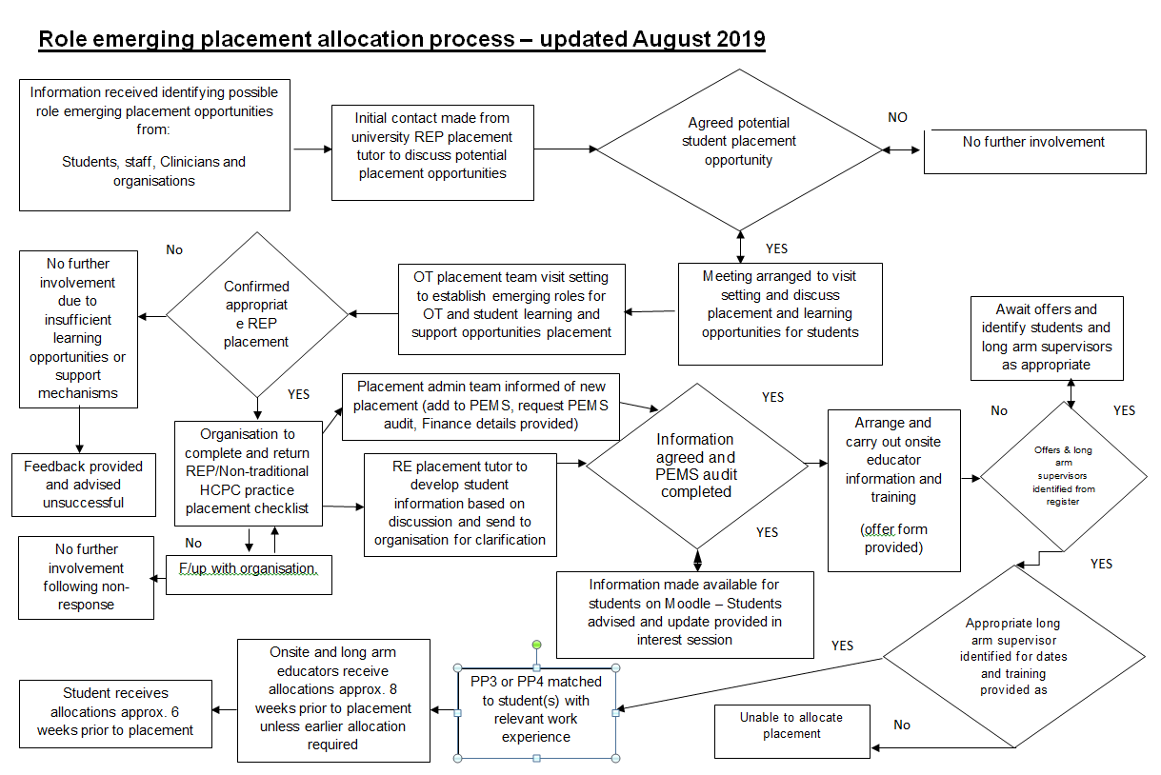

Benefits of role-emerging placements

* The learner has opportunity to learn and experience alternative perspectives to identifying and meeting service user need in other sectors of communities
* The learner can demonstrate practical skills and develop their professional reasoning, resourcefulness, and autonomy to a high level
* The placement provides potential for an occupational therapy role to emerge within a new service setting
* Collaboration between agencies is promoted through shared learner supervision
* Optimise potential for furthering collaborative service development work

Learner supervision for role-emerging placements

In common with learners from other health professions who undertake placements, occupational therapy learners require someone from the service to assume responsibility for supervision of their practice during working hours.

In settings where occupational therapists are not routinely or otherwise employed, a ‘long arm model’ of supervision can be undertake that requires an appropriately experienced member of staff at the placement setting provides informal managerial supervision for day-to-day working practice and to provide support for the learner. In addition, professional supervision of the learner and assessed components would be provided by a nominated ‘off site’ registered occupational therapist in practice or from the occupational therapy team at the university on a weekly basis.

There is an agreement that both the ‘on site’ supervisor and ‘off site’ occupational therapist work in close collaboration to monitor, assess and provide feedback about the learners’ progress throughout the placement.

A minimum of 1 hour protected formal supervision each week is provided at a time to be agreed between the OT ‘long arm supervisor and OT learner. The service ‘onsite’ supervisor will be required to meet with the supervising long arm registered OT and learner at agreed intervals throughout the placement, minimally this must be at least 3 times (weeks 1, midway and final week) to gauge the learner’s performance for assessment purposes. Supervision meetings may be arranged to take place on or off site or a mix of these to suit both the learner and supervisors needs as the placement progresses.

Promoting and accessing role emerging placement opportunities

The role emerging placement tutor is responsible for sourcing and setting up new placement opportunities in this diverse area of practice, working collaboratively with the placement team, organisations, and practice educators.

Learners have access to available placement information on Moodle to find out more about these diverse practice placements.

Please note: Learners will only be able to attend these placements if there are placement offers and appropriate support available.

If you have an interest in attending or supporting role emerging placements contact role emerging lead for OT: Ellen Adomako [ellen.adomako@essex.ac.uk](mailto:ellen.adomako@essex.ac.uk) .

Practice Placement Education Quality Assurance and Monitoring

The Occupational Therapy programme and each placement provider have a shared responsibility to ensure that the placement experience offers a constructive & individualised learning environment that meets requisite professional and regulatory body placement and educational quality standards and guidelines. COT (2014), HCPC (2012), QAA (2007), DoH (2001)

Placements and standards are monitored and reviewed through the following processes:

* An audit is carried out by each organisation prior to learners commencing placement.
* All learners and educators are requested to provide feedback on the placement within 2 weeks of completing the placement. Learner feedback will be stored on PEMS and will be available for educators to view following on from the placement.
* Non-traditional and role emerging placement areas must complete a health and safety checklist. This will be completed by a person within the organisation and returned to the University role emerging placement tutor.
* Placement halfway tutorial monitoring forms – screened/reviewed by academic tutor /Practice Placement Lead – action as required
* Learner placement evaluation - reviewed by Practice Placement Lead – action as required
* Placement educator feedback - reviewed by Practice Placement Lead – action as required
* Placement educator development events/course evaluation - reviewed by Practice Placement Team staff – development as required
* Course programme management committee meetings – student representatives
* Placement module evaluation screened by programme lead and academic team – reviewed by Practice Placement Lead for action as appropriate

Prior to placement commencement placement educators are required to sign a placement standards agreement summarising the standards in the following key areas:

* Placement educator’s skills & knowledge are current and learner assessment outcomes meet criteria
* Placement educator understands and negotiates the achievement of requisite learner placement learning outcomes with the learner using a variety of development/monitoring tools, considering any individual needs
* Learners receive formal and informal supervision and feedback on their performance by their named educator
* Placement educators understand and contribute to the course curriculum and facilitate the learner’s professional development on placement in partnership with the University
* Learners are given responsibility for their learning and have access to adequately resourced workplace opportunities including multi-disciplinary learning opportunities
* The quality of the placement working/learning environment reflects current evidence and legislative based practice
* There is responsive communication between the placement provider and the University in all aspects of the process of placement provision

## Learner Information File – can be on-line/virtual

|  |
| --- |
|  |

An appropriately structured and up to date practice placement information file is potentially a useful learning resource for learners, their placement educators and other service providers involved in the education of Occupational Therapy learners. The file can be a reference point to assist learners in their induction and orientation to the placement, personnel, and the services it provides. It can give indicators to the variety of general and more specific learning resources and opportunities available to the learner.

It can also contain an outline of placement educator and learner support and development processes and the mechanics expected in the provision of the learner’s placement learning and assessment experience. At the same time the file contents can also provide a ready source of evidence for meeting the professional and statutory benchmark standards and guidance contained in the following documents:

Bloom, B. S. (1994). "Reflections on the development and use of the taxonomy". In Rehage, Kenneth J.; Anderson, Lorin W.; Sosniak, Lauren A. (eds.). Bloom's taxonomy: A forty-year retrospective. Yearbook of the National Society for the Study of Education. 93. Chicago: National Society for the Study of Education

Health and Care Professions Council (2016a) Guidance on Conduct and Ethics for Students Online at [https://www.hcpc-uk.org/resources/guidance/guidance-on-conduct-and-ethics-for-students/[accessed](https://www.hcpc-uk.org/resources/guidance/guidance-on-conduct-and-ethics-for-students/%5baccessed) 07/08/21]

Health and Care Professions Council (2016b) Standards of Conduct, Performance & Ethics <https://www.hcpc-uk.org/standards/standards-of-conduct-performance-and-ethics/> [accessed 07/08/21]

Health and Care Professions Council (2017) Standards of Education & Training Online at [https://www.hcpc-uk.org/resources/standards/standards-of-education-and-training/[accessed](https://www.hcpc-uk.org/resources/standards/standards-of-education-and-training/%5baccessed) 07/08/21]

Health and Care Professions Council (2013) Standards of Proficiency- Occupational Therapists Online at <https://www.hcpc-uk.org/resources/standards/standards-of-proficiency-occupational-therapists/>accessed 07/08/21]

Hocking C & Ness NE (2002) World Federation of Occupational Therapists Revised Minimum Standards for the Education of Occupational Therapists Sydney World Federation of Occupational Therapists

Quality Assurance Agency for Higher Education (2007) Code of Practice for the Assurance of academic quality and standards in higher education, Section 9: Work-based and placement learning Online at <http://www.qaa.ac.uk/Publications/InformationAndGuidance/Pages/Code-of-practice-Section-9.aspx> (accessed 20th August 2019)

Royal College of Occupational Therapists (2021) Professional Standards for Occupational Therapy Practice, Conduct and Ethics Online at <https://www.rcot.co.uk/practice-resources/rcot-publications/downloads/rcot-standards-and-ethics> [accessed 07/08/21]

Royal College of Occupational Therapists (2019)

Learning and development standards for pre-registration education  [https://www.rcot.co.uk/practice-resources/rcot-publications/learning-and-development-standards-pre-registration-education [accessed 07/08/21]](%20https://www.rcot.co.uk/practice-resources/rcot-publications/learning-and-development-standards-pre-registration-education%20%5baccessed%2007/08/21%5d%20)

In order to meet these placement standards and guidelines for Occupational Therapy learner education it is recommended that a learner information file could usefully

contain and/or have signposting to material that relates to the following:

Practice Placement processes

* The administrative, preparatory, and evaluative processes undertaken by the occupational therapy programme, placement providers and learners throughout the placement period. How placements are put into operation within the service.

Organisation or Service philosophy and information

* What the service aims to achieve and how.
* General management & staffing, multi-disciplinary team, and occupational therapy.

Legal and ethical frameworks and practice

* Underpinning policies, procedures, and guidelines that learners are required to adhere to including health and safety and risk and workload management.

Placement service quality – Clinical governance

* Professional practice & service development – how service and staff meet service user & corporate objectives.

Placement education quality

* Practice educator support & development structure – how staff develop their learner educator skills.
* Working partnership links with the University OT programme – how service influences the course curriculum.

Placement support processes

* How the service and University supports practice educators and learners

Local useful information not already contained in a learner information pack

* Promoting work life balance

Should you require advice or assistance in the compilation or updating of a learner information file in relation to the standards outlined please contact the Occupational Therapy Practice Placement Team.

References

Royal College of Occupational Therapists (2019) Learning and development standards for pre-registration education <https://www.rcot.co.uk/practice-resources/rcot-publications/learning-and-development-standards-pre-registration-education> (Accessed 20th October 2020)

Royal College of Occupational Therapists (2021) Professional Standards for Occupational Therapy Practice, Conduct and Ethics Online at <http://www.cot.co.uk/standards-ethics/professional-standards-occupational-therapy-practice> (accessed 20th August 2019)

Health and Care Professions Council (2017) Standards of Education & Training Online at [https://www.hcpc-uk.org/resources/standards/standards-of-education-and-training/[accessed](https://www.hcpc-uk.org/resources/standards/standards-of-education-and-training/%5baccessed) 07/08/21]

Health and Care Professions Council (2016b) Standards of Conduct, Performance & Ethics <https://www.hcpc-uk.org/standards/standards-of-conduct-performance-and-ethics/> [accessed 07/08/21]

Parliament of United Kingdom (1998) Data Protection Act 1998 Online at <http://www.legislation.gov.uk/ukpga/1998/29/contents> [accessed 07/08/21]Parliament of United Kingdom (2010) <https://www.gov.uk/guidance/equality-act-2010-guidance> [accessed 07/08/21]

Quality Assurance Agency for Higher Education (2007) Code of Practice for the Assurance of academic quality and standards in higher education, Section 9: Work-based and placement learning Online at <http://www.qaa.ac.uk/Publications/InformationAndGuidance/Pages/Code-of-practice-Section-9.aspx> (accessed 20th August 2019)

Introduction to OT placement documentation appendices

These appendices illustrate placement paperwork required by OT learners and practice educators for all course placements.

It is particularly important that practice educators provide written feedback on placement assessment forms and negotiate individual learner learning contracts that are specifically aligned to the placement learning outcomes as outlined in the handbook.

It is particularly important that practice educator written feedback on placement assessment forms, as well as the construction of individual learner learning contracts, be informed by the specific placement learning outcomes as outlined in the placement handbook.

Learners will assume responsibility for ensuring that all forms are completed and signed alongside their practice educators and then returned to the University at the end of the placement via FASer and the ipl team, as outlined previously.

Please do not hesitate to contact the Practice Placement team if in doubt about the use of requisite documentation.

For a copy of our most up to date Placement handbooks or Practice Placement Assessment Documentation (PAD) please follow this link:

<https://www.essex.ac.uk/departments/health-and-social-care/placements/occupational-therapy-placements> [accessed 07/08/21]

|  |  |  |
| --- | --- | --- |
|  | Appendices - Contents |  |
|  |  |  |
| Appendix No. |  | Page |
| 1 | Placement allocation process | 72 |
| 2 | Pre-placement learner advance information form | 73 |
| 3 | Example SWAIN analysis form | 74 |
| 4 | Case study consent form | 76 |
| 5 | Supervision logs | 77 |
| 6 | Weekly action plan | 78 |
| 7 | Blank learning contract | 79 |
| 8 | Example Learning Contract – Level 4 | 80 |
| 9 | Learner Moving & Handling log | 81-82 |
| 10 | Placement tutorial support information | 83 |
| 11 | Placement halfway tutorial monitoring form | 84-85 |
| 12 | Learner evaluation form | 86-89 |
| 13 | Placement educator feedback form | 90-92 |
| 14 | Risk of Failure form | 93-94 |
| 15 | Risk of Failure Review form | 95-97 |
| 16  17  18 | PDSA Plan  Paperwork submission checklist  Occupational profile pro-forma | 98-101  102  103-104 |
|  |  |  |
|  |  |  |

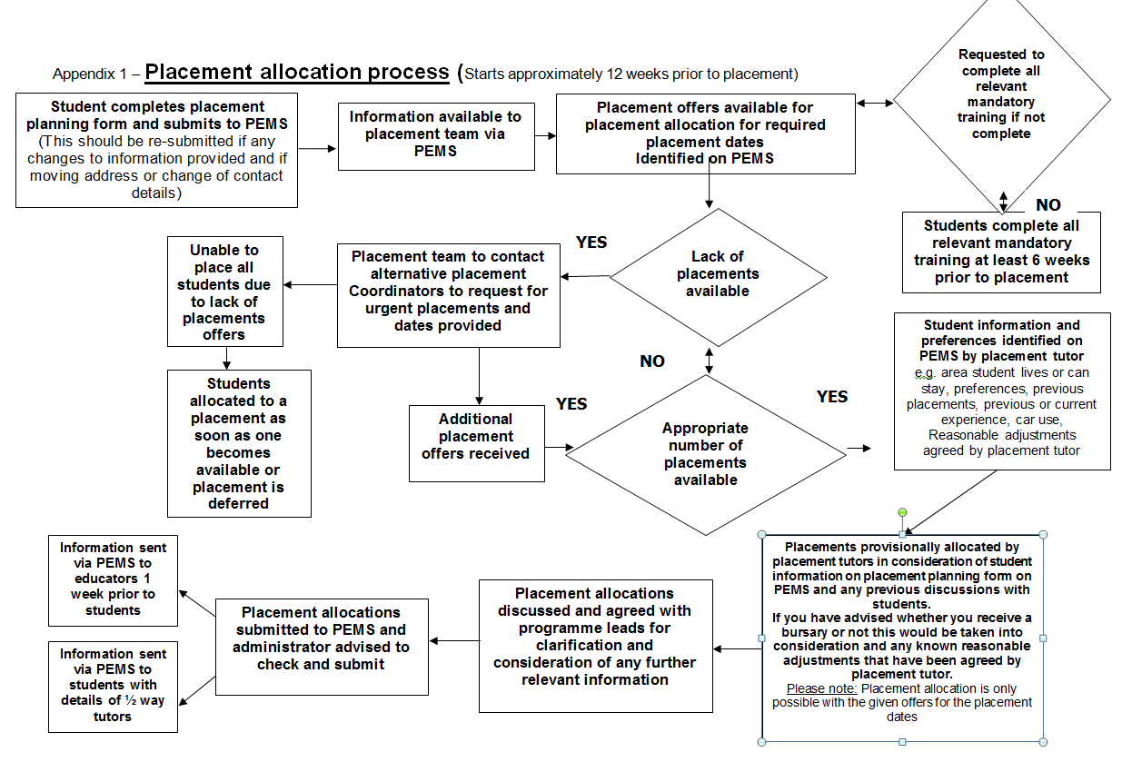



Appendix 2

School of Health and Social Care

OT Learner Advance Information for Practice Placement Educators

|  |
| --- |
| Learner Name: |
|  |
| Address for correspondence: |
|  |
|  |
| Tel. No: |
|  |
| Email: |

|  |
| --- |
| Current Occupational Therapy Working Experience (if applicable) |

Practice Placement Experience (in order, include details of name of placement, description of experience gained, role and skills learned)

|  |
| --- |
| PP1 |

|  |
| --- |
| PP2 |

|  |
| --- |
| PP3 |

|  |
| --- |
| PP4 |
|  |
| PP5 |

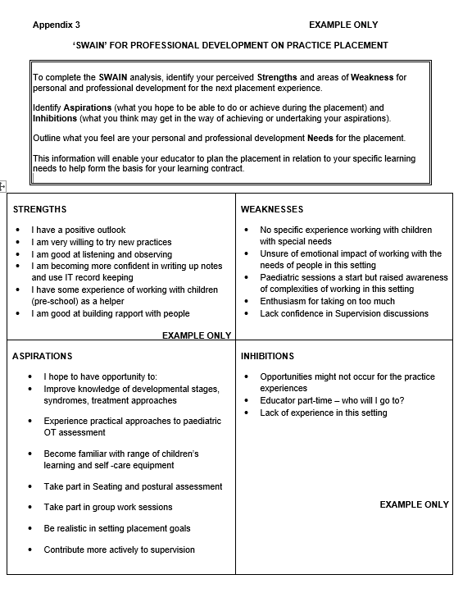

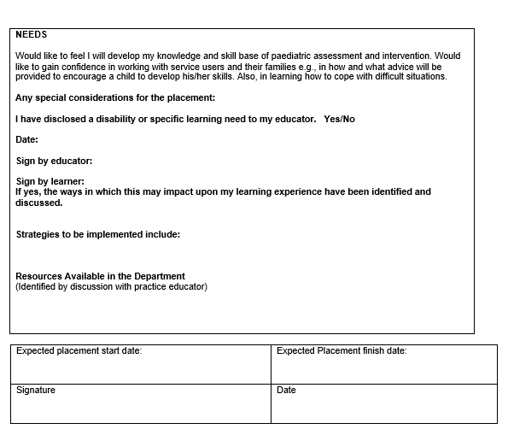



Appendix 4

School of Health and Social Care

Occupational Therapy Case Study Consent Form

I consent to being part of a case study used for the education of the University of Essex Occupational Therapy learner named below.

I understand that all my details will remain confidential and will only be used for the purposes of this study and that this form will remain with the occupational therapy service.

|  |
| --- |
| Name |
| Signature |
| Occupational Therapy Learner Name |
| Occupational Therapy Learner Signature |
| OT Practice Placement Educator’s Name |
| OT Practice Placement Educator’s Signature |
| Date |

Please note, it is recognised that it is not always possible to ascertain or accommodate a service users’ wishes for mental capacity or legal reasons. In such circumstances you must always act in the service users’ best interests and abide by legal and local requirements

N.B. It is important this form must remain within the occupational therapy practice placement education placement setting.

 School of Health and Social Care Appendix 5 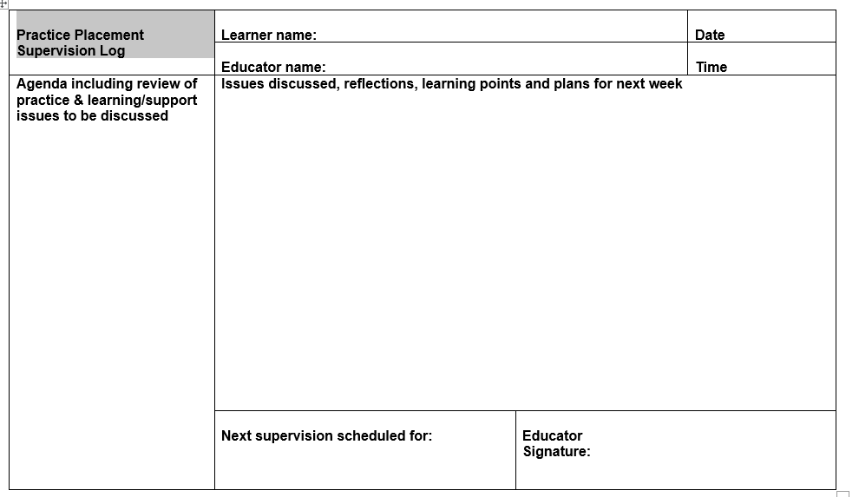

 School of Health and Social Care

Appendix 6

Weekly Action Plan – OT Learner Name:

|  |  |  |  |
| --- | --- | --- | --- |
| Objective – development point | Resources | Action | Met? |
|  |  |  |  |
|  |  |  |  |
|  |  |  |  |
|  |  |  |  |
|  |  |  |  |



Appendix 7 – School of Health and Social Care, Occupational Therapy placement learning contract

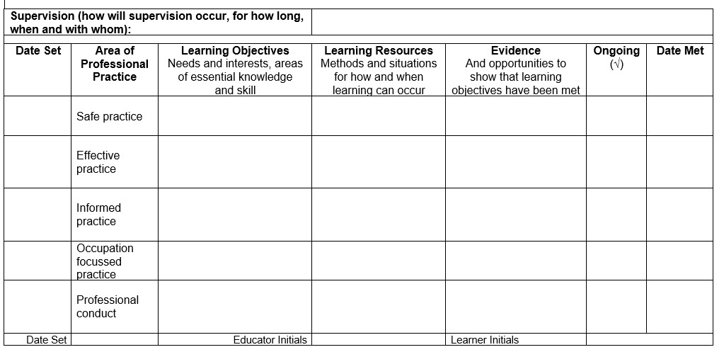



Appendix 8

Placement Learning Contract: Level 4 Examples

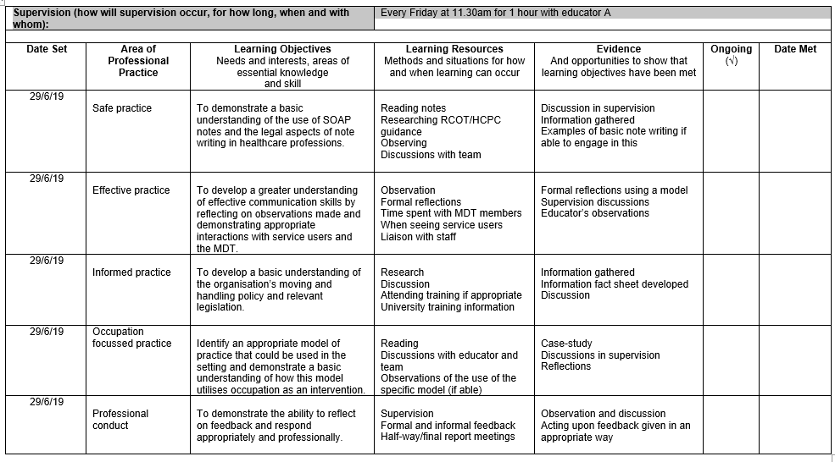

|  |  |  |  |  |
| --- | --- | --- | --- | --- |
| Date | Moving and Handling Activity  e.g., Transferring patient (above knee amputation) from bed to chair using a transfer board | Location  e.g., Ward | Learner responsibility and activity duration  e.g., Observation of OT educator assisting service user with transfer – 10 mins | Educator initials and designation |
|  |  |  |  |  |
|  |  |  |  |  |
|  |  |  |  |  |
|  |  |  |  |  |
|  |  |  |  |  |
|  |  |  |  |  |
|  |  |  |  |  |





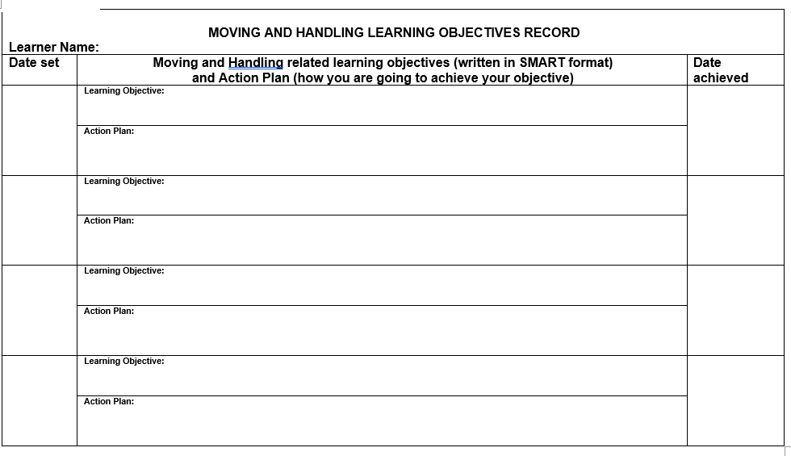

Appendix 10: Protocol for tutorial support during placement

Practice placements 1-4 (All programmes from 2016 cohort)

By the end of week 1: Placement Lead or Practice educator (university) to make initial contact with learners and placement educators (separately) to see how the placement is going and to advise on the various support mechanisms available from the university.

Placement lead/practice educator (university) to arrange to either telephone or visit the learners who have requested support because of this email communication or other correspondence. If the learner is at risk of failing the placement, Placement lead/Practice educator to advise on implementation of the Risk of Failure protocol, as outlined in appendix 14.

In all other cases where a visit/telephone call has not been deemed essential, the placement lead/practice educator/programme lead will decide as to who to visit during this round of placements. Practice educator (university) to contact these learners and educators advising that they will be visited during this placement.

All learners will be visited at least once during the programme. Practice educator (university) will have a system to ensure that all learners will be visited at least once, more if needed.

NB: This process will not apply to role emerging placement as these learners will be continued to be visited. The placement contact tutorial is an opportunity for the learner and placement educator to review the placement experience, seek support, ask questions, and gain further advice and feedback as appropriate. It is an opportunity to review the learner’s assessment progress and identify recommendations for further development. One visit is all that is required, however if there are areas of concern identified, subsequent visits can be arranged after consultation with the Practice Placement Lead or Practice Educator. The halfway tutorial contact tutor monitoring form which is filled out by the visiting tutor and inputted onto Moodle can be found in appendix 11.

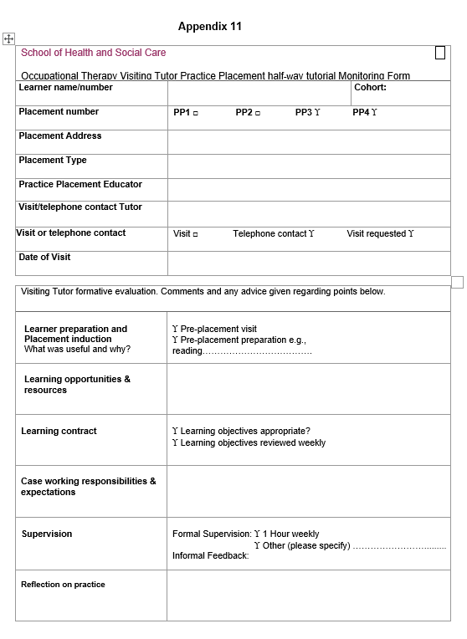

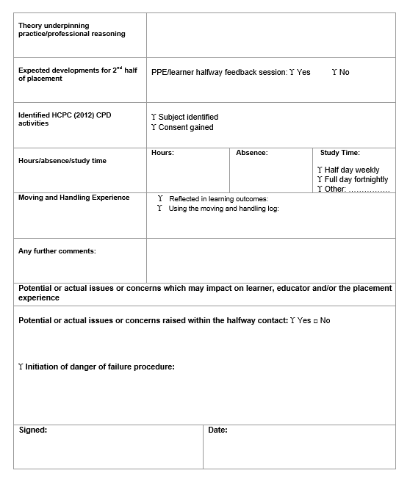

Appendix 12

Learner Placement Evaluation Form - Please complete on PEMS

Logged in as: (Programme) (Cohort)

Complete the evaluation form for every placement that you attend

Complete the form for the following Placement

Organisation (Placement)

The dates of the placement were (Dates)

Evaluation of your placement

Pre-placement

I received adequate information about this placement in relation to travel, geography, personnel etc. from the PEMS portal.

Yes No

Please comment on any other information that would have been useful.

It was easy to contact my practice educator prior to my placement.

Yes No

Induction

I had a timely induction with my practice educator in which we discussed how to achieve the learning outcomes for the placement.

Yes No

Please comment on any other information that would have been useful.

My induction included health and safety information

Yes No

Please comment on any other information that would have been useful.

I was supported by the practice educator to set appropriate goals in my learning contract.

Yes No

Please comment on anything else that would have been useful.

Support from practice educator

My practice educator helped me to integrate knowledge into my practice

Yes No

Please comment on anything else that would have been useful.

I received regular feedback about my learning needs and achievements from my practice educator(s)

Yes No

Please comment on anything else that would have been useful.

I was encouraged by my practice educator to reflect on my practice experience

Yes No

The support I had to facilitate my learning was appropriate to my stage of education

Yes No

Please comment on anything else that would have been useful.

I was given guidance and opportunities to focus on the care of specific patients/service users/clients/carers in a caseload appropriate to my stage of learning.

Yes No

Where appropriate, I was able to work independently.

Yes No

The types of conditions I encountered matched my expectations.

Yes No

Please comment on anything else that would have been useful.

I was given the opportunity to gain experience of inter-professional team working

Yes No

Please comment on anything else that would have been useful.

Preparation for this placement

I felt well prepared for this practice placement by the general information provided within the academic setting.

Yes No

Please comment on any other information that would have been useful.

Theoretical preparation within the University was relevant to this placement.

Yes No

Please comment on anything else that would have been useful.

Practical skill preparation within the University was relevant to this placement.

Yes No

Please comment on anything else that would have been useful.

There were aspects of this placement experience I felt unprepared for.

Yes No

Please comment on any experiences and specific details of what part of the placement you felt unprepared for.

Support from the University

I received the support I needed from university staff during the placement

Yes No

The placement visit by the university lecturer was constructive

Yes, No Visit not undertaken

Please comment on any other support that would have been useful.

I was able to share my placement experiences with learners from the same or other disciplines

Yes No

Final assessment

The halfway and final assessment discussions were constructive in helping me to plan improvements in my future performance

Yes No

Please comment on any other information that would have been useful.

My learning needs were met on this placement

Yes No

Please comment on anything else that would have been useful.

I felt able to offer constructive feedback about my experience of the placement to my practice educator

Yes No

Comments

Please make any comments on what went well, or any issues encountered here

What was the most beneficial aspect of this learning experience?

What was the least beneficial aspect of this learning experience?

If you require help, or have any problems with this site, please contact

[practiceplacements@essex.ac.uk](mailto:practiceplacements@essex.ac.uk)

School of Health and Social Care, Wivenhoe Park, Colchester, Essex, CO4 3SQ, UK

Telephone: +44 (0)1206 874312/874974

Appendix 13

Placement Educator Evaluation Form – Please complete on PEMS

Logged in as: ..............................

Please complete the form for the following placement

Organisation (Placement)

The dates of the placement were (Dates)

Evaluation of the placement

Pre-placement

I received sufficient notice that I would be supervising a learner and adequate information about this placement from the University of Essex.

Yes No

Please comment on any other information that would have been useful.

My allocated learner contacted me/ the placement area prior to the placement

Yes No

Induction

The learner has had a timely initial induction which included health and safety information.

Yes No

The learner was able to inform me of the learning outcomes they anticipated working towards during the placement.

Yes No

I was able to meet with the learner at the beginning of the placement to discuss how they could achieve the learning outcomes for the placement.

Yes No

Please comment on anything else that would have been useful.

I had a clear understanding of the requirements for the learner’s practice assessment

Yes No

Please comment on any other information that would have been useful.

Support from the University of Essex

I know how and when to contact the University of Essex placement lead if I need support

Yes No

Please comment on anything else that would have been useful.

I feel adequately prepared to undertake the role of practice assessor

Yes No

Please comment on anything else that would have been useful.

Please state when and where you last undertook practice educator training.

I find the University of Essex Practice Education Management System (PEMS) a useful means of accessing information

Yes No

Please comment on anything else that would have been useful.

I feel I received the support I needed from university staff during the placement

Yes, No None needed

I feel the learner received the support they needed from university staff during the placement

Yes, No None needed

The placement visit by the university lecturer was constructive

Yes, No Visit not undertaken

Please comment on any other support that would have been useful.

Preparation for this placement

The learner was adequately prepared to commence the placement.

Yes No

Please comment on anything else that would have been useful.

The learner had adequate theoretical knowledge relevant to this placement.

Yes No

Please comment on anything else that would have been useful.

The learner had adequate practical skills for this placement.

Yes No

Please comment on anything else that would have been useful.

There were aspects of this placement experience I felt the learner was unprepared for.

Yes No

Please comment on any experiences and specific details of what part of the placement you felt the learner was unprepared for.

Final assessment

The halfway and final assessment discussions were constructive in helping me to reflect on my role as an educator and plan improvements in my future performance

Yes No

Please comment on anything else that would have been useful.

Overall, I found supporting this learner a positive experience

Yes No

Please make any comments on what went well, or any issues encountered here

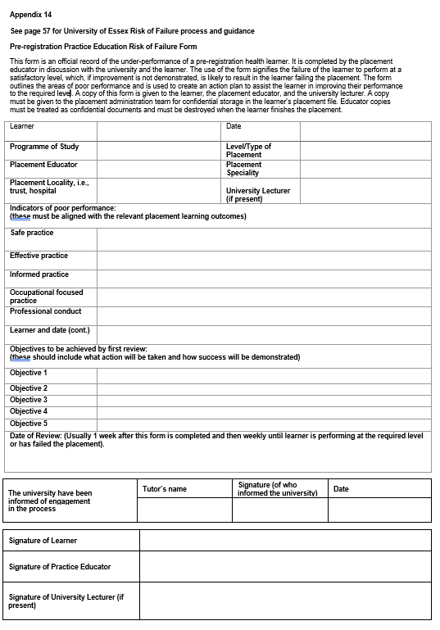

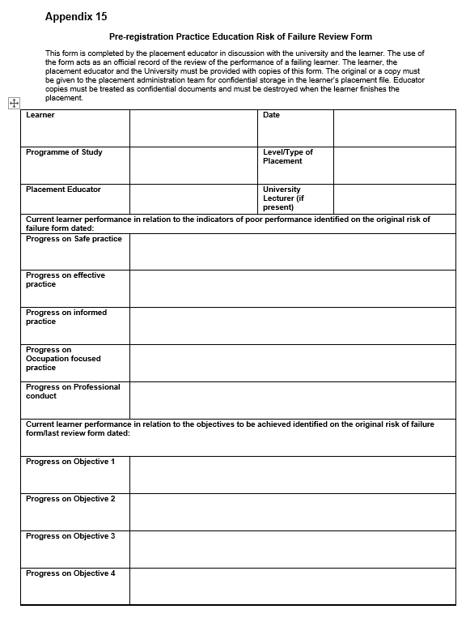

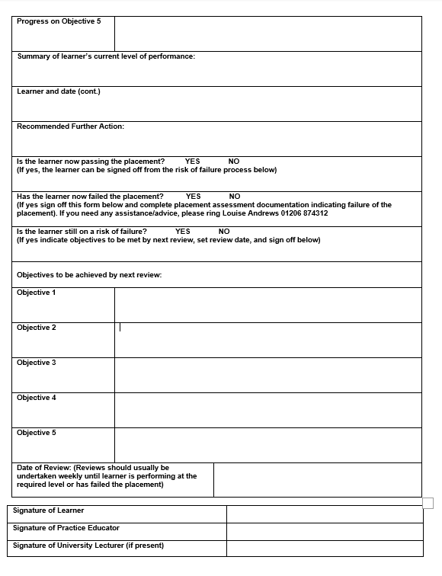

Appendix 16

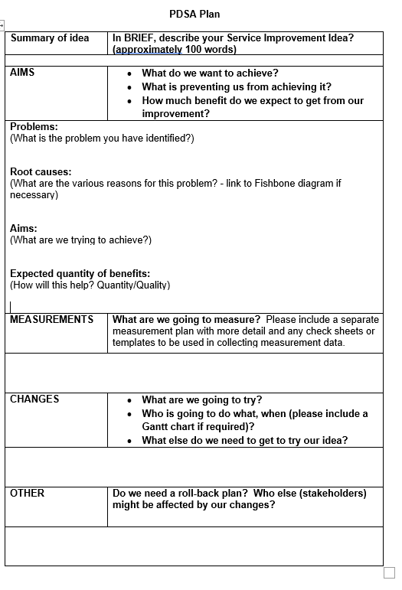

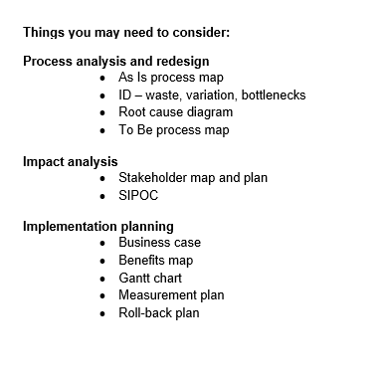

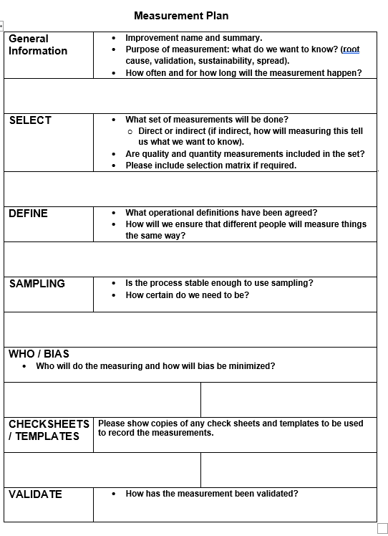

Appendix 17: Checklist for completion of the assessment booklets

Please indicate the following for completion of the assessment booklets prior to returning to the university.

1. All details completed on front page

*Note: This includes learner number, full placement address,*

*full name of practice educator, final grade, completed hours,*

*placement dates and total no. of absence completed.*

1. SWAIN analysis completed, signed, and dated.

*.*

1. Practice Education Placement Learner Induction Record
2. Placement learning contract completed
3. Part 1 – Professional conduct completed
4. Part 2 – Professional practice areas Halfway assessment

and final assessment forms completed.

1. All relevant boxes with final pass/fail mark completed on

Assessment summary page including overall Pass or Fail

1. Educator completed general comments box on

assessment summary page and both learner and

educator must sign and date

1. Attendance record completed

*Note: This should be completed whether you have had*

*any absence or not and must be signed by the educator.* *You*

*must notify the University of absences whilst on placement (as per*

*Placement Handbook).*

1. Record of practice hours completed with total for each

week and final total checked and signed by both learner

and educator.

Appendix 18: Occupational Profile Proforma

HS171: Occupational Profile

Adapted from The American Occupational Therapy Association (2008) *Occupational Therapy Practice Framework: Domain and Process (2nd Edition)* USA: AOTA Press

|  |  |  |
| --- | --- | --- |
| Key area | Prompts | Comments |
| Person | Who is the individual, their family, significant others and any caregivers? |  |
| History of engagement in occupation – what is the person’s history of self-care, productivity and leisure occupations?  Include information on life experiences, values, interests and previous patterns of engagement in occupations and daily life activities, and the meanings associated with them. | Self-care:  Personal care *(e.g. dressing, bathing, feeding, hygiene)*  Functional mobility *(e.g. transfers, indoor and outdoor mobility)*  Community management *(e.g. transportation, shopping, finances)*  Productivity:  Paid/Unpaid work *(e.g. finding/keeping a job, volunteering)*  Household Management *(e.g. cleaning, laundry, cooking)*  Play/School *(e.g. play skills, homework)*  Leisure:  Quiet Recreation*(e.g. hobbies, crafts, reading)*  Active Recreation *(e.g. sports, outings, travel)*  Socialisation *(e.g. visiting, phone calls, parties, correspondence)* |  |
| Successful/unsuccessful occupational engagement | What areas of occupation are successful? Are there any areas causing problems or risks? |  |
| Environment | What aspects of the person’s physical, institutional, cultural and social environments support or inhibit participation and engagement in their desired occupations? |  |
| Priorities and desired outcomes | What are the person’s priorities and desired outcomes in relation to engaging in occupations? |  |
| Discussion with appropriate supporting literature | Why are the aspects included in the questions above important? What impact might these have on you and your ability to engage in other occupations? |  |