BSc Nursing Programmes
Literacy and Numeracy Assessment
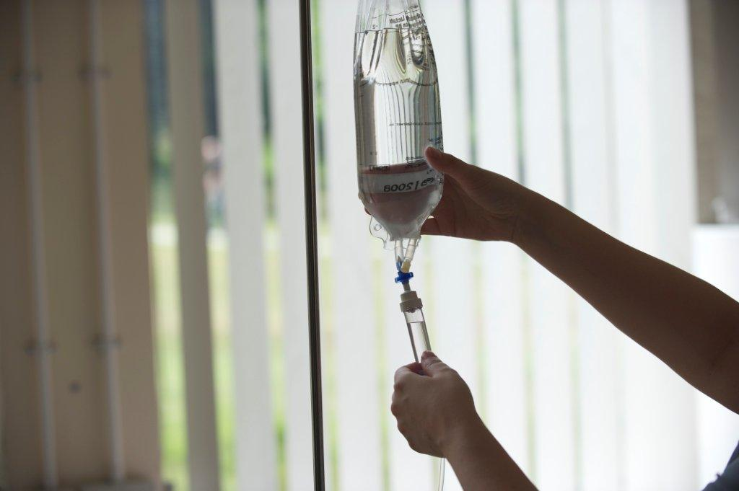
Name: |  |  | Date:
Please circle: | Adult Nursing | Mental Health Nursing

General Instructions:
- Write your name and the date in the boxes above, and indicate your nursing field
- Please answer ALL the questions. Take your time and check your answers
- You have 30 minutes to complete ALL assessments

Literacy Assessment
- Read the article carefully and critically
- Answer the 14 multiple choice/short answer questions

Numeracy Assessment
- Work through the 12 problems, writing your answers in the spaces provided
- Please ensure that you INCLUDE THE CORRECT UNITS in ALL your answers
- No marks will be given for answers with missing or incorrect units
- You may use a calculator

Free-Writing Assessment
- Complete the writing task in the space provided

Candidate Booklet

LITERACY ASSESSMENT

PRESS RELEASE – DEPARTMENT OF HEALTH, 2013

Thousands of tonnes of saturated fat to be taken out of the nation’s diet

Paragraph
- More than one and a half Olympic size swimming pools of saturated fat will be removed from the nation’s diet over the next year as part of a drive to cut the amount of saturated fat in our food.
- Almost half of the food manufacturing and retale industry has signed up to the Responsibility Deal Saturated Fat Reduction Pledge by agreeing to reduce the amount of saturated fat in our food and by changing products to make them healthier.
- Cutting the amount of saturated fat we eat by just fifteen per cent could prevent around 2,600 premature deaths every year from diseases such as cardiovascular disease, heart disease and stroke.
- Public Health Minister Jane Ellison said: “One in six male deaths and one in nine female deaths are from coronary heart disease – this is why it’s critical that we challenge the way we eat and that we all make changes where we can.”
- There are a number of ways that companies can lower the amount of saturated fat in our diets, including reformulating recipes so they include less fat and introducing new products with lower fat.
- Chair of the Responsibility Deal Food Network, Professor Susan Jebb said: “The Responsibility Deal has made great progress in changing our eating options and habits.
- From the introduction of front of pack labelling to today’s announcement, everyone involved can be proud of the work done so far. We know that more can still be done.
- These commitments to help reduce saturated fat are an important step forward. They recognise that too much saturated fat can increase cholesterol levels and cause heart disease and premature deaths which is why its fantastic that so many company’s have committed to helping people cut down on their consumption.
- This development means we now have a suite of Responsibility Deal pledges that help companies cut fat, sugar and salt which together will help consumers achieve a healthier diet, stop them getting so ridiculously fat and reduce their of cardiovascular disease.”
Questions
- This article is mainly about an initiative designed to:
  - Repackage food products to introduce better labelling
  - Prevent 2,600 deaths from strokes
  - Remove cholesterol from pre-packaged food
  - Reduce the amount of saturated fat in the nation’s diet /1

- According to the press release, food manufacturing companies can help by:
  - Selling their products in smaller portions
  - Reformulating recipes to include less fat
  - Including strong health warnings on their packaging
  - Committing to the reduction of premature deaths /1

- The best word to replace ‘diseases’ in paragraph 3 is:
  - sickness
  - conditions
  - weaknesses
  - problems /1

- The word ‘premature’ in paragraphs 3 & 8, when used in this context means:
  - incomplete
  - timely
  - early
  - underdeveloped /1

- The best word to fill the gap in paragraph 9 is:
  - morbidity
  - deaths
  - risk
  - fatality /1

- A phrase has been added to paragraph 9 that contains inappropriate language for a Department of Health Press release. Please identify the phrase and write it out below.

/1
______________________________________________________________________
- There is a spelling error in paragraph:
  - 2
  - 5
  - 6
  - 7 /1

- Please write the correction here: fgh /1

- There are 2 punctuation errors in paragraph :
  - 1
  - 4
  - 8
  - 9 /1

- Please write the corrections here:g f gh&gfhf sdfsdf /2

- The commas in paragraph 9 are used to:
  - introduce a new topic
  - separate a parenthetical element
  - separate items in a list
  - separate several adjectives /1

- Select the correct spelling of the missing word in paragraph 2:
  - there
  - they’re
  - their
  - they are /1

- According to the article, coronary heart disease causes a greater proportion of female deaths than male deaths.
  - True b. False /1

- The two short sentences in paragraph 7 could best be joined by the word:
  - anyway
  - therefore
  - however
  - because /1
NUMERACY ASSESSMENT
REMEMBER TO INCLUDE THE CORRECT UNITS IN YOUR ANSWERS

- Add £93.80 to £45.60. What is the total?

/1

- A starting salary for a registered nurse is £21,388. If they are awarded a pay rise of 1%, what will their new salary be?

/1

- A patient is advised not to exceed a daily salt intake of 4 grams. Their meals for the day contained the following amounts of salt:

Breakfast: 1.4 g
Lunch: 800 mg
Dinner 2,000 mg
Snacks and drinks: 0.6 g

  - How much salt did they consume over the day?

/1

  - Were they over or under the recommended limit?

/1

REMEMBER TO INCLUDE THE CORRECT UNITS IN YOUR ANSWERS

- An estate agency sold a number of property types during the last quarter of the year. The table below shows the types and numbers sold:

Detached Houses | 7,325
Semi-detached Houses | 14,650
Terraced Houses | 21,975
Flats | 29,300
Total | 73,250

  - What fraction of the total number of properties sold were semi-detached houses? Express your answer as a simple fraction.

/1

  - Which type of property made up 10% of the total sales figure?

/1

- The scale below indicates a patient’s weight:

  - The reading on the scale is:

/1

  - The most likely unit of weight for this measurement is:

/1
REMEMBER TO INCLUDE THE CORRECT UNITS IN YOUR ANSWERS

- At the start of a weight loss programme, a person weight 85.3 kilograms. Their target weight is 61.4 kilograms. How much weight do they need to lose?

/1
- A patient is advised to eat 1,750 calories a day. Their breakfast contains 269 calories. How many calories are left in their daily allowance after they have eaten their breakfast?

/1
- A standard packet of breakfast cereal contains 500g. A shopper buys a ‘special offer’ packet which contains an extra 200g. How many 35g servings does the ‘special offer’ packet contain?

/1

- A supermarket sells a 200g jar of Coffee A for £2.79, and a 300g jar of Coffee B for £3.99. Which jar represents better value for money?

/1
- If 1 pint is equal to 0.57 litres, how many litres is 11 pints?

/1
- A patient is prescribed 750mg of an antibiotic drug. You have a packet of tablets of strength 250mg. How many tablets must you give to the patient?

/1
- A patient is receiving an IV infusion that will last for 6 ¾ hours. The infusion started at 9:00am. At what time should the infusion end?

/1
FREE WRITING ASSESSMENT
In the space below, please write a short summary of the skills and qualities required to be an outstanding nurse (100 – 200 words).

END OF ASSESSMENT

