Literacy & Numeracy Assessment - Answers
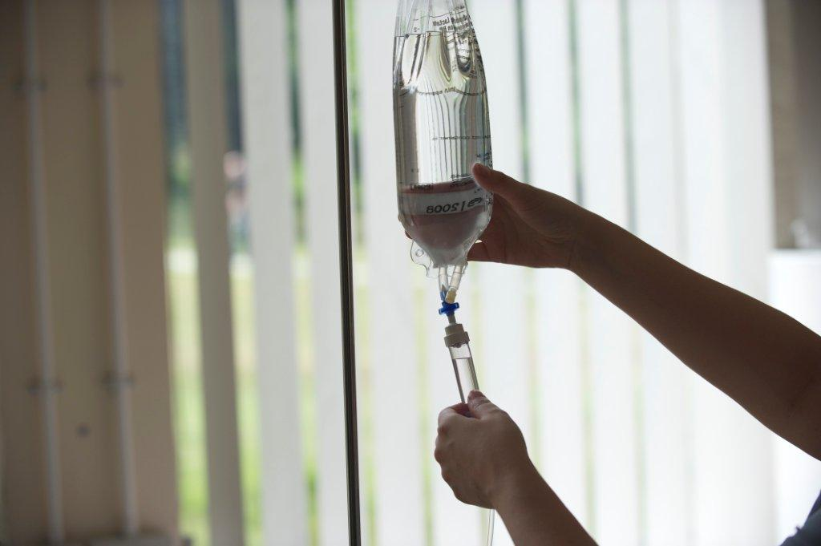
Answers - Literacy
1. d. Reduce the amount of saturated fat in the nation’s diet /1

2. b. Reformulating recipes to include less fat /1

3. b. conditions /1

4. c. early /1

5. c. risk /1

6. Answer must include the words ‘ridiculously fat’ but no more than ‘stop them
getting so ridiculously fat’. /1

7. a. 2 /1

8. retail /1

9. c. 8 /1

10. it’s (1 mark – apostrophe must be correct) – ‘it is’ is also acceptable
companies (1 mark - no apostrophe) /2

11. c. separate items in a list /1

12. c. their /1

13. b. False /1

14. c. however /1

TOTAL (PASS MARK = 10/15) /15

NUMERACY ASSESSMENT
Markers’ guidelines: where a unit is indicated in brackets, a correct numerical answer can be accepted without it. In all other instances the unit must be included for the mark to be awarded.

- £139.40 /1

- £21,601.88
Accept £21,602 for correct rounding /1

- a. either 4.8 g or 4,800 mg is acceptable. /1

Units must be present and correct, but do not need to be abbreviated
e.g. 4800 milligrams is fine

b. Over /1

4. a. 1/5 /1
b. Detached Houses /1

5. a. 54 (kg) /1
b. Any correct variation on kg, kilos, kilograms as long as it is clear! /1

6. 23.9kg /1
/1
7. 1481 (cal/calories) /1

8. 20 (servings) /1

9. Coffee B or the 300g jar or the £3.99 jar /1

10. 6.27 (litres) /1
11. 3 (tablets) /1

12. Either 3:45pm or 15:45 /1
Do not accept 3:45 without the ‘pm’

TOTAL (PASS MARK = 10/15) /15

FREE WRITING – MARKED BY LLN TUTOR ONLY
In the space below, please write a short summary of the skills and qualities required to be an outstanding nurse (100 – 200 words).

Has the candidate:
Presented their ideas clearly and effectively?
Used paragraphs to organise their writing?
Used an appropriate style and tone for the task?
- Informative
- Relatively formal language – no slang
- Personal opinions are acceptable
Used accurate spelling?
- Almost all words spelt correctly
- Any errors appear atypical, ‘one-off’ slips
Used accurate punctuation?
- Commas, apostrophes, capital letters, full stops.
- Any errors appear atypical, ‘one-off’ slips
Used accurate grammar?
- Use of tense, syntax, subject/verb agreement is accurate
- Any errors appear atypical, ‘one-off’ slips
Is their writing legible?

Score: (circle learner’s skill level)

Emerging 0 – 3

Consolidating 4 – 5

Established 6 – 7

