BSc (Hons) Speech and Language Therapy (Pre-Registration)

Year 1 HS136 Practice Placement 1 (Professional Development)

Workbook for pre-clinical skills development

Student name

Registration Number

Personal Tutor

Dates of Placement

Placement Sites | Location A | Location B | Location C
Practice Facilitators | Location A | Location B | Location C
This workbook is designed to support you in developing the professional and pre-clinical skills required to progress to future SLT clinical placements. You should complete and record the skills development tasks suggested in the booklet. This booklet is your working document: notes may be written in bullet point and should be hand written and contemporaneous. You are also encouraged to extend your learning by completing the tasks with a range of individuals across a range of locations and to experiment with different strategies and techniques.
The term individual is used throughout to refer to both the child and adult.

Completion of this workbook accounts for Part 3 of your practice placement assessment.
Tasks completed in this workbook may also be useful evidence for completion of your Part 2 learning outcomes.

This workbook should be submitted along with your Practice Placement Assessment booklet at the end of the placement. It will be assessed by University staff as part of the placement portfolio.

Placement support:
If you require support in completing this booklet, please contact the SLT placement team.
01206 874557
sltplace@essex.ac.uk

University use only
Part 3: Workbook | Grade awarded  (also see separate feedback sheet) | Signature of University lecturer

Contents/check list

Page | Tasks relating to interpersonal skills | Date completed | Location A/B/C
3 | 1.1 Observation of staff
4 | 1.2 Discussion with staff
5 | 1.3 Discussion with parent/significant other
Page | Tasks relating to professional knowledge | Date completed | Location A/B/C
6 | 2.1 SLT provision
7 | 2.2. Language Development
8 | 2.3 Form, content, use
9 | 2.4 Hierarchy of needs
10 | 2.5 Communication chain
11 | 2.6, 2.7 Means, reasons, opportunities
14 | 2.8 Symbolic continuum
15 | 2.9 Attention control
16 | 2.10 Symbolic play
17 | 2.11 Social play
18 | 2.12 Memory development
19 | 2.13 Memory strategies
Page | Tasks relating to professional skills | Date completed | Location A/B/C
20 | 3.1 Interaction with a individual
21 | 3.2 Interaction with an individual
22 | 3.3 Running a group session
23 | 3.4 Reading/writing individual activity
24 | 3.5 SOAP notes
25 | 3.6 Transcription
27 | 3.7 Linguistic sampling
28 | 3.8 Reflection
Interpersonal skills tasks

Task  1.1 | Observe 2 different members of staff working with individuals. What communication strategies and behaviour management strategies do they use which are effective? Why are they effective? Did you notice differentiation for different individuals? How did the styles compare? What tips have you picked up for your work as an SLT?
Date |  | Location A / B / C | Individual group
Useful resources or references to support the task

Notes

Task  1.2 | Initiate a discussion with a member of staff in each location about a professional issue of your choice. What interpersonal communication skills did you notice yourself using? Why did you use them? Were they successful? Did you interact on a professional level? What did you learn? What did they learn? Next steps?
Date |  | Location A / B / C | Individual group
Useful resources or references to support the task

Notes

Task  1.3 | In 1 location initiate a discussion with a parent/carer about a relevant topic of your choice. In a 2nd location initiate a discussion with a significant other about a relevant topic of your choice How did you set up the interactions? What interpersonal communication skills did you notice yourself using? Why did you use them? Were they successful? How did the parent and significant other respond to you? Next steps?
Date |  | Location A / B / C | Individual group
Useful resources or references to support the task

Notes

Professional Knowledge Tasks

Task  2.1 | Investigate the SLT work within each setting – what SLT input does the setting receive? What type/level of provision is it? Is it effective and why? How is it funded? What are the perceptions of the staff? What are your thoughts about the SLT input in the setting?
Date |  | Location A / B / C | Individual group
Useful resources or references to support the task

Notes

Task  2.2 | Consider one induvidual that you work with:- what do you notice about their language development. Use Lyon’s (2013) pyramid model as a guide for your observations.
Date |  | Location A / B / C | Individual group
Useful resources or references to support the task
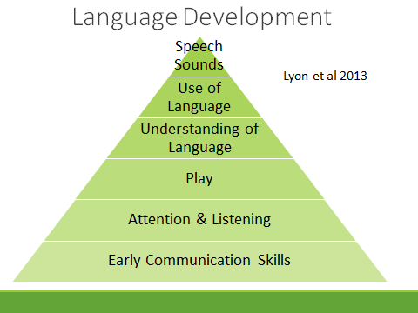
Notes

Task  2.3 | Consider one individual that you work with, record what you notice about their language form/content/use, using Bloom and Lahey’s (1978) model as a guide. Do your observations match your expectations of how a individual of this age would present?
Date |  | Location A / B / C | Individual group
Useful resources or references to support the task
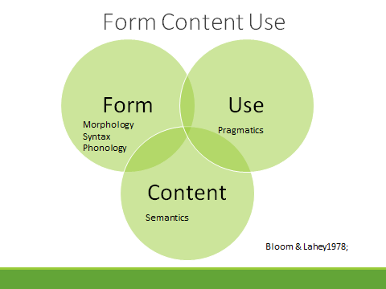
Notes

Task  2.4 | Consider one individual that you work with, record what you notice about their communication motivations and content, using Maslow’s hierarchy of needs (1954). Is the person able to express themselves at each level of the hierarchy? If not, why not? How would this information be useful to an SLT?
Date |  | Location A / B / C | Individual group
Useful resources or references to support the task
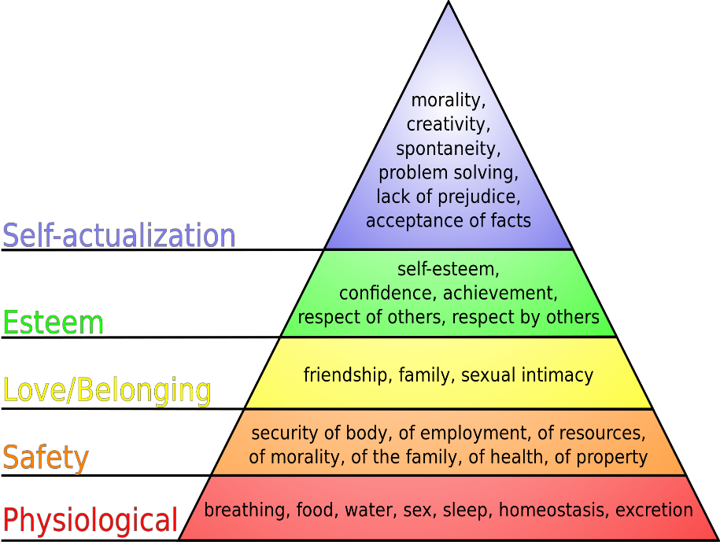
Notes

Task  2.5 | Consider one individual that you work with and identify where you think their areas of difficulty lie in McLachlan and Elks (2006) communication chain. What evidence did you have for this? What affect does this have on subsequent areas of the chain?
Date |  | Location A / B / C | Individual group
Useful resources or references to support the task
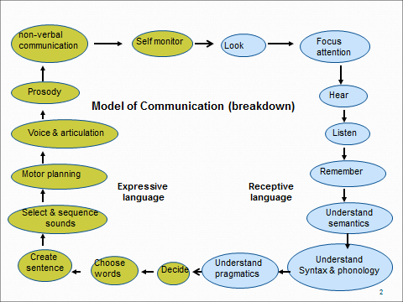

See also Elks & McLaughlan 2006

Notes

Task  2.6 | Complete Means Reasons and Opportunities (MRO) (Money, 1994) observations with two different individuals. How do the two observations compare? What communication support strategies would be appropriate for each person? What have you learnt?  As part of your observations, watch for and note:-  Communication stages – watch for an example of:- pre-linguistic communication:- pre-intentional communication – reflexive; pre-intentional communication – anticipatory; linguistic communication:- verbal; non-verbal; vocab range; syntactic structures
Date |  | Location A / B / C | Individual group
Useful resources or references to support the task
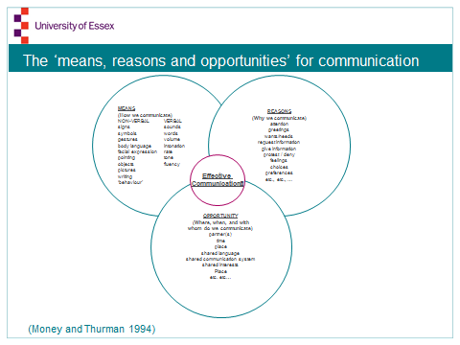
Notes

Task  2.7 | For one individual who you focussed on in the MRO exercise above, consider what factors were necessary for positive interaction; how did the environment affect positive interaction; what opportunities did they have for positive interaction? How did they engage with others? How can independence and choice be encouraged in this environment?
Date |  | Location A / B / C | Individual group
Useful resources or references to support the task

Notes

Task  2.8 | For one individual you have been working with, design and implement a simple task which can identify their level of symbolic understanding, based upon the symbolic continuum. How might this information be useful to staff working with the individual?
Date |  | Location A / B / C | Individual group
Useful resources or references to support the task
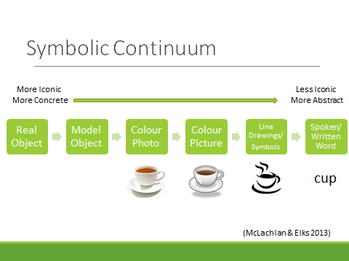
Notes

Task  2.9 | For an individual you have been working with, identify their level of attention. What evidence do you have for this? How might this information be useful for people working with the individual?  If you disregard the age equivalents given, could you apply these descriptors to individuals in other locations? Give an example of how you did this.
Date |  | Location A / B / C | Individual group
Useful resources or references to support the task
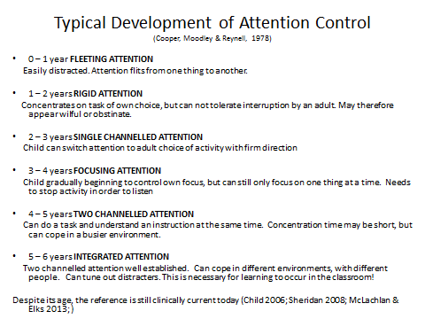
Notes

Task  2.10 | For an individual you have been working with, identify their level of symbolic play. What evidence do you have for this? How might this information be useful for the people working with the individual? Consider play in the broadest sense of the activity.
Date |  | Location A / B / C | Individual group
Useful resources or references to support the task

- Exploratory play (object knowledge);
- Relational play (relating objects);
- Self pretend play (relating objects/actions to self);
- Simple pretend play (relating objects/actions to others);
- Sequenced pretend play.
(Jeffrey, McConkey, Austin & Houghton, 1988; Cooke & Williams, 1991; Weitzner-Lin, 2004; McLachlan & Elks, 2007; Owens 2012)

Notes

Task  2.11 | For a individual you have been working with, identify their level of social play. What evidence do you have for this? How might this information be useful for the people working with the individual?  For a individual, how could you apply this staged approach if ‘play’ is substituted with ‘interaction and engagement’?
Date |  | Location A / B / C | Individual group
Useful resources or references to support the task

- Solitary play;
2. Parallel play;
3. Associative play;
4. Co-operative play
(Berk 2006; McLachlan & Elks 2007; Lyon et al 2013)

Notes

Task  2.12 | Memory – short term memory. For a individual that you work with, devise and implement an activity to determine their ‘magic number’. What does this tell you about their memory development? What is the impact of their ‘magic number’ on their learning and language? How might this information be useful to those who work with the individual?  For an individual, consider where you have observed evidence relating to this theory and the relevance of memory capacity for the individual.
Date |  | Location A / B / C | Individual group
Useful resources or references to support the task
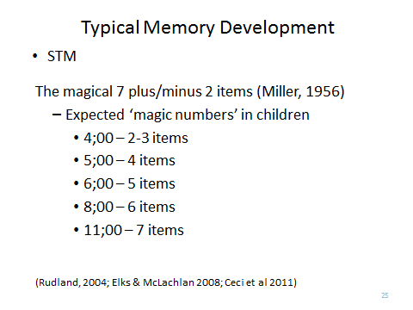
Notes

Task  2.13 | Memory – memory strategies. What evidence can you collate to demonstrate the memory strategy stage of a individual you work with? How would this information be useful to an SLT?  Observe what memory strategies a individual is actively using.
Date |  | Location A / B / C | Individual group
Useful resources or references to support the task
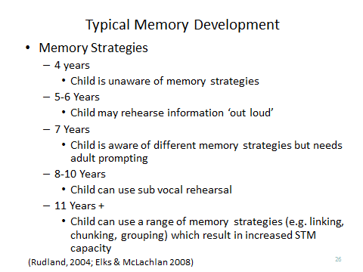
Notes

Professional skills tasks

Task  3.1 | Undertake a 1:1 interaction with a shy individual. Plan strategies to support individual in interaction (e.g. non-confrontational seating/environment, reduce questioning, individual lead vs therapist lead, trigger materials appropriate for individual). What strategies were most effective and why? What would you do differently next time?
Date |  | Location A / B / C | Individual group
Useful resources or references to support the task

Notes

Task  3.2 | Undertake a 1:1 interaction with a individual who is quieter/more difficult to engage with than others in the environment. Plan strategies to support the individual in interaction (e.g. non-confrontational seating/environment, reduce questioning, individual lead vs SLT lead, trigger materials appropriate for individual). What strategies were most effective and why? What would you do differently next time?
Date |  | Location A / B / C | Individual group
Useful resources or references to support the task

Notes

Task  3.3 | Run a group session as appropriate to the setting. Plan strategies for group management. Environment? Materials? How did you feel about running a group? Did it go well and why? What would you do differently? Reflection in action?
Date |  | Location A / B / C | Individual group
Useful resources or references to support the task

Notes

Task  3.4 | In each location, devise a session with one individual to share a reading or writing task at a level appropriate to the individual. Provide justification for the content of the session.  What level of reading ability does the individual have? How does this compare to their speech and language ability? Are the two linked? What other factors influence the individual’s reading?
Date |  | Location A / B / C | Individual group
Useful resources or references to support the task

Notes

Task  3.5 | Professional note writing/session recording:- practice writing notes for one of your reading sessions using the SOAP note writing format.
Date |  | Location A / B / C | Individual group
Useful resources or references to support the task

S: subjective
O: objective
A: assessment (or activity)
P: plan

Notes

Task  3.6 | Transcription  Throughout your placement and in all locations:-  - Listen for different accents of English amongst staff & individuals. How do they differ to your own? How would you transcribe some of the words which you realise differently?  - Listen for examples of individuals who follow the typical patterns/ age acquisition for sounds and for examples of those who do not. What do you notice?  - Listen for any individual whose speech is more difficult to understand than that of their peers. What impact does that have on them?
Date |  | Location A / B / C | Individual group
Useful resources or references to support the task

Notes

Task  3.7 | Linguistic sampling and analysis  Throughout your placement and in all locations:-  Following your current topics from class, autographically transcribe and consider/analyse utterances of some of the individuals you work with. Take samples from a range of ages and abilities. How do their linguistic structures differ?
Date |  | Location A / B / C | Individual group
Useful resources or references to support the task

Notes

Task  3.8 | Write one critical event reflection which focusses on an event that has promoted development of your identity as an SLT student and/or has reinforced your choice to train to become an SLT.
Date |  | Location A / B / C | Individual group
Useful resources or references to support the task

Notes

