4-year PhD Studentship

Time-resolved synchrotron and XFEL crystallography of metalloenzymes using anaerobic photocages

Start date: October 2019
Project Description
X-ray crystallography has been the leading method to understand the structure and function of proteins and enzymes for decades. Despite this, it has a key limitation in that structures are not time-resolved and so do not represent the dynamic and changing nature of a protein’s structure as it carries out its function or enzymatic reaction. Time-resolved crystallography is one approach for capturing structures of reaction intermediates, though for probing fast changes approaches are typically limited to light activated processes.
Metalloproteins are vital to a wide range of biological functions and are particularly susceptible to site-specific radiation damage, a problem that is considerably worse when working at room temperature. Serial sample delivery and the use of photocages to trap and trigger reactions offer a means of resolving both of the above challenges, making fast time-resolved experiments applicable to a wide range of targets.
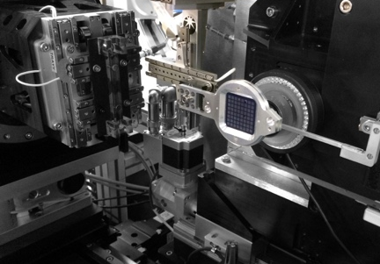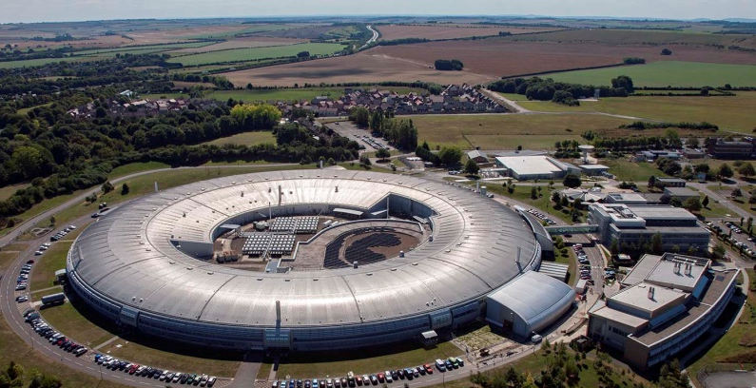

In this joint studentship between the University of Essex and Diamond Light Source you will perform cutting-edge research in the areas of metalloprotein structure determination, serial synchrotron crystallography (SSX), and X-ray free electron laser (XFEL) data collection to develop approaches for time-resolved SSX at Diamond. To this end you will exploit state-of-the-art fixed target instrumentation at Diamond and characterise photocages and their activation in crystals. Experiments and developments will be carried out using metalloproteins prepared by you at the University of Essex. There will also be
the opportunity to carry out experimental work at the SACLA XFEL in Japan.
You will spend approximately half of the studentship based at the University of Essex and half based at Diamond.

The Candidate
We are looking for an exceptional and highly motivated candidate with a good Undergraduate or Masters degree in a relevant subject including Life Sciences, Physics or Chemistry. A willingness to travel to carry out experimental work at international facilities is essential.

Training
This interdisciplinary project offers exceptional training opportunities in the rapidly developing field of serial and time-resolved structural biology. Full training in all required methodology will be provided. The University of Essex Proficio scheme offers an extensive range of training courses in transferable skills.

Funding
This is a fully-funded 4-year PhD Studentship covering Home/EU fees and with an enhanced stipend.
Please note: International students need to have additional funding to cover the difference in tuition fees which is currently £12,410 per year, evidence will be requested that you have these additional funds.

Application procedure
Applications should be submitted electronically by the 8th April 2019 see here for details https://www.essex.ac.uk/pgapply/enter.aspx and should state the project title and supervisors. Potential applicants are strongly encouraged to informally contact the supervisors in advance: Dr Mike Hough (mahough@essex.ac.uk; https://www.essex.ac.uk/people/hough20300/mike-hough) or Dr Robin Owen (robin.owen@diamond.ac.uk; https://www.diamond.ac.uk/Instruments/Mx/I24/Staff/Owen.html)

Research Environment and Further Information
For general information about the School of Biological Sciences at the University of Essex please visit our webpages http://www.essex.ac.uk/bs/. For information regarding macromolecular crystallography beamlines at Diamond please visit https://www.diamond.ac.uk/Instruments/Mx

