

Professional services line manager's probation guidance

Authors: People & Culture

Publication date: April 2025

Amended: April 2025

Review date: April 2028

Table of Contents

Introduction 3

Why is probation so important? 3

The role of the line manager 4

The role of the new employee 5

The role of People & Culture 6

The stages of probation 6

Induction 7

The probation agreement 7

Mid-Point review 8

Final review 8

Top tips for giving feedback 9

Top tips for making the most of a probation period 9

Once probation is completed… 10

Where can I find additional support? 10

Annex 1: Professional services employee timeline 11

Annex 2: Probation checklist for line managers 16

Annex 3: Getting the most out of your meeting 18

Annex 4: Feedback is a key tool in developing others 20

## Introduction

This guidance supplements the University’s Probation Policy, providing additional guidance on what needs to be done and when. It is important individuals feel supported through their probation period.

The probation period should be a positive, productive time in which the new employee learns about both the University and their role. ‘[Welcome to Essex](https://moodle.essex.ac.uk/course/view.php?id=5696)’ on the Moodle site contains a number of useful links on the key areas a new employee needs to know in their first year.

**The key stages of probation are:**

* Induction, which includes Essential Training.
* If a probation agreement is being used, this needs to be discussed and agreed upon with the line manager within the first few weeks of starting in the role.
* Midway through probation, at 3 or 6 months, there should be a review of how the role is going, and whether any guidance or support is needed. Any concerns should be flagged at this point.
* At the end of probation, the line manager should meet with the employee and review the probation period.

## Why is probation so important?

Probation is a key time for both employer and employee and therefore it is vital that it’s managed correctly to ensure both parties benefit. Probation is a period when employees are finding their way and learning their new role. They will also be forming their opinion of their new employer. Probation is a great time to offer new employees support and to identify any additional training needs.

It is important for line managers to meet regularly with their new employee so that they can understand the progress they are making. Setting initial objectives and documenting progress can really help both parties to clarify expectations. You should always highlight to the new employee at the earliest opportunity if there are any problems and allow them time to improve. Populating a probation agreement can help with this.

If you have any concerns about your new employee you should keep a written record and flag your concerns as early as possible. It is also important to encourage your new employee to flag or record any areas of concern they may have during their probation period. Probation is very much a two-way process, behaviours as well as ability must be considered.

## The role of the line manager

Line managers play a crucial role in welcoming new employees to the University and ensuring they make the best possible start. Most importantly, line managers must ensure that new employees are receiving the support and guidance they need. This starts with a full induction, followed by regular meetings to review progress and provide support.

It is important to be fully prepared for the arrival of the new employee. This includes, planning an Induction programme and having a main point of contact. On their first day the new employee should,

* Have the induction and probation process explained to them
* Be given the tools to carry out their role
* Shown around the campus/office/workplace etc,
* Introduced to fellow work colleagues
* Shown how to access relevant systems (HR Organiser/Moodle etc)

When the new employee starts in their new role their line manager should explain the requirements of the role, how they can make the best start (who to meet, what to read etc) and any development objectives. If appropriate the new employee may benefit from a ‘buddy’ or a [‘mentor’](https://www.essex.ac.uk/staff/professional-development/mentoring) while they are settling into the department. This should be arranged by the line manager. During induction, line managers must ensure the new employee has completed all Essential Training which can be accessed on the [Moodle site](https://moodle.essex.ac.uk/course/view.php?id=5696). Essential Training is mandatory for all roles, as the University has a duty of care to new employees. There should be regular communication between the line manager and the new employee, ideally once a fortnight.

The mid-point meeting is a particularly important time to reflect on progress and learning. Mid-point occurs at 3 months for a 6 month probation, and 6 months for a 12 month probation. If line managers have any concerns these must be raised openly and honestly at this point. This will ensure that the new employee has enough time to get back on track and be given additional support.

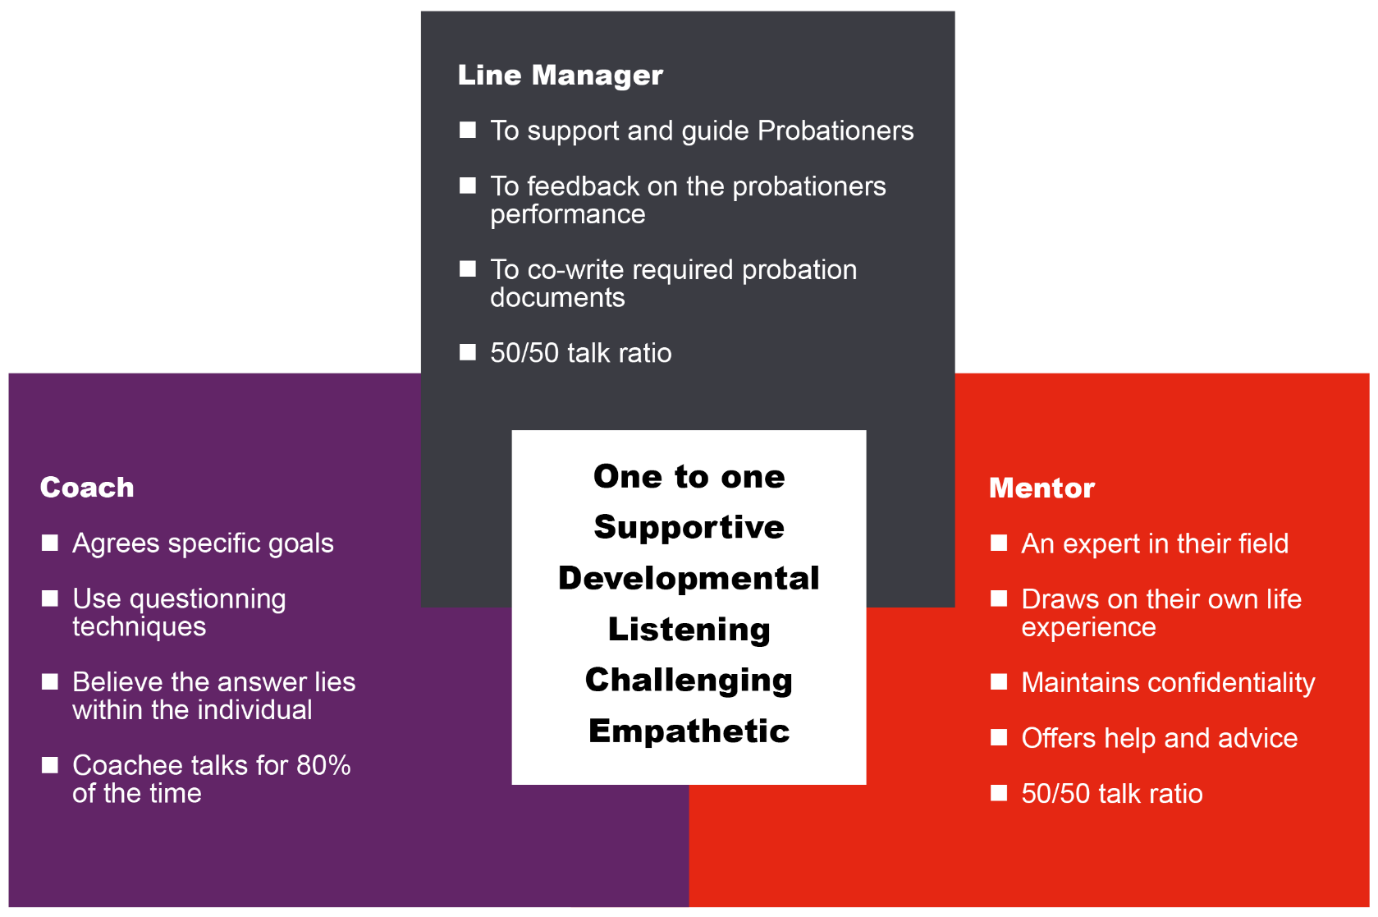

## The role of the new employee

The new employee needs to play an active role to get the most out of their probation. This means:

* Ensuring they understand the requirements of the role and seek guidance where they are not clear.
* Attending regular meetings with their line manager and playing an active role in them.
* Taking responsibility for their personal development.
* Being open to feedback and coaching
* Raising any problems and seeking support, where needed.
* Ensuring that Essential Training is completed in good time.

The new employee must own their probation agreement and make sure they are actively looking to complete their objectives.

## The role of People & Culture

People & Culture are there to support line managers and new starters to get the best out of the probation period.

People & Culture initially send contractual information to the new employee before they start. This will include information about the length of their probation period and the University’s induction programme.

People & Culture can support the line manager in tackling any issues around performance and development. It is always best to involve People & Culture at an early stage – this does not mean that a formal process will be followed but they can help support you to get things back on track. People & Culture can provide a range of professional development opportunities that can also help. If a probation agreement is not in place, it might be good to introduce one.

Once the line manager is happy to confirm probation they must contact People & Culture so that a confirmation of permanency letter can be sent through to the individual.

In those rare cases where the individual fails to improve, this may lead to either an extension of their probation period or non-confirmation of probation. [The Employee Relations Advisory Team](mailto:Hremployeerelations@essex.ac.uk) will help guide the line manager and the individual through this process.

## The stages of probation

The key stages of probation are:

* Induction, which includes Essential Training.
* If a probation agreement is being used, this needs to be discussed and agreed upon with the line manager within the first few weeks of starting in a role.
* Midway through probation, at 3 or 6 months, there should be a review of how the role is going, and whether any guidance or support is needed. Any concerns should be flagged at this point.
* At the end of probation, the line manager should meet with the employee and review the probation period.

At the end of the probation process, the line manager needs to inform People & Culture if the employee has passed through probation or if they have any concerns about the employee's performance these should have been raised earlier in the process.

## Induction

Induction is a crucial time to ensure that new starters have all the essential information and training they need. Line managers must ensure the new employee has completed all Essential Training within 6 months, which can be accessed on the [Moodle site](https://moodle.essex.ac.uk/course/view.php?id=5696). There is a comprehensive induction checklist to follow and new employees are also invited to book onto and attend induction events including networking and role-specific inductions. The invitations to these events are sent directly by Organisational Development and can be booked through [HR Organiser](https://hrorganiser.essex.ac.uk/tlive_ess/ess/dist/#/main/home/dashboard).

## The probation agreement

The [probation agreement](https://www.essex.ac.uk/staff/starting-at-essex/probation) is a record of the expectations and objectives set out by the line manager and discussed with the new employee. A probation agreement can be a useful tool to ensure that new starters are clear about what is expected of them.

The agreement has two parts.

* Objectives for the role.
* Identified training and development activities to support the individual in their new role.

Both parts of the agreement should be completed within the first few weeks of the appointment so that it can be most useful.

The probation agreement and the milestones within it should form part of regular review meetings with the line manager.

## Mid-Point review

The first formal review of progress happens at 3 months for grades 1-6 and 6 months for grades 7-11.

This is a good opportunity to check that the new employee is settling in and making good progress in the role. It is the new employee’s opportunity to give feedback, seek guidance and agree next steps.

Before the review meeting, it may be of benefit to encourage the new employee to prepare a self-reflective account of how the first half of their probation has gone. The line manager may also wish to ask for feedback at this point.

Any areas to improve must be acknowledged and addressed. This allows the new employee sufficient time to meet targets and does not put them in a difficult position at the end of their probation period.

The line manager should consider strengths and gaps a new employee may have, acknowledging setbacks and what (if relevant) the new employee is doing to improve.

## Final review

The final review happens at the end of the Probation Period and allows the line manager and new employee to reflect on the past 6 or 12 month period and what has been achieved. The probation agreement will help both parties to do this in a structured way. If any issues arise it is important to try and resolve them informally in the first instance. If this is not possible, they must be flagged to People & Culture at the earliest opportunity – who can provide support and guidance.

In exceptional circumstances, it may be felt that the probation period should be extended. This should not happen as a matter of course and would need to be agreed upon by a senior manager, in collaboration with People & Culture.

Following the final review, the probation agreement can be taken forward as the basis of the employee’s ongoing Performance and Development Review (PDR). Please see [PDR](https://www.essex.ac.uk/staff/grading-and-reviews/conducting-appraisals) for further information.

## Top tips for giving feedback

* Make sure the recipient is prepared
* Try to give the feedback in a timely manner while it is still fresh
* Don’t give feedback in a public place or in front of others
* Focus on helping to improve performance
* Demonstrate the behaviour you wish to see
* Don’t focus on personality or personal comments
* Vary your style according to the needs of the individual
* Recognise the positives as well as negatives
* Don’t make assumptions
* Don’t argue with or ignore the recipient
* Don’t dwell on the past without looking at the future
* Ask for feedback on the way you handled the session
* Look to continuously improve

## Top tips for making the most of a probation period

**Make sure you meet your new employee regularly.** All line managers are very busy with business as usual, but before you know it the probation period will have ended and you may not have spent enough time with your new employee. If you have not spent the time with them how will you know if they are settling into their role? Commit to meeting regularly from day one.

**Training and Development.** Take advantage of the probation period to train, develop and monitor your new employee. At the end of the probation period, your new employee can then be ready to hit the ground running and excel in their new role.

**Two-way feedback.** It is important for feedback to be a two-way process, as well as identifying how well the new employee is fitting into their new role, it is important to find out what the employee thinks of their new role. It is important to find out if it meets their expectations and what they were promised at interview. Are they happy with their induction? What additional training would they like to have?

**Be Sure.** If you are not 100% sure your new employee is right for the role or if you have concerns about their ability to carry out the job beyond the intervention of training and development, it is crucial not to sign off their probation period. If required, it is better to extend the probation period.

**Share experience.** It is important to make a good impression on your new employee by telling them about the University’s strategy, vision and values. It is vital you help and support a new employee to understand the bigger picture and the important part they have to play. If a new employee has a bad initial experience, they are likely to carry it with them throughout their career at the University.

## Once probation is completed…

The reflection, learning, feedback and achievements of the probation period can be taken forward once permanency has been achieved.

* A development log can be created to assist with this.
* A mentor may also help with development and achieving the next set of goals.
* The [performance and development review](https://www.essex.ac.uk/staff/grading-and-reviews/conducting-appraisals) process will also provide an opportunity to have time with your line manager for feedback and reflection

## Where can I find additional support?

[Probation Policy](C://Users/cl17961/Downloads/54573_Managers_Probation_Guidance%20(4).pdf)

[Coaching](https://www.essex.ac.uk/staff/professional-development-and-training/coaching-essentials-for-managers)

[Mentoring](https://www.essex.ac.uk/staff/professional-development-and-training/mentoring)

[Induction](https://www.essex.ac.uk/staff/starting-at-essex/your-induction-to-essex)

[Performance and development reviews](https://www.essex.ac.uk/staff/grading-and-reviews/conducting-appraisals)

[Probation agreement](https://www.essex.ac.uk/staff/starting-at-essex/probation)

## Annex 1: Professional services employee timeline

#### 6 Month probation

|  |
| --- |
| Month 01 |
| * Welcome new employee * Populate probation agreement * Initial induction * Initial online Moodle Essential Training * Set expectations |

|  |
| --- |
| Month 02 |
| * On-going 121’s and coaching * Reviewing initial objectives |

|  |
| --- |
| Month 03 |
| * Hold a mid-point review * Review objectives * Flag if there are any issues on either side in writing * Inform People & Culture of any problems |

|  |
| --- |
| Month 04 |
| * On-going 121’s and coaching * Reviewing initial objectives |

|  |
| --- |
| Month 05 |
| * On-going 121’s and coaching * Reviewing initial objectives |

|  |
| --- |
| Month 06 |
| * Confirm appointment with individual if successful * Inform People & Culture of outcome * Confirm in writing to individual * Consider extension if individual is not meeting objectives or has been absent * Look at future development plan and on-going training * Implement regular performance and development one to ones and schedule an annual [performance and development review](https://www.essex.ac.uk/staff/grading-and-reviews/conducting-appraisals). |

#### 12 Month probation

|  |
| --- |
| Month 01 |
| * Welcome new employee * Populate probation agreement * Initial induction * Initial online Moodle Essential Training * Set expectations |

|  |
| --- |
| Month 02 |
| * On-going 121’s and coaching |

|  |
| --- |
| Month 03 |
| * On-going 121’s and coaching * Reviewing initial objectives |

|  |
| --- |
| Month 04 |
| * On-going 121’s and coaching |

|  |
| --- |
| Month 05 |
| * On-going 121’s and coaching |

|  |
| --- |
| Month 06 |
| * Hold a mid-point review * Review objectives * Flag if there are any issues on either side in writing * Inform People & Culture of any problems |

|  |
| --- |
| Month 07 |
| * On-going 121’s and coaching |

|  |
| --- |
| Month 08 |
| * On-going 121’s and coaching * Reviewing initial objectives |

|  |
| --- |
| Month 09 |
| * On-going 121’s and coaching |

|  |
| --- |
| Month 10 |
| * On-going 121’s and coaching * Reviewing initial objectives * Flag any problems |

|  |
| --- |
| Month 11 |
| * On-going 121’s and coaching |

|  |
| --- |
| Month 12 |
| * Confirm appointment with individual if successful * Inform People & Culture of outcome * Confirm in writing to individual * Consider extension if the individual has been absent or has not responded to actions put in place to improve performance. * Look at future development plan and on-going training * Implement regular performance and development one to ones and schedule an annual [performance and development review](https://www.essex.ac.uk/staff/grading-and-reviews/conducting-appraisals). |

## Annex 2: Probation checklist for line managers

|  |  |
| --- | --- |
|  | Meet with the new employee and explain the requirements of the role |
|  | Fill out the probation agreement template and identify key objectives/areas for development |
|  | Book in regular 121’s (ideally weekly/fortnightly during at individuals probation period) |
|  | Send calendar invitations to the new employee for their midpoint and final review |
|  | Complete the new starter ‘Checklist for line managers’ |
|  | Make sure the new employee has completed the ‘new starter’ Essential Training (details on Moodle) |
|  | Make sure the new employee has completed their Induction (details on Moodle) |
|  | Have a formal meeting at the ‘midpoint’ of probation and review progress inline with the probation agreement (e.g. 6 month probation meet at 3 month point, 12 month probation meet at 6 month point) |
|  | If any issues are identified at the midpoint meeting ensure your Employee Relations Adviser is made aware and the necessary support is put in place. |
|  | Have a formal meeting one month before the ‘end’ of probation and review progress inline with the probation agreement |
|  | If the individual has successfully completed their probation ensure your Employee Relations Adviser is made aware, alternatively if issues have been identified also make sure your Employee Relations Adviser is made aware. |
|  | If successful arrange for Employee Relations to send a letter to the new employee confirming appointment. |
|  | Agree a probation extension of up to 3 months if appropriate (extensions should only be considered in extreme circumstances with support from your Employee Relations Adviser please refer to the probation policy) |
|  | Once the appointment has been confirmed set up regular 121’s and agree an ongoing development plan |

## Annex 3: Getting the most out of your meeting

|  |
| --- |
| Before the meeting |
| * Organise a suitable private room * Ensure the individual is aware of the date/time/room * Ensure the individual understands the purpose of the meeting and areas to be discussed * Ensure the correct, most up to date documentation is being used from the probation online toolkit * Review the appropriate documents (probation agreement, development plan) * Consider examples against the objectives on the probation agreement * Consider skills and behavioural strengths. Are there any gaps? * Gather feedback from colleagues who have worked with the individual |

|  |
| --- |
| During the meeting |
| * Welcome the individual * Clarify the reason for the meeting and the desired outputs * Ask the individual to talk through their objectives and how they feel their probation has gone * Line manager needs to give structured feedback against objectives * Look at areas to feed into the new development plan * Consider the available courses on HR Organiser and check how both parties feel the meeting went * Agree frequency of 121’s coaching sessions going forward * Discuss the possibility of a Mentor |

|  |
| --- |
| After the meeting |
| * Ensure a copy of the completed probation agreement is shared with People & Culture so that if successful a letter can be sent confirming permanency to the individual * If unsuccessful refer to the probation policy and contact People & Culture to consider next steps * Ensure regular 121’s and future coaching sessions are booked * Ensure a development plan is completed * Look at appointing a mentor if it would be beneficial for the individual and they are in agreement |

## Annex 4: Feedback is a key tool in developing others

Feedback can be handled in two ways:

|  |  |
| --- | --- |
| 1  It can be told  e.g. When you were presenting at the meeting yesterday you failed to mention that we had increased the deadline for the activity | 2  …Or it can be consulted  e.g. How do you think the presentation went yesterday? Do you think you covered all the key information? |
| * Good for quick, short, effective feedback between 2 people who have high levels of trust and respect * Effective fall-back if the employee is unable to identify the feedback area for themselves * Can lead to low levels of motivation | * Great for motivation levels and “buy-in” * Increases likelihood that behaviour will change / be reinforced * Much easier for all concerned with “difficult” areas * Is likely to take considerably longer |

A blend of the two is the most natural approach

#### Feedback Do’s and Don’ts

|  |  |
| --- | --- |
| Do | Don’t |
| * Check your motivation for giving feedback * Give feedback as soon as possible * Make sure the recipient is prepared * Demonstrate the behaviour you wish to see * Recognise the positives as well as negatives * Make your discussion’s two-way; ask questions, check reactions * Vary style according to needs of individual and situation * Focus on helping to improve performance * Ask for feedback on the way you handled the session | * Ignore the recipient’s comments * Make assumptions * Argue * Promise what you can’t deliver * Focus on personality or personal comments * Discuss people’s performance in public, with them or others * Avoid giving any of the ‘bad news’ * Get caught up with destructive criticism * Dwell on the past without thinking about future opportunities |