DSE Facilitator (Level 2) Assessment
The DSE user should first complete the online computer safety course and standard DSE self- assessment checklist. Where the checklist has identified problems, this checklist can be used by the DSE facilitator.

Name of person being assessed:
Department / location:
Name of DSE facilitator:
Date of assessment:
Why it is needed / why: |  |  |  | notes
DSE self-assessment form:
Part A answered– ‘yes’ due to:
Part B answered– ‘no’ due to:

(it is recommended the DSE User completes Computer Safety Essentials training and self-assessment)
Stage 1: Questions  Confidentiality – Check that it is OK to discuss in office.  Any aches and pains, medical problems or disability that are affecting ability to use the computer safely?  Nature of work tasks. Work locations. Any non-work related factors. | Observations |  | Recommended action | Action required
Stage 2: Is specialist advice needed?  If an existing medical condition or disability has been diagnosed, what advice have they been given regarding DSE use. | Observations |  | Recommended action  Ask if they need specialist equipment. If Yes, either recommend purchase of same equipment or speak to WHSW  If they have complex needs recommend referral to an OH adviser. (See guidance on OH referral) | Action required
Stage 3: Observe users posture (see image 1)  Head and neck upright  Facing forward  Shoulders and upper arm perpendicular to floor.  Arms & elbows close to body  Forearms, hands and wrists straight & parallel to floor.  Thighs angled slightly from hip to knee (5-10º)  Feet flat on floor or footrest  It’s a good idea to take a picture before and after the assessment to record the changes. | Photographs Before (Image 1) |  | Photograph After adjustments

Stage 4: Chair  Move chair away from desk and take off any jackets, bags or supports.  Check it over to ensure it is stable and not broken.  Show the user the How to set up your workstation video.  Show the user their chair instructions (usually below the seat.)  Adjust seat angle ((5-10º forward tilt)  Lower back supported by rest. Adjust lumber support if available.  Back rest supports body.  3 finger width between front edge and lower leg.  Return to chair, user to the desk.  Check height to elbow vs desk height. (Up to 3-4 cm greater than desk height.) If too low raise chair. If too high may need to raise desk (wooden blocks available up to approx. 5 cm). | Observations | Recommended action  The chair should be the standard Solar, Task or Harlequin chair and not broken. If you need to order a new chair, refer to info sheet:  Flow chart to replace operator chairs  Remove arm rests if they impede the User reaching the workstation.  Adjust the Users chair using the adjustment features. The adjustment features should all work. Follow the chair’s instructions and give a copy to the User. Refer to info sheets: Solar/Task chair instructions and Harlequin chair instructions  The User achieves a good seated posture (image 1 below)  The User should be familiar with the video: How to set up your workstation  The User arms in the right position at the desk and if necessary desk blocks or a foot rest. Some desks the feet and screw up or down.  CHECK - Ask the User to adjust the chair to the correct posture. Refer to image 1 below. | Action required

Stage 5: Desk and what’s on it  Desk  Large enough, clear working zones, square chair-keyboard- monitor arrangement, desk space adequate.  Monitor  Monitor arms’ length away, ear in line with shoulders and hips, eyes see whole monitor  Keyboard and mouse  Arms work inside shoulder, 90⁰ elbow, horizontal arm and wrist. Wrists not on desk whilst typing.  Document holder  In line when reading screen.  Phone  Within reach and correct side for user. | Observations | Recommended action  Desk is tidy, free from clutter and clean.  User is in line with keyboard, screen and square to the desk.  Monitor is an arm’s length away from the seated User.  The User’s eyes should be in line with the top of monitor.  Keyboard works and can be moved easily and tiltable. Observe whether the number pad causes the User to bend their wrist.  The User’s lower arms, wrists and hands, when observed from above, should be in a line.  The User’s lower arms, wrists and hands, when observed from side, should be in a straight line, not touching the desk.  Different types of mouse – flat, tracker ball and ‘penguin’. Does not reach out excessively to use mouse.  The User’s phone within reach.  If you need to order a new equipment or wish to trial it, refer to info sheets: Flowchart for the procurement of peripheral computer equipment, Procedure for obtaining equipment for DSE Users  and Computer accessories | Action required

Stage 6: Environment – what’s around  Light  Glare, contrast, reflected light. Look up at ceiling light and blinds.  Temperature  Too hot/cold?  Humidity  Too dry/hot/cold?  Air pollution  Smells. Any obvious sources from inside or outside?  Noise  Distracting noises. Too quite. | Observation | Recommended action  Glare - from windows and overhead lights. Set monitor at right angles to window. Turn off overhead lights.  Reflected – light reflected off shiny and light surfaces (eg desk, painted walls, glass). Turn of sources, matt surfaces, move shiny surfaces if possible.  Blinds in good condition and in place.  Task lighting on desk may help.  Too cold, too hot, too dry – advice and possible solutions here: http://www.essex.ac.uk/ohsas/temperature/default.htm  Users can open the windows easily without obstruction. House plants can help with low humidity.  Air pollution – what are the outdoor and indoor sources. Ask if there is a pattern to it. Ascertain who is responsible for controlling these and contact the relevant group. Air conditioning is working.  Noise – what are the sources of distracting noise? Can it be eliminated or reduced. Is machinery broken or running poorly. Find out who is responsible for the source and contact the relevant group. | Action required
Stage 7: Task  Discuss work tasks – duration and intensity  Home working and other workstations?  Breaks?  Other activities at work?  Software suitability |  | DSE work sessions should last no more than 90 minutes.  The User can and has adequate breaks and can move around.  User should take regular breaks. WorkRave software may help. Refer to info sheets: WorkRave Leaflet, WorkRave recommended settings and WorkRace instructions.  Sudden and scheduled excessive workloads have been found to cause musculo-skeletal problems. The manager plan work to minimise risk.  Check that the software is suitable for the work and the User knows how to use it. ISS provide and range of training.  Remember to rest eyes 20/20/20; 20 min work = 20 seconds = looking at something 20m ways

Stage 8: Specific situations  Pregnancy  Couple with Pregnancy Risk Assessment  Two screens  iPads/Laptops  How often and for how long are they used?  Where are they used.  Personal safety  Separate keyboard, mouse, monitor?  Laptop – weight, carrying case, suitable specification.  Tall, small, wide, narrow users  Desk and chair adequate for the size and height of user. | Observation | Recommended action  Review DSE for pregnant Users regularly. Users adjust chair regularly. For more information go to http://www.essex.ac.uk/ohsas/DSE/DSEandPregnancy.htm  Two screens: is it necessary – can a wide screen be used? same specification and size. In line with the user and slight turned in. User is symmetrical to the monitors and on the straight part of the desk. Far edges of the monitor turn so the User does not have to twist neck. Equipment in line.  iPads/laptops: can the User reduce the time spent on the laptop. Regular breaks. Separate keyboard and mouse. Laptop docking station.  If the standard equipment does not suit the User’s body shape contact WHSW for advice. | Action required

Signed: (employee) Date:

Signed: (manager) Date:

Review
The assessment and action plan should be reviewed regularly until all actions have been taken and employee has confirmed any ill health problems through using DSE have been resolved. It is then recommended that it is reviewed annually. It is only necessary to complete a new form if the assessment is no longer valid.

Date of Review | Agreed actions taken? | Assessment still valid? | Name of reviewer
 | Yes / No | Yes / No

The completed form should be kept by the employee, manager (e.g. in employee’s file) or DSE Facilitator. The information should be treated as confidential.

Image 1- good seated posture
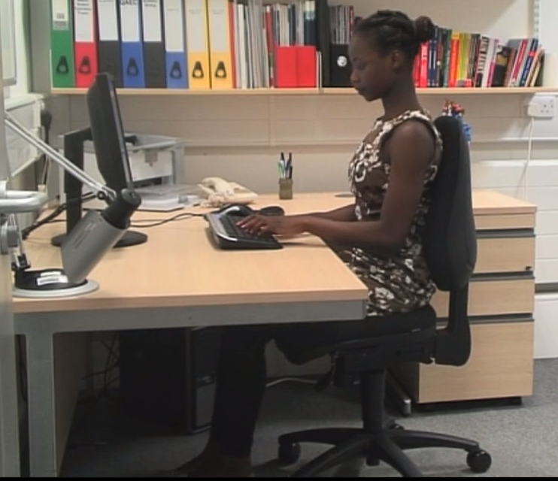

Workplace Health, Safety and Wellbeing Service
Occupational Health Adviser

