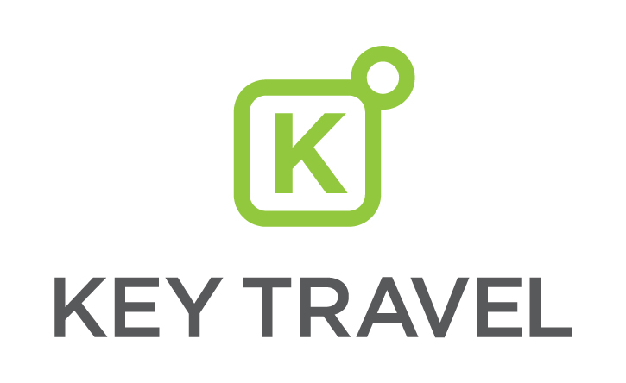

**UK Rail ‘Mobile Ticket’ guide**

**What is a Mobile Ticket’?**

Mobile Ticket is a barcode ticket downloadable via the Trainline mobile app on iOS or Android devices. Currently available with specific rail operators and ticket types, Mobile Ticket will display as a selectable option during the booking process if it’s applicable to the route selected.

**Features and benefits**

* Removes the hassle of printing tickets
* Tickets ready to download within around 5 minutes of booking
* Downloads tickets to the Trainline app
* Real time journey and platform information, alternative trains, and busy carriage indicator

**Traveller actions**

To enable mTickets for use, the traveller must have:

* Downloaded the Trainline App on their iOS or Android device
* For multiple passenger trips:
  + A lead passenger name will be requested at the time of booking and a form of ID will be required to complete the transaction
  + Lead travellers must take responsibility of showing the relevant ID upon request during travel for all passengers
  + Multiple passengers must travel together

**Booking flow**

The booker will proceed through the booking flow as normal, and the option for Mobile Ticket will be offered on the Delivery Options page for valid routes and ticket types.

The booker is required to assign a lead traveller and enter their name as shown below:

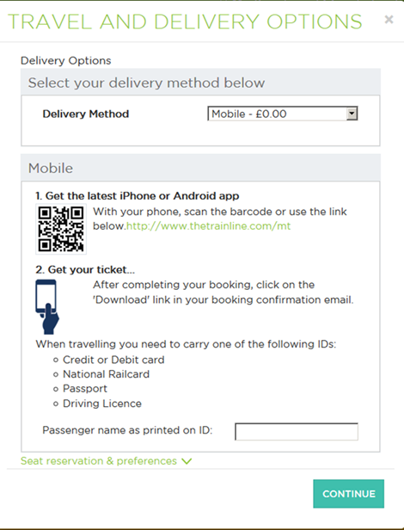

The lead traveller must carry one of the accepted forms of ID and show this if requested during the trip:

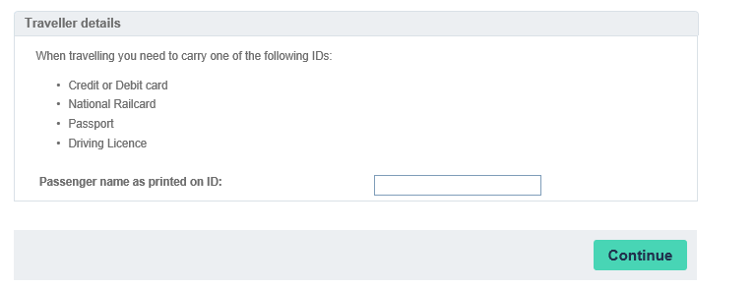

**Adding another journey**

A maximum of 2 Mobile Tickets can be included in one transaction.

Select ‘Add a train’ from the Basket page. It is not possible to mix delivery options within a single transaction so if the second journey searched for cannot be fulfilled by Mobile Ticket, it will not be possible for the booker to add the journey to their basket. A separate transaction is required.

**Accessing the Mobile Ticket**

When the trip is booked, a confirmation is emailed to the booker. Please ensure the traveller has access to this email as the Mobile Ticket instruction is included:

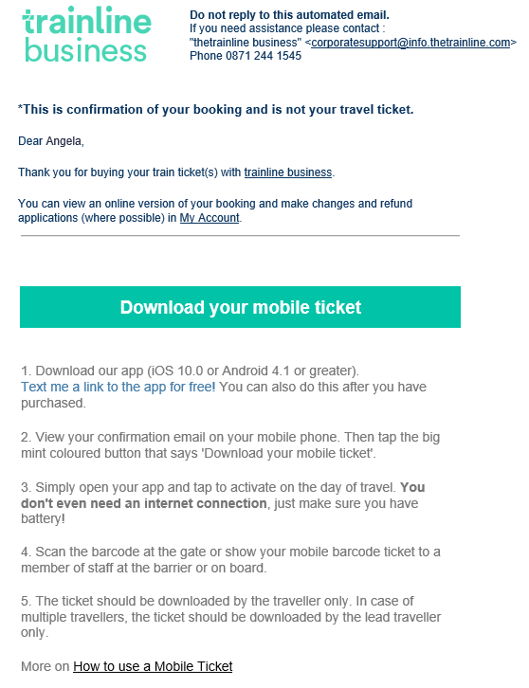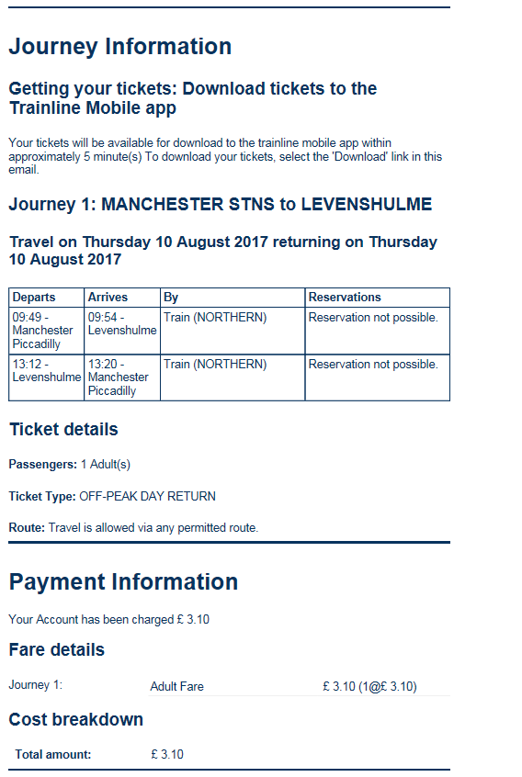

A link to download Mobile Tickets to the Trainline app is included. The lead traveller should have the latest version of the Trainline app downloaded to their iOS or Android device:

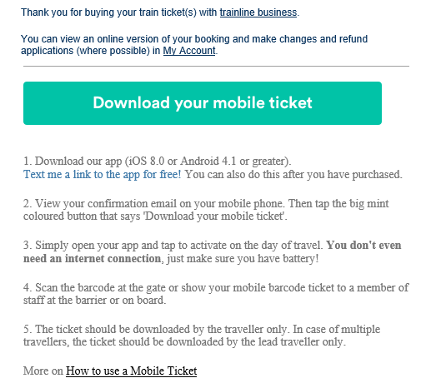

Tapping ‘download your mobile ticket’ from your mobile phone opens the traveller’s ticket within their Trainline app.

The lead traveller can then select ‘view tickets’ to open and activate the ticket. The lead traveller must active their ticket on their device on the day of travel, prior to boarding the train.

Clicking to activate the Mobile Ticket displays a warning message to ensure the traveller definitely wants to proceed. If the traveller activates the ticket, it is locked to this device and is non-refundable and non-changeable.

 

**Route availability**

The following Rail Operator routes are currently enabled for MobileTicket:

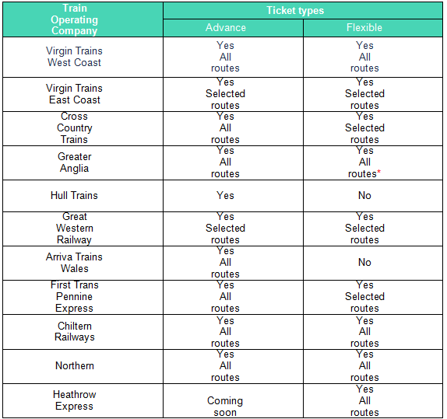

* Everything except peak times into London and the PAYG oyster area.

Trainline continues to work closely with the Rail Operators to expand the route and ticket type coverage of Mobile Tickets. An up-to-date list of the available routes can be found here:

[**http://railportal.custhelp.com/app/answers/detail/a_id/4865**](http://railportal.custhelp.com/app/answers/detail/a_id/4865)

**Support and Assistance**

Should you have any questions about Mobile Tickets, please contact our online helpdesk on:

T: 0844 335 0260

E: [online@keytravel.com](mailto:online@keytravel.com)

Thanks for booking with booking with Key Travel.