Skimming, Scanning and Note-taking

To be used alongside the Skimming, Scanning and Note-taking 2020 workshop. Please do not skip ahead as this will spoil some of the activities and games.

Name

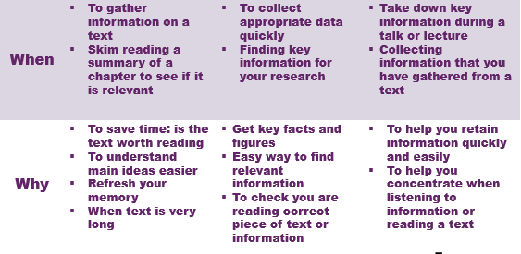
Differences between skimming, scanning and note-taking (Slide 3 & 4)
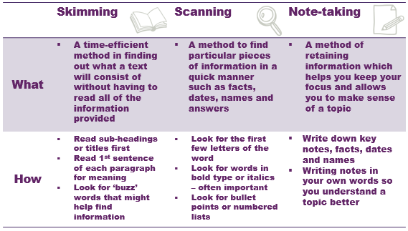
Notes

Activity 1: Using Skimming, Scanning and Note-taking (Slide 5)
- When would you skim read a text? And what techniques would you use to do so? Use the space below to write and/or draw your answers.

- When would you scan a text? And what techniques would you use to do so? Use the space below to write and/or draw your answers.

- When would you use note-taking on a text? And what techniques would you use to do so? Use the space below to write and/or draw your answers.

Activity 2: Skim read the extract from ‘The path that lead nowhere’ in order to answer the questions below. (Slide 8)
The mist clouded Harry's view as he woke up early that morning. Looking out of his apartment window, he had expected to be greeted with the promised view of rolling hills and animals grazing in the meadow below. Instead, the mist meant that he couldn't see for more than 20 metres.

Harry had looked forward to his annual holiday. Working hard in the city centre, the daily grind had started to get to him and he had had little time for pleasures such as relaxation. The holiday had been booked for weeks. He had looked forward to a country retreat, far away from the hustle and bustle of work. This apartment in an eighteenth-century mansion had caught his eye as it promised exquisite cuisine, beautiful interior decor and a range of country pursuits such as clay pigeon shooting and horse riding.

This Sunday morning though, many activities were cancelled due to the low lying mist. Anxious not to let the day slip away, Harry decided that a walk through the nearby forest would enable him to relax. So he set off just after breakfast. He headed towards the forest with a small packed lunch in case the mist prevented him from returning to the mansion before lunchtime.

As he walked along the path, the twigs snapped under his feet and the dew from the trees dripped on to his shoulder. Harry heard the birds sitting in the trees above him, letting him know that he wasn't alone. He had been told about a clearing in the middle of the forest that would greet him with a comfortable bench, often used in the warmer summer months. Harry thought he was heading in the right direction but, over an hour later, he still hadn't reached it. By now he was getting worried. Another hour passed...then another hour...he was still walking amongst the tall oak trees. He decided to rest and sat on a fallen tree to enjoy his lunch.

Questions

Skim the text and answer the following questions by ticking the correct answer:

- The weather in this story can best be described as:

( ) sunny
( ) misty
( ) humid
( ) stormy

- Why was Harry in the apartment?

( ) It was his home
( ) He was visiting his parents who lived there
( ) He was visiting his friends who lived there
( ) He was on holiday

- At this hotel you can normally do clay pigeon shooting and horse riding.

( ) true
( ) false

- This extract doesn't mention:

( ) the birds in the forest
( ) what Harry does for a job
( ) how long the holiday had been booked
( ) the weather

- Why did Harry decide to stop and rest on a tree?

( ) to tie his shoe lace
( ) to listen to the birds
( ) to rest and eat his lunch
( ) none of the above

- How many people are featured in this story?

( ) one
( ) three
( ) two
( ) four people and a dog

- Which of these has the right events in the right order?

( ) Harry eats his lunch and then decides to go for a walk. However, he gets lost and has to stay overnight at a hotel
( ) Harry goes on holiday, decides to go for a walk, looks for a clearing but doesn't find it, stops for lunch
( ) Harry wakes up, then eat breakfast. He gets lost when he takes a walk and has to ask for direction
( ) Harry goes on holiday, decides to go for a walk, he finds a nice clearing so stops for lunch

- Apart from the birds, there were lots of animals in the forest.

( ) true
( ) false
( ) The text doesn't say

- By the end of this piece of text, Harry has found his way out of the forest.

( ) true
( ) false

- Harry was on holiday alone.
( ) true
( ) false
( ) The text doesn't say

Exercise adapted from: http://www.bbc.co.uk/skillswise

Activity 3: Scan this extract of a school prospectus in order to answer the questions below. (Slide 9)
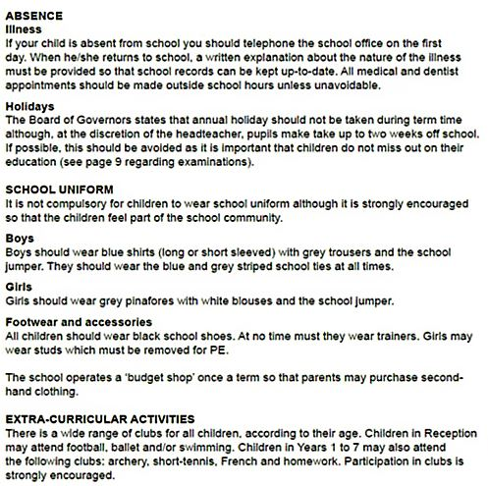
Portham Village School 2010/2011 prospectus

Questions

- If a child is ill and will be absent, who should be telephoned?

- Which school year does the prospectus relate to?

- Who has stated that children cannot take holidays during term time?

- Are children allowed to attend the dentist during school hours?

- Are girls allowed to wear stud earrings?

- What colour is the school tie?

- What school years do children have to be in to attend archery?

- Can children wear trainers in school?

- On which page will you find information about exams?

- How often is the budget uniform shop open?

Exercise adapted from: http://www.bbc.co.uk/skillswise

Effective note taking
Activity 4: In your own way, take notes on the article below. You will have to answer questions later using only your notes. (Slide 13)

Campus Fad That's Being Copied: Internet Plagiarism Seems on the Rise
Author: Rimer, Sara
Publication info: New York Times , Late Edition (East Coast) [New York, N.Y] 03 Sep 2003: B.7.

A study conducted on 23 college campuses has found that Internet plagiarism is rising among students.

Thirty-eight percent of the undergraduate students surveyed said that in the last year they had engaged in one or more instances of ''cut-and-paste'' plagiarism involving the Internet, paraphrasing or copying anywhere from a few sentences to a full paragraph from the Web without citing the source. Almost half the students said they considered such behaviour trivial or not cheating at all.

Only 10 percent of students had acknowledged such cheating in a similar, but much smaller survey three years ago.

This year's study, organized by Donald L. McCabe, a management professor at Rutgers University, surveyed more than 18,000 students, 2,600 faculty members and 650 teaching assistants’ at large public universities and small private colleges nationwide. No Ivy League schools were included.

''There are a lot of students who are growing up with the Internet who are convinced that anything you find on the Internet is public knowledge and doesn't need to be cited,'' Professor McCabe said.
The survey solicited students' comments about cheating, and one student wrote, ''If professors cannot detect a paper from an Internet source, that is a flaw in the grader or professor.''

Another student wrote: ''One time I downloaded a program off the Internet for my class. I hated the class and it was mandatory so I didn't care about learning it, just passing it.''

Forty percent of students acknowledged plagiarizing written sources in the last year. As with the Internet cheating, about half the students considered this sort of plagiarism trivial.

Twenty percent of the faculty members said they use their computers, such as the turnitin.com site, to help detect student plagiarism.

Twenty-two percent of undergraduates acknowledged cheating in a ''serious'' way in the past year -- copying from another student on a test, using unauthorized notes or helping someone else to cheat on a test.

''When I work with high school students, what I hear is, 'Everyone cheats, it's not all that important,' '' Professor McCabe said. ''They say: 'It's just to get into college. When I get into college, I won't do it.' But then you survey college students, and you hear the same thing.''

The undergraduates say they need to cheat because of the intense competition to get into graduate school, and land the top jobs, Professor McCabe said. ''It never stops,'' he said.

One of the students from the survey wrote: ''This isn't a college problem. It's a problem of the entire country!''

Professor McCabe said: ''Students will say they're just mimicking what goes on in society with business leaders, politicians. I don't know whether they're making excuses for what they've already done, or whether they're saying, 'It's O.K. if I do this because of what's going on.' ''

Many of the colleges involved in the survey have begun trying to fight cheating by educating both faculty members and students on academic integrity and revising school policies.

Princeton University was not involved in the survey, but it is among the schools that have been taking steps to make sure students know that it is wrong to use material from the Internet without citing the source.

''We need to pay more attention as students join our communities to explaining why this is such a core value -- being honest in your academic work and why if you cheat that is a very big deal to us,'' said Kathleen Deignan, Princeton's dean of undergraduate students.

There has not been any noticeable increase in cheating at Princeton, Ms. Deignan said, with 18 to 25 cases reported a year. Administrators have noticed, however, that sometimes students and parents do not understand why it is wrong to ''borrow'' sections of text for a paper without providing attribution, Ms. Deignan added.

Princeton students are also concerned, and they have organized a campus assembly on integrity for Sept. 21.

''We live in a world where a lot of this is negotiable,'' Ms. Deignan said. ''Academic institutions need to say, 'This is not negotiable.' ''

Publication title: New York Times, Late Edition (East Coast)
Pages: B.7
Number of pages: 0
Publication year: 2003
Publication date: Sep 3, 2003
Year: 2003
Section: B
Publisher: New York Times Company
Document URL: http://search.proquest.com/docview/432532491?accountid=45111

Notes

Notes

Activity 5: Using only your notes (don’t cheat!) answer these questions about the article. (Slide 14)
- Who authored the article?

- Where was the article published?

- What year was the article published?

- How many college campuses were included in the current study?

- Did the percentage of students reporting plagiarism increase or decrease since the last study?

- Which schools were excluded from the current study?

- Why do students say they need to cheat?

- How have the colleges involved in the study started to try to fight cheating?

- Why is copy and pasting information without citing a source for it a problem?

- What is the main point outlined in the article?

Top tips for effective note taking
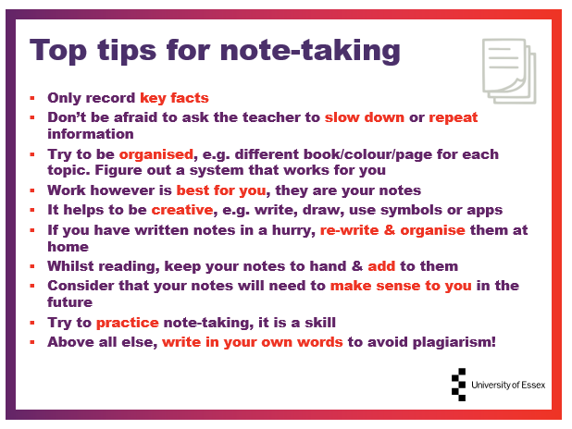

Notes

Cornell Note Taking System
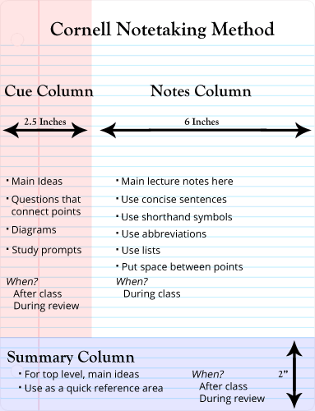

Template
CORNELL NOTES  SHEET | Name: ______________________________  Class: _______________ Topic: _______________  Date: _______/ _____/ ________
QUESTIONS | NOTES
SUMMARY: Write 4 or more sentences describing specific learning from these notes.
________________________________________________________________________________
________________________________________________________________________________
________________________________________________________________________________
________________________________________________________________________________

Activity 6: Reflecting on skimming, scanning and note-taking (Slide 16)

What did you notice during those exercises?

Why are skimming, scanning and note-taking good academic skills to have?

Well done for completing the Skimming, Scanning and Note-taking workshop, we hope you enjoyed it and learned something new!
If you have any questions please send them to www.sli.do and enter #SkimandScan and one of the team will get back to you as soon as they can. Alternatively, you can email outreach@essex.ac.uk

Outstanding Questions

Bonus Activity: Effective note taking (Slide 17)
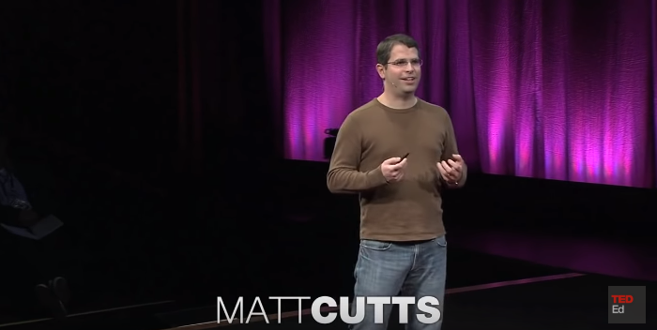
Ted Talk by Matt Cutts on trying something new for 30 days: https://www.youtube.com/watch?v=UNP03fDSj1U
Notes:

