Independent Study

To be used alongside the Independent Study 2020 video. Please do not skip ahead as this will spoil some of the activities and games.

Name
Learning Objectives (Slide 2)
- To understand what independent study is
- To identify different methods of learning
- To identify how a variety of learning methods can help you succeed
- To understand how to tailor your study according to your preferred methods of learning

Notes:

Activity 1: Confidence on the subject (Slide 5)
Please rate the following statements from 1 (Strongly Disagree) to 5 (Strongly Agree):

I know a lot about independent study
Strongly Agree Agree Neutral Disagree Strongly Disagree

I am good at studying independently
Strongly Agree Agree Neutral Disagree Strongly Disagree

Notes:

Activity 2: Independent learning skills (Slide 8)
Brainstorm some of the important things you think you should do when it comes to independet study

Important to…

Independent learning skills (Slide 9)
Here are some examples of what is important when it comes to independent study. Take this opportunity to go back to Activity 2 and add to your own brainstorm the things that you find very important to focus on.

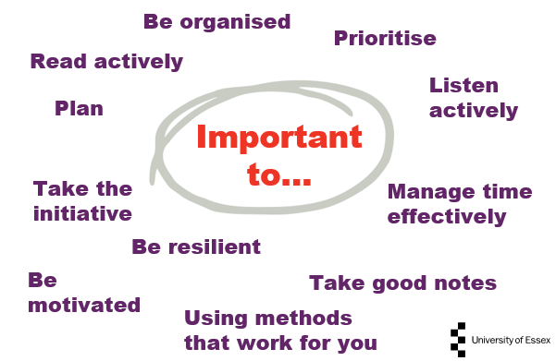

Activity 3: How could you learn or revise? (Slide 11)
Pause the video and spend a few minutes thinking of different ways someone could revise or learn something new

Learning methods
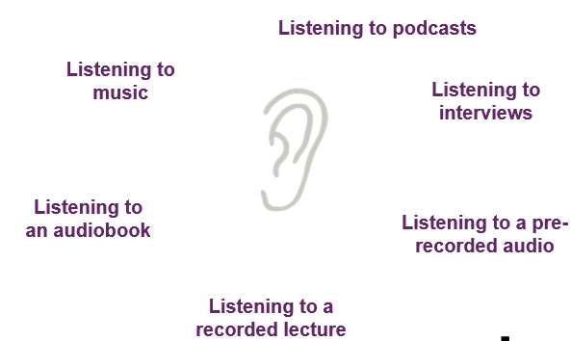

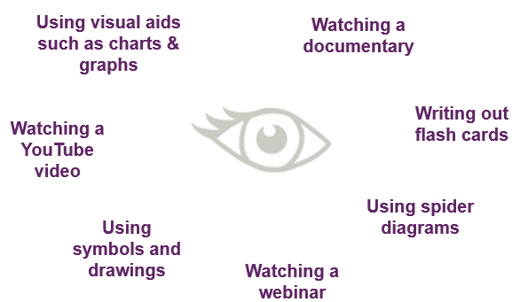
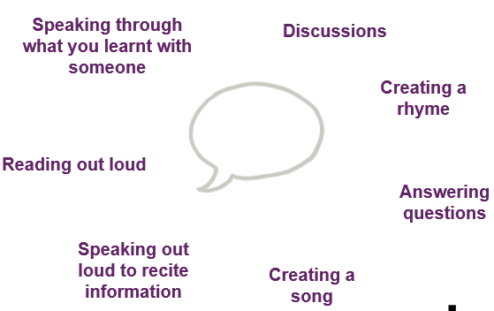

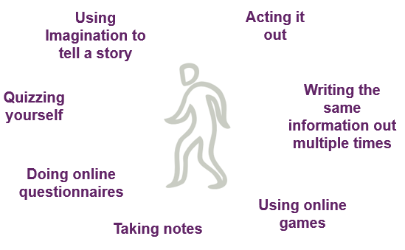
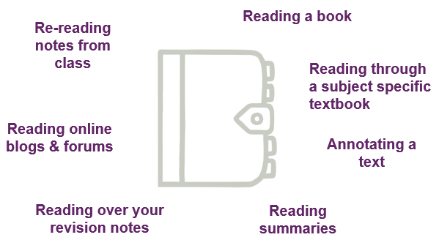

Activity 4: How do you learn best? (Slide 17)
Pause the video and make a brainstorms of how you personally learn best. Think about which methods you like to use in different scenarios: Do you use the same technique when learning new martial vs when you’re revising?

When revising

When learning something new

Useful Techniques (Slide 18)
The Pomodoro Technique
- Work for 25 minutes followed by a 5 minute rest. During the rest you can have a quick stretch, make yourself a cup of tea or simply review and plan what you can do with your next 25 minutes.
To do lists
- Make a to do list with 3 sections- ‘Complete’, ‘Today’ and ‘This week’. Move the tasks around when you wish to do them and once you have completed them.

Notes:

Activity 5: Action Plan (Slide 11)
Pause the video and think about a topic you need to revise, or something new that you need to learn.
Now spend some time putting together a time table that can help you do this.
Include what you will be studying, what methods you will be using and how long for?
Remember: This should be designed to fit around your school schedule, and can include weekend planning or even a study schedule for the holidays! Feel free to make yourself more than 1 version.

Time | Mon | Tue | Wed | Thu | Fri | Sat | Sun

Activity 6: Test your knowledge (Slide 22)
Independent Learning Skills
Complete the crossword below
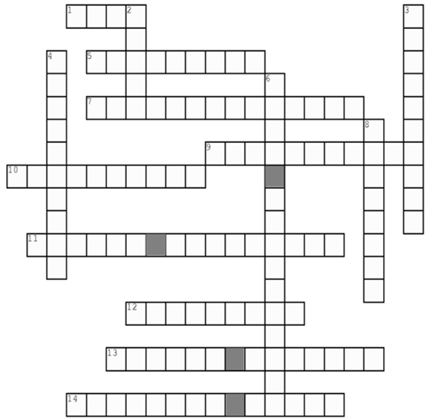
Down
- It is important to take good ………. whether in a lesson or studying alone
3. Putting the important things first
4. Process of adaptation and recovery in the face of difficulty
6. ………. is the key to working efficiently
8. Systematic investigation of materials and sources in order to establish facts and reach new conclusions

Across
- Course of action decided in advance
5. Another word for driven
7. Take .......... for your own learning
9. Another word for autonomous
10. Assessing and initiating things independently means to take ……….
11. To try to concentrate on, understand and respond to what is being said
12. Prepared
13. Critically engaging with the context of a text in order to understand and learn its meaning
14. An individual’s unique approach to acquiring new knowledge and skills

Activity 7: Confidence on the subject (Slide 24)
Please rate the following statements from 1 (Strongly Disagree) to 5 (Strongly Agree):

I know a lot about independent study
Strongly Agree Agree Neutral Disagree Strongly Disagree

I am good at studying independently
Strongly Agree Agree Neutral Disagree Strongly Disagree

Notes:

Some final tips and conclusion (Slide 26)
- Independent study may take some time to get the handle of – don’t panic if you struggle to grasp it straight away
- There are many different ways to learn independently - mix and match them as you please to maximise the benefits
- It is a different way of learning so you shouldn’t be too harsh on yourself if you struggle to adjust

Notes:

Well done for completing the Independent Study workshop, we hope you enjoyed it and learned something new!
If you have any questions please send them to www.sli.do and enter #IndependentStudy and one of the team will get back to you as soon as they can. Alternatively, you can email outreach@essex.ac.uk

Outstanding Questions

