Life Design

Post 16

To be used alongside the Life Design 2020 – Post 16 video. Please do not skip ahead as this will spoil some of the activities and games.

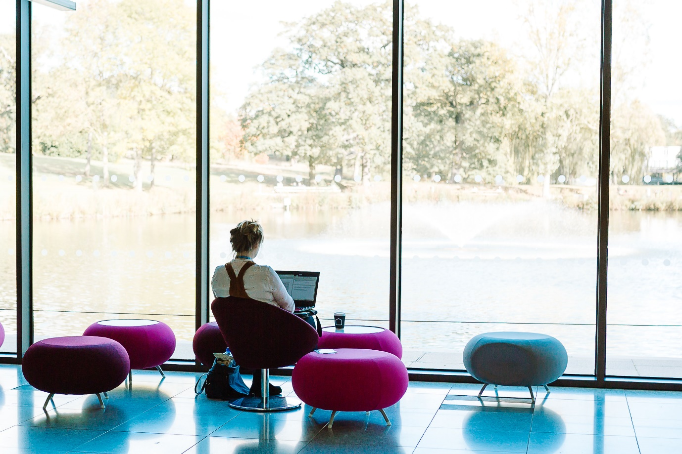

Name

Task (Slide 2)

In four minutes, how many uses can you come up with for a paper clip?

* Have a think…
* How did you do?
* Did you find this task easy or hard?

You will find out the purpose of this later!

Aims (Slide 3)

* During this workshop you are going to learn about the process of Life Design and the theory behind it.
* You are doing this because it adds another skill to your toolkit when thinking about your future. You can then apply this skill across other areas of your life.
* It will help you to plan the steps that you will need to take, including A Level/BTEC choices, volunteer work, university courses and future careers.
* You will end this workshop with one ‘killer idea’ you are going to try out in the real world. This will hopefully take you a step closer to your dream life!

What is Life Design? (Slide 4)

Definition: An approach which applies the principles of product design or design thinking to personal and professional development.

Five Steps of Design Thinking (Slides 6-7)

Write notes for the five steps of design thinking:

Empathy:

Definition:

Ideation:

Prototype:

Test:

Life Design Mind-sets (Slide 11)

Match the life design mind-set to the correct definition:



You have to be aware of where you are now and the steps needed to go forward.



Working with and learning from people who are different from you. Several minds solving a problem is always better than one!



Rather than keeping everything in your head, this approach allows you to gain information by taking action (doing).

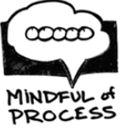

To get the best ideas you have to start with human beings. Learning to listen to yourself and others.

Planning a Party (Slide 12)

Working in pairs, you need to plan a party.

**Round 1** – start each sentence of your conversation with **‘Yes, *BUT’.***

How did the conversation go? How was the party you planned?

**Round 2** – start each sentence of your conversation with ‘**Yes, *AND’.***

How did this conversation go? Were there any differences?

Life Design Task (Slides 13-21)

This part of the workshop will require you to speak to a partner. See if a family member, parent or guardian can help you complete the task or video call a friend from your school! You will need to decide who is person A and who is person B.

For each Life Design step you will have a list of questions that you need to ask each other. Start with person A being the interviewer and then swap. Remember to make notes about their answers in the space provided.

**Empathy**

* What part of your daily routine do you really enjoy?
* What part of your daily routine do you **not** enjoy?
* What are your proudest achievements?
* What does worthwhile work mean to you?
* What values are important to you?

**Empathy example:**

I really enjoy my lessons where I can work in a group and present information to others. I also really like my geography lessons where I can research a project on my own. I don’t enjoy getting up early! I am really proud of when I did some fundraising for our local Hospice. It made me feel really good knowing I was helping others. I also think it is really important in life to help others when you can.

Life Design Task (Slides 13-21)

**Definition**

* + What do you think is important to your partner?
  + What are they good at?
  + What do they enjoy?
  + What stood out to you?

**Definition example:**

I understand that I am currently looking for a career that involves working with people. I am good at talking in front of people and I enjoy researching information. It is important to me that I listen to people and help them when I can.

Life Design Task (Slides 13-21)

**Ideation**

* Imagine your partner’s life is a blank slate!
* They could do anything they wanted without constraint
* Write down fantasy future careers that you think would match your partner

**Ideation example:**

Nurse, doctor, solicitor, lawyer, vet, primary school teacher, secondary school teacher, carer, police officer, researcher, dog walker, hotel receptionist, life coach

Life Design Task (Slides 13-21)

**Empathy/Definition**

* Each of you must describe to your partner the fantasy future careers you have generated for them
* Listen to their responses
  + Do any particularly appeal to them?
  + Do they dismiss any?

Once you have listened to each other you need to decide on a favourite future career.

**Definition/Ideation/Prototype**

* What are all of things that you could do to test or prototype this future?
* Write a list of as many as possible
* Share with the group if possible, add any more ideas that are suggested

**Prototype Example:**

Talk to someone who is currently studying a Law degree; attend a Law taster session at university; interview someone who is a lawyer; go to a courthouse and observe a trial; shadow a lawyer for a day/do work experience in a law firm; do research into Law courses at university and find out entry requirements

Life Design Task (Slides 13-21)

* Select one idea from your list to take forward and prototype in the real world
* Each person to tell their group which idea they have chosen and what action they are going to take.

**Test Example:**

I have decided to attend a Law taster session at university and will find out how to book my place either through my school or researching on the internet.

**Write your killer idea here:**

In Conclusion (Slide 22)

* Design Thinking allows you to think about problems in a different way.
* Applying this way of thinking to Life Design allows you to consider and explore lots of different options.
* It gives you more control over your life and the direction that you want it to take.
* It is great way of working out what is important to you.
* It allows you to make informed choices about A Levels, voluntary work, university courses and future careers.

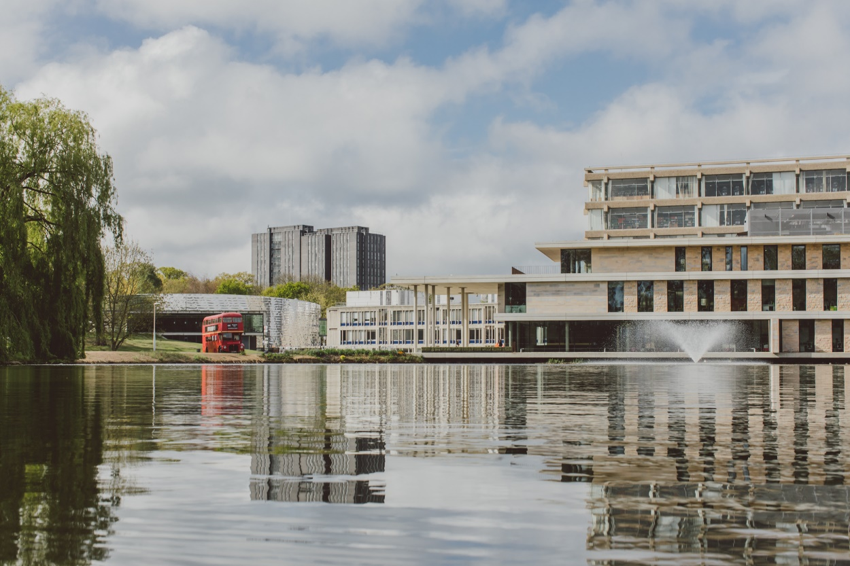

If you have any questions please send them to our email outreach@essex.ac.uk

**My questions/notes**